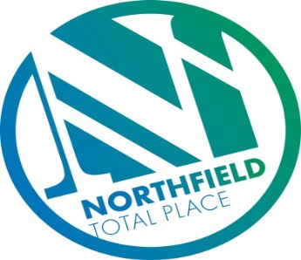

Northfield Total Place
Locality Partnership Board Meeting
Northfield Academy
Wednesday 9am – 11am on Wednesday 30th August 2017

AGENDA

- Welcome and introductions
- Apologies
- Minutes of previous meeting – one change
- Matters arising
- Improvement Methodology/Tests of Change Presentation
- Criminal Justice Presentation
- Pupil Equity Fund
- Middlefield and Heathryfold Matters
- SURF Awards
- Review of Action Tracker
- Priorities
- Developing the workforce
- AOCB
- Date of next meeting – to be decided

