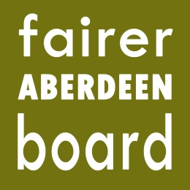

Fairer Aberdeen Board
6pm, Thursday 10th December
Town House

Agenda

- Apologies
- Northfield Academy welding money, change of use – Neil Hendry
- Minute of meeting 29th September 2015
- Minute of meeting 29th October 2015
- Matters arising – reply from ADP
- Financial update
- Indicative 3 year funding
- Cash In Your Pocket verbal update – Susan Thoms
- Community Support Fund verbal update – Anne Knight
- Draft Annual Report for Council 16.12.15
- AOCB

