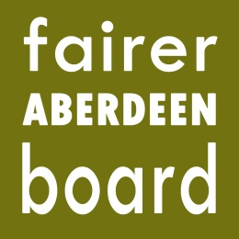
Fairer Aberdeen Board

6pm, Thursday 13th March 2014
Committee Room 5
Town House

AGENDA

- Apologies
- Note of meeting held on 6th February 2014
- Matters arising
- Applications 2014-15 – agreed for continuation of funding
- Applications 2014-15 – to be considered by Board
- Fairer Aberdeen Board review
- AOCB
- Date of next meeting

