Model for Improvement Toolkit

Driver Diagram
Driver Assessment Tool

HELP SHEET 2

Why would I use this tool?

A Driver Diagram helps translate a high-level improvement goal into a logical set of related goals and sub-projects. The tool helps organise change concepts and ideas as an improvement team answers the question “what changes can we make that will result in an improvement?” Driver Diagrams are used to test theories about cause and effect and are meant to be updated throughout the project.

The Driver Prioritisation Tool can help you to understand the status of the drivers and help to make decisions about which improvement projects should be prioritised.

Example Driver Diagram

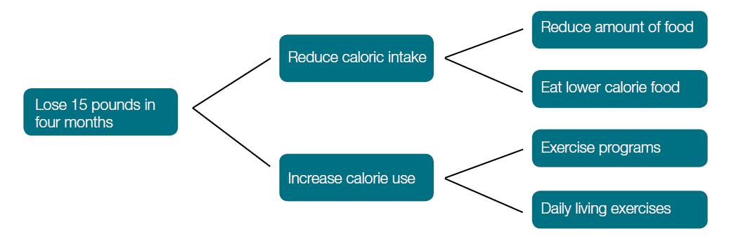

Driver Diagrams Explained

Aim or Outcome: Driver Diagrams start with a clearly defined and SMART (Specific, measurable, achievable, realistic, timely) goal.

Primary Drivers: The overall aim is linked to those factors that are believed to have a direct impact. For example, in order to lose weight we need to reduce caloric intake and increase effective caloric use. These are referred to as primary drivers because they drive the achievement of your main outcome.

Secondary Drivers: To have an effect on primary drivers, we need to carry out clearly defined actions, namely: reduce the amount of food, eat lower calorie food, join an exercise program, and increase our daily living activities (i.e. take the stairs instead of the elevator).

How would I use this tool differently at different stages of the Model for Improvement?
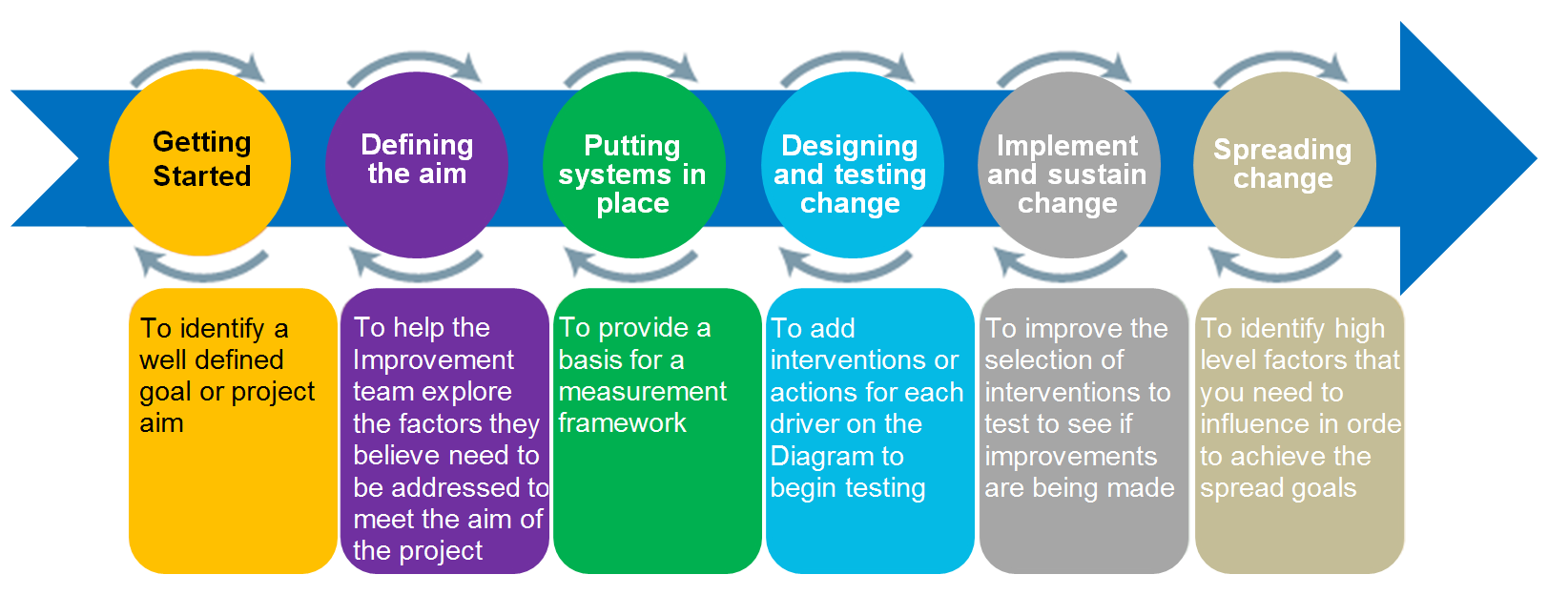
How do I use this tool?

- Convene a meeting with the improvement team and content matter experts
- Start by identifying a clearly defind goal
- Brainstorm “What changes can we make that will result in an improvement?”
- Cluster the ideas together to see if any groups of ideas represent a common driver
- Expand the groups to see if new drivers come to mind
- Logicaly link together the groups into a driver diagram format
- Devide which drivers and interventions you want to measure and add to the diagram

What do I need to use this tool?
Setup

Before beginning it is important to be clear about the aim of the improvement project. Complete as a team

Timing

Driver diagrams are ‘live’ tools and will change over time as you make changes to your system

Materials

Driver diagram template

What tips and tricks will be useful in facilitating the use of this tool?

- Creating a Driver Diagram with a team ensures that all team members understand the goals and how they can contribute to achieving them

- Driver diagrams will vary from place to place – there is no definitive “right answer” as your situation may be very different from that of other organisations

- A Driver Diagram will represent the problem as seen by the group and a way to communicate the change strategy to others

- Work backwards from change concepts if that helps.

This video provides a short introduction to driver diagrams.

Driver diagram template

You can create a simple driver diagram template using SmartArt in word. Altrnatively, just use pen and paper!

For more information, email CommunityPlanning@aberdeencity.gov.uk
Driver Assessment Tool

When you have completed your driver diagram, the driver assessment tool can be used to make decisions about how to prioritse your improvement efforts.

How do I use this tool?

- Convene a meeting with the improvement team and content matter experts
- Ask each individual to assess the status of each driver using the Driver Assessment Tool
- Each individual should score each driver by using the scale in the tool
(from 0 to 5)
- Ask each individual to assess the predicted impact of each driver using the Driver Assessment Tool
- Each individual should score each driver by using the scale in the tool
(from 0 to 5)
- Ask each individual to share the scores provided.

The team should focus on the drivers that score lowest in the Driver Status and highest in the Predicted Impact. Most impact will be achieved if improvement projects are focussed on drivers that score 0 or 1 in terms of Driver Status and 4 or 5 in terms of Predicted Impact.

Driver Diagram Assessment Tool
Level | Driver Status
0 | Driver not defined or status unknown
1 | Informal understanding by some people. No formal description
2 | Driver documented and understood by all (including ‘customers’ where appropriate)
3 | Driver is defined and carried out reliably. Measures to track the quality of the outcomes related to the Driver are defined
4 | Regular monitoring of Driver outcomes with stakeholders acting on data for further improvement
5 | Driver outcomes predictable and embedded in the system. Consistently meets the needs of all requiring it
Level | Predicted impact
0 | Driver has no impact / irrelevant to our ‘customers’ or staff
1 | Driver area has minimal impact on outcomes
2 | Driver will improve services and outcomes but others are more important
3 | Driver has significant impact on outcomes
4 | This project is necessary for delivering services. It has a direct impact on the outcomes for our ‘customers’
5 | Driver is essential for achieving results. Improvement in this Driver alone would have a direct, immediate impact on outcomes

