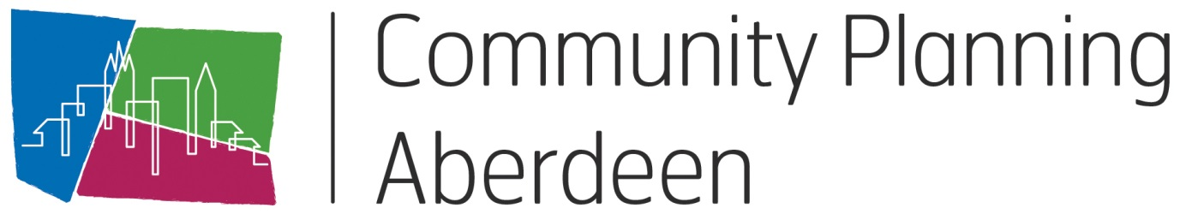

Model for Improvement Toolkit

Measurement Plan

HELP SHEET 4

Why would I use this tool?

Data collection is crucial for effective, evidence-based improvement work. The Measurement plan is a checklist for examing the data collection process in all its aspects: what, how, where, when and by whom. Engaging all team members through a clear, shared plan creates understanding of the outcomes you are trying to accomplish, making it easier to implement and monitor results.

How would I use this tool differently at different stages of the Model for Improvement?

A Measurement Plan is an important tool that assists the improvement team at every stage.
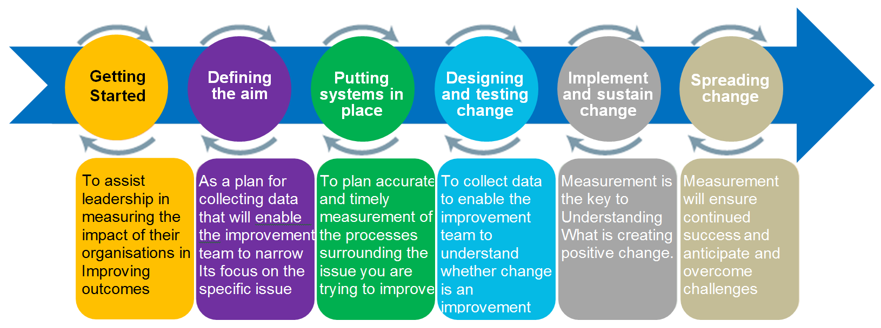

How do I use this tool?

- Bring together the Improvement Team and ensure you have representation from the staff that will be accessing the data for the plan.

- Complete the sections of the Measurement Plan tool.

- Make sure to identify whether the measure is a process, outcome or balancing measure. Don’t forget to indicate the unit of measure for your data (minutes, hours, percentage, etc.).

Types of measures
There are three types of measures that can be used to support our improvement projects. However, do not get caught up trying to ensure that your measures fit into these categories, use them for reference.

Outcome measures reflect the impact of changes on your target group, for example, a community, a pupil, a team. An outcome measure shows us if we are on track to achieve our improvement aim, and what changes have a positive impact, such as fewer referrals or less complaints.

Examples of outcome measures could be:
- Improved attainment for a young person or group of young people
- Increased attendance at community meeting
- Customer satisfaction levels

Process measures relate to the changes we put in place to achieve our aim. These measures help us understand if interventions are being carried out as often or reliably as we planned to or assumed they were.

Examples include:
- Time spent on a particular task
- Number of events held (of those we planned to do)
- Number of people attending training

Balancing measures show whether unintended consequences have been introduced elsewhere in the system, these can be positive or negative. For example, the aim of an improvement might be to improve the attainment of the lowest 20% of young people by coaching them in class. As a balancing measure you might wish to track if the additional time spent with these pupils has a negative impact on the attainment or behaviour of the rest of the class.

Other examples may be:
- Increase in crime rates in a different area
- Decrease in footfall at other attractions
- Increase in decrease in complaints in another area

You may not know what your balancing measures will be before you begin your improvement. The complexity of the work may mean the knock-on effect happens elsewhere, for this reason make sure you are sharing what you are doing and keep communication open. If other people identify a change – be it positive or negative – you can address and monitor it early.

What do I need to use this tool?
Materials

Microsoft Excel
Project charter

Timing

30-40 minutes

Setup

Familiarity with Microsoft Excel

What tips and tricks will be useful in facilitating this tool?

- The Measurement Plan should be created as soon as the team identifies its improvement aim and has mapped the process it wants to improve.
- Use lots of clarifying questions, and try not to debate hunches – a great answer to “How much data do we need?” is “Just enough.”
- Automate the collection process if possible.
- Always explore existing data sources.
- Ensure that the measurement plan is directly linked to the aim statement in the charter.

Measurement Plan Template
Name of measure  Indicate whether it’s an Outcome (O), Process (P) or Balancing (B) measure and specify type of measure (e.g. percentage / count / rate / variable / days or cases between). | Concept being measured and why it’s important to look at this  What is the purpose of this measure? | Operational definition  Clear, precise definition of the measure and how it is calculated. Include numerator and denominator if it’s a % or rate. What / who is included or excluded? | Data collection  Who is collecting it? How often and when? Where is the data coming from? What’s the sampling method and sample size (if used)? | Where are we and where do we want to be?  Baseline info and goal for this measure
e.g. Outcome  Percentage of children reaching developmental milestone in language and literacy | This measure will enable us to understand children’s developmental progress in language and literacy | % = Number of children reaching developmental milestones in language and literacy divided by total number of children in the early education and childcare class. All children in the class are included. | All children’s language and literacy skills will be assessed each month by their key worker. The key worker will record the outcome on each child’s individual overview every month for every child in their group. The Senior Early Years Practitioner will collate results for the whole class every month on the class overview | 1 October 2017 = 40% of children were reaching their developmental milestone in language and literacy.  Aim = 95% of children by 30 June 2018
e.g. Process  Percentage of children attending Talking Time  sessions | This measure will help us to understand the level of attendance at this evidenced based intervention programme | % = Number of children attending Talking Time divided by the number of children in the early education and childcare class | Senior Early Years Practitioner will record the total number of children who attend the Talking Time group every day in the identified section on the class register. | 1 October 2017 = 0% of children attend each Talking Time session  Aim = By 31 December 90% of children will be attending each Talking Time session

For more information, email CommunityPlanning@aberdeencity.gov.uk

