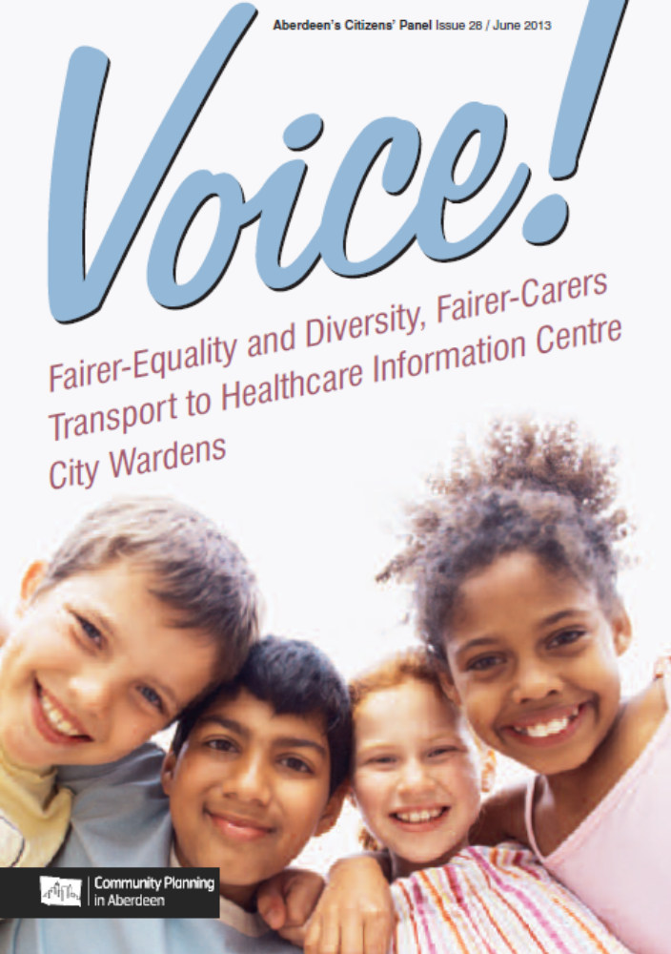

TABLE OF CONTENTS

TABLE OF CONTENTS 2

TABLE OF TABLES 3

TABLE OF FIGURES 10

INTRODUCTION 13

EQUALITY AND DIVERSITY 14

CARERS 28

TRANSPORT TO HEALTHCARE INFORMATION CENTRE 48

CITY WARDENS 69

APPENDIX A: OVERVIEW OF RESPONDENTS’ CHARACTERISTICS 94

APPENDIX B: CROSSTABULATED OUTPUT 97

APPENDIX C: CROSSTABULATED OUTPUT (ADJUSTED FIGURES) 130

TABLE OF TABLES

Table 1: Have you, or a member of your household, experienced discrimination when receiving Council services because of the following during the past two years? 15

Table 2: Have you, or a member of your household, experienced discrimination when receiving Council services because of the following during the past two years? (% by all cases of discrimination) 15

Table 3: If you did not report this incident / experience, why not? 19

Table 4: What more could the Council do to improve the quality of life for people from different equality groups in the City? 26

Table 5: What type of care / help do you provide for the person? 38

Table 6: Do you or the person you care for get help or support from any of the following? (‘Other Support Organisation’ responses) 42

Table 7: Do you or the person you care for get help or support from any of the following? (‘Other’ responses) 43

Table 8: Please describe the main support you, or the person you care for, receives from them. 44

Table 9: Thinking about yourself, do you have any health issues that impact on your caring role? 45

Table 10: Please tell us what one thing could improve support for you in your role as a carer? 46

Table 11: If you attended a healthcare appointment in the last 12 months, please say how you got there. 52

Table 12: Have any of the following happened to you in the last 12 months if you had an invitation to a healthcare appointment? 54

Table 13: Thinking about the next 6 months, if you had to attend a healthcare appointment, how do you think you would get there? 56

Table 14: Which of the following do you think would be the best method(s) / place(s) to promote a service such as this? 61

Table 15: Which of the following do you think would be the best method(s) / place(s) to promote a service such as this? (Other responses) 62

Table 16: To what extent do you agree or disagree that Aberdeen is a welcoming place for members of equality groups to live and work? (% by Gender) 98

Table 17: To what extent do you agree or disagree that Aberdeen is a welcoming place for members of equality groups to live and work? (% by Neighbourhood) 98

Table 18: To what extent do you agree or disagree that Aberdeen is a welcoming place for members of equality groups to live and work? (% by Age-Group) 98

Table 19: To what extent do you agree or disagree that people from equality groups living and working in the city are valued and respected? (% by Gender) 99

Table 20: To what extent do you agree or disagree that people from equality groups living and working in the city are valued and respected? (% by Neighbourhood) 99

Table 21: To what extent do you agree or disagree that people from equality groups living and working in the city are valued and respected? (% by Age-Group) 99

Table 22: How long have you been a carer? (% by Gender) 100

Table 23: How long have you been a carer? (% by Neighbourhood) 100

Table 24: How long have you been a carer? (% by Age-Group) 100

Table 25: What is your relationship with the person(s) you care for? (% by Gender) 101

Table 26: What is your relationship with the person(s) you care for? (% by Neighbourhood) 101

Table 27: What is your relationship with the person(s) you care for? (% by Age-Group) 101

Table 28: Do you live in the same house as the person you mainly (if you care for more than one person) care for? (% by Relationship) 102

Table 29: During an average week, on how many days do you provide care? (% by Relationship) 102

Table 30: During an average week, on how many days do you provide care? (% by Living Status) 103

Table 31: How long, on an average day, do you spend caring? (% by Living Status) 103

Table 32: How long, on an average day, do you spend caring? (% by Relationship) 104

Table 33: What type of care / help do you provide for the person? (% by Gender) 105

Table 34: What type of care / help do you provide for the person? (% by Neighbourhood) 106

Table 35: What type of care / help do you provide for the person? (% by Age-Group) 107

Table 36: What type of care / help do you provide for the person? (% by Relationship) 108

Table 37: What type of care / help do you provide for the person? (% by Living Status) 109

Table 38: Do you or the person you care for get help or support from any of the following? (PERSON CARED FOR) (% by Gender) 110

Table 39: Do you or the person you care for get help or support from any of the following? (PERSON CARED FOR) (% by Neighbourhood) 110

Table 40: Do you or the person you care for get help or support from any of the following? (PERSON CARED FOR) (% by Age-Group) 110

Table 41: If you attended a healthcare appointment in the last 12 months, please say how you got there. (% by Gender) 111

Table 42: If you attended a healthcare appointment in the last 12 months, please say how you got there. (% by Neighbourhood) 111

Table 43: If you attended a healthcare appointment in the last 12 months, please say how you got there. (% by Age-Group) 112

Table 44: If you attended a healthcare appointment in the last 12 months, please say how you got there. (% by Appointment Location) 112

Table 45: Have any of the following happened to you in the last 12 months if you had an invitation to a healthcare appointment? (% by Gender) 113

Table 46: Have any of the following happened to you in the last 12 months if you had an invitation to a healthcare appointment? (% by Neighbourhood) 113

Table 47: Have any of the following happened to you in the last 12 months if you had an invitation to a healthcare appointment? (% by Age-Group) 114

Table 48: Have any of the following happened to you in the last 12 months if you had an invitation to a healthcare appointment? (% by Appointment Location) 114

Table 49: Thinking about the next 6 months, if you had to attend a healthcare appointment, how do you think you would get there? (% by Gender) 115

Table 50: Thinking about the next 6 months, if you had to attend a healthcare appointment, how do you think you would get there? (% by Neighbourhood) 115

Table 51: Thinking about the next 6 months, if you had to attend a healthcare appointment, how do you think you would get there? (% by Age-Group) 116

Table 52: Overall how easy or difficult do you find it to arrange transport to get to a healthcare appointment? (% by Gender) 116

Table 53: Overall how easy or difficult do you find it to arrange transport to get to a healthcare appointment? (% by Neighbourhood) 116

Table 54: Overall how easy or difficult do you find it to arrange transport to get to a healthcare appointment? (% by Age-Group) 117

Table 55: Which of the following do you think would be the best method(s) / place(s) to promote a service such as this? (% by Gender) 117

Table 56: Which of the following do you think would be the best method(s) / place(s) to promote a service such as this? (% by Neighbourhood) 117

Table 57: Which of the following do you think would be the best method(s) / place(s) to promote a service such as this? (% by Age-Group) 118

Table 58: If yes, how helpful did you find City Wardens? (% by Gender) 118

Table 59: If yes, how helpful did you find City Wardens? (% by Neighbourhood) 118

Table 60: If yes, how helpful did you find City Wardens? (% by Age-Group) 118

Table 61: "How strongly do you agree or disagree with the following statement: “The City Wardens have been effective in making Aberdeen City a safer place”. (% by Gender) 119

Table 62: "How strongly do you agree or disagree with the following statement: “The City Wardens have been effective in making Aberdeen City a safer place”. (% by Neighbourhood) 119

Table 63: "How strongly do you agree or disagree with the following statement: “The City Wardens have been effective in making Aberdeen City a safer place”. (% by Age-Group) 119

Table 64: How well do you think City Wardens deal with antisocial behaviour and crime in your area? (% by Gender) 120

Table 65: How well do you think City Wardens deal with antisocial behaviour and crime in your area? (% by Neighbourhood) 120

Table 66: How well do you think City Wardens deal with antisocial behaviour and crime in your area? (% by Age-Group) 120

Table 67: How well do you think City Wardens deal with illegal parking in your area? (% by Gender) 121

Table 68: How well do you think City Wardens deal with illegal parking in your area? (% by Neighbourhood) 121

Table 69: How well do you think City Wardens deal with illegal parking in your area? (% by Age-Group) 121

Table 70: How well do you think City Wardens deal with dog fouling in your area? (% by Gender) 122

Table 71: How well do you think City Wardens deal with dog fouling in your area? (% by Neighbourhood) 122

Table 72: How well do you think City Wardens deal with dog fouling in your area? (% by Age-Group) 122

Table 73: How well do you think City Wardens deal with littering in your area? (% by Gender) 123

Table 74: How well do you think City Wardens deal with littering in your area? (% by Neighbourhood) 123

Table 75: How well do you think City Wardens deal with littering in your area? (% by Age-Group) 123

Table 76: To what extent do you agree or disagree that your local area benefits from having City Wardens? (% by Gender) 124

Table 77: To what extent do you agree or disagree that your local area benefits from having City Wardens? (% by Neighbourhood) 124

Table 78: To what extent do you agree or disagree that your local area benefits from having City Wardens? (% by Age-Group) 124

Table 79: To what extent do you agree or disagree that City Wardens are well trained and know what they are doing? (% by Gender) 125

Table 80: To what extent do you agree or disagree that City Wardens are well trained and know what they are doing? (% by Neighbourhood) 125

Table 81: To what extent do you agree or disagree that City Wardens are well trained and know what they are doing? (% by Age-Group) 125

Table 82: To what extent do you agree or disagree that City Wardens engage well with people in your local area? (% by Gender) 126

Table 83: To what extent do you agree or disagree that City Wardens engage well with people in your local area? (% by Neighbourhood) 126

Table 84: To what extent do you agree or disagree that City Wardens engage well with people in your local area? (% by Age-Group) 126

Table 85: To what extent do you agree or disagree that City Wardens are visible on the streets? (% by Gender) 127

Table 86: To what extent do you agree or disagree that City Wardens are visible on the streets? (% by Neighbourhood) 127

Table 87: To what extent do you agree or disagree that City Wardens are visible on the streets? (% by Age-Group) 127

Table 88: To what extent do you agree or disagree that City Wardens deal with problems effectively? (% by Gender) 128

Table 89: To what extent do you agree or disagree that City Wardens deal with problems effectively? (% by Neighbourhood) 128

Table 90: To what extent do you agree or disagree that City Wardens deal with problems effectively? (% by Age-Group) 128

Table 91: To what extent do you agree or disagree that it is easy to get in touch with City Wardens when you need to? (% by Gender) 129

Table 92: To what extent do you agree or disagree that it is easy to get in touch with City Wardens when you need to? (% by Neighbourhood) 129

Table 93: To what extent do you agree or disagree that it is easy to get in touch with City Wardens when you need to? (% by Age-Group) 129

Table 94: How well do you think City Wardens deal with antisocial behaviour and crime in your area? (% by Gender) (ADJUSTED FIGURES – DO NOT CITE) 131

Table 95: How well do you think City Wardens deal with antisocial behaviour and crime in your area? (% by Neighbourhood) (ADJUSTED FIGURES – DO NOT CITE) 131

Table 96: How well do you think City Wardens deal with antisocial behaviour and crime in your area? (% by Age-Group) (ADJUSTED FIGURES – DO NOT CITE) 131

Table 97: How well do you think City Wardens deal with illegal parking in your area? (% by Gender) (ADJUSTED FIGURES – DO NOT CITE) 132

Table 98: How well do you think City Wardens deal with illegal parking in your area? (% by Neighbourhood) (ADJUSTED FIGURES – DO NOT CITE) 132

Table 99: How well do you think City Wardens deal with illegal parking in your area? (% by Age-Group) (ADJUSTED FIGURES – DO NOT CITE) 132

Table 100: How well do you think City Wardens deal with dog fouling in your area? (% by Gender) (ADJUSTED FIGURES – DO NOT CITE) 133

Table 101: How well do you think City Wardens deal with dog fouling in your area? (% by Neighbourhood) (ADJUSTED FIGURES – DO NOT CITE) 133

Table 102: How well do you think City Wardens deal with dog fouling in your area? (% by Age-Group) (ADJUSTED FIGURES – DO NOT CITE) 133

Table 103: How well do you think City Wardens deal with littering in your area? (% by Gender) (ADJUSTED FIGURES – DO NOT CITE) 134

Table 104: How well do you think City Wardens deal with littering in your area? (% by Neighbourhood) (ADJUSTED FIGURES – DO NOT CITE) 134

Table 105: How well do you think City Wardens deal with littering in your area? (% by Age-Group) (ADJUSTED FIGURES – DO NOT CITE) 134

Table 106: To what extent do you agree or disagree that your local area benefits from having City Wardens? (% by Gender) (ADJUSTED FIGURES – DO NOT CITE) 135

Table 107: To what extent do you agree or disagree that your local area benefits from having City Wardens? (% by Neighbourhood) (ADJUSTED FIGURES – DO NOT CITE) 135

Table 108: To what extent do you agree or disagree that your local area benefits from having City Wardens? (% by Age-Group) (ADJUSTED FIGURES – DO NOT CITE) 135

Table 109: To what extent do you agree or disagree that City Wardens are well trained and know what they are doing? (% by Gender) (ADJUSTED FIGURES – DO NOT CITE) 136

Table 110: To what extent do you agree or disagree that City Wardens are well trained and know what they are doing? (% by Neighbourhood) (ADJUSTED FIGURES – DO NOT CITE) 136

Table 111: To what extent do you agree or disagree that City Wardens are well trained and know what they are doing? (% by Age-Group) (ADJUSTED FIGURES – DO NOT CITE) 136

Table 112: To what extent do you agree or disagree that City Wardens engage well with people in my local area? (% by Gender) (ADJUSTED FIGURES – DO NOT CITE) 137

Table 113: To what extent do you agree or disagree that City Wardens engage well with people in my local area? (% by Neighbourhood) (ADJUSTED FIGURES – DO NOT CITE) 137

Table 114: To what extent do you agree or disagree that City Wardens engage well with people in my local area? (% by Age-Group) (ADJUSTED FIGURES – DO NOT CITE) 137

Table 115: To what extent do you agree or disagree that City Wardens are visible on the streets? (% by Gender) (ADJUSTED FIGURES – DO NOT CITE) 138

Table 116: To what extent do you agree or disagree that City Wardens are visible on the streets? (% by Neighbourhood) (ADJUSTED FIGURES – DO NOT CITE) 138

Table 117: To what extent do you agree or disagree that City Wardens are visible on the streets? (% by Age-Group) (ADJUSTED FIGURES – DO NOT CITE) 138

Table 118: To what extent do you agree or disagree that City Wardens deal with problems effectively? (% by Gender) (ADJUSTED FIGURES – DO NOT CITE) 139

Table 119: To what extent do you agree or disagree that City Wardens deal with problems effectively? (% by Neighbourhood) (ADJUSTED FIGURES – DO NOT CITE) 139

Table 120: To what extent do you agree or disagree that City Wardens deal with problems effectively? (% by Age-Group) (ADJUSTED FIGURES – DO NOT CITE) 139

Table 121: To what extent do you agree or disagree that it is easy to get in touch with wardens when you need to? (% by Gender) (ADJUSTED FIGURES – DO NOT CITE) 140

Table 122: To what extent do you agree or disagree that it is easy to get in touch with wardens when you need to? (% by Neighbourhood) (ADJUSTED FIGURES – DO NOT CITE) 140

Table 123: To what extent do you agree or disagree that it is easy to get in touch with wardens when you need to? (% by Age-Group) (ADJUSTED FIGURES – DO NOT CITE) 140

TABLE OF FIGURES

Figure 1: If you or a member of your household have experienced discrimination when receiving Council services, did you report this incident / experience to anyone? 17

Figure 2: If you reported this incident / experience, how satisfied were you with the response you received? 18

Figure 3: To what extent do you agree or disagree that Aberdeen is a welcoming place for members of equality groups to live and work? 20

Figure 4: To what extent do you agree or disagree that people from equality groups living and working in the city are valued and respected? 22

Figure 5: Did you know that information about Council services is available in the following formats? 23

Figure 6: How aware do you feel you are on what the Council is doing to improve the quality of life for different equality groups? 24

Figure 7: Using the definition above, would you say you were a ‘carer? 29

Figure 8: How long have you been a carer? 30

Figure 9: How many people do you care for? 31

Figure 10: What is your relationship with the person(s) you care for? 32

Figure 11: Do you live in the same house as the person you mainly (if you care for more than one person) care for? 33

Figure 12: During an average week, on how many days do you provide care? 34

Figure 13: How long, on an average day, do you spend caring? 35

Figure 14: Do you or the person you care for get help or support from any of the following? (PERSON PROVIDING CARE) 39

Figure 15: Do you or the person you care for get help or support from any of the following? (PERSON CARED FOR) 41

Figure 16: In the last 12 months, have you attended an NHS healthcare appointment for a service in any of the following categories: specialist or consultant services, diagnostic treatment (e.g. scan), pre-assessment appointment from planned hospital treatment? 49

Figure 17: Where did you go for the appointment(s)? 50

Figure 18: Overall how easy or difficult do you find it to arrange transport to get to a healthcare appointment? 57

Figure 19: Thinking about the pilot Transport to Healthcare Information Centre, which of the following aspects of the service do you think would be useful to you? 58

Figure 20: Which of the following best describes your attitude to the pilot Transport to Healthcare Information Centre? 60

Figure 21: Were you to access a service such as this, which of the following do you think you would use? 63

Figure 22: Do you have a disability or other condition that limits your mobility? 64

Figure 23: Do you have access to a motor car or other private vehicle (your own or someone else’s)? 65

Figure 24: Do you have access to the internet? 66

Figure 25: Are you comfortable using the internet / transacting online? 67

Figure 26: Over the last 12 months, have you seen City Wardens in your local area? 70

Figure 27: Over the last 12 months, have you seen City Wardens anywhere else in the city? 71

Figure 28: Over the last 12 months, have you sought assistance from City Wardens? 72

Figure 29: If yes, how helpful did you find City Wardens? 73

Figure 30: "How strongly do you agree or disagree with the following statement: “The City Wardens have been effective in making Aberdeen City a safer place”. 74

Figure 31: How well do you think City Wardens deal with antisocial behaviour and crime in your area? 76

Figure 32: How well do you think City Wardens deal with illegal parking in your area? 78

Figure 33: How well do you think City Wardens deal with dog fouling in your area? 80

Figure 34: How well do you think City Wardens deal with littering in your area? 81

Figure 35: How well do you think City Wardens deal with the following problems in your area? (ADJUSTED FIGURES – DO NOT CITE) 82

Figure 36: To what extent do you agree or disagree that your local area benefits from having City Wardens? 84

Figure 37: To what extent do you agree or disagree that City Wardens are well trained and know what they are doing? 85

Figure 38: To what extent do you agree or disagree that City Wardens engage well with people in your local area? 86

Figure 39: To what extent do you agree or disagree that City Wardens are visible on the streets? 88

Figure 40: To what extent do you agree or disagree that City Wardens deal with problems effectively? 89

Figure 41: To what extent do you agree or disagree that it is easy to get in touch with City Wardens when you need to? 90

Figure 42: To what extent do you agree or disagree with the following statements? (ADJUSTED FIGURES – DO NOT CITE) 92

Figure 43: Gender breakdown of respondents 94

Figure 44: Age breakdown of respondents 95

Figure 45: Neighbourhood breakdown of respondents 95

Figure 46: Survey Response Type 96

INTRODUCTION

The final survey sample consisted of 671 responses from members of the Citizens’ Panel. The total Panel currently comprises 989 citizens of Aberdeen and so the response rate amounts to 67.8%. The 671 responses are, in the first instance, considered as a whole. Further analysis can be conducted where the various project partners direct further investigation. The further analysis will take the form of targeted analysis on the basis of the personal information of the respondents. This information allows breakdown on the basis of the following variables:

- Gender
- Area
- Age
- Employment
- Home Ownership
- Health Issues
- Ethnicity

The report as it stands attempts to provide a ‘key findings’ breakdown of many of the results by age, gender and neighbourhood area. However, where age-group analysis is included, the two youngest age groups (16-24 and 25-34) are considered in aggregate as one group (i.e. 16-34), due to the under-representation of the very youngest age group (16-24) in the Panel. An overview of the age, gender and neighbourhood breakdown is provided at Appendix A. Please note that we are happy to provide full details of our crosstabulated results on request.

It should be noted that no demographic data was available for 5 respondents. For this reason, there may occasionally be a slight mismatch between the percentage results quoted in relation to the overall population for each question (which includes those panellists for whom demographic data is absent) and any subsequent analysis on the basis of gender, age or neighbourhood (which necessarily excludes these panellists). Despite the occasional minor inconsistency between total results and disaggregated/stratified analysis, the approach adopted is intended to provide the greatest possible degree of analytical accuracy in each case. Please also note that due to a) multiple responses to a question from one or more respondents, and b) the process of rounding percentage figures to one decimal place, total percentage figures given for some questions may not tally to exactly 100.0% (particularly where compounded figures are provided).

The analysis presented here is split into the following main topics:

- Equality and Diversity
- Carers
- Transport to Healthcare Information Centre
- City Wardens

EQUALITY AND DIVERSITY

Local authorities have a central role to play in improving the lives of the people of their cities. This includes tackling disadvantage and inequality wherever they exist and bringing people together. In addition to this, the Scottish Government introduced specific duties for public authorities to produce and publish a set of ‘equalities outcomes’ by April 2013. An ‘equality outcome’ is a result that the authority aims to achieve in order to further one or more of the following needs: eliminate discrimination; advance equality of opportunity; and foster good relations.

In preparation for these outcomes, Aberdeen City Council undertook a comprehensive evidence review and consultation. This gave the Council a baseline for developing priority areas of concern to allow them to measure progress and demonstrate that they have made a real difference in key areas of inequality.

The answers to the following questions will help the Council to monitor the progress in different areas of equality, identify any barriers and provide data that will enable them to track future progress.

The first question in this section asked whether panellists (or any member of their households) had experienced discrimination when receiving Council services during the past two years. Panellists were provided with a list of types of discrimination and asked to select all those which applied. Their responses are provided below in Table 1 (see page 15), which shows that the vast majority of respondents (587; 97.2%) have not experienced any of these forms of discrimination. Of those who have experienced some form of discrimination, the most frequently identified type was disability (11 respondents; 1.8%), followed by age (3 respondents; 0.5%), sex (also 3 respondents; 0.5%), pregnancy and maternity (2 respondents; 0.3%), race (also 2 respondents; 0.3%) and religion and belief (1 respondent; 0.2%). No respondents felt that they (or any member of their households) had suffered discrimination on the basis of sexual orientation, gender reassignment or marriage and civil partnership.

Due to the small number of respondents experiencing discrimination (and the resultant likelihood of distorted results), we do not recommend performing further stratified analysis on these results.

Table 1: Have you, or a member of your household, experienced discrimination when receiving Council services because of the following during the past two years?
Response | Respondents
Response | Count | %
Not experienced discrimination | 587 | 97.2
Disability | 11 | 1.8
Age | 3 | 0.5
Sex | 3 | 0.5
Pregnancy and maternity | 2 | 0.3
Race | 2 | 0.3
Religion and belief | 1 | 0.2
Sexual orientation | 0 | 0.0
Gender reassignment | 0 | 0.0
Marriage and civil partnership | 0 | 0.0
Base = 604 respondents

A slightly different perspective on these figures is provided below in Table 2, which shows the proportion of discrimination types as a percentage of all cases of discrimination. This data shows that the 11 cases of discrimination on the basis of disability constitute 61.1% of all cases of discrimination. The 3 cases apiece for age and sex each constitute 16.7% of all cases of discrimination, whilst the 2 cases apiece of discrimination on the basis of pregnancy and maternity and race constitute 11.1% of all cases. The 1 case of discrimination on the basis of religion and belief represents 5.6% of all discrimination cases reported by respondents.

Once again, due to the extremely small number of respondents experiencing discrimination (and the resultant likelihood of distorted results), we do not recommend performing further stratified analysis on the basis of gender, age and neighbourhood area.

Table 2: Have you, or a member of your household, experienced discrimination when receiving Council services because of the following during the past two years? (% by all cases of discrimination)
Response | Respondents
Response | Count | %
Disability | 11 | 61.1
Age | 3 | 16.7
Sex | 3 | 16.7
Pregnancy and maternity | 2 | 11.1
Race | 2 | 11.1
Religion and belief | 1 | 5.6
Base = 18 respondents

The next question was addressed only at those respondents who stated that they had suffered discrimination. They were asked whether or not they had reported the incident to anyone. Their responses are provided below in Figure 1 (see page 17), which shows that of the 15 respondents who answered the question, a majority (9 respondents; 60.0%) stated that they did not report the incident to anyone. Conversely, 6 respondents (40.0%) did report the incident to someone.

Once again, due to the extremely small number of respondents experiencing discrimination (and the resultant likelihood of distorted results), we do not recommend performing further stratified analysis on these results.

We can, however, provide a crosstabulation of the responses to this question and the response to the previous question. This provides a breakdown of the proportion of different types of discrimination which were reported and which went unreported. Only 15 of the 18 respondents who claimed to have experienced discrimination actually chose to answer this question, so the results are incomplete. For this reason (and due to the very small number of panellists involved) we would strongly caution against using these figures as a basis for policy decisions.

However, when we break these results down by discrimination type, we see that the proportion of incidents which were reported for each type of discrimination was as follows:

- Disability: 50.0% of cases were reported; 50.0% of cases were not reported
- Age: 50.0% of cases were reported; 50.0% of cases were not reported
- Sex: no cases were reported; 100.0% of cases were not reported
- Pregnancy and maternity: no cases were reported; 100.0% of cases were not reported
- Race: no cases were reported; 100.0% of cases were not reported
- Religion and belief: no cases were reported; 100.0% of cases were not reported

Figure 1: If you or a member of your household have experienced discrimination when receiving Council services, did you report this incident / experience to anyone?
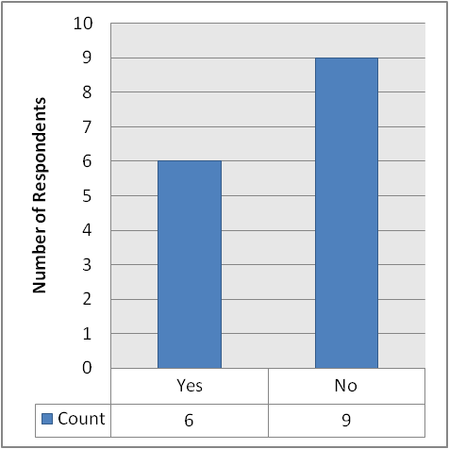
Base = 15 respondents

The next question was directed at the 6 respondents who stated that they had reported the incident to someone. These respondents were asked how satisfied they were with the response received. The answers provided by respondents are laid out below in Figure 2 (see page 18), which shows that 5 respondents provided an answer. Of these, 4 (80.0%) stated that they were very dissatisfied and 1 (20.0%) said that they were dissatisfied.

Once again, due to the extremely small number of respondents experiencing discrimination (and the resultant likelihood of distorted results), we do not recommend performing further stratified analysis on these results.

Figure 2: If you reported this incident / experience, how satisfied were you with the response you received?
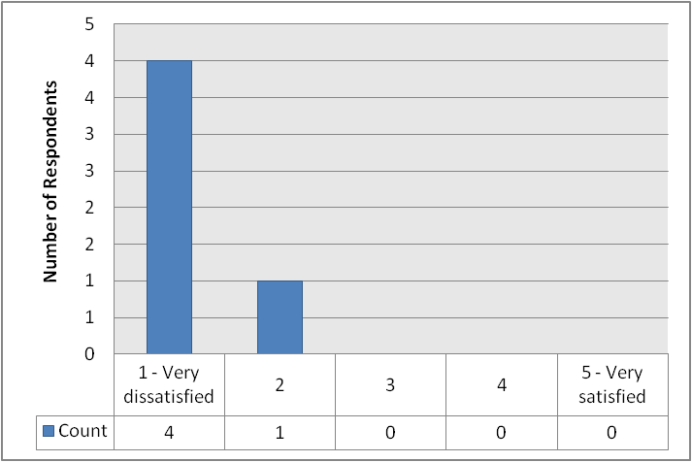
Base = 5 respondents

The respondents who stated that they had not reported an incident of discrimination (see Figure 1, page 17) were then asked why they chose not to report the incident to anyone. 9 panellists provided a response: these are tabulated below in Table 3 (see page 19), which shows that the most frequently offered responses were that it would have been a waste of time and/or energy (2 respondents; 22.2%) and that discrimination is simply a part of life (also 2 respondents; 22.2%). Each other response was provided by only 1 respondent (11.1% each).

Once again, due to the extremely small number of respondents experiencing discrimination (and the resultant likelihood of distorted results), we do not recommend performing further stratified analysis on these results.

Table 3: If you did not report this incident / experience, why not?
Response | Respondents
Response | Count | %
Waste of time / energy | 2 | 22.2
Discrimination is just part of life | 2 | 22.2
Fear of retaliation / persecution | 1 | 11.1
Didn't think anyone would believe me | 1 | 11.1
Previous negative experience of reporting discrimination | 1 | 11.1
Other people advised me not to | 1 | 11.1
No evidence | 1 | 11.1
Tried to, but got nowhere | 1 | 11.1
N/a | 1 | 11.1
Base = 9 respondents

The term ‘equality group’ refers to persons who share a relevant protected characteristic. The public sector equality duty covers the following protected characteristics: age; disability; gender reassignment; marriage and civil partnership; pregnancy and maternity; race; religion and belief; sex; and sexual orientation.

On this basis, all panellists were asked to state the extent to which they agreed with two statements relating to equality groups. The first statement was: “Aberdeen is a welcoming place for members of equality groups to live and work”, whilst the second was: “People from equality groups living and working in the City are valued and respected”. The responses received to these statements are provided below in Figure 3 (see page 20) and Figure 4 (see page 22), respectively.

Dealing with the first of these two statements, Figure 3 (see page 20) shows that out of 651 respondents, a majority (352; 54.1%) agreed with the proposition. 89 respondents (13.7%) strongly agreed, 62 (9.5%) disagreed and only 11 respondents (1.7%) strongly disagreed. 137 respondents (21.0%) stated that they did not know.

Tables 16-18 (see page 98) provide a breakdown of these responses by gender, neighbourhood area and age-group. Firstly dealing with gender, Table 16 shows that there was virtually no difference between male and female respondents’ answers to this question.

There were some notable differences between neighbourhoods (see Table 17, page 98). The overall proportion of respondents expressing some degree of disagreement (i.e. selecting either the “strongly disagree” or “disagree” options) was noticeably larger in Central (17.8%) than in North (8.8%) and South (8.2%). Conversely, the proportion expressing some degree of agreement (i.e. selecting either the “strongly agree” or “agree” options) was largest in South (73.1%), followed by North (65.7%) and Central (62.9%).

When considering age-groups (see Table 18, page 98), the proportion of respondents expressing some degree of disagreement with the statement (i.e. selecting either the “strongly disagree” or “disagree” options) decreased with age profile: the proportion disagreeing to any extent was greatest among those aged 16-34 (14.7%), falling to 13.7% of those aged 35-54 and 9.9% of those aged 55-64, and was lowest among those aged 65+ (7.0%). There was no such correlation in terms of overall levels of agreement, though (i.e. selecting either the “strongly agree” or “agree” options). Although this was highest among those aged 16-34 (72.1%) and lowest among those aged 65+ (62.9%), there was also a relatively high level of agreement with the statement among those aged 55-64 (70.9%). In comparison, only 66.9% of respondents aged 55-64 agreed with the proposition. Only two other age-related correlations emerged: the proportion of respondents selecting the “disagree” option decreased from a high among those aged 16-34 (13.2%) through each successively older age-group to a low among those aged 65+ (4.9%). Similarly, the proportion of respondents selecting the “strongly agree” option was largest among those aged 16-34 (23.5%), declining across each successively older age-group to a low of 4.9% among those aged 65+.

Figure 3: To what extent do you agree or disagree that Aberdeen is a welcoming place for members of equality groups to live and work?
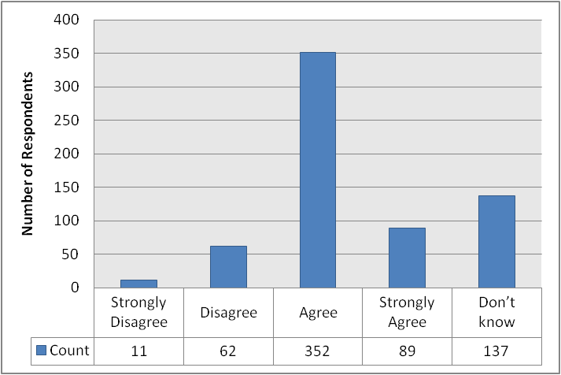
Base = 651 respondents

Turning to consider the second of these statements (“Aberdeen is a welcoming place for members of equality groups to live and work”), Figure 4 (see page 22) shows that once again, a majority of respondents (327; 50.6%) agreed with the statement, although the majority was smaller than it was for the previous statement. 61 respondents (9.4%) strongly agreed with the statement, 85 respondents (13.2%) disagreed and 9 respondents (1.4%) strongly disagreed. 164 respondents (25.4%) selected the “don’t know” option.

Tables 19-21 (see page 99) provide a detailed breakdown of these responses by gender, neighbourhood area and age-group, but some headline findings will be discussed here.

There was a very slightly larger degree of variation between male and female respondents’ answers to this statement than to the previous statement. A slightly larger proportion of females (27.0%) than males (23.7%) selected the “don’t know” option. However, the proportion of males expressing both some form of disagreement and some form of agreement (15.6% expressing some form of disagreement, 60.7% expressing some form of agreement) was larger than the equivalent proportions among females (13.5% expressing some form of disagreement, 59.5% expressing some form of agreement).

There was once again considerable variation across neighbourhoods when aggregating the proportion of respondents expressing some form of disagreement and those who expressed some form of agreement (see Table 20, page 99). In terms of disagreement, the greatest share of respondents disagreeing with the statement was again found in Central (20.5%), followed by South (13.6%) and North (9.9%). In terms of overall levels of agreement, these were highest in South (61.7%) and North (61.1%), and slightly lower in Central (56.9%).

There was much less evidence of age-related correlation in this statement than in the previous statement (see Table 21, page 99). The only correlation found at all was in relation to the “strongly agree” option, which was selected by 16.2% of those aged 16-34, 12.2% of those aged 35-54, 7.6% of those aged 55-64 and 3.6% of those aged 65+. Beyond this, there was no evidence of clear age-related correlation, even when aggregating overall levels of disagreement and overall levels of agreement. In terms of the former, overall levels of disagreement with the statement were greatest among those aged 16-34 (20.6%), followed by those aged 55-64 (15.7%), those aged 35-54 (15.3%) and smallest among those aged 65+ (8.6%). Overall levels of agreement were highest among those aged 55-64 (64.0%), followed by those aged 16-34 and those aged 35-54 (both 60.3%) and smallest among those aged 65+ (54.7%). The proportion of respondents selecting the “don’t know” option also varied considerably among age-groups, rising from a low of 19.1% of those aged 16-34 to 20.3% of those aged 55-64 and 24.4% of those aged 35-54, to a high of 36.7% of those aged 65+.

Figure 4: To what extent do you agree or disagree that people from equality groups living and working in the city are valued and respected?
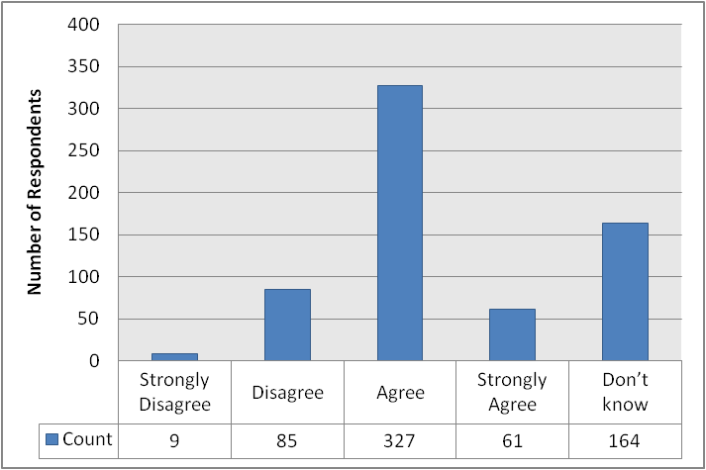
Base = 646 respondents

All panellists were then asked whether or not they were aware that information about Council services is available in large print, community languages, audiotape / CD and British Sign Language (BSL). For each of these, the number of respondents who stated that they were aware of information being available is provided below in Figure 5 (see page 23). The chart shows that a clear majority of respondents (559; 83.3%) were aware of information being available in large print and community languages (427 respondents; 63.6%). However, only a minority of respondents were aware of the availability of information about Council services on audiotape/CD (242 respondents; 36.1%) and BSL (215 respondents; 32.0%).

There were some minor differences between levels of awareness of male and female panellists. For each option, the proportion of female respondents claiming awareness of the availability of information was larger than the equivalent proportion of male respondents. This was most pronounced in the case of community languages (69.0% of females vs. 57.9% of males) and large print (85.9% of females vs. 80.2% of males) but was also visible (albeit to a lesser extent) in the options for British Sign Language (33.6% of females vs. 29.9% of males) and audiotape / CD (35.9% of females vs. 35.8% of males).

A specific pattern also emerged when considering responses to this question across different neighbourhoods. Broadly speaking, the proportions of respondents in North and South who were aware of the availability of information were very similar in each case, as well as being consistently smaller than the equivalent proportion in Central. This was most evident for British Sign Language (36.6% in Central, 30.0% in North and 29.5% in South) and community languages (68.3% in Central, 62.2% in South and 61.0% in North) but could also be seen in relation to audiotape / CD (40.1% in Central, 34.8% in North and 33.5% in South) and large print (85.6% in Central, 82.7% in South and 81.4% in North).

Only one age-related correlation emerged from our further scrutiny of the results. This was in relation to information on audiotape / CD. The proportion of respondents aware of the availability of information in this medium was greatest among those aged 16-34 (42.6%), dropping to 37.5% of those aged 35-54, 35.6% of those aged 55-64 and 30.5% of those aged 65+. Other than this, only a small number of individual results were noteworthy. For example, the proportion of respondents aged 65+ who were aware of the availability of information in community languages (54.5%) was smaller than it was in other age-groups (63.2% of those aged 16-34, 67.8% of those aged 35-54 and 65.5% of those aged 55-64).

Figure 5: Did you know that information about Council services is available in the following formats?
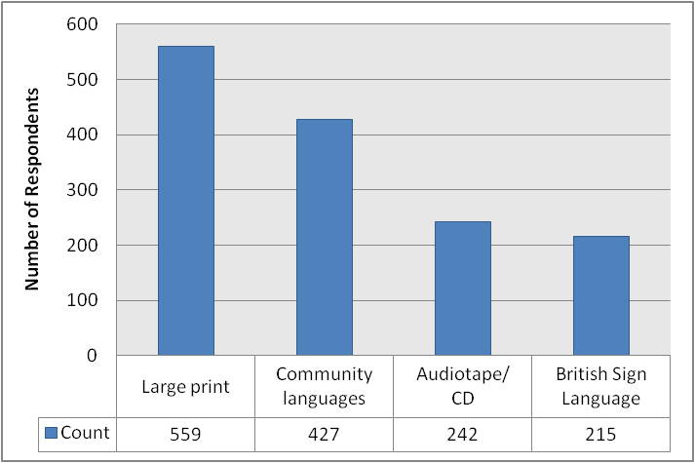
Base = 671 respondents

The next question was once again put to all panellists. They were asked how aware they feel they are on what the Council is doing to improve the quality of life for different equality groups in Aberdeen. Their responses are laid out below in Figure 6 (see page 24), which shows that only 33 respondents (5.0%) stated that they are very aware of what the Council is doing. 274 respondents (41.8%) stated that they are aware, with 349 respondents (53.2%) stating that they are unaware.

There were some minor differences between male and female respondents. The proportion of females who claimed to be very aware (6.2%) or aware (42.8%) was larger than the equivalent proportion of males (3.8% and 40.4%, respectively). However, the proportion of males claiming to be unaware of what the Council is doing (55.8%) was larger than among females (51.0%).

Some differences could also be seen between different neighbourhood areas. The proportion of respondents who said that they were unaware of what the Council was doing was smallest in Central (49.0%), and larger in North (55.1%) and South (55.2%). There was little difference between the proportion of respondents who said that they felt very aware, but the proportion selecting the “aware” option was largest in Central (46.0%), followed by South (40.7%) and North (38.5%).

Two age-related correlations also emerged. The proportion of respondents who stated that they felt aware of what the Council was doing was largest among those aged 65+ (50.3%), dropping to 48.0% of those aged 55-64, 36.2% of those aged 35-54 and 27.9% of those aged 16-34. Conversely, the proportion of respondents who stated that they were unaware of what the Council was doing was largest by far among those aged 16-34 (69.1%), dropping to 57.4% of those aged 35-54, 46.8% of those aged 55-64 and 46.2% of those aged 65+.

Figure 6: How aware do you feel you are on what the Council is doing to improve the quality of life for different equality groups?
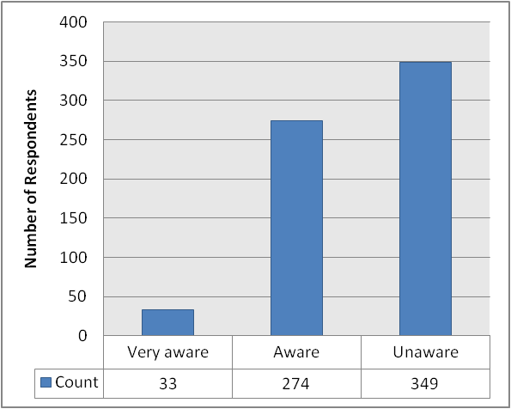
Base = 656 respondents

All respondents were then asked to provide suggestions on what more the Council could do to improve the quality of life for people from different equality groups in the City. 199 panellists provided some form of response: these have been aggregated thematically and are listed below in Table 4 (see page 26). The most popular response was that the Council should encourage better integration and interaction between different social groups (e.g. through its housing policy or by supporting cultural events) (19 respondents; 9.5%). The three next most popular responses were all based upon the idea that nothing more should be done by the Council. However, these responses had different motives. For 17 respondents (8.5%), their “nothing” response was based on the idea that the Council was already doing enough at the current time. 16 respondents (8.0%) believed that nothing more should be done for equality groups as they did not support positive discrimination and felt that the focus should be on an even-handed approach to helping people from all backgrounds across the city. 12 respondents (6.0%) stated that nothing more should be done for equality groups as the Council’s primary focus should be the welfare of native Aberdonians / Scottish people. An identical number of respondents (12; 6.0%) stated that the Council should focus on providing more and/or better public information resources for and about different equality groups in the city. Each of the remaining answers was provided by fewer than 10 respondents.

Table 4: What more could the Council do to improve the quality of life for people from different equality groups in the City?
Response | Respondents
Response | Count | %
Actively encourage integration / interaction between groups | 19 | 9.5
Nothing: already doing enough | 17 | 8.5
Nothing: focus should be on everyone, not specific groups | 16 | 8.0
Nothing: focus should be on native Aberdonians / Scots | 12 | 6.0
More / better public information resources | 12 | 6.0
Better dialogue with equality groups | 9 | 4.5
More / better support for learning English | 9 | 4.5
Nothing (no other context given) | 8 | 4.0
Better access for elderly and disabled | 7 | 3.5
Cultural events for ethnic groups | 7 | 3.5
Better education - leads to better choices | 7 | 3.5
Change public attitudes towards equality groups | 7 | 3.5
Nothing: too much being done as it is | 6 | 3.0
Broaden the attitudes of Councillors and Council workers | 5 | 2.5
Befriending service(s) | 5 | 2.5
Better translation services | 3 | 1.5
More support / facilities for disabled people | 3 | 1.5
Create a permanent site for travellers | 3 | 1.5
Poster campaign | 2 | 1.0
Publicise Council action plan better | 2 | 1.0
Better policing of parking (for the benefit of disabled people) | 2 | 1.0
More religious facilities | 2 | 1.0
More / better adult learning facilities | 2 | 1.0
Council to employ more appropriately qualified staff | 1 | 0.5
Independent investigation of equalities complaints | 1 | 0.5
Encourage people to be more open to immigrants / refugees | 1 | 0.5
Outreach groups | 1 | 0.5
More consideration of elderly people in housing allocation | 1 | 0.5
Don't know | 28 | 14.1
N/a | 23 | 11.6
Base = 199 respondents

SERVICE RESPONSE

The City Voice survey is one of the ways in which we collect information about people’s experiences, and this survey has marked a starting point in developing baseline data. We used a variety of methods to gather quantitative and qualitative information to develop our Equality Outcomes to provide a fuller picture of people’s perceptions of life in Aberdeen. We will continue do this so that we gain that wider picture of progress towards our Equality Outcomes.

Whilst recognising that in some part this may be due to an increased awareness and confidence in reporting, nevertheless, the information from the Prejudice Incidence Reporting scheme paints a different picture of Aberdeen. These figures show a clear increase year on year in the number of prejudice incidents, in contrast to the 22 from 609 respondents (2.8%) who said in the City Voice survey that they had experienced discrimination.

We also acknowledge that approaching and talking to specific equality groups, such as the Ethnic Minority Forum and the Disability Advisory Group rather than a cross-section of the public, will give different results as these are groups of people with a common interest who have got together to campaign for social justice.

Of the 22 respondents who reported having experienced discrimination, only 6 reported the incident, with only 1 person saying they were satisfied with the response received. Therefore we need to look at increasing people’s confidence to report and improving our response to such reporting.

It is interesting to note that the variation in responses across the neighbourhoods shows the greatest share of respondents who disagree that “ Aberdeen is a welcoming place for members of equality groups to live and work” is within the Central area. This gives us valuable information in terms of knowing where to focus our resource. Similarly, the variation in terms of age is interesting. Older people seemed to be more aware of the different ways in which council information is available – possibly because there is a greater need for that kind of service among older people.

The most popular response to “What more could the Council do to improve the quality of life for people from different equality groups in the City” is “Actively encourage integration/interaction between groups”. This fits perfectly with the Council’s duty to foster good relations between different groups. Responses to this final question also demonstrated the need to promote more effectively the Council’s positive duties to raise awareness of the lives of some people living and/or working in the city, who continue to face disadvantage and discrimination.

Faiza Nacef
Development Officer
Aberdeen City Council

CARERS

The Carers Strategy for Scotland (2010-15) estimates that there are approximately 25,000 carers in Aberdeen City. A carer is someone who provides unpaid help and support to a relative, partner, friend or neighbour who is in need of help because they are ill, frail, have a disability, mental illness or have a substance misuse issue. Keeping track of how many people are carers or what support they need can be difficult as this role is often done unofficially and therefore not recorded or counted.

The Aberdeen City Health & Social Care Partnership is currently reviewing the support it offers to carers and wants to reach out to as many careers as possible to help shape future policy and support. The Partnership wants to compare the results from this questionnaire with a previous survey to see if the caring situation has changed and, if so, how. They also hope this survey will raise the profile of carers in Aberdeen City and encourage more of them to seek support.

The first question in this section sought to identify whether or not panellists consider themselves to be carers (using the definition provided in the first paragraph on this page). Their responses are provided below in Figure 7 (see page 29), which shows that the vast majority of respondents (535; 83.1%) are not carers. Conversely, 109 respondents (16.9%) stated that they are carers according to the definition given.

There was virtually no difference between the proportion of male (16.5%) and female (16.9%) respondents who said that they are carers. However, there was some minor difference between neighbourhood areas. The proportion of respondents identifying as carers was largest in North (22.2%), followed by Central (14.9%) and South (13.6%). There was also some clear difference between the different age-groups. The proportion of respondents who stated that they are carers was smallest among those aged 16-34 (5.9%), rising to 16.0% of those aged 35-54, 18.6% of those aged 65+ and 20.7% of those aged 55-64.

Figure 7: Using the definition above, would you say you were a ‘carer?
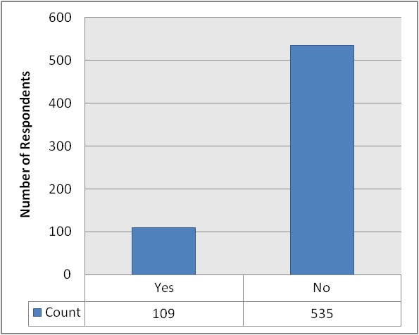
Base = 644 respondents

The next question was directed only at the 109 respondents who identified themselves as carers in the immediately preceding question. These panellists were asked how long they have been a carer. Their responses are provided below in Figure 8 (see page 30). The results show that the greatest share of respondents (46; 45.5%) have been a carer for 1-5 years. 25 respondents (24.8%) have been a carer for over 10 years, 23 respondents (22.8%) have been a carer for 5-10 years and 7 respondents (6.9%) have been a carer for less than a year.

Tables 22-24 (see page 100) provide a detailed breakdown of these responses by gender, neighbourhood area and age-group, but some headline findings will be discussed here.

The proportions of male and female respondents (see Table 22, page 100) who have been carers for less than a year were very similar (6.1% and 7.8%, respectively). However, the proportion of females who have been a carer for more than 10 years (35.3%) is considerably larger than the equivalent proportion of males (14.3%) who have been. Conversely, a larger proportion of male respondents have been carers for 1-5 years (53.1%) or 5-10 years (26.5%) than was the case for female respondents (37.3% and 19.6%, respectively).

There was considerable variation across neighbourhoods (see Table 23, page 100), although this did not appear to follow any clear pattern. In North and South, the greatest share of respondents stated that they had been carers for 1-5 years, whereas in Central the most popular response was 5-10 years. No respondents in Central stated that they had been carers for less than a year. A noticeably larger proportion of respondents in North (31.7%) than in Central (19.2%) and South (21.2%) stated that they had been a carer for more than 10 years.

Disaggregating these results by age-group revealed only one correlation (see Table 24, page 100). This was in relation to the proportion of respondents who have been carers for 1-5 years, which was smallest among those aged 16-34 (25.0%), rising to 45.0% of those aged 35-54, 45.5% of those aged 55-64 and 47.8% of those aged 65+. Indeed, this was the most popular response for all but the youngest age-group, for whom the most popular response was 5-10 years (50.0%, compared to 17.5% of those aged 35-54, 24.2% of those aged 55-64 and 26.1% of those aged 65+). Other than this, the only notable age-related result was the fact that all of the respondents who said that they had been carers for less than a year were found in the 35-54 age-group.

Figure 8: How long have you been a carer?
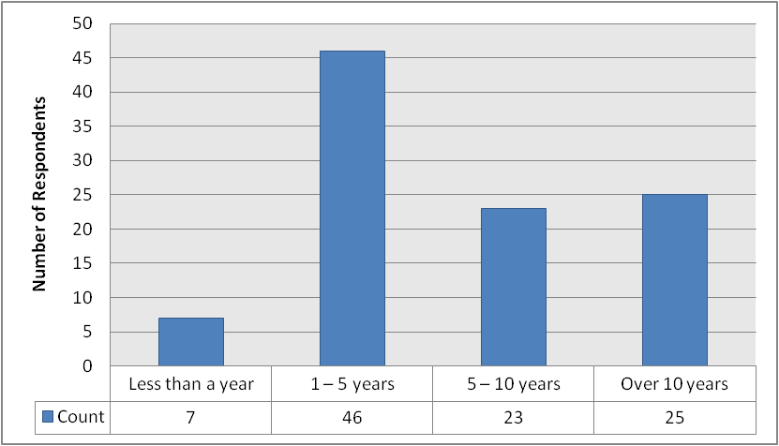
Base = 101 respondents

Again, the next question was targeted at the 109 respondents who identified as carers in the first question in this section. This time, they were asked how many people they care for. Their responses are provided below in Figure 9 (see page 31), which shows that most respondents (77; 75.5%) only care for 1 person. 20 respondents (19.6%) care for 2 people and 5 respondents (4.9%) care for 3 people. No respondents care for 4 or more people.

Once again, due to the small number of respondents in all but one of the response categories (and the resultant likelihood of distorted results), we do not recommend performing further stratified analysis on these results.

Figure 9: How many people do you care for?
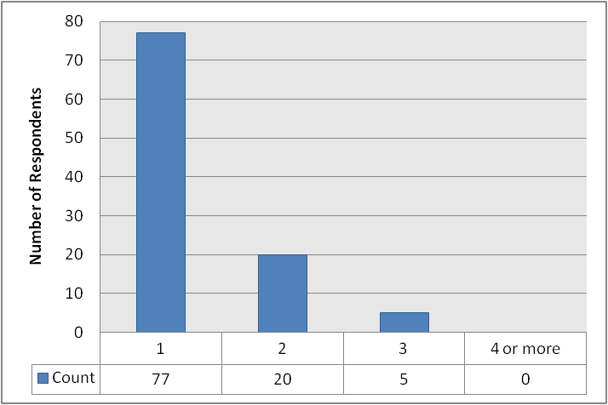
Base = 102 respondents

The 109 respondents identifying themselves as carers were then asked what their relationship is with the person(s) they care for. Their responses are provided below in Figure 10 (see page 32), which shows that in most cases, the person being cared for is a carer’s parent (40 respondents; 36.7%), a carer’s husband / wife / partner (24 respondents; 22.0%) or another family member (23 respondents; 21.1%). 18 respondents (16.5%) care for their son / daughter, 11 respondents (10.1%) care for a neighbour and 10 respondents (9.2%) care for a friend. 3 respondents (2.8%) provided an ‘other’ suggestion, but none of these were relevant to the question.

These results were disaggregated by gender, neighbourhood area and age-group: the results can be seen in Tables 25-27 (see page 101). A few notable headline results emerged, although these should be treated with caution due to the small number of respondents in some of the response categories.

Dealing firstly with gender, it is worth noting that there were considerable differences between male and female respondents in relation to caring for a son / daughter and caring for a husband / wife / partner. The proportion of female respondents who said that they care for a son / daughter (28.6%) was considerably larger than the proportion of male respondents who do so (3.9%). Conversely, the proportion of male respondents who look after a husband / wife / partner (31.4%) was much larger than the proportion of female respondents who do likewise (14.3%).

There were also some notable differences between neighbourhood areas, although these did not follow any clear or consistent pattern. The proportion of respondents caring for a parent was noticeably smaller in North (26.7%) than in Central (41.4%) and South (39.4%). Conversely, the proportion of respondents caring for a son / daughter in Central (6.9%) was smaller than in North (22.2%) and South (18.2%). The proportion of respondents caring for another family member was larger in North (20.0%) than in Central (13.8%) and South (15.2%).

Finally, in terms of age-group, there was only one correlation. This related to the proportion of respondents who care for a husband / wife / partner. No carers aged 16-34 care for someone who fits this description. However, this rises to 9.5% of carers aged 35-54, 14.3% of those aged 55-64 and 57.7% of carers aged 65+. However, the proportion of respondents aged 16-34 who care for a son / daughter (50.0%) is considerably larger than in the other age-groups (16.7% of those aged 35-54, 14.3% of those aged 55-64 and 15.4% of those aged 65+). The same was true of those who care for a friend (25.0% of those aged 16-34, compared to 7.1% of those aged 35-53, 5.7% of those aged 55-64 and 11.5% of those aged 65+). The only other notable result was that a particularly large proportion of respondents aged 35-54 (52.4%) and 55-64 (42.9%) care for a parent (this compares to 0.0% of those aged 16-34 and 0.0% of those aged 65+).

Figure 10: What is your relationship with the person(s) you care for?
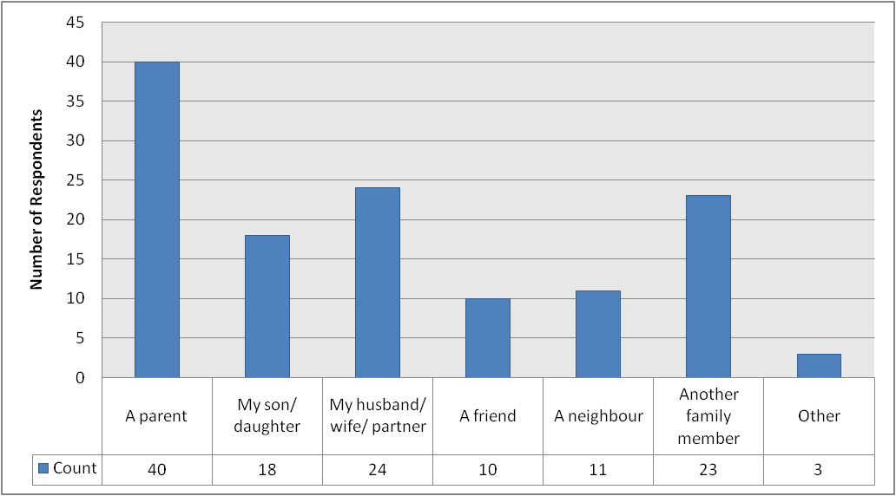
Base = 109 respondents

Once again, the same 109 respondents identifying as carers were targeted with the next question. This sought to establish whether or not carers live in the same house as the person they care for (or the person they mainly care for, if they care for more than one person). Their responses are provided below in Figure 11 (see page 33), which shows that the majority of carers who responded (65; 62.5%) do not live in the same house as the person they (mainly) care for. Conversely, 39 respondents (37.5%) do live in the same house as the person they (mainly) care for.

These results can also be disaggregated by gender, neighbourhood area and age-group. When doing so, the results show that there is virtually no difference whatsoever between the proportion of male and female respondents who do live with the person they care for (38.8% and 37.7%, respectively). A very similar proportion of respondents in North (40.5%) and Central (40.7%) live with the person they care for, although the figure is lower in South (33.3%). Finally, there was also wide variation between age-groups: the proportion of respondents who live with the person they care for was largest in the 16-34 age-group (75.0%), followed by the 65+ age-group (58.3%) and the 55-64 age-group (35.3%), and was smallest in the 35-54 age-group (25.0%).

We also crosstabulated the results of this question with the relationship carers have with the person they care for. The results of this can be seen in Table 28 (see page 102), which shows that 10.5% of people who care for a parent live in the same house as them. The equivalent proportion for people who care for a son / daughter is 77.8%. For those caring for a husband / wife / partner, the proportion was 79.2%, and it was 20.0% for those caring for a friend. 10.0% of people who care for a neighbour live in the same house as them, whilst 11.1% of those who care for another family member live in the same house as them.

Figure 11: Do you live in the same house as the person you mainly (if you care for more than one person) care for?
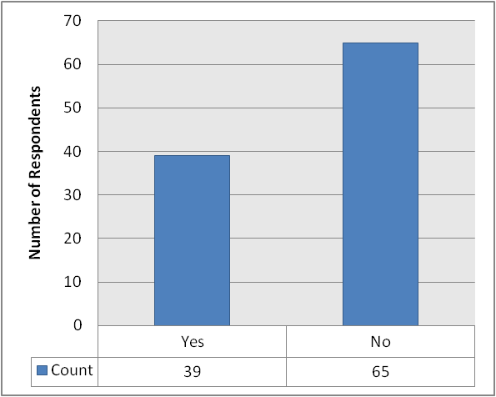
Base = 104 respondents

This same group of respondents was then asked to state the number of days on which they provide care during an average week. Their responses are provided below in Figure 12, which shows that the largest share of respondents provide care 7 days a week (49 respondents; 49.0%). The next most popular responses were 3 days per week (17 respondents; 17.0%), followed by 1 day a week (13.0%) and 2 days a week (8 respondents; 8.0%). 7 respondents (7.0%) provide care on 4 days during an average week, whilst 6 respondents (6.0%) provide care on 5 days during an average week.

Due to the extremely small number of respondents in some of these categories (and the resultant likelihood of distorted results), we do not recommend performing further stratified analysis on these results.

Once again, we crosstabulated responses to this question with the relationship carers have with the person they (mainly) care for. The results are very detailed, but are provided in Table 29 (see page 102). We also broke down responses to this question by whether or not carers live with the person they (mainly) care for. Again, the responses are somewhat detailed, but are nevertheless provided in Table 30 (see page 103).

Figure 12: During an average week, on how many days do you provide care?
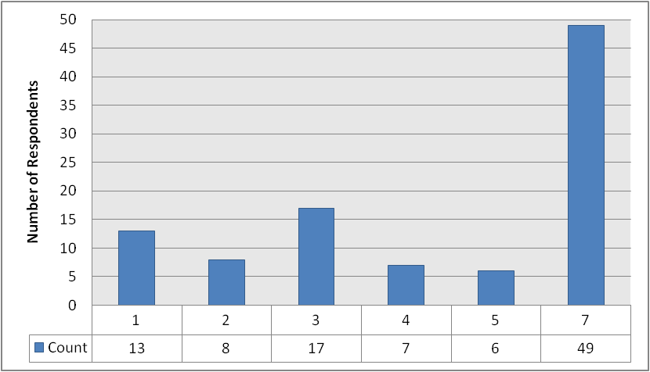
Base = 100 respondents

The respondents identifying as carers were then asked how long they spend caring during an average day. Their responses are provided below in Figure 13 (see page 35), which shows that a majority of respondents (59; 59.6%) spend up to 4 hours caring. 20 respondents (20.2%) spend more than 12 hours caring, whilst 10 respondents apiece (10.1%) care for 4-8 hours and 8-12 hours.

Again, due to the extremely small number of respondents in some of these categories (and the resultant likelihood of distorted results), we do not recommend performing further stratified analysis on these results.

Once again, we crosstabulated responses to this question with whether or not carers live with the person they (mainly) care for. The results are somewhat detailed, but are provided in Table 31 (see page 103). We also broke down responses to this question by the relationship carers have with the person they (mainly) care for. Again, the responses are very detailed, but are nevertheless provided in Table 32 (see page 104).

Figure 13: How long, on an average day, do you spend caring?
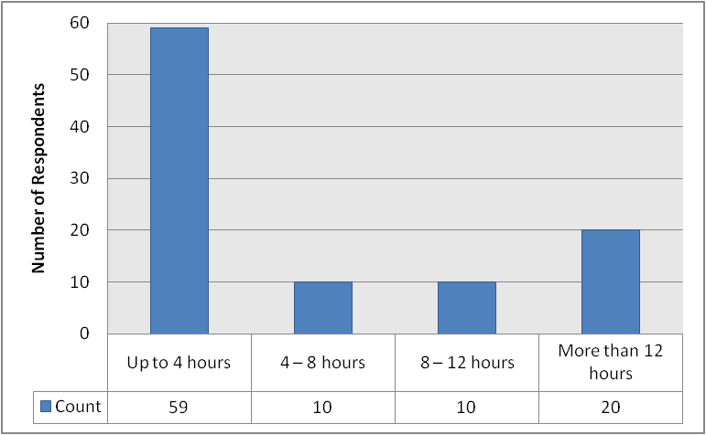
Base = 99 respondents

The 109 carers were then asked to identify the different types of care / help they provide to the person(s) for whom they care. They were provided with a list of predefined responses, but were also able to supply their own ‘other’ responses. All of the answers received are aggregated below in Table 5 (see page 38), which shows that the most frequently cited types of care / help are shopping (80 respondents; 73.4%), emotional support (77 respondents; 70.6%), keeping company (75 respondents; 68.8%), accompanying to appointments (73 respondents; 67.0%), help with paperwork (72 respondents; 66.1%), getting out and about (70 respondents; 64.2%), transport (62 respondents; 56.9%), housework (54 respondents; 49.5%) and cooking (53 respondents; 48.6%). 8 respondents (7.3%) provided an ‘other’ response. These were finance (4 respondents; 3.7%), helping with holidays / leisure (1 respondent; 0.9%), advocacy (also 1 respondent; 0.9%) and altering clothes (also 1 respondent; 0.9%). Additionally, 5 responses were provided which were not actually relevant to the question at hand.

These results have also been broken down according to gender, neighbourhood area and age-group. The results of this can be seen in Tables 33-35 (see pages 105-107). The results are obviously very detailed, but some top-level discussion of results will be provided here.

In terms of gender, a few notable differences emerged. The proportion of female respondents who provide the following types of care was noticeably larger than the proportion of male respondents who do so: dressing; washing; bathing; cooking; medication; toileting; laundry; emotional support; and helping to communicate. Conversely, the proportion of male respondents who provide the following types of care was noticeably larger than the proportion of female respondents who do so: shopping; do-it-yourself; getting out and about; gardening; and transport (please see Table 33 on page 105 for exact percentage figures).

There was also some variation between the responses given by panellists in different neighbourhood areas. Compared to the overall proportion listed below in Table 5 (see page 38), a relatively large proportion of respondents in North provide the following types of care: emotional support; transport; medication; dressing; washing; toileting; and feeding. Compared to the overall proportion listed below in Table 5 (see page 38), the only type of care which was provided by a relatively small proportion of respondents in North was housework.

Compared to the overall proportion listed below in Table 5 (see page 38), a relatively large proportion of respondents in Central provide the following types of care: help with paperwork; cooking; and helping to communicate. Compared to the overall proportion listed below in Table 5 (see page 38), a relatively small proportion of respondents in Central provide the following types of care: emotional support; getting out and about; transport; gardening; and washing.

Compared to the overall proportion listed below in Table 5 (see page 38), the only type of care which was provided by a relatively large proportion of respondents in South was housework. Compared to the overall proportion listed below in Table 5 (see page 38), a relatively small proportion of respondents in South provide the following types of care: emotional support; cooking; keeping safe or supervising; medication; dressing; bathing; washing; and toileting.

Please see Table 34 on page 106 for exact percentage figures for the neighbourhood-related findings outlined above.

Only two age-related correlations were found: these related to the options for “laundry” and “accompanying to appointments”. In each case, the proportion of respondents selecting the option was smallest among those aged 16-34, rising in each successively older age-group to its highest point in the 65+ age-group. Other than this, there were some notable individual age-group variations. The most notable of these variations could be seen between the 16-34 age-group and the other age-groups. For example, compared to the overall proportion listed below in Table 5 (see page 38), a relatively large proportion of respondents aged 16-34 selected the following options: dressing; washing; emotional support; and helping to communicate. Conversely, compared to the overall proportion listed below in Table 5 (see page 38), a relatively small proportion of respondents in this age-group selected the following options: getting in and out of bed; shopping; do-it-yourself; getting out and about; gardening; help with paperwork; transport; and accompanying to appointments.

Compared to the overall proportion listed below in Table 5 (see page 38), there was no type of care which was provided by a relatively large proportion of respondents aged 35-54. Compared to the overall proportion listed below in Table 5 (see page 38), a relatively small proportion of respondents in this age-group provide the following types of care: keeping company; housework; and laundry.

Compared to the overall proportion listed below in Table 5 (see page 38), a relatively large proportion of respondents aged 55-64 provide the following types of care: keeping company; housework; laundry; gardening; washing; toileting; and feeding. Compared to the overall proportion listed below in Table 5 (see page 38), there was no type of care which was provided by a relatively small proportion of respondents in this age-group.

Compared to the overall proportion listed below in Table 5 (see page 38), a relatively large proportion of respondents aged 65+ provide the following types of care: housework; cooking; and laundry. Compared to the overall proportion listed below in Table 5 (see page 38), a relatively small proportion of respondents aged 65+ provide the following types of care: emotional support; getting out and about; and washing.

Please see Table 35 on page 107 for exact percentage figures for the age-related findings outlined above.

Once again, we also crosstabulated responses to this question with the relationship carers have with the person they (mainly) care for. The results are very detailed, but are provided in Table 36 (see page 108). We also broke down responses to this question by whether or not carers live with the person they (mainly) care for. Again, the responses are somewhat detailed, but are nevertheless provided in Table 37 (see page 109).

Table 5: What type of care / help do you provide for the person?
Response | Respondents
Response | Count | %
Shopping | 80 | 73.4
Emotional Support | 77 | 70.6
Keeping company | 75 | 68.8
Accompanying to appointments | 73 | 67.0
Help with paperwork | 72 | 66.1
Getting out and about | 70 | 64.2
Transport | 62 | 56.9
Housework | 54 | 49.5
Cooking | 53 | 48.6
Keeping safe or supervising | 48 | 44.0
Laundry | 47 | 43.1
Do-it-yourself | 46 | 42.2
Medication | 43 | 39.4
Help to communicate | 36 | 33.0
Gardening | 34 | 31.2
Dressing | 28 | 25.7
Bathing | 22 | 20.2
Washing | 21 | 19.3
Toileting | 18 | 16.5
Getting in and out of bed | 18 | 16.5
Feeding | 16 | 14.7
Other | 8 | 7.3
N/a | 5 | 4.6
Base = 109 respondents

The following question aimed to establish whether or not carers (and the person they care for) receive help or support from any outside agencies. Panellists were asked to consider a list of agencies and then state whether or not they (and the person they care for) receive help or support from them. Their responses are provided below in Figure 14 (carers themselves) (see page 39) and Figure 15 (the person they care for) (see page 41).

Dealing firstly with help or support given to carers themselves, Figure 14 (see page 39) shows that 18 respondents (16.5%) receive help or support from friends and family, 5 (4.6%) receive help or support from the NHS, 3 (2.8%) receive help or support from their employer, 2 (1.8%) receive help or support from Aberdeen City Council and 1 (0.9%) receives help or support from other support organisations (see also Table 6, page 42).

Once again, due to the extremely small number of respondents in some of these categories (and the resultant likelihood of distorted results), we do not recommend performing further stratified analysis on these results.

Figure 14: Do you or the person you care for get help or support from any of the following? (PERSON PROVIDING CARE)
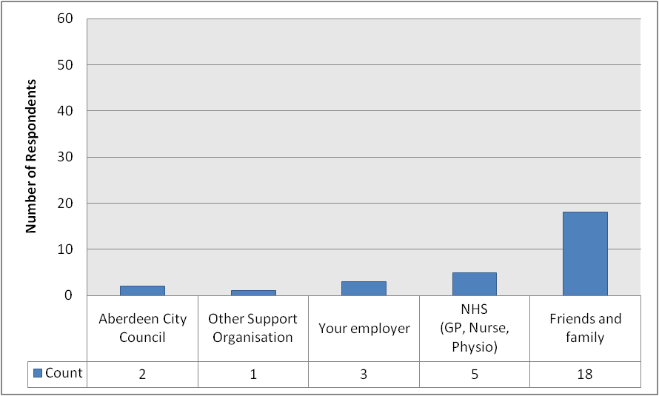
Base = 109 respondents

Turning now to consider the person(s) that carers care for, Figure 15 (see page 41) shows that they receive more help than their carers from each of the agencies considered. 56 respondents (51.2%) stated that the person(s) they care for get help or support from friends and family, 41 (37.6%) get help from the NHS, 34 (31.2%) get help or support from Aberdeen City Council, and 16 (14.7%) get help or support from another support organisation (see also Table 6, page 42). No respondents stated that the person(s) they care for get help from their employer.

These results have also been broken down according to gender, neighbourhood area and age-group. The results of this can be seen in Tables 38-40 (see page 110). The results are obviously somewhat detailed, but some top-level discussion of results will be provided here.

Only a small number of notable differences emerged when these results were broken down further. Compared to the overall proportion discussed above in relation to Figure 15, a relatively large proportion of male respondents selected the Aberdeen City Council (35.3%) option (compared to 26.8% of female respondents). Conversely, compared to the overall proportion discussed above in relation to Figure 15, a relatively large proportion of female respondents selected the friends and family (57.1%) and other support organisation (17.9%) options (compared to 47.1% and 11.8% of male respondents, respectively). There was no major difference between their responses in relation to the NHS, and no respondents identified receiving any help from their employer.

Please see Table 38 on page 110 for exact percentage figures for the gender-related findings outlined above.

In terms of different neighbourhood areas, compared to the overall proportion discussed above in relation to Figure 15, a relatively large proportion of respondents in North selected every option except the “your employer” option (which nobody selected in any area). Compared to the overall proportion discussed above in relation to Figure 15, there was no type of support which was identified by a relatively large proportion of respondents in Central. However, compared to the overall proportion discussed above in relation to Figure 15, a relatively small proportion of respondents in Central selected the Aberdeen City Council, NHS and friends and family options. Compared to the overall proportion discussed above in relation to Figure 15, a relatively large proportion of respondents in South selected the friends and family option, whilst a relatively small proportion of respondents in South selected the NHS and other support organisation options.

Please see Table 39 on page 110 for exact percentage figures for the neighbourhood-related findings outlined above.

Only one age-related correlation was found: this related to the “other support organisation” option: the proportion of respondents selecting this option was smallest among those aged 16-34, rising in each successively older age-group to its highest point in the 65+ age-group. Other than this, there were some notable individual age-group variations. Compared to the overall proportion discussed above in relation to Figure 15, a relatively large proportion of respondents aged 16-34 selected the NHS and other support organisation options. Compared to the overall proportion discussed above in relation to Figure 15, a relatively small proportion of respondents aged 16-34 selected the Aberdeen City Council option.

Compared to the overall proportion discussed above in relation to Figure 15, a relatively large proportion of respondents aged 35-54 selected the NHS, friends and family, and other support organisation options. Compared to the overall proportion discussed in relation to Figure 15 (see page 41), a relatively small proportion of respondents aged 35-54 selected the Aberdeen City Council option.

Compared to the overall proportion discussed above in relation to Figure 15, a relatively large proportion of respondents aged 55-64 selected the Aberdeen City Council and friends and family options. Compared to the overall proportion discussed above in relation to Figure 15, a relatively small proportion of respondents aged 55-64 selected the NHS and other support organisation options.

Compared to the overall proportion discussed above in relation to Figure 15, there was no type of support which was selected by a relatively large proportion of respondents aged 65+. However, compared to the overall proportion discussed above in relation to Figure 15, a relatively small proportion of respondents aged 65+ selected the NHS, friends and family, and other support organisation options.

Please see Table 40 on page 110 for exact percentage figures for the neighbourhood-related findings outlined above.

Figure 15: Do you or the person you care for get help or support from any of the following? (PERSON CARED FOR)
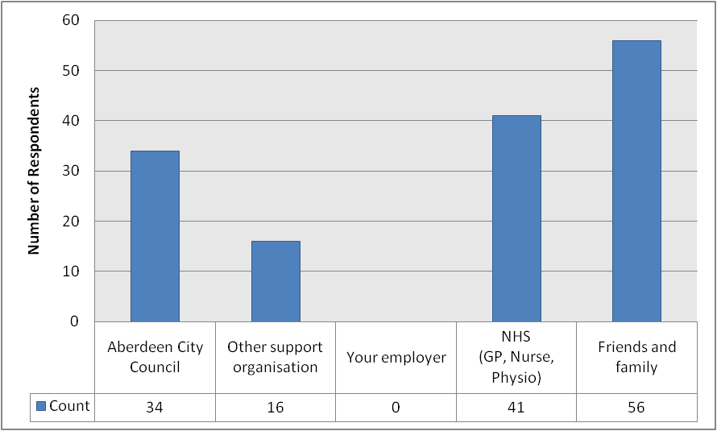
Base = 109 respondents

When selecting the ‘other support organisation’ in the foregoing question (both for carers and the people they care for), respondents were asked to elaborate on which organisations these were. The responses provided have been aggregated and reproduced below in Table 6 (see page 42). They show that from the responses received, the most frequently cited support organisations were Carewatch (2 respondents; 1.8%) and an unspecified care home (also 2 respondents; 1.8%). A number of options were mentioned by 1 respondent each (0.9%), whilst 7 respondents provided information which was not relevant to the question.
Table 6: Do you or the person you care for get help or support from any of the following? (‘Other Support Organisation’ responses)
Response | Respondents
Response | Count | %
Carewatch | 2 | 1.8
Care home | 2 | 1.8
Aberdeenshire Council | 1 | 0.9
Beannachar | 1 | 0.9
Red | 1 | 0.9
Cyrenians | 1 | 0.9
VSA | 1 | 0.9
SAMH | 1 | 0.9
Carers | 1 | 0.9
Future Choices | 1 | 0.9
NESS | 1 | 0.9
Occupational Therapist | 1 | 0.9
Playgroups | 1 | 0.9
Crossroads | 1 | 0.9
N/a | 7 | 6.4
Base = 109 respondents

The 109 carers were also able to identify any other organisations who gave support to them or the person they cared for. These organisations have been listed below in Table 7 (see page 43) along with the frequency with which they were mentioned. The results show that the most frequently mentioned ‘other’ organisation was again Carewatch (5 respondents; 4.6%), perhaps suggesting some confusion on the part of some respondents in terms of whether such organisations should have been included here or as an ‘other support organisation’ (see Table 6 above). The second most popular response was Alzheimer’s Scotland (3 respondents; 2.8%). CLAN (2 respondents; 1.8%) was the only other organisation identified by more than one respondent. 2 respondents (1.8%) gave answers which were not applicable to the question being asked.

Table 7: Do you or the person you care for get help or support from any of the following? (‘Other’ responses)
Response | Respondents
Response | Count | %
Carewatch | 5 | 4.6
Alzheimer’s Scotland | 3 | 2.8
CLAN | 2 | 1.8
Archway Respite | 1 | 0.9
Chest Heart & Stroke Scotland | 1 | 0.9
Crossroads | 1 | 0.9
Cruse | 1 | 0.9
Dementia Scotland | 1 | 0.9
Down’s Syndrome Scotland | 1 | 0.9
Friends of Anchor | 1 | 0.9
MacMillan | 1 | 0.9
Future Choices | 1 | 0.9
Grampian Society for the Blind | 1 | 0.9
Inspire | 1 | 0.9
Mental Health Support Worker(s) | 1 | 0.9
NESS | 1 | 0.9
Other local authority | 1 | 0.9
Paramount Care | 1 | 0.9
Raeburn Health Care | 1 | 0.9
SAGA | 1 | 0.9
VSA | 1 | 0.9
N/a | 2 | 1.8
Base = 109 respondents

Respondents were then asked to describe the main type of support they (or the person they care for) receives from the organisations covered in the preceding questions. Their responses have been aggregated and are provided below in Table 8 (see page 44). The results show that the most frequently cited types of support were washing or bathing (11 respondents; 10.1%), feeding (9 respondents; 8.3%), general care home care (8 respondents; 7.3%), medical care (7 respondents; 6.4%), general unspecified care (also 7 respondents; 6.4%) and keeping company (6 respondents; 5.5%). Each other answer was identified by no more than 3 respondents. 10 panellists (9.2%) gave answers which were not relevant to the question.

Table 8: Please describe the main support you, or the person you care for, receives from them.
Response | Respondents
Response | Count | %
Washing / bathing | 11 | 10.1
Feeding | 9 | 8.3
Care home care | 8 | 7.3
Medical | 7 | 6.4
General unspecified | 7 | 6.4
Keeping company | 6 | 5.5
Shopping | 3 | 2.8
Advice / understanding | 3 | 2.8
None | 3 | 2.8
Day centre care | 2 | 1.8
Housework | 2 | 1.8
Getting in and out of bed | 2 | 1.8
Respite care | 2 | 1.8
Emotional support | 2 | 1.8
Transport | 2 | 1.8
Keeping safe or supervising | 2 | 1.8
DIY | 2 | 1.8
Financial support | 1 | 0.9
Dressing/ undressing | 1 | 0.9
Leisure activities | 1 | 0.9
N/a | 10 | 9.2
Base = 109 respondents

The 109 respondents identifying as carers were then asked if they had any health issues which impacted upon their caring role. The responses received are tabulated below in Table 9 (see page 45). The table shows that the most commonly identified health issue was stress / depression, identified by 12 respondents (11.0%). This was followed by cardiac problems (8 respondents; 7.3%), arthritis (5 respondents; 4.6%), restricted mobility (4 respondents; 3.7%), old age (also 4 respondents; 3.7%), back problems (also 4 respondents; 3.7%) and joint problems (also 4 respondents; 3.7%). Each remaining health issue was identified by no more than 3 respondents. 24 respondents (22.0%) provided a response which was not relevant to the question being asked.

Table 9: Thinking about yourself, do you have any health issues that impact on your caring role?
Response | Respondents
Response | Count | %
Stress / depression | 12 | 11.0
Cardiac problems | 8 | 7.3
Arthritis | 5 | 4.6
Restricted mobility | 4 | 3.7
Age | 4 | 3.7
Back problems | 4 | 3.7
Joint problems | 4 | 3.7
Fatigue | 3 | 2.8
Not specified | 3 | 2.8
Isolation | 2 | 1.8
Diabetes | 2 | 1.8
Osteoporosis | 1 | 0.9
Autism | 1 | 0.9
Thyroid problems | 1 | 0.9
Sleep deprivation | 1 | 0.9
N/a | 24 | 22.0
Base = 109 respondents

The final question in this section was once again addressed to the 109 respondents who had initially identified themselves as carers. They were asked to identify one thing which could improve support for them in their role as a carer. 58 panellists provided a response: these have been aggregated thematically and are laid out below in Table 10 (see page 46). The most popular responses were assistance with care (8 respondents; 7.3%), access to respite care (5 respondents; 4.6%), more consistency of treatment, respect, compassion and understanding from Aberdeen City Council (also 5 respondents; 4.6%) and that no further support was needed at present (also 5 respondents; 4.6%). 4 respondents (3.7%) identified a better understanding of the support available. The same number of respondents (4; 3.7%) each identified financial support, general support and better public transport links. The remaining answers were each identified by no more than 3 respondents, whilst 8 respondents (7.3%) provided responses which were not relevant to the question.

Table 10: Please tell us what one thing could improve support for you in your role as a carer?
Response | Respondents
Response | Count | %
Care assistance | 8 | 7.3
Access to respite | 5 | 4.6
More consistency / respect / compassion / understanding | 5 | 4.6
No further support needed | 5 | 4.6
Better understanding of support available | 4 | 3.7
Financial support | 4 | 3.7
Support (general) | 4 | 3.7
Better public transport links | 4 | 3.7
Provide (or reinstate) care package | 3 | 2.8
Access to befriending services | 2 | 1.8
Day centre(s) | 2 | 1.8
Extended community care hours | 2 | 1.8
Better long-term care planning | 2 | 1.8
Special needs after-school care | 1 | 0.9
Clearer cost structures | 1 | 0.9
Better accommodation for person cared for | 1 | 0.9
Better quality of care | 1 | 0.9
More continuity among carers | 1 | 0.9
Better services for the elderly | 1 | 0.9
Better mental health services | 1 | 0.9
More carers in the community | 1 | 0.9
More recognition | 1 | 0.9
ACC to stop charging for issuing blue badges | 1 | 0.9
Replace Taxi Card scheme | 1 | 0.9
Regular checks for support requirements | 1 | 0.9
Parking Permit for visits to sheltered housing | 1 | 0.9
Time off work | 1 | 0.9
N/a | 8 | 7.3
Base = 109 respondents

SERVICE RESPONSE
It was extremely encouraging that 109 respondents identified themselves as carers. This is equal to 17% of respondents and this helps to give the results real validity and credibility.

I was surprised that there was virtually no difference between the proportion of male and female respondents who said that they were carers, and this is a significant change from the last time we asked the panel. It was interesting to note that 46 carers had been caring from 1-5 years and that in most cases; the person being cared for is the carer’s parent. It was also humbling to note that 49 carers provide care 7 days a week and often up to 4 hours a day. In terms of what could improve support for carers, the main issues raised were care assistance and access to respite.

The results from City Voice 28 will be used to inform our future commissioning intentions for carer support and will be feedback to the Aberdeen City Health and Social Care Partnership Committee. Finally, I would like to personally thank all the carers who took the time to respond to this survey.

Sandy Reid
Programme Development Manager
Aberdeen City Community Health Partnership

TRANSPORT TO HEALTHCARE INFORMATION CENTRE

Some people experience problems getting to healthcare appointments, such as local clinics, outpatient or specialist hospital appointments, because of transport issues. To try and ease these problems, a new initiative is being piloted in the Grampian region. Aberdeen City, Aberdeenshire and Moray councils, along with NHS Grampian, the Scottish Ambulance Service and Nestrans have joined forces to address the transport difficulties faced by patients by supporting the Transport to Healthcare Information Centre.

The Centre opened in January 2013 and acts as a dedicated helpline, offering advice on accessing suitable transport for the public to get to and from their appointments where they may have no personal means of transport. For the first three months the pilot will cover 3 areas: patients from across the region going to the Dental School and the Eye Clinic, and the whole of Moray. Following evaluation, the Centre hopes to roll this out across all regions and services. The information City Voice panellists provide will help the Centre to measure demand for this service in Aberdeen City and help the Centre to plan for variations across the Grampian area.

Those health services included in the pilot will be NHS hospital or health service referral appointments (e.g. specialist or consultant services, diagnostic treatments, pre-assessment appointments for planned hospital treatment, outpatient services following treatment). The pilot will not cover visits to GPs, appointments unrelated to an NHS referral (e.g. attending a private podiatrist) or emergency visits.

The first question in this section asked all panellists if they have attended an NHS healthcare appointment in the last 12 months for a service in any of the following categories: specialist or consultant services; diagnostic treatment (e.g. scan); and a pre-assessment appointment from planned hospital treatment. The responses received are provided below in Figure 16 (see page 49), which shows that just under half of all respondents (322; 49.5%) have attended an NHS appointment of this nature in the past 12 months. Conversely, just over half (328 respondents; 50.5%) have not.

The proportion of female respondents who have attended an NHS healthcare appointment for a service in any of the categories described below in the last 12 months (51.5%) was slightly larger than the equivalent proportion among male respondents (46.9%). The proportion of respondents who have attended an appointment of this nature was lowest in North (47.1%) and Central (49.7%), and highest in South (50.8%). In terms of age-groups, the proportion of respondents who have attended an appointment of this nature in the last 12 months was smallest among those aged 16-34 (35.8%), followed by those aged 35-54 (43.3%) and those aged 65+ (56.9%), and was highest among those aged 55-64 (57.3%).

Figure 16: In the last 12 months, have you attended an NHS healthcare appointment for a service in any of the following categories: specialist or consultant services, diagnostic treatment (e.g. scan), pre-assessment appointment from planned hospital treatment?
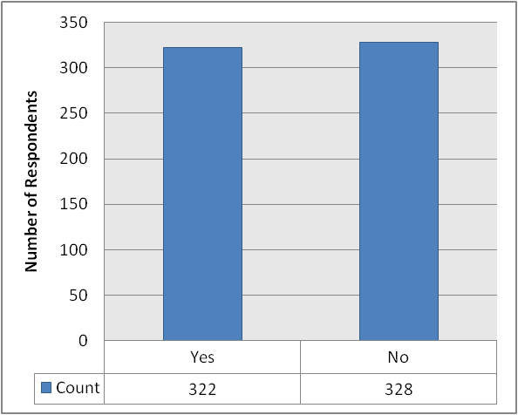
Base = 650 respondents

The 322 respondents who stated that they have attended an appointment of this nature in the last 12 months were subsequently asked where they went for the appointment(s). The two options provided and the number of respondents selecting them are provided below in Figure 17 (see page 50). The chart shows that 67 respondents (20.8%) attended at least one appointment at a clinic or service in their local area (not a hospital), whilst 277 respondents (86.0%) had attended at least one appointment at a hospital or clinic elsewhere in Aberdeen.

Further analysis of these responses shows that there was virtually no difference between males and females. There was much greater variation between neighbourhoods and age-groups, though. Dealing firstly with neighbourhood areas, the proportion of respondents who had attended an appointment of this nature at a clinic or service in their local area (not a hospital) was highest in Central (28.9%), followed by North (19.8%) and South (15.2%). The proportion of respondents who had attended an appointment of this nature at a hospital or clinic elsewhere in Aberdeen was highest in South (88.8%), followed by North (86.5%) and Central (82.5%).

In terms of age-group variations, the proportion of respondents who had attended an appointment of this nature at a clinic or service in their local area (not a hospital) was largest among those aged 65+ (25.6%), followed by those aged 16-34 (25.0%), those aged 35-54 (20.2%) and those aged 55-64 (16.3%). The proportion of respondents who had attended an appointment of this nature at a hospital or clinic elsewhere in Aberdeen was largest among those aged 35-54 (89.5%), followed by those aged 55-64 (88.8%), those aged 65+ (80.5%) and those aged 16-34 (79.2%).

Figure 17: Where did you go for the appointment(s)?
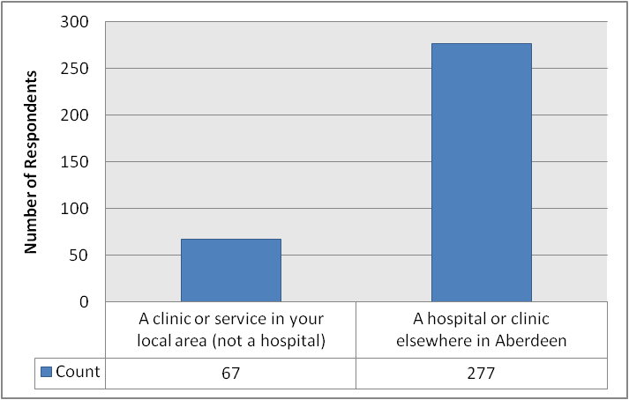
Base = 322 respondents

These 322 respondents were then asked to identify how they got to their healthcare appointment(s) in the last 12 months. Panellists were provided with a list of 8 possible transport options, as well as a “can’t remember” and “other” option. The responses are provided below in Table 11 (see page 52). The results show that the most popular response was a panellist’s own vehicle, which was selected by 190 respondents (59.0%). After this, the most popular responses were public bus (85 respondents; 26.4%), a friend or relative driving a panellist (73 respondents; 22.7%), walking (61 respondents; 18.9%) and taking a taxi (20 respondents; 6.2%). Each remaining option was identified by no more than 4 respondents. No patients were unable to remember how they got to their appointment(s), whilst 1 respondent (0.3%) provided an “other” answer: this was a hospital shuttle bus (which may actually be part of the Patient Transport Service, although this was not made clear by the respondent).

We have also broken these results down by gender, neighbourhood area and age-group. The full results can be found in Tables 41-43 (see pages 111-112), but we report some headline findings here.

There were some differences between male and female panellists’ responses. A greater proportion of male respondents than female respondents selected the following options: walk (21.9% vs. 16.9% of females), own vehicle (62.3% vs. 54.7% of females) and public bus (28.1% vs. 25.0% of females), whilst a greater proportion of females than males selected the “friend or relative drove me” (24.4% vs. 19.2% of males) and taxi (7.6% vs. 4.8% of males) options.

There was also variation across different neighbourhood areas. The most dramatic of these came in relation to the “walk” option, which was selected by 8.3% of respondents in North and 9.6% in South, but by 42.3% of respondents in Central. There was also notable (albeit less pronounced) variation in relation to the “own vehicle” option, selected by 61.6% of respondents in South and 64.6% of respondents in North, but by only 47.4% in Central. There was also much less dramatic variation found in relation to the “friend or relative drove me” (17.5% in North and 18.8% in Central, compared to 28.0% in South), public bus (29.2% in North, 23.7% in Central and 26.4% in South) and taxi (8.3% in North and 9.3% in Central but just 2.4% in South) options.

In relation to age-groups, only one correlation was found. This was in relation to the “walk” option, which was selected by 29.2% of those aged 16-34, 21.9% of those aged 35-54, 17.3% of those aged 55-64 and 14.6% of those aged 65+. Despite being the only correlation, there was nevertheless also variation in relation to other options. For example, the proportion of respondents selecting the “own vehicle” option was largest among those aged 35-54 (69.3%), falling to 58.3% of those aged 16-34, 55.1% of those aged 55-64 and 46.3% of those aged 65+. Similarly, the proportion of respondents selecting the “friend or relative drove me” option was largest among those aged 16-34 (37.5%), falling to 28.0% of those aged 65+, 21.4% of those aged 55-64 and 14.9% of those aged 35-54. The proportion of respondents selecting the public bus option was largest among those aged 55-64 (34.7%), falling to 34.1% of those aged 65+, 16.7% of those aged 16-34 and 15.8% of those aged 35-54. Finally, the proportion of respondents selecting the taxi option was largest among those aged 65+ (12.2%), falling to 5.3% of those aged 35-54, 4.2% of those aged 16-34 and 3.1% of those aged 55-64.

As an extra piece of analysis, we have also broken down these responses according to whether the appointment in question was at a clinic or service in respondents’ local areas, or a hospital / clinic elsewhere in Aberdeen. The results of this analysis can be found in Table 44 (see page 112).

Table 11: If you attended a healthcare appointment in the last 12 months, please say how you got there.
Response | Respondents
Response | Count | %
Own vehicle (car, bike, van etc) | 190 | 59.0
Public bus | 85 | 26.4
Friend or relative drove me | 73 | 22.7
Walk | 61 | 18.9
Taxi | 20 | 6.2
Patient Transport Service | 4 | 1.2
Community bus | 2 | 0.6
Train | 1 | 0.3
Can't remember | 0 | 0.0
Other | 1 | 0.3
Base = 322 respondents

The next question was addressed to all panellists, and asked them to state whether any of a number of particular situations had arisen in the last 12 months if they had been invited to a healthcare appointment. The situations in question were as follows:

- You had to rearrange an appointment to fit in with transport availability
- You missed an appointment because you forgot about it
- You missed an appointment because something else came up
- You were late for an appointment because of transport availability
- You missed an appointment because you could not get suitable transport

The number of people involved in each of these situations is provided below in Table 12 (see page 54). The results show that 24 panellists (3.6% of all respondents to this edition of the City Voice) had to rearrange an appointment to fit in with transport availability, 22 respondents (3.3%) missed an appointment because they forgot about it, 20 respondents (3.0%) missed an appointment because something else came up, 19 respondents (2.8%) were late for an appointment because of transport availability and 5 respondents (0.7%) missed an appointment because they could not get suitable transport.

These results were also broken down further by gender, neighbourhood area and age-group, although there were few meaningful differences due to the small number of respondents for each of the situations being discussed. Nevertheless, we provide the full results in Tables 45-47 (see pages 113-114) and report some headline findings here.

Dealing firstly with gender, there were very few differences between male and female respondents. The largest difference between the two was found in relation to the “you missed an appointment because you forgot about it” option, which was selected by 2.2% of male respondents and 4.3% of females.

There were also very few differences between responses from different neighbourhood areas. The most pronounced differences could be seen in relation to the “you were late for an appointment because of transport availability” option (selected by just 1.2% of respondents in South, but by 2.9% in North and 5.0% in Central), the “you missed an appointment because something else came up” option (selected by just 1.9% in North and 2.0% in South, but by 5.4% in Central) and the “you had to rearrange an appointment to fit in with transport availability” option (selected by just 2.0% of respondents in South but by 3.8% in North and 5.4% in Central).

There were no correlations with age-group and responses received, but there were some minor variations between age-groups. The most notable of these were found in relation to the “you missed an appointment because something else came up” option (selected by just 0.6% of respondents aged 55-64 and 1.9% of those aged 65+, but by 3.7% of those aged 35-54 and 8.8% of those aged 16-34) and the “you missed an appointment because you forgot about it” option (selected by just 1.9% of those aged 65+ and 2.6% of those aged 35-54, but by 4.4% of those aged 16-34 and 5.1% of those aged 55-64).

As an extra piece of analysis, we have also broken down these responses according to whether the appointment in question was at a clinic or service in respondents’ local areas, or a hospital / clinic elsewhere in Aberdeen. The results of this analysis can be found in Table 48 (see page 114).

Table 12: Have any of the following happened to you in the last 12 months if you had an invitation to a healthcare appointment?
Response | Respondents
Response | Count | %
You had to rearrange an appointment to fit in with transport availability | 24 | 3.6
You missed an appointment because you forgot about it | 22 | 3.3
You missed an appointment because something else came up | 20 | 3.0
You were late for an appointment because of transport availability | 19 | 2.8
You missed an appointment because you could not get suitable transport | 5 | 0.7
Base = 671 respondents

All panellists were subsequently asked how they think they would get to a healthcare appointment in the next 6 months. Again, panellists were presented with the same 8 possible transport options, as well as “don’t know” and “other” options. The responses received are provided below in Table 13 (see page 56), which shows that the most popular answer is once again a panellist’s own vehicle (442 respondents; 65.9%), followed by a public bus (231 respondents; 34.4%). The next most popular options were walking (205 respondents; 30.6%), being driven by a friend or relative (135 respondents; 20.1%), a taxi (43 respondents; 6.4%) or the Patient Transport Service (12 respondents; 1.8%). Each remaining option was identified by no more than 3 respondents. 8 panellists (1.2%) provided a “don’t know” response, whilst 3 (0.4%) offered an “other” suggestion. Of these, 1 (0.1%) was not applicable to the question at hand, and the other 2 respondents (0.3%) referred to a hospital shuttle bus (again, this may refer to the Patient Transport Service, but this was not made clear by the respondents).

These results were also broken down further by gender, neighbourhood area and age-group. The full results can be found in Tables 49-51 (see pages 115-116), and we provide an overview of some of the findings here.

There was very little difference between the responses received from male and female panellists. The most prominent differences came in relation to the “walk” option (which was selected by 34.0% of males but only 27.6% of females) and the “own vehicle” option (selected by 68.6% of male respondents but only 61.5% of females).

Some differences could also be seen across neighbourhood areas. The proportion of respondents who would walk was much larger in Central (52.5%) than in North (20.0%) and South (22.0%). Conversely, the proportion of respondents who would use their own vehicle was larger in North (68.6%) and South (70.1%) than in Central (54.5%), although this was the most popular response in each of the three neighbourhood areas. A smaller proportion of respondents in South (29.9%) than in North (36.2%) or Central (36.6%) would use a public bus, whilst a slightly larger proportion of respondents in North (3.3%) than Central (1.0%) or South (1.2%) would use the Patient Transport Service. The proportion of respondents who would use a taxi was slightly higher than in Central (9.4%) than in North (5.2%) and South (5.1%).

Only one age correlation was found: this related to the “walk” option, which was selected by 41.2% of respondents aged 16-34, falling to 37.1% of those aged 35-54 and 28.2% of those aged 55-64, before reaching its lowest point of 17.5% among those aged 65+. Other than this, a small number of noteworthy results emerged. The proportion of respondents aged 65+ who would use their own vehicle was noticeably smaller (50.6%) than among the other age-groups (70.6% of those aged 16-34, 73.4% of those aged 35-54 and 62.1% of those aged 55-64). Conversely, the proportion of those aged 65+ who would use a taxi (12.3%) was noticeably larger than among other age-groups (2.9% of those aged 16-34, 6.0% of those aged 35-54 and 3.4% of those aged 55-64). The same was true of the Patient Transport Service option (selected by 4.5% of those aged 65+, compared to 0.0% of those aged 16-34, 1.1% of those aged 35-54 and 1.1% of those aged 55-64). The proportion of respondents who would use a public bus was smaller among those aged 16-34 (17.6%) and 35-54 (27.0%) than among those aged 55-64 (42.9%) and 65+ (also 42.9%). The same was true of the “friend or relative will drive me” option (selected by just 17.6% of those aged 16-34 and 14.2% of those aged 35-54, but by 23.2% of those aged 55-64 and 26.6% of those aged 65+).

Table 13: Thinking about the next 6 months, if you had to attend a healthcare appointment, how do you think you would get there?
Response | Respondents
Response | Count | %
Own vehicle (car, bike, van etc.) | 442 | 65.9
Public bus | 231 | 34.4
Walk | 205 | 30.6
Friend or relative will drive me | 135 | 20.1
Taxi | 43 | 6.4
Patient Transport Service | 12 | 1.8
Train | 3 | 0.4
Community bus | 2 | 0.3
Don’t know | 8 | 1.2
Other | 3 | 0.4
Base = 671 respondents

All panellists were then asked to rate the level of difficulty they encounter when arranging transport to get to a healthcare appointment. Their responses are provided below in Figure 18 (see page 57). The results show that just under half of respondents (304; 47.3%) find it very easy to arrange transport. 213 respondents (33.1%) find it easy to do so. 62 respondents (9.6%) find it quite difficult, whilst only 11 respondents (1.7%) find it very difficult. 53 respondents (8.2%) stated that they don’t know.

These results were also broken down further by gender, neighbourhood area and age-group. The full results can be found in Tables 52-54 (see pages 116-117), and we provide an overview of some of the findings here.

There was very little difference between male and female panellists’ responses to this question. The most notable differences could be seen in relation to the “quite difficult” option (8.4% of males vs. 10.9% of females) and the “don’t know” option (10.1% of males vs. 6.7% of females), but even these were of a small magnitude. The most popular response for both male and female respondents was “very easy”. Similarly, there were few differences across neighbourhood areas. The only noteworthy difference was in relation to the “quite difficult” option (selected by 12.1% of respondents in North and 9.6% in Central, but by only 7.8% in South). The most popular response in each area was “very easy”.

Some of the responses appeared to correlate with age-group. These were the “quite difficult” (selected by 13.5% of those aged 65+, dropping to 9.5% of those aged 55-64, 8.7% of those aged 35-54 and just 6.2% of those aged 16-34), “easy” (selected by 38.3% of those aged 65+, dropping to 36.7% of those aged 55-64, 30.0% of those aged 35-54 and 24.6% of those aged 16-34) and “very easy” (selected by 61.5% of those aged 16-34, dropping to 51.7% of those aged 35-54, 44.4% of those aged 55-64 and just 35.5% of those aged 65+) options. The most popular response in each of the three youngest age-groups was “very easy”, but the most popular response for those aged 65+ was “easy”.

Figure 18: Overall how easy or difficult do you find it to arrange transport to get to a healthcare appointment?
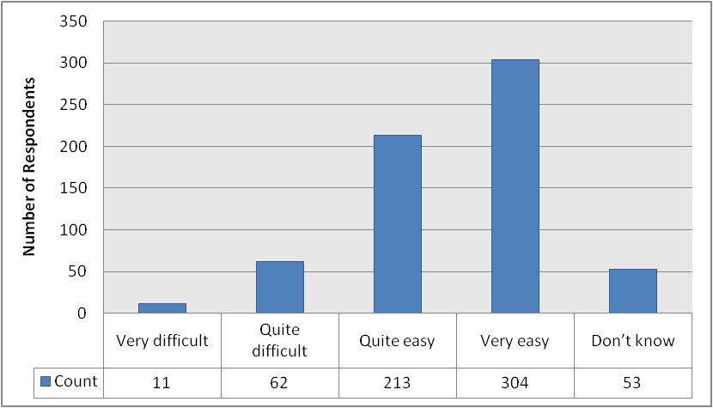
Base = 643 respondents

The next question was once again aimed at all panellists, who were asked which aspects of the pilot Transport to Healthcare Information Centre would be useful to them. Figure 19 (see page 58) shows that 356 respondents (53.1% of all panellists completing this edition of the City Voice) stated that “informing you about detailed travel options” would be useful to them, whilst 131 respondents (19.5%) said that “rearranging appointments on your behalf where appropriate, to link with available transport” would be useful to them.

There was virtually no difference between male and female panellists’ opinions on “informing you about their detailed travel options”, but a slightly larger proportion of females (21.6%) than males (17.6%) selected the “rearranging appointments on your behalf where appropriate” option.

There was some variation across neighbourhood areas for both options. The proportion who selected the “informing you about their detailed travel options” option was largest in North (58.1%), followed by South (48.5%) and Central (52.8%). The proportion who selected the “rearranging appointments on your behalf where appropriate” option was largest in Central (22.3%), followed by South (20.1%) and North (16.7%).

With regard to different age-groups, there appeared to be a correlation between age-group and responses to the “informing you about their detailed travel options” option: the proportion selecting this as useful was smallest among those aged 16-34 (41.2%), rising to 51.7% of those aged 35-54, 54.8% of those aged 55-64 and 59.1% of those aged 65+. There was no such correlation in relation to the “rearranging appointments on your behalf where appropriate” option (selected by 20.6% of those aged 16-34, 24.3% of those aged 35-54, 15.8% of those aged 55-64 and 15.6% of those aged 65+).

Figure 19: Thinking about the pilot Transport to Healthcare Information Centre, which of the following aspects of the service do you think would be useful to you?
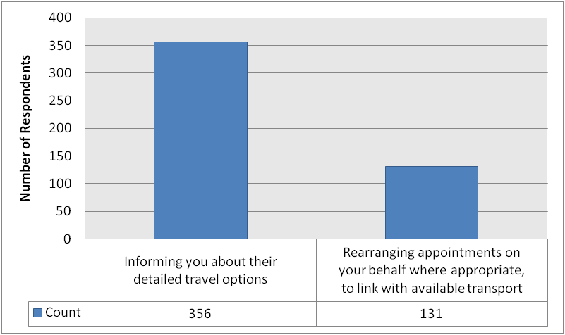
Base = 671 respondents

All panellists were then asked to select one of three options which best describes their attitude towards the pilot Transport to Healthcare Information Centre. The three options and the number of respondents selecting each one are laid out below in Figure 20 (see page 60). The results show that almost two thirds of respondents (410; 65.6%) stated that they think it will be a useful service but that they do not think it will be of benefit to them or a member of their household. 155 respondents (24.8%) stated that it will be a useful service and they think it will be of benefit to them or a member of their household. 60 respondents (9.6%) stated that they do not think the service is needed.

There were some differences between male and female panellists’ responses. The most popular response for both groups was “it will be a useful service but I don’t think it will be of benefit for me or a member of my household” (63.3% of males vs. 67.8% of females). A similar proportion of each group stated that “it will be a useful service and I think it will be of benefit to me or a member of my household” (23.9% of males vs. 25.4% of females) but the proportion of respondents stating that they don’t think the service is needed was almost twice as large among male respondents (12.8%) as among female respondents (6.8%).

The most popular response across each neighbourhood was also “it will be a useful service but I don’t think it will be of benefit for me or a member of my household” (60.2% in Central, 61.1% in North and 73.7% in South). There was only minor variation in relation to the “I don’t think this service is needed” option (8.5% in South, 9.3% in North and 11.5% in Central), but there was more of a difference in relation to the “it will be a useful service and I think it will be of benefit to me or a member of my household” option (29.5% of respondents in North and 28.3% in Central, but only 17.8% in South).

There was only minor variation across age-groups in relation to the “I don’t think this service is needed” option (6.3% of those aged 16-34, 11.4% of those aged 35-54, 9.0% of those aged 55-64 and 9.0% of those aged 65+), but each of the other options appeared to correlate with age. The proportion of respondents selecting the “it will be a useful service but I don’t think it will be of benefit for me or a member of my household” was largest among those aged 16-34 (84.4%), falling to 69.4% of those aged 35-54, 65.9% of those aged 55-64 and 49.3% of those aged 65+. Conversely, the proportion of respondents selecting the “it will be a useful service and I think it will be of benefit to me or a member of my household” option was largest among those aged 65+ (41.8%), dropping to 25.1% of those aged 55-64, 19.2% of those aged 35-54 and 9.4% of those aged 16-34.

Figure 20: Which of the following best describes your attitude to the pilot Transport to Healthcare Information Centre?
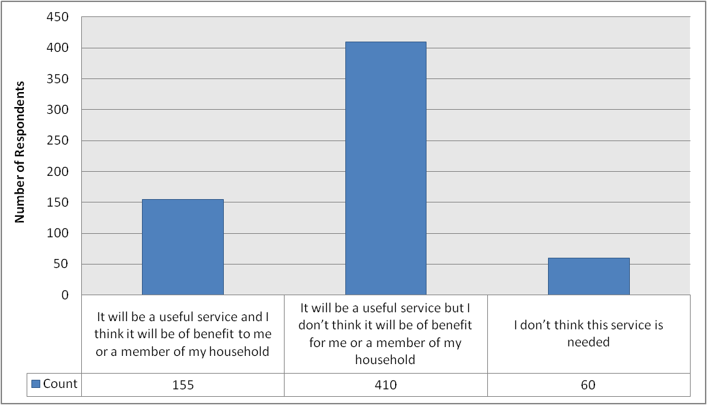
Base = 625 respondents

Panellists were then asked to identify what they thought would be the best methods / places to promote a service like the Transport to Healthcare Information Centre. Panellists were given a list of 5 possible options, but were also invited to provide their own ‘other’ suggestions. Table 14 (see page 61) firstly shows the number of responses to the predefined options. The most popular option was information issued with people’s appointment notices (518 respondents; 77.2%), followed by leaflets / posters in GP surgeries (492 respondents; 73.3%), information in local newspapers (362 respondents; 53.9%), leaflets / posters in hospitals (342 respondents; 51.0%) and information on the NHS website or other partners’ websites (222 respondents; 33.1%).

These results have also been broken down according to gender, neighbourhood area and age-group. The results of this can be seen in Tables 55-59 (see pages 117-118). The results are obviously somewhat detailed, but some top-level discussion of results will be provided here.

In terms of gender, a few notable differences emerged. The most noteworthy of these related to leaflets / posters in hospitals (selected by 45.0% of males vs. 55.7% of females), information in local newspapers (selected by 49.4% of males vs. 57.8% of females) and information issued with people’s appointment notices (selected by 71.7% of males vs. 82.2% of females). The most popular response for both genders was information issued with people’s appointment notices, although in the case of males, this was the joint most popular response alongside leaflets / posters in GP surgeries.

The most popular response in each neighbourhood area was also information issued with people’s appointment notices. There were only minor variations across different neighbourhoods. Of these, the most notable were that a slightly smaller proportion of respondents in Central (46.0%) selected the “information in local newspapers” option than in North (54.8%) and South (59.1%). A slightly smaller proportion of respondents in South (29.9%) selected the “information on NHS / other partners’ websites” option than in North (35.2%) and Central (34.7%), whilst the proportion selecting the “leaflets / posters in hospitals” option was larger in North (53.3%) than in Central (49.5%) and South (49.2%). Finally, the proportion of respondents selecting the “leaflets / posters in GP surgeries” option was marginally larger in South (75.2%) than in North (71.4%) and Central (72.3%).

The most popular response across all age-groups was “information issued with people’s appointment notices”. One apparent age correlation was found in relation to the “information in local newspapers” option: the proportion of respondents selecting this option was largest among those aged 65+ (59.7%), falling to 55.4% of those aged 55-64, 51.7% of those aged 35-54 and 44.1% of those aged 16-34. There was a noticeably wide spread of responses in relation to the “leaflets / posters in hospitals” option, which was selected by 58.8% of respondents aged 35-54 and 54.4% of those aged 16-34, but by only 48.0% of those aged 55-64 and 37.7% of those aged 65+. Similarly, the proportion of respondents who selected the “information on NHS / other partners’ websites” option was largest among those aged 35-54 (43.1%), falling to 33.8% of those aged 16-34 and 30.5% of those aged 55-64, before reaching a low of just 18.2% among those aged 65+. The only other notable response was that a lower proportion of respondents aged 65+ selected the “leaflets / posters in GP surgeries” option than was the case in other age-groups.

Table 14: Which of the following do you think would be the best method(s) / place(s) to promote a service such as this?
Response | Respondents
Response | Count | %
Information issued with people’s appointment notices | 518 | 77.2
Leaflets / posters in GP surgeries | 492 | 73.3
Information in local newspapers | 362 | 53.9
Leaflets / posters in hospitals | 342 | 51.0
Information on NHS / other partners’ websites | 222 | 33.1
Other | 39 | 5.8
Base = 671 respondents

39 panellists provided an “other” suggestion to the question above. These have been aggregated thematically and are laid out below in Table 15. This shows that the most popular “other” suggestions were in libraries (6 respondents; 0.9%), on public transport (e.g. on buses or at bus stops) (5 respondents; 0.7%), a general mailshot to residential addresses (4 respondents; 0.6%), in chemists / pharmacies (also 4 respondents; 0.6%), in shops (also 4 respondents; 0.6%) and in community centres (also 4 respondents; 0.6%). Each remaining suggestion was made by no more than 3 respondents. 10 respondents provided an answer which was not applicable to the question.

Table 15: Which of the following do you think would be the best method(s) / place(s) to promote a service such as this? (Other responses)
Response | Respondents
Response | Count | %
Libraries | 6 | 0.9
Public transport | 5 | 0.7
Mailshot | 4 | 0.6
Chemists / pharmacies | 4 | 0.6
Shops | 4 | 0.6
Community Centres | 4 | 0.6
Carers | 3 | 0.4
Radio | 3 | 0.4
Churches | 2 | 0.3
Internet | 2 | 0.3
Post Offices | 2 | 0.3
TV | 2 | 0.3
When told (e.g. by GP) that will be referred | 1 | 0.1
Day centres | 1 | 0.1
Council offices | 1 | 0.1
GPs | 1 | 0.1
Community Councils | 1 | 0.1
Local charities | 1 | 0.1
Public spaces | 1 | 0.1
Social media | 1 | 0.1
Mobile phone | 1 | 0.1
N/a | 10 | 1.5
Base = 671 respondents

The next question sought to establish how panellists would access this service if they were to use it. They were given three options to choose from: these are listed below in Figure 21 (see page 63), along with the number of respondents selecting each one. The chart shows that the most popular option was a dedicated telephone number (selected by 463 respondents; 69.0%), followed by a website (327 respondents; 48.7%) and a mobile phone app (91 respondents; 13.6%).

There were no major differences between male and female respondents’ answers to this question. However, there were some differences between neighbourhood areas. The “dedicated telephone number” option was slightly more popular in North (71.0%) than in Central (68.3%) and South (67.3%), whilst the opposite was true in relation to the website option (selected by 45.2% of respondents in North but by 51.0% in Central and 50.0% in South). Finally, the “mobile phone app” option was more popular in North (16.2%) and Central (15.3%) than in South (10.2%).

Each of the options available in this question seemed to correlate with age-group. The “dedicated telephone number” option was most popular among those aged 65+ (selected by 85.7% of respondents in this group), falling to 79.7% of those aged 55-64, 59.6% of those aged 35-54 and 38.2% of those aged 16-34. Conversely, the proportion of respondents selecting the website option was largest among those aged 16-34 (75.0%), falling to 61.8% of those aged 35-54, 46.9% of those aged 55-64 and 16.9% of those aged 65+. The same was true of the “mobile phone app” option (selected by 27.9% of those aged 16-34, 16.1% of those aged 35-54, 9.6% of those aged 55-64 and 7.8% of those aged 65+).

Figure 21: Were you to access a service such as this, which of the following do you think you would use?
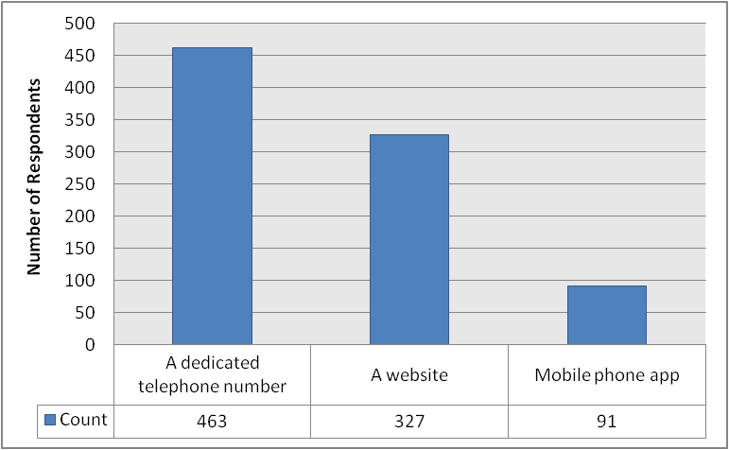
Base = 671 respondents

All panellists were then asked a range of questions which would allow the questioners to better interpret the results to the preceding questions. The first of these sought to establish whether or not panellists have a disability or another condition that limits their mobility. Figure 22 below shows that the vast majority of respondents (534; 83.7%) do not have a disability or other such condition. Conversely, 104 respondents (16.3%) state that they do have a disability or another condition of the nature described above.

The proportion of male respondents who stated that they do have a disability or other condition that affects their mobility (15.6%) was marginally smaller than the equivalent proportion of female respondents (16.9%). The proportion of respondents answering “yes” was larger in North (17.2%) and Central (18.4%) than in South (13.8%), and also correlated with age: the proportion answering “yes” was smallest among those aged 16-34 (4.5%), rising to 9.4% of those aged 35-54, 19.0% of those aged 55-64 and 31.0% of those aged 65+.

Figure 22: Do you have a disability or other condition that limits your mobility?
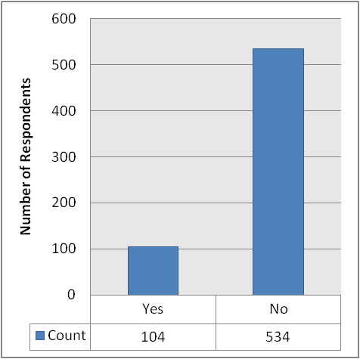
Base = 638 respondents

The next question aimed to find out whether or not panellists have access to a car or any other private vehicle (whether their own or someone else’s). The results are laid out below in Figure 23 (see page 65), which shows that a very clear majority of respondents (562; 87.0%) do have access to a car or another private motor vehicle. Conversely, only a small minority do not (13.0%).

The proportion of male respondents who stated that they do have access to a motor car or other private vehicle (88.3%) was marginally larger than the equivalent proportion of females (85.6%). The proportion of respondents answering “yes” was largest in South (93.5%), followed by North (88.0%) and Central (77.4%). Access to a motor car or other private vehicle also seemed to correlate with age: the proportion of respondents answering “yes” was largest among those aged 16-34 (91.0%), followed by those aged 35-54 (88.5%), those aged 55-64 (88.3%) and those aged 65+ (80.4%).
Figure 23: Do you have access to a motor car or other private vehicle (your own or someone else’s)?
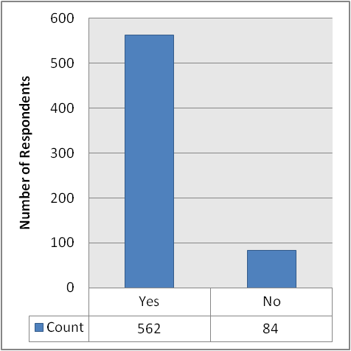
Base = 646 respondents

Panellists were then asked whether or not they have access to the internet. Their responses to this question are laid out below in Figure 24 (see page 66), which once again shows that a very clear majority of respondents (548; 85.9%) do have access to the internet, whilst only a small proportion of respondents (90; 14.1%) do not.

There was virtually no difference between male and female respondents’ answers, although a very slightly larger proportion of males (86.5%) than females (85.4%) stated that they do have access to the internet. There was also very little difference in terms of the proportion answering “yes” across different neighbourhood areas (86.3% of respondents in North, 85.6% of respondents in Central and 86.0% of respondents in South). There was also an age correlation in the responses to this question: the proportion of panellists stating that they do have access to the internet fell from a high of 100.0% of those aged 16-34 to 96.1% of those aged 53-54, 87.7% of those aged 55-64 and just 58.3% of those aged 65+.

Figure 24: Do you have access to the internet?
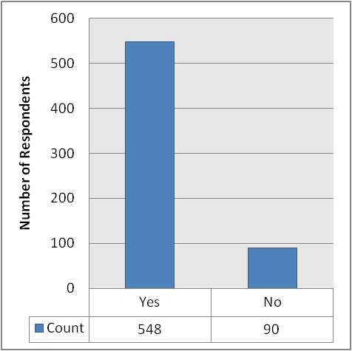
Base = 638 respondents

Finally in this section, panellists were asked if they are comfortable using the internet and transacting online. The responses received for this question are provided below in Figure 25 (see page 67), which shows that a majority of respondents (500; 79.9%) are happy to use the internet and conduct transactions online, whilst a minority (126 respondents; 20.1%) are not comfortable with this.

A very slightly larger proportion of males (82.2%) than females (77.8%) stated that they are comfortable using the internet and transacting online. There was also only very minor variation across neighbourhoods: the proportion answering “yes” was largest in South (81.4%), followed by North (79.1%) and Central (78.8%). Once again, an age correlation emerged in relation to the answers to this question. The proportion answering “yes” was again largest among those aged 16-34 (100.0%), falling to 91.4% of those aged 35-54, 78.2% of those aged 55-64 and just 48.4% of those aged 65+.

Figure 25: Are you comfortable using the internet / transacting online?
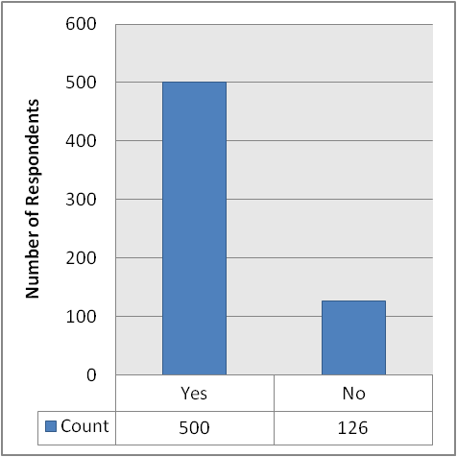
Base = 626 respondents

SERVICE RESPONSE

It is becoming increasingly important for organisations that have an interest in supporting the public’s travel needs to healthcare appointments, to gain an appreciation for how patients make their way to healthcare appointments. As a result of those relevant questions within the City Voice being responded to, Service Design and Operational managers, across a range of local organisations, will now have sample data on recent and probable ‘modes of transport’ usage. They will be able to use this information both to review existing plans and to devise new initiatives. It will also provide feedback that can be shared with other agencies, charities and volunteer groups and also provides a benchmark for similar future surveys and used as reference point in determining changes or picking up on ‘trends’.

It has also been extremely valuable to have received opinions on the value of progressing with a concept that is largely at the development stage. In this particular situation (Transport to Healthcare Information Centre – THInC) there has been an extremely positive response with regards the acknowledged value of such a proposed service. There were also many valuable suggestions for how to promote THInC received with, significantly, a number of ways noted that had previously not been considered.

There is a lot of detail in the feedback report which has not yet been fully analysed. Some of the things that will be explored will be to see if the reported variations between gender are actually significant and if differences across age groups or if geography has a fundamental bearing on outcomes / responses. If there are marked differences then this will enable Service Planners to consider different, targeted, approaches and not necessarily assume that one approach will be totally satisfactory for all.

Many thanks to all who took the time to complete the questionnaire.

John Gallagher
Planning Manager (NHS Grampian)
On behalf of the Health and Transport Action Plan Partners

CITY WARDENS

The City Warden Service has been operating in Aberdeen since January 2009. They undertake high visibility patrols throughout the city to help ensure safety, cleanliness and free flow of traffic. The City Warden Service has been recognised nationally, winning several awards including the British Parking Awards 2011 ‘Parking in the Community’ category and a Bronze Award from COSLA in the ‘One to Watch’ category.

Between April and December 2012, the City Wardens issued over 30,000 Penalty Charge Notice for illegal parking, uplifted 164 vehicles for non-payment of Penalty Charge Notices and issued over 620 Fixed Penalty Notices to people who litter or let their dog foul and fail to pick it up. They have also made 11,500 reports to partners in Grampian Police, Grampian Fire and Rescue as well as other partnership agencies, including Aberdeen City Council departments. These reports consist of Environmental, Anti-Social Behaviour and General fault reporting.

The new Community Safety Hub is now operational, with the first staff from the Council, Grampian Police and Grampian Fire and Rescue Service moving into the Hub in January 2013. The City Wardens are part of this Hub, being involved in daily briefings on how the Community Safety Partnership can best serve the city. The City Warden Service wants to measure the impact its service is having and to get panellists’ feedback so they can develop it to best meet the needs of the city.

The first question sought to establish whether panellists had seen City Wardens in their local area over the past 12 months. The responses, which are provided below in Figure 26 (see page 70), show that 343 respondents (53.0%) have seen City Wardens in their local area over the last 12 months. 286 respondents (44.2%) have not, whilst 18 respondents (2.8%) stated that they didn’t know.

There was virtually no difference whatsoever between male and female panellists’ responses to this question. However, the proportion of respondents who have seen City Wardens in their local area was much larger in Central (67.9%) than in North (45.1%) and South (47.3%). Conversely, the proportion stating that they have not seen City Wardens in their local area was much larger in North (52.5%) and South (49.8%) than in Central (29.1%).

In terms of age-group analysis, the proportion of respondents answering “no” appeared to correlate with age. Thus, the proportion giving this answer rose from a low of 39.4% of those aged 16-34 to 40.1% of those aged 35-54, 44.5% of those aged 55-64 and 54.2% of those aged 65+. The proportion of respondents who answered “yes” was reasonably consistent among the three youngest age-groups (56.1% of those aged 16-34, 56.9% of those aged 35-54 and 53.8% of those aged 55-64), but was noticeably lower among those aged 65+ (43.0%).

Figure 26: Over the last 12 months, have you seen City Wardens in your local area?
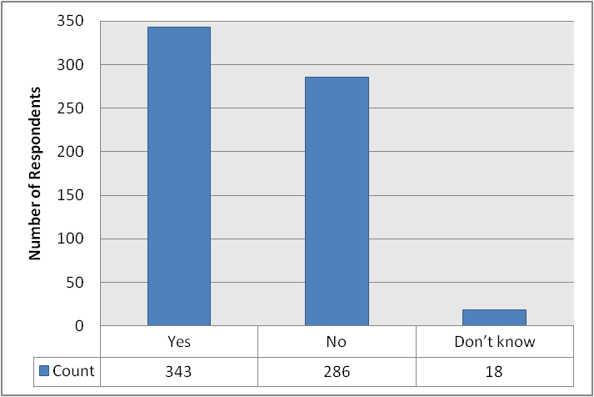
Base = 647 respondents

All panellists were subsequently asked whether they had seen City Wardens anywhere else in the city (i.e. not in their local area) over the last 12 months. Their responses are provided below in Figure 27 (see page 71), which shows that 562 respondents (56.9%) have seen City Wardens elsewhere in the city. 63 respondents (9.7%) have not, whilst 22 respondents (3.4%) said that they didn’t know.

A slightly larger proportion of males (89.3%) than females (84.7%) stated that they have seen City Wardens elsewhere in the city, whilst the opposite was true for those stating that they had not (7.8% of males vs. 11.4% of females). The proportion stating that they have seen City Wardens elsewhere was largest in Central (89.8%) and South (87.7%), and slightly lower in North (83.3%). The proportion stating that they had not seen City Wardens elsewhere was highest in North (12.3%), followed by South (10.7%) and Central (5.6%).

There was some variation between age-groups, although there were no clear correlations. The proportion of respondents stating that they have seen City Wardens elsewhere in the city was largest among those aged 35-54 (89.4%), followed by those aged 55-64 (88.4%), those aged 65+ (83.6%) and those aged 16-34 (80.6%). Conversely, the proportion of respondents who have not seen City Wardens elsewhere was largest among those aged 65+ (12.1%), followed by those aged 16-34 (11.9%), those aged 55-64 (10.4%) and those aged 35-54 (7.2%).

Figure 27: Over the last 12 months, have you seen City Wardens anywhere else in the city?
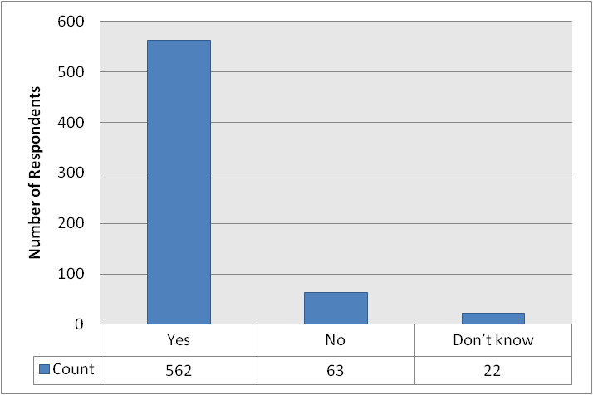
Base = 647 respondents

Panellists were then asked whether they had sought assistance from City Wardens over the last 12 months. As shown in Figure 28 (see page 72), the vast majority of respondents (597; 92.0%) have not sought assistance, whilst a small minority (52 respondents; 8.0%) have.

A very slightly larger proportion of female respondents (8.9%) than male respondents (7.1%) stated that they have sought assistance from City Wardens over the last 12 months. A noticeably larger proportion of respondents in Central (12.6%) have sought assistance, compared to North (6.9%) and South (5.3%). The proportion of respondents who have sought assistance was largest among those aged 55-64 (9.8%), followed by those aged 35-54 (8.4%), those aged 65+ (7.0%) and those aged 16-34 (4.5%).

Figure 28: Over the last 12 months, have you sought assistance from City Wardens?
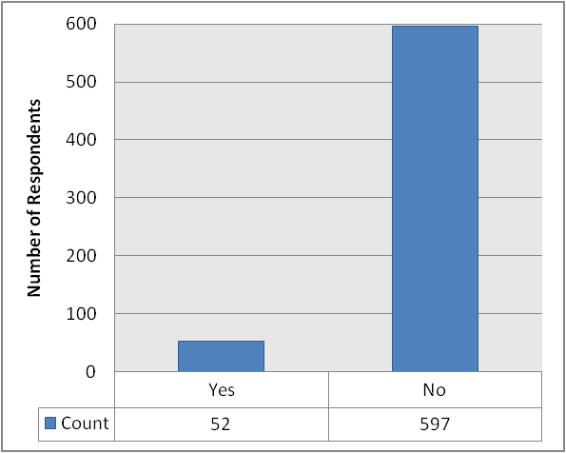
Base = 649 respondents

The 52 panellists who had stated in the previous question that they have sought assistance from City Wardens over the last 12 months were then asked to rate how helpful they found the City Wardens. Their responses are provided below in Figure 29 (see page 73), which shows that the greatest share of respondents rated the City Wardens either very helpful (34.6%) or helpful (30.8%). Conversely, 11 respondents (21.2%) rated them as very unhelpful and 7 (13.5%) rated them unhelpful.

These results have also been broken down according to gender, neighbourhood area and age-group. The results of this can be seen in full in Tables 58-60 (see page 118). For the analysis here, we focus on the most popular responses, as well as discussing compounded “helpful” (i.e. combining the totals for “helpful” and “very helpful”) and “unhelpful” (i.e. combining the totals for “unhelpful” and “very unhelpful”) results. Compounding the figures in this way helps to offset some of the potential for distortion associated with such small numbers of respondents. However, the number of respondents in each response category remains small and, as such, we would strongly caution against using these disaggregated figures as a basis for policy decisions.

The most popular response for both males and females was “very helpful”, although in the case of females this was joint most popular response along with “helpful”. The proportion of male respondents who gave some form of “unhelpful” response (i.e. either “unhelpful” or “very unhelpful”) was slightly larger (36.4%) than the equivalent proportion among female respondents (33.3%). Conversely, the proportion of female respondents giving some form of “helpful” response (i.e. either “helpful” or “very helpful”) was slightly larger (66.7%) than the equivalent proportion among male respondents (63.6%). The most popular response in each neighbourhood area was “very helpful”, although this was the joint most popular answer in Central (alongside “helpful”). The proportion of respondents who believed that City Wardens were either “very unhelpful” or “unhelpful” was largest in Central (36.0%), followed by North (35.7%) and South (30.8%). Conversely, the proportion of respondents providing some form of “helpful” response was largest in South (69.2%), followed by North (64.3%) and Central (64.0%).

The most popular response varied across age-groups. For those aged 16-34 and 35-54, the most popular response was “helpful”. For those aged 55-64 and 65+, it was “very helpful”. Overall “helpful” and “unhelpful” responses also varied: the proportion of respondents providing either an “unhelpful” or “very unhelpful” response was largest among those aged 35-54 (45.5%), followed by those aged 55-64 (29.4%), those aged 65+ (30.0%) and those aged 16-34 (0.0%). Conversely, the proportion providing either a “helpful” or “very helpful” response was largest among those aged 16-34 (100.0%), followed by those aged 55-64 (70.6%), those aged 65+ (70.0%) and those aged 35-54 (54.5%).

Figure 29: If yes, how helpful did you find City Wardens?
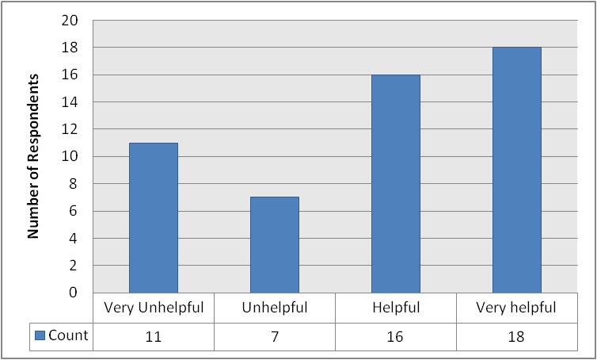
Base = 52 respondents

All panellists were then asked to say how strongly they agreed or disagreed that City Wardens have been effective in making Aberdeen a safer place. Their responses are laid out below in Figure 30 (see page 74), which shows that the most popular response was “don’t know” (269 respondents; 41.8%). 224 respondents (34.8%) agreed with the proposition, 72 (11.2%) disagreed, 45 (7.0%) strongly agreed and 34 (5.3%) strongly disagreed.

These results have also been broken down according to gender, neighbourhood area and age-group. The results of this can be seen in full in Tables 61-63 (see page 119). For the analysis here, we focus on the most popular responses, as well as discussing compounded “agree” (i.e. combining the totals for “agree” and “strongly agree”) and “disagree” (i.e. combining the totals for “disagree” and “strongly disagree”) results.

For both males and females, the most popular response was “don’t know” (39.3% and 44.2%, respectively). In terms of overall levels of disagreement, 20.0% of male respondents provided either a “disagree” or “strongly disagree” response, whilst the equivalent proportion among females was just 12.8%. The proportion of females providing a response indicating some level of agreement (i.e. either “agree” or “strongly agree”) was 43.0%, compared to 40.7% of male respondents.

The most popular response in each neighbourhood area was “don’t know”. Overall levels of agreement were highest in Central (44.9%), followed by South (42.0%) and North (38.8%). Overall levels of disagreement were highest in North (18.9%), followed by Central (17.9%) and South (12.8%).

Turning to consider different age-groups, the results show that the most popular response for panellists aged 16-34, 35-54 and 65+ was “don’t know”, whilst for panellists aged 55-64, it was “agree”. Overall levels of agreement were highest among those aged 55-64 (49.1%), followed by those aged 16-34 (40.3%), those aged 35-54 (39.1%) and those aged 65+ (39.0%). Overall levels of disagreement were highest among those aged 16-34 (17.9%), followed by those aged 55-64 (16.4%), those aged 65+ (16.3%) and those aged 35-54 (15.7%).

Figure 30: "How strongly do you agree or disagree with the following statement: “The City Wardens have been effective in making Aberdeen City a safer place”.
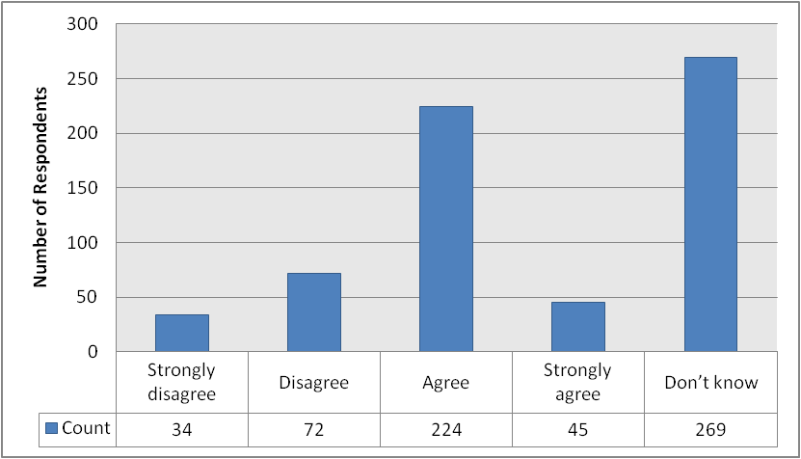
Base = 644 respondents

The following questions then sought to establish how well panellists feel that City Wardens have dealt with a range of different problems in their local area. The problems in question were antisocial behaviour and crime, illegal parking, dog fouling and littering. Dealing firstly with antisocial behaviour and crime, Figure 31 (see page 76) shows that the most popular response by far was “don’t know” (289 respondents; 46.4%). 152 respondents (24.4%) were not aware of a problem with antisocial behaviour and crime in their area. 80 respondents (12.8%) said that City Wardens had dealt with this issue quite well, 61 (9.8%) said they had done so poorly, 31 (5.0%) said that they had done so very poorly, and only 10 (1.6%) said that they had dealt with it very well.

These results have also been broken down according to gender, neighbourhood area and age-group. The results of this can be seen in full in Tables 64-66 (see page 120). For the analysis here, we focus on the most popular responses, as well as discussing compounded “well” (i.e. combining the totals for “quite well” and “very well”) and “poorly” (i.e. combining the totals for “poorly” and “very poorly”) results.

The most popular response for both males and females was “don’t know”. However, there were differences between the aggregated results for satisfaction with the performance of City Wardens in this respect. Whilst 18.9% of male respondents said that the City Wardens had done poorly or very poorly, the equivalent proportion among females was only 10.7%. However, the proportion of respondents who stated that they had done quite well or very well was virtually identical (14.3% of males vs. 14.2% of females). There was also some variation in the proportions selecting the “not aware this is a problem in my area” option (21.9% of males vs. 26.7% of females).

The most popular response in each neighbourhood was “don’t know”. There was, however, a degree of difference between aggregated levels of satisfaction and dissatisfaction. The proportion of respondents who stated that the City Wardens had either done poorly or very poorly was largest in North (19.4%), followed by Central (15.7%) and South (10.1%). The proportion of respondents who stated that the City Wardens had done either quite well of very well in respect of antisocial behaviour and crime was largest in Central (17.3%), followed by North (14.7%) and South (11.4%). The proportion of respondents who were not aware of a problem in their area was largest in South (32.9%), followed by Central (19.4%) and North (18.8%).

There were no clear age-related patterns in the responses to this question. The most popular response in each age-group was “don’t know”. Overall levels of satisfaction were highest in the 55-64 age-group, in which 18.1% of respondents selected either the “quite well” or “very well” option. This compared to 16.3% of those aged 35-54, 11.9% of those aged 16-34 and 6.3% of those aged 65+. The proportion of respondents selecting either the “poorly” or “very poorly” option was largest among those aged 65+ (16.4%), followed by those aged 16-34 (14.9%), those aged 35-54 (14.3%) and those aged 55-64 (13.9%). The proportion of respondents stating that they were not aware of a problem in their area was largest among those aged 16-34 and those aged 65+ (both 31.3%), followed by those aged 55-64 (22.9%) and those aged 35-54 (20.2%).

Figure 31: How well do you think City Wardens deal with antisocial behaviour and crime in your area?
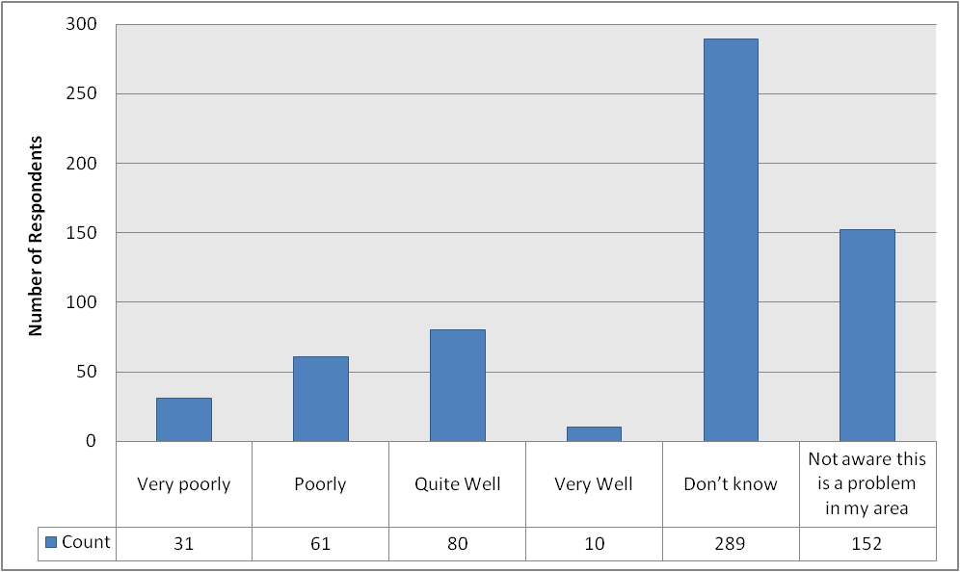
Base = 623 respondents

Turning to consider the way in which City Wardens have dealt with illegal parking in panellists’ local areas, Figure 32 (see page 78) shows that once again, the most popular response received was “don’t know” (189 respondents; 30.3%). 120 respondents (19.2%) said that they were not aware of a problem with illegal parking in their area. 106 respondents (17.0%) said that City Wardens had dealt with the problem quite well, 78 (12.5%) said they had dealt with it poorly, 73 (11.7%) said they had dealt with it very well and 58 (9.3%) said that they had dealt with it very poorly.

These results have also been broken down according to gender, neighbourhood area and age-group. The results of this can be seen in full in Tables 67-69 (see page 121). For the analysis here, we focus on the most popular responses, as well as discussing compounded “well” (i.e. combining the totals for “quite well” and “very well”) and “poorly” (i.e. combining the totals for “poorly” and “very poorly”) results.

The most popular response for both male and female respondents was “don’t know”. The proportion of respondents who were not aware that illegal parking was a problem in their area was only very slightly larger among males (19.7%) than females (18.7%). In terms of overall appraisal of the City Wardens’ performance, the proportion of respondents offering an overall “poor” rating (i.e. either a “poorly” or “very poorly” response) was larger among males (25.4%) than females (18.1%). Conversely, the proportion of respondents offering an overall positive view (i.e. selecting either a “quite well” or “very well” response) was slightly larger among females (29.6%) than males (27.8%).

The most popular response in North and South was “don’t know”. However, the most popular response in Central was “quite well”. The proportion of respondents who were not aware of a problem with illegal parking in their area was noticeably smaller in Central (11.1%) than in North (22.9%) and South (22.7%). In terms of an overall assessment of the City Wardens’ performance with regard to illegal parking, there were again clear differences between North and South on the one hand, and Central on the other. Whilst the proportion of respondents offering a positive (i.e. “quite well” or “very well”) response was 41.1% in Central, this dropped to 21.4% in North and 24.8% in South. However, the proportion offering an overall negative assessment (i.e. a “poorly” or “very poorly” response) was also largest in Central (24.7%), followed by South (22.3%) and North (17.7%).

The most popular response in each age-group was “don’t know”. The proportion of respondents who were not aware of illegal parking being a problem in their area was largest among those aged 16-34 (25.4%), followed by those aged 35-54 (20.9%), those aged 65+ (18.0%) and those aged 55-64 (15.0%). The age-group which contained the largest proportion of respondents offering a positive assessment (i.e. a “quite well” or “very well” response) of the work of City Wardens in relation to this problem was the 55-64 age-group (34.7%), followed by those aged 16-34 (32.8%), those aged 35-54 (27.5%) and those aged 65+ (21.1%). The proportion of respondents offering an overall negative assessment (i.e. a “poorly” or “very poorly” response) correlated with age-group, dropping from a high of 28.1% of those aged 65+ to 24.6% of those aged 55-64, 18.6% of those aged 35-54 and just 13.4% of those aged 16-34.

Figure 32: How well do you think City Wardens deal with illegal parking in your area?
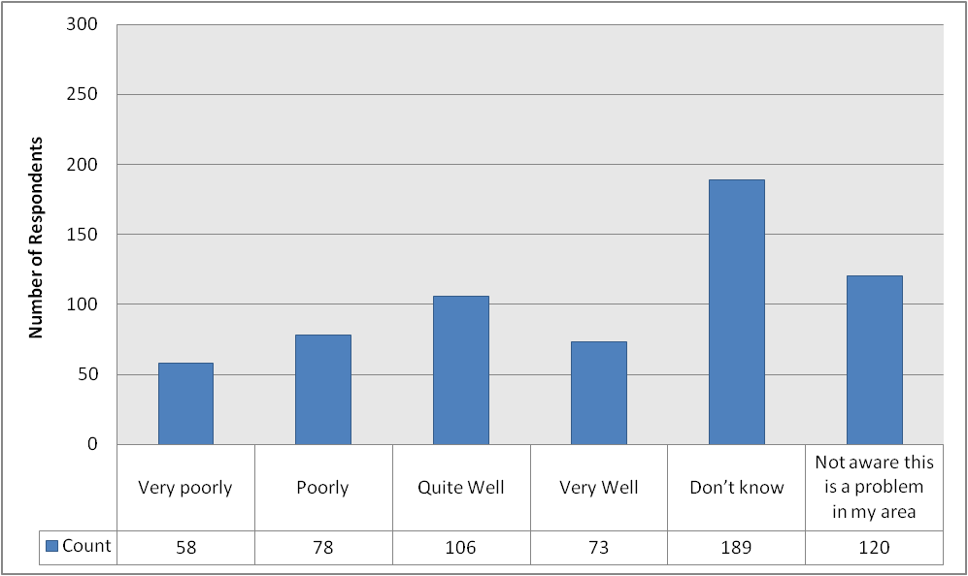
Base = 624 respondents

The next issue considered was dog fouling. Figure 33 (see page 80) shows that once again, the greatest share of respondents (259; 41.2%) provided a “don’t know” answer. 72 (11.4%) stated that they were not aware of dog fouling being a problem in their local area. 132 respondents (21.0%) believe that City Wardens have dealt poorly with the issue of dog fouling in their local area, whilst 103 (16.4%) believe that they have done so very poorly. 54 respondents (8.6%) believe that City Wardens have dealt with this issue quite well, whilst only 9 (1.4%) believe that they have done so very well.

These results have also been broken down according to gender, neighbourhood area and age-group. The results of this can be seen in full in Tables 70-72 (see page 122). For the analysis here, we focus on the most popular responses, as well as discussing compounded “well” (i.e. combining the totals for “quite well” and “very well”) and “poorly” (i.e. combining the totals for “poorly” and “very poorly”) results.

The most popular answer among both males and females was “don’t know”. The proportion of respondents who were unaware of dog fouling being a problem in their area was slightly larger among females (12.6%) than males (10.3%). There was no large difference between the proportion of males (10.3%) and females (9.8%) who offered an overall positive assessment of the City Wardens’ performance in dealing with dog fouling, but there was a more pronounced gap between the proportions offering an overall negative assessment (41.0% of males vs. 33.8% of females).

The most popular response in each neighbourhood area was “don’t know”. The proportion of respondents in North and Central who stated that they were unaware of a dog fouling problem in their area (9.9% and 9.3%, respectively) was smaller than the proportion in South (14.6%) who did likewise. The proportion of respondents who provided an overall negative assessment (i.e. providing either a “poorly” or “very poorly” response) of City Wardens’ performance in dealing with dog fouling was larger in Central (45.6%) than in North (34.9%) and South (32.5%). However, the proportion providing a positive overall assessment was larger in Central (14.0%) than in North (7.8%) and South (8.8%).

As with neighbourhood area and gender, the most popular response in each age-group was “don’t know”. The proportion of respondents who were unaware of a problem in their area was largest in the 16-34 age-group (18.2%) followed by those aged 35-54 (12.5%), those aged 65+ (9.8%) and those aged 55-64 (8.8%). The age-group containing the largest proportion of respondents offering an overall positive assessment (i.e. a “quite well” or “very well” response) of City Wardens’ performance was the 16-34 group (15.2%), followed by those aged 55-64 (11.8%), those aged 35-54 (10.5%) and those aged 65+ (4.5%). The proportion of respondents who gave an overall negative assessment (i.e. a “poorly” or “very poorly” response) once again appeared to correlate with age, with the smallest proportion found among those aged 16-34 (25.8%), followed by 33.5% of those aged 35-54, 39.4% of those aged 55-64 and 47.7% of those aged 65+.

Figure 33: How well do you think City Wardens deal with dog fouling in your area?
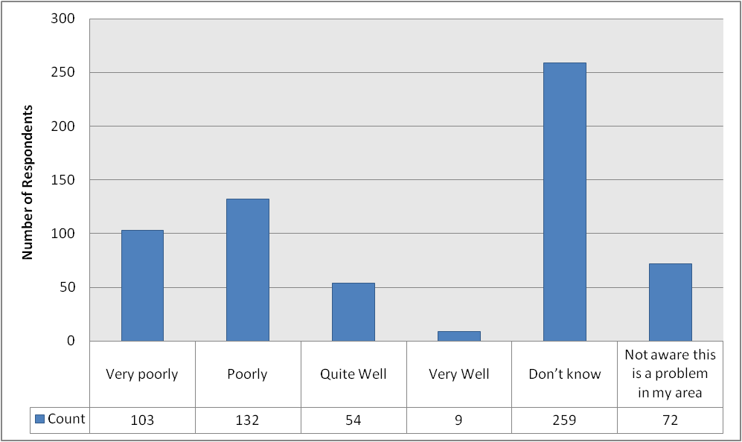
Base = 629 respondents

The final of these four issues to be considered related to littering. Figure 34 (see page 81) shows that as with the three other issues, the greatest share of respondents (242; 38.5%) provided a “don’t know” response. 77 respondents (12.3%) said that they were not aware of a problem with littering in their area. 136 respondents (21.7%) stated that City Wardens had dealt poorly with littering in their local area, 99 (15.8%) said they had done so very poorly, 60 (9.6%) stated that they had dealt with it quite well, and 14 (2.2%) said that City Wardens had dealt with littering very well in their local area.

These results have also been broken down according to gender, neighbourhood area and age-group. The results of this can be seen in full in Tables 73-75 (see page 123). For the analysis here, we focus on the most popular responses, as well as discussing compounded “well” (i.e. combining the totals for “quite well” and “very well”) and “poorly” (i.e. combining the totals for “poorly” and “very poorly”) results.

The most popular response for both male and female respondents was “don’t know”. The proportion of respondents who were unaware of a littering problem in their area was slightly larger among females (13.9%) than males (10.6%). The proportion of respondents offering an overall negative response (i.e. a “poorly” or “very poorly” response) was noticeably larger among males (43.9%) than females (31.3%). The proportion offering an overall positive response (i.e. a “quite well” or “very well” response) was slightly larger among females (12.7%) than males (11.0%).

The most popular response across each neighbourhood area was once again “don’t know”. The proportion of respondents who stated that they were unaware of a littering problem in their area was largest in South (16.0%), followed by North (10.3%) and Central (9.9%). The proportion of respondents offering an overall positive assessment (i.e. a “quite well” or “very well” response) of City Wardens’ performance in dealing with littering was largest in Central (14.1%) followed by South (11.3%) and North (10.3%). The proportion offering the largest overall negative assessment (i.e. a “poorly” or “very poorly” response) of their performance was found in Central (45.8%), followed by North (36.6%) and South (31.1%).

The most popular response in each age-group was “don’t know”. The proportion of respondents stating that they were unaware of a littering problem in their area was largest among those aged 16-34 (16.4%), followed by those aged 35-54 (14.1%), those aged 65+ (10.7%) and those aged 55-64 (9.4%). The proportion of respondents providing an overall negative (i.e. a “poorly” or “very poorly” response) assessment of the performance of City Wardens was largest in the 65+ age-group (47.3%), followed by those aged 55-64 (43.3%), those aged 16-34 (31.3%) and those aged 35-54 (29.8%). The proportion offering an overall positive (i.e. a “quite well” or “very well” response) assessment was largest among those aged 16-34 (13.4%), followed by those aged 35-54 and 55-64 (both 12.9%) and those aged 65+ (7.6%).

Figure 34: How well do you think City Wardens deal with littering in your area?
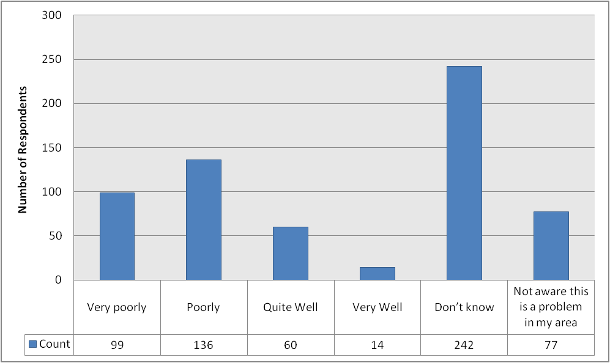
Base = 628 respondents

Given the fact that “don’t know” answers dominate the responses to the preceding four issues, we have decided to strip these out in order to perform a piece of additional analysis which only contains the informed opinions on these issues (i.e. only considering “very poorly”, “poorly”, “quite well” and “very well” responses). We hope that this provides more of a meaningful proportionate breakdown of opinions on the performance of City Wardens.

This analysis can be seen below in Figure 35, which shows the proportion of respondents selecting each option for the four issues of antisocial behaviour and crime, illegal parking, dog fouling and littering. Please note that these are adjusted figures and should not be cited in this form (as the percentage figures provided in Figure 35 refer to a subset of respondents and not the entire dataset). Please refer to the percentage figures provided in the explanatory text for Figures 31-34 (above) if percentage figures are required for reporting / modelling etc.

We also provide a breakdown of these results by gender, neighbourhood area and age-group in Tables 94-105 (see pages 131-134) but do not discuss the findings here due to limitations of space.

Figure 35: How well do you think City Wardens deal with the following problems in your area? (ADJUSTED FIGURES – DO NOT CITE)
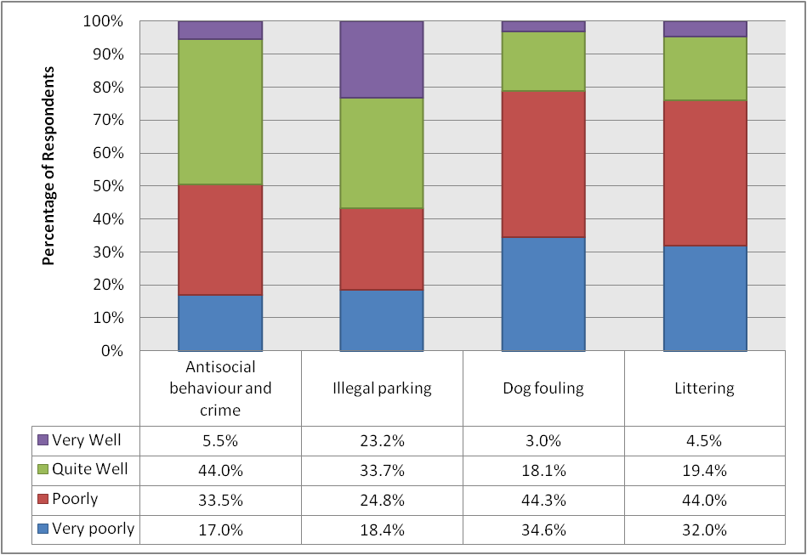
Base = multiple

All panellists were then asked to identify the extent to which they agree that their local area benefits from having City Wardens. Figure 36 (see page 84) shows that the greatest share of respondents (226; 35.6%) selected the “don’t know” option. 143 respondents (22.5%) stated that they agree, whilst 20 (3.1%) stated that they strongly agree. 70 respondents (11.0%) disagreed that their area benefits from having City Wardens, and 33 respondents (5.2%) strongly disagreed. 143 panellists (22.5%) neither agreed nor disagreed.

These results have also been broken down according to gender, neighbourhood area and age-group. The results of this can be seen in full in Tables 76-78 (see page 124). For the analysis here, we focus on the most popular responses, as well as discussing compounded “disagreement” (i.e. combining the totals for “strongly disagree” and “disagree”) and “agreement” (i.e. combining the totals for “agree” and “strongly agree”) results.

The most popular response for both males and females was “don’t know”. In terms of overall levels of agreement, the proportion of respondents selecting either the “agree” or “strongly agree” response was slightly larger among females (26.6%) than males (24.7%). Conversely, the proportion of respondents who disagreed with the proposition to some extent was larger among males (17.4%) than females (14.7%).

The most popular response in North and South was “don’t know”, but in Central was “agree”. The proportion of respondents who expressed some level of agreement with the idea that their local area benefits from having City Wardens was largest in Central (35.4%), followed by North (22.2%) and South (20.6%). The proportion who disagreed to any extent was largest in North (19.2%), followed by Central (15.9%) and South (13.4%).

The most popular response in each age-group was “don’t know”. The age-group containing the largest proportion who agreed with the statement was the 35-54 age-group (28.0%), followed by those aged 55-64 (27.8%), those aged 16-34 (27.3%) and those aged 65+ (17.8%). The proportion of respondents who disagreed with the statement was largest among those aged 16-34 (19.7%), followed by those aged 65+ (18.5%), those aged 55-64 (17.8%) and those aged 35-54 (12.6%).

Figure 36: To what extent do you agree or disagree that your local area benefits from having City Wardens?
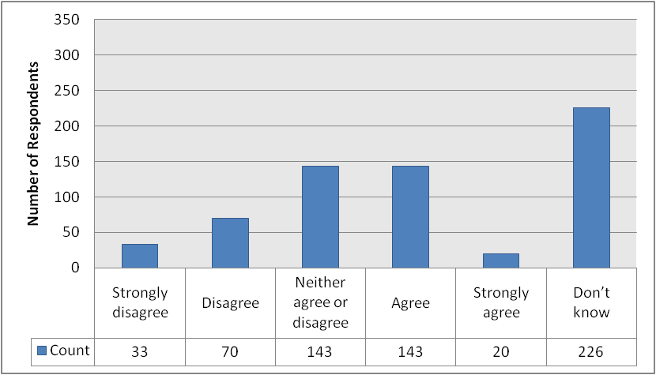
Base = 635 respondents

The next question aimed to find out whether panellists believe that City Wardens are well trained and know what they are doing. Figure 37 below (see page 85) shows that just under half of respondents (301; 47.3%) selected the “don’t know” option. 145 respondents (22.8%) agreed that Wardens are well trained and know what they are doing, whilst 23 (3.6%) strongly agreed. 24 respondents (3.8%) disagreed and 10 (1.6%) strongly disagreed. 133 respondents (20.9%) neither agreed nor disagreed.

These results have also been broken down according to gender, neighbourhood area and age-group. The results of this can be seen in full in Tables 79-81 (see page 125). For the analysis here, we focus on the most popular responses, as well as discussing compounded “disagreement” (i.e. combining the totals for “strongly disagree” and “disagree”) and “agreement” (i.e. combining the totals for “agree” and “strongly agree”) results.

The most popular response for both males and females was “don’t know”. In terms of overall levels of agreement, the proportion was slightly larger among males (26.9%) than females (23.8%). Conversely, the proportion of respondents who disagreed with the statement to at least some extent was marginally higher among females (5.0%) than males (4.5%).

“Don’t know” was also the most popular response in each neighbourhood area. Overall levels of agreement with the statement that wardens are well-trained and know what they are doing was largest in Central (30.8%), followed by North (26.1%) and South (23.1%). Overall levels of disagreement were highest in Central (6.2%), followed by North (5.0%) and South (4.2%).

The most popular response in each age-group was “don’t know”. The proportion of respondents who agreed that City Wardens are well-trained and know what they are doing was largest among those aged 55-64 (29.1%), followed by those aged 65+ (28.0%), those aged 16-34 (26.9%) and those aged 35-54 (23.8%). Overall levels of disagreement were highest among those aged 65+ (6.1%), those aged 35-54 (5.0%) and those aged 55-64 (4.7%), and were lowest among those aged 16-34 (4.5%).

Figure 37: To what extent do you agree or disagree that City Wardens are well trained and know what they are doing?
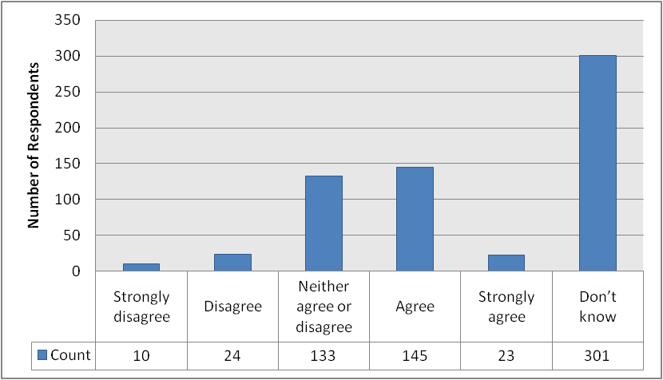
Base = 636 respondents

All panellists were then asked to identify the extent to which they believe that City Wardens engage well with people in their local area. Their responses are provided below in Figure 38 (see page 86), which shows that once again, just under half of all responses (312; 49.3%) were “don’t know”. 116 respondents (18.3%) agreed that City Wardens engage well with people in the local area, and 25 (3.9%) strongly agreed. 47 respondents (7.4%) disagreed, and 26 (4.1%) strongly disagreed. 107 respondents (16.9%) neither agreed nor disagreed.

These results have also been broken down according to gender, neighbourhood area and age-group. The results of this can be seen in full in Tables 82-84 (see page 126). For the analysis here, we focus on the most popular responses, as well as discussing compounded “disagreement” (i.e. combining the totals for “strongly disagree” and “disagree”) and “agreement” (i.e. combining the totals for “agree” and “strongly agree”) results.

“Don’t know” was the most popular response for both males and females. Overall levels of agreement with the statement that City Wardens engage well with people in the local area were higher among female respondents (24.8%) than males (19.5%), whilst overall levels of disagreement were slightly higher among males (12.5%) than females (10.1%). “Don’t know” also proved to be the most popular response in each neighbourhood area of the city. The proportion of respondents who agreed that City Wardens engage well with people in the local area was markedly larger in Central (34.4%) than in North (18.2%) and South (15.7%). There was much less variation between the overall levels of disagreement between the areas (9.3% in South, 11.3% in Central and 13.6% in North).

The most popular response in each age-group was “don’t know”. Overall levels of agreement that City Wardens engage well with people in the local area were highest among those aged 55-64 (27.3%), followed by those aged 35-54 (23.1%), those aged 65+ (18.3%) and those aged 16-34 (13.6%). Overall levels of disagreement peaked at 18.2% among those aged 16-34, falling to 13.0% of those aged 65+, 10.0% of those aged 35-54 and 9.3% of those aged 55-64.

Figure 38: To what extent do you agree or disagree that City Wardens engage well with people in your local area?
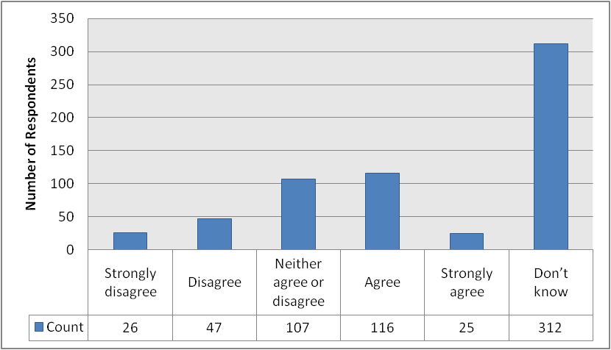
Base = 633 respondents

The next question was also aimed at all panellists, and asked them to rate the extent to which they agreed that City Wardens are visible on the streets. The responses received are provided below in Figure 39 (see page 88), which shows that just under half of respondents (293; 45.9%) agree with the statement. 60 respondents (20.5%) strongly agreed, whilst 69 respondents (10.0%) provided a “don’t know” response. 87 respondents (12.6%) disagreed and 45 (6.5%) strongly disagreed. 85 respondents (12.3%) neither agreed nor disagreed.

These results have also been broken down according to gender, neighbourhood area and age-group. The results of this can be seen in full in Tables 85-87 (see page 127). For the analysis here, we focus on the most popular responses, as well as discussing compounded “disagreement” (i.e. combining the totals for “strongly disagree” and “disagree”) and “agreement” (i.e. combining the totals for “agree” and “strongly agree”) results.

The most popular response among both males and females was “agree”. Overall levels of agreement with the statement that City Wardens are visible on the streets was slightly higher among males (57.4%) than females (53.3%), whilst the opposite was true in relation to overall levels of disagreement with the proposition (22.1% of females vs. 19.0% of males).

“Agree” also emerged as the most popular response in each neighbourhood area. Overall levels of agreement that City Wardens were visible on the streets were noticeably higher in Central (65.1%) than in North (49.7%) and South (51.9%). Conversely, overall levels of disagreement were lower in Central (14.9%) than in North (25.6%) and South (21.2%).

Similar to the findings for gender and neighbourhood area, the most popular response in each age-group was “agree”. Overall levels of agreement with the statement that City Wardens are visible on the streets appeared to correlate with age. The largest proportion of respondents agreeing with the statement was found among those aged 16-34 (65.7%), falling to 55.4% of those aged 35-54, 54.3% of those aged 55-64 and 51.1% of those aged 65+. Overall levels of disagreement did not correlate. The 65+ age-group contained the largest proportion of respondents who either disagreed or strongly disagreed (28.1%), followed by those aged 16-34 (20.9%), those aged 55-64 (19.7%) and those aged 35-54 (17.3%).

Figure 39: To what extent do you agree or disagree that City Wardens are visible on the streets?
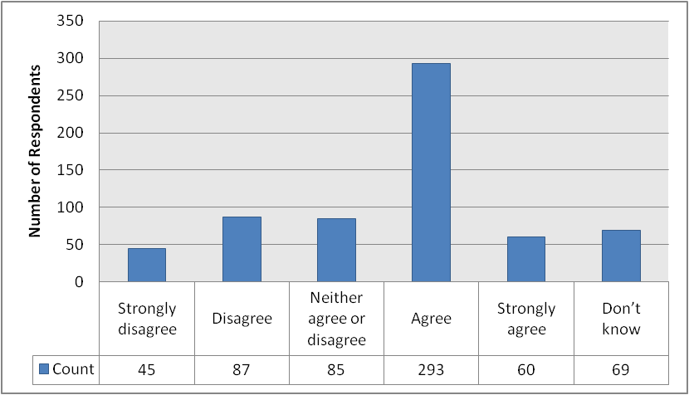
Base = 639 respondents

The penultimate question in this edition of the City Voice asked all panellists to rate the extent to which they agree that City Wardens deal with problems effectively. Their responses are provided below in Figure 40 (see page 89), which shows that just over half of respondents (331; 52.0%) selected the “don’t know” response (presumably reflecting the fact that only 8.0% of respondents have actually sought assistance from City Wardens over the past two years – see Figure 28, page 72). 140 respondents (22.0%) neither agreed nor disagreed with the statement. 89 respondents (14.0%) agreed, and 17 (2.7%) strongly agreed. 41 respondents (6.4%) disagreed and 18 (2.8%) strongly disagreed that City Wardens deal with problems effectively.

These results have also been broken down according to gender, neighbourhood area and age-group. The results of this can be seen in full in Tables 88-90 (see page 128). For the analysis here, we focus on the most popular responses, as well as discussing compounded “disagreement” (i.e. combining the totals for “strongly disagree” and “disagree”) and “agreement” (i.e. combining the totals for “agree” and “strongly agree”) results.

The most popular response for both males and females was “don’t know”. Overall levels of agreement with the statement that City Wardens deal with problems effectively were virtually identical (16.6% of males vs. 16.7% of females), but the proportion of respondents who disagreed to any extent with the statement was slightly larger among males (10.9%) than females (7.3%).

The most popular response in each neighbourhood area was “don’t know”. The proportion of respondents who agreed to any extent that City Wardens deal with problems effectively was largest in Central (20.9%), followed by South (14.7%) and North (14.6%). Overall levels of disagreement were highest in North (9.6%), followed closely by Central (9.2%) and South (8.4%).

Once again, “don’t know” proved to be the most popular response across all age-groups. Overall levels of agreement that City Wardens deal with problems effectively were highest among those aged 55-64 (18.2%), followed by those aged 65+ (17.2%), those aged 35-54 (16.5%) and those aged 16-34 (11.9%). Overall levels of disagreement were highest among those aged 65+ (11.2%), followed by those aged 55-64 (10.6%), those aged 16-34 (7.5%) and those aged 35-54 (7.3%).

Figure 40: To what extent do you agree or disagree that City Wardens deal with problems effectively?
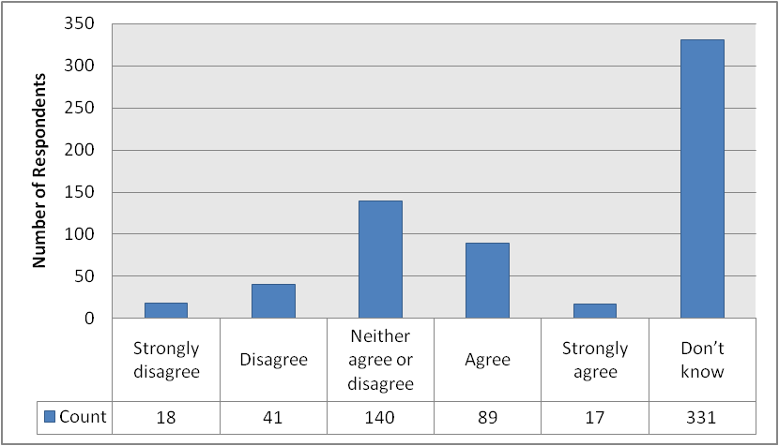
Base = 636 respondents

The final question was again put to all panellists, and sought to establish the extent to which they agree that it is easy to get in touch with City Wardens when you need to. The responses to this question are provided below in Figure 41 (see page 90). Once again reflecting the fact that so few panellists have need to seek assistance from City Wardens over the past two years (see Figure 28, page 72), just under half of respondents (297; 46.5%) selected the “don’t know” option. 132 respondents (20.7%) disagreed and 75 (11.7%) strongly disagreed. This was considerably larger than the number who agreed or strongly agreed: these were just 34 (5.3%) and 9 (1.4%), respectively. 92 respondents (14.4%) neither agreed nor disagreed with the statement.

These results have also been broken down according to gender, neighbourhood area and age-group. The results of this can be seen in full in Tables 91-93 (see page 129). For the analysis here, we focus on the most popular responses, as well as discussing compounded “disagreement” (i.e. combining the totals for “strongly disagree” and “disagree”) and “agreement” (i.e. combining the totals for “agree” and “strongly agree”) results.

Once again, “don’t know” was the most popular response for both male and female respondents. Overall levels of agreement with the statement that it is easy to get in touch with City Wardens when you need to were slightly higher among female respondents (7.9%) than males (5.3%), although the same was also true in relation to overall levels of disagreement (32.6% of females vs. 31.6% of males).

The most popular answer in each neighbourhood was “don’t know”. Overall levels of agreement that it is easy to get in touch with City Wardens when you need to were highest in Central (8.1%), followed by South (7.1%) and North (4.5%). However, overall levels of disagreement were also highest in Central (37.6%), followed by North (32.2%) and South (27.6%).

For each age-group, the most popular response was “don’t know”. Overall levels of agreement were highest among those aged 16-34 (9.0%), followed by those aged 55-64 (7.6%), those aged 65+ (6.6%) and those aged 35-54 (5.4%). Overall levels of disagreement were at their highest in the 65+ age-group (36.8%), followed by those aged 35-54 (34.1%), those aged 55-64 (29.8%) and those aged 16-34 (20.9%).

Figure 41: To what extent do you agree or disagree that it is easy to get in touch with City Wardens when you need to?
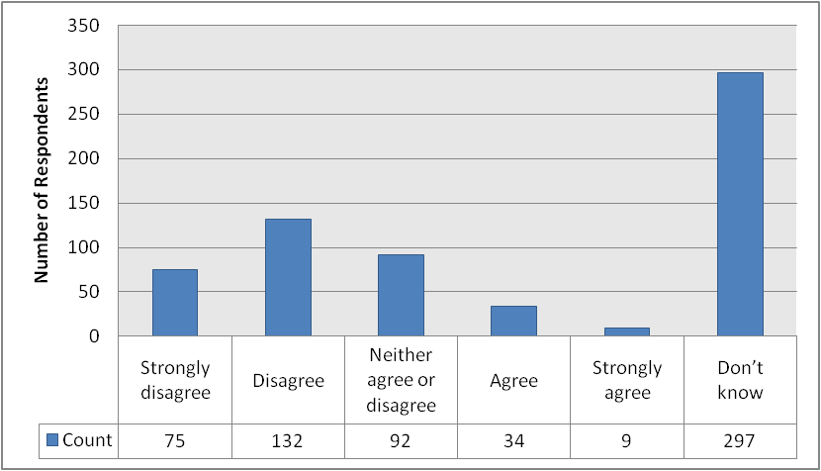
Base = 639 respondents

Given the fact that “don’t know” answers make up a large portion of the responses to the preceding questions, we have again decided to strip these out in order to perform a piece of additional analysis which only contains the informed opinions on these issues (i.e. only considering the “strongly disagree”, “disagree”, “neither agree nor disagree”, “agree” and “strongly agree” responses). We hope that this provides more of a meaningful proportionate breakdown of opinions on the performance of City Wardens.

This analysis can be seen below in Figure 42 (see page 92), which shows the proportion of respondents selecting each option for the statements put to panellists. Please note that these are adjusted figures and should not be cited in this form (as the percentage figures provided in Figure 42 refer to a subset of respondents and not the entire dataset). Please refer to the percentage figures provided in the explanatory text for Figures 36-41 (above) if percentage figures are required.

We also provide a breakdown of these results by gender, neighbourhood area and age-group in Tables 106-123 (see pages 135-140) but do not discuss the findings here due to limitations of space.

Figure 42: To what extent do you agree or disagree with the following statements? (ADJUSTED FIGURES – DO NOT CITE)
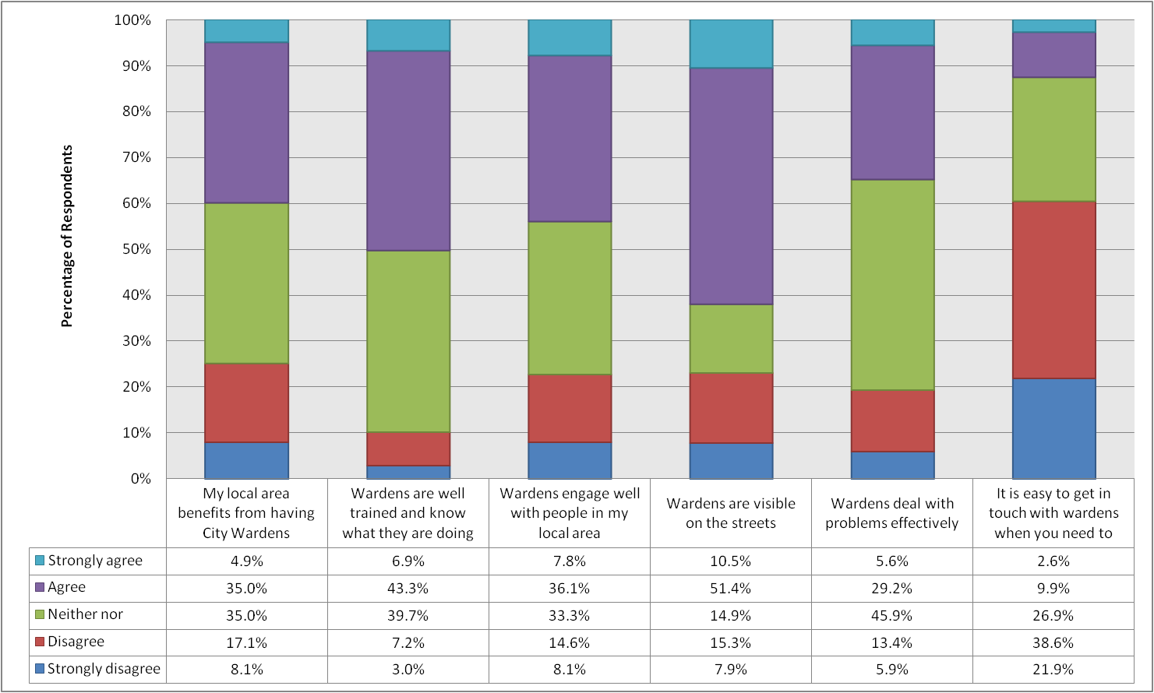
Base = multiple
SERVICE RESPONSE

I am very grateful to the City Voice panel members for providing feedback on our City Warden Service. These views help us identify our strengths and areas for improvement. We are currently reviewing deployment of City Wardens and the information collected will be analysed alongside various other information to determine future use of our resources.

We are pleased that City Wardens have been highly visible over the past 12 months. High visibility patrols are a key aim of the service helping provide reassurance to residents and deterring antisocial and offending behaviour. Comparing these results with feedback from City Voice 19th edition survey I am delighted that City Wardens are now far more visible in the city. Central parts of the city receive highest deployment of City Wardens and results confirm that they are most visible in these areas. We shall now be working to improve City Wardens profile and accessibility in all areas of the city and particularly outside the city centre.

Improving community safety, cleanliness and parking compliance are the main objectives for City Wardens. It is welcomed that the majority of panellists stating an opinion recognise that City Wardens have been effective in making Aberdeen a safer place. However, responses also clearly show dissatisfaction in our progress towards improving parking compliance and reducing litter and dog fouling. Results are similar to the 2010 survey and since then City Wardens have been substantially more active in enforcing environmental offences particularly in respect of littering. We will now ensure City Wardens' focus is on meeting our core service objectives more effectively.

We will seek more opportunities to publicise City Wardens' work and outcomes being achieved to help demonstrate their activity and positive impacts being made. In doing so, we will also publicise how City Wardens can be contacted, endeavouring to make the service more accessible when residents require assistance.

If you would like more information about the city wardens, please contact us on citywardens@aberdeencity.gov.uk or tel: 01224 627800.

Robin Donald, City Warden Officer

Aberdeen City Council

APPENDIX A: OVERVIEW OF RESPONDENTS’ CHARACTERISTICS

This section contains a brief overview of the different demographic characteristics of respondents to the survey.

In relation firstly to gender, a breakdown of respondents is provided below in Figure 43. The results show that a majority of respondents to this particular survey (51.6%) are female, whilst 48.4% are male.

Figure 43: Gender breakdown of respondents
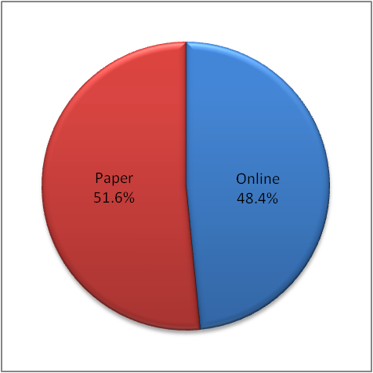
Base = 666 respondents

Secondly, Figure 44 (see page 95) shows that when considering the age-group to which respondents belong, the greatest share of respondents are aged 35-54 (40.1%), followed by 55-64 (26.6%) and 65+ (23.1%). Those aged 16-34 constituted the smallest group of respondents (just 10.2%).

Figure 44: Age breakdown of respondents
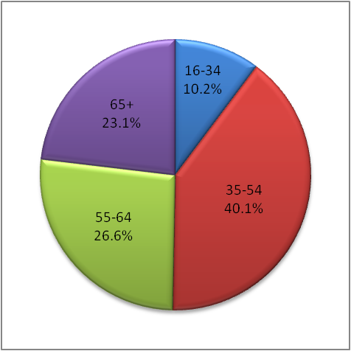
Base = 666 respondents

It is also possible to identify the area of the city in which respondents live. The results are provided below in Figure 45, which shows that there is a relatively even spread of respondents across the North, South and Central areas of the city. The largest share of respondents live in South (38.1%), followed by North (31.5%) and Central (30.3%).

Figure 45: Neighbourhood breakdown of respondents
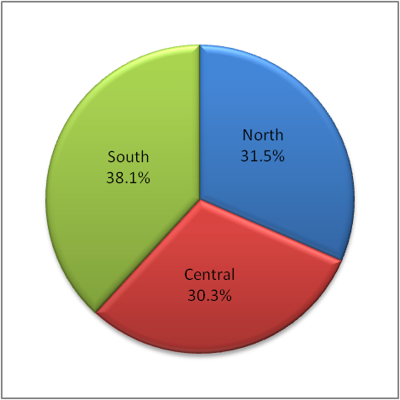
Base = 666 respondents

Finally, we consider the distribution of the two different methods available for completing the survey. Figure 46 (see page 96) shows that a large minority of respondents (48.4%) completed their survey online, whilst a slight majority (51.6%) returned the paper copy. Compared to the equivalent results from City Voice 27, the proportion of panellists completing their survey online increased by 0.6%.

Figure 46: Survey Response Type
Base = 666 respondents

APPENDIX B: CROSSTABULATED OUTPUT

This section contains tables for some of the questions we have crosstabulated. In particular, we use this section to provide tabulated output for the questions whose complexity makes a detailed in-text discussion difficult.

Table 16: To what extent do you agree or disagree that Aberdeen is a welcoming place for members of equality groups to live and work? (% by Gender)
Response | Gender
Response | Male | Female
Strongly Disagree | 1.3 | 2.1
Disagree | 9.0 | 10.1
Agree | 53.2 | 54.5
Strongly Agree | 14.5 | 13.1
Don’t know | 21.9 | 20.2
Base = multiple

Table 17: To what extent do you agree or disagree that Aberdeen is a welcoming place for members of equality groups to live and work? (% by Neighbourhood)
Response | Neighbourhood
Response | North | Central | South
Strongly Disagree | 0.5 | 3.0 | 1.6
Disagree | 8.3 | 14.7 | 6.5
Agree | 50.5 | 50.3 | 59.6
Strongly Agree | 15.2 | 12.7 | 13.5
Don’t know | 25.5 | 19.3 | 18.8
Base = multiple

Table 18: To what extent do you agree or disagree that Aberdeen is a welcoming place for members of equality groups to live and work? (% by Age-Group)
Response | Age Group
Response | 16-34 | 35-54 | 55-64 | 65+
Strongly Disagree | 1.5 | 2.3 | 0.6 | 2.1
Disagree | 13.2 | 11.4 | 9.3 | 4.9
Agree | 48.5 | 47.9 | 61.6 | 58.0
Strongly Agree | 23.5 | 19.0 | 9.3 | 4.9
Don’t know | 13.2 | 19.4 | 19.2 | 30.1
Base = multiple

Table 19: To what extent do you agree or disagree that people from equality groups living and working in the city are valued and respected? (% by Gender)
Response | Gender
Response | Male | Female
Strongly Disagree | 1.0 | 1.8
Disagree | 14.6 | 11.7
Agree | 51.6 | 49.5
Strongly Agree | 9.1 | 9.9
Don’t know | 23.7 | 27.0
Base = multiple

Table 20: To what extent do you agree or disagree that people from equality groups living and working in the city are valued and respected? (% by Neighbourhood)
Response | Neighbourhood
Response | North | Central | South
Strongly Disagree | 0.5 | 2.6 | 1.2
Disagree | 9.4 | 17.9 | 12.3
Agree | 50.7 | 47.2 | 53.1
Strongly Agree | 10.3 | 9.7 | 8.6
Don’t know | 29.1 | 22.6 | 24.7
Base = multiple

Table 21: To what extent do you agree or disagree that people from equality groups living and working in the city are valued and respected? (% by Age-Group)
Response | Age Group
Response | 16-34 | 35-54 | 55-64 | 65+
Strongly Disagree | 1.5 | 1.9 | 0.6 | 1.4
Disagree | 19.1 | 13.4 | 15.1 | 7.2
Agree | 44.1 | 48.1 | 56.4 | 51.1
Strongly Agree | 16.2 | 12.2 | 7.6 | 3.6
Don’t know | 19.1 | 24.4 | 20.3 | 36.7
Base = multiple

Table 22: How long have you been a carer? (% by Gender)
Response | Gender
Response | Male | Female
Less than a year | 6.1 | 7.8
1 – 5 years | 53.1 | 37.3
5 – 10 years | 26.5 | 19.6
Over 10 years | 14.3 | 35.3
Base = multiple

Table 23: How long have you been a carer? (% by Neighbourhood)
Response | Neighbourhood
Response | North | Central | South
Less than a year | 12.2 | 0.0 | 6.1
1 – 5 years | 46.3 | 38.5 | 48.5
5 – 10 years | 9.8 | 42.3 | 24.2
Over 10 years | 31.7 | 19.2 | 21.2
Base = multiple

Table 24: How long have you been a carer? (% by Age-Group)
Response | Age Group
Response | 16-34 | 35-54 | 55-64 | 65+
Less than a year | 0.0 | 17.5 | 0.0 | 0.0
1 – 5 years | 25.0 | 45.0 | 45.5 | 47.8
5 – 10 years | 50.0 | 17.5 | 24.2 | 26.1
Over 10 years | 25.0 | 20.0 | 30.3 | 26.1
Base = multiple

Table 25: What is your relationship with the person(s) you care for? (% by Gender)
Response | Gender
Response | Male | Female
A parent | 33.3 | 35.7
My son / daughter | 3.9 | 28.6
My husband / wife / partner | 31.4 | 14.3
A friend | 9.8 | 7.1
A neighbour | 7.8 | 8.9
Another family member | 19.6 | 14.3
Base = multiple

Table 26: What is your relationship with the person(s) you care for? (% by Neighbourhood)
Response | Neighbourhood
Response | North | Central | South
A parent | 0.0 | 52.4 | 42.9
My son / daughter | 50.0 | 16.7 | 14.3
My husband / wife / partner | 0.0 | 9.5 | 14.3
A friend | 25.0 | 7.1 | 5.7
A neighbour | 0.0 | 9.5 | 11.4
Another family member | 25.0 | 16.7 | 14.3
Base = multiple

Table 27: What is your relationship with the person(s) you care for? (% by Age-Group)
Response | Age Group
Response | 16-34 | 35-54 | 55-64 | 65+
A parent | 26.7 | 41.4 | 39.4 | 26.7
My son / daughter | 22.2 | 6.9 | 18.2 | 22.2
My husband / wife / partner | 17.8 | 24.1 | 27.3 | 17.8
A friend | 8.9 | 13.8 | 3.0 | 8.9
A neighbour | 6.7 | 13.8 | 6.1 | 6.7
Another family member | 20.0 | 13.8 | 15.2 | 20.0
Base = multiple

Table 28: Do you live in the same house as the person you mainly (if you care for more than one person) care for? (% by Relationship)
Response | Relationship
Response | A parent | My son / daughter | My husband / wife / partner | A friend | A neighbour | Another family member
Yes | 10.5 | 77.8 | 79.2 | 20.0 | 10.0 | 11.1
No | 89.5 | 22.2 | 20.8 | 80.0 | 90.0 | 88.9
Base = multiple

Table 29: During an average week, on how many days do you provide care? (% by Relationship)
Response | Relationship
Response | A parent | My son / daughter | My husband / wife / partner | A friend | A neighbour | Another family member
1 | 13.5 | 0.0 | 0.0 | 33.3 | 33.3 | 23.5
2 | 10.8 | 0.0 | 0.0 | 11.1 | 11.1 | 17.6
3 | 29.7 | 16.7 | 4.2 | 22.2 | 11.1 | 17.6
4 | 13.5 | 0.0 | 0.0 | 0.0 | 22.2 | 11.8
5 | 2.7 | 5.6 | 4.2 | 0.0 | 0.0 | 11.8
6 | 0.0 | 0.0 | 0.0 | 0.0 | 0.0 | 0.0
7 | 29.7 | 77.8 | 91.7 | 33.3 | 22.2 | 17.6
Base = multiple
Table 30: During an average week, on how many days do you provide care? (% by Living Status)
Response | Do you live in the same house as the person you mainly care for?
Response | Yes | No
1 | 0.0 | 21.0
2 | 0.0 | 12.9
3 | 2.6 | 25.8
4 | 0.0 | 11.3
5 | 0.0 | 9.7
6 | 0.0 | 0.0
7 | 97.4 | 19.4
Base = multiple

Table 31: How long, on an average day, do you spend caring? (% by Living Status)
Response | Do you live in the same house as the person you mainly care for?
Response | Yes | No
Up to 4 hours | 31.6 | 77.0
4 – 8 hours | 2.6 | 14.8
8 – 12 hours | 21.1 | 3.3
More than 12 hours | 44.7 | 4.9
Base = multiple
Table 32: How long, on an average day, do you spend caring? (% by Relationship)
Response | Relationship
Response | A parent | My son / daughter | My husband / wife / partner | A friend | A neighbour | Another family member
Up to 4 hours | 64.9 | 11.1 | 52.2 | 77.8 | 88.9 | 88.2
4 – 8 hours | 18.9 | 5.6 | 4.3 | 11.1 | 11.1 | 0.0
8 – 12 hours | 0.0 | 16.7 | 26.1 | 11.1 | .0 | 11.8
More than 12 hours | 16.2 | 66.7 | 17.4 | 0.0 | 0.0 | 0.0
Base = multiple
Table 33: What type of care / help do you provide for the person? (% by Gender)
Response | Gender
Response | Male | Female
Getting in and out of bed | 17.6 | 16.1
Dressing | 17.6 | 32.1
Washing | 9.8 | 26.8
Bathing | 13.7 | 25.0
Cooking | 41.2 | 57.1
Feeding | 15.7 | 14.3
Medication | 33.3 | 44.6
Toileting | 11.8 | 21.4
Housework | 51.0 | 48.2
Laundry | 39.2 | 46.4
Emotional Support | 62.7 | 76.8
Shopping | 76.5 | 69.6
Keeping company | 68.6 | 67.9
Do-it-yourself | 54.9 | 30.4
Getting out and about | 68.6 | 60.7
Gardening | 41.2 | 23.2
Keeping safe or supervising | 41.2 | 48.2
Help to communicate | 23.5 | 42.9
Help with paperwork | 64.7 | 66.1
Transport | 60.8 | 53.6
Accompanying to appointments | 64.7 | 69.6
Base = multiple

Table 34: What type of care / help do you provide for the person? (% by Neighbourhood)
Response | Neighbourhood
Response | North | Central | South
Getting in and out of bed | 17.8 | 17.2 | 15.2
Dressing | 35.6 | 24.1 | 12.1
Washing | 26.7 | 13.8 | 12.1
Bathing | 24.4 | 17.2 | 15.2
Cooking | 53.3 | 55.2 | 39.4
Feeding | 20.0 | 10.3 | 12.1
Medication | 48.9 | 37.9 | 27.3
Toileting | 22.2 | 13.8 | 12.1
Housework | 44.4 | 51.7 | 54.5
Laundry | 42.2 | 44.8 | 42.4
Emotional Support | 82.2 | 62.1 | 60.6
Shopping | 75.6 | 69.0 | 72.7
Keeping company | 68.9 | 72.4 | 63.6
Do-it-yourself | 40.0 | 41.4 | 45.5
Getting out and about | 66.7 | 55.2 | 69.7
Gardening | 37.8 | 20.7 | 33.3
Keeping safe or supervising | 48.9 | 48.3 | 36.4
Help to communicate | 28.9 | 44.8 | 30.3
Help with paperwork | 64.4 | 72.4 | 60.6
Transport | 64.4 | 44.8 | 57.6
Accompanying to appointments | 71.1 | 65.5 | 63.6
Base = multiple

Table 35: What type of care / help do you provide for the person? (% by Age-Group)
Response | Age Group
Response | 16-34 | 35-54 | 55-64 | 65+
Getting in and out of bed | 0.0 | 14.3 | 20.0 | 19.2
Dressing | 50.0 | 21.4 | 25.7 | 26.9
Washing | 25.0 | 16.7 | 25.7 | 11.5
Bathing | 50.0 | 19.0 | 20.0 | 15.4
Cooking | 50.0 | 47.6 | 45.7 | 57.7
Feeding | 0.0 | 11.9 | 22.9 | 11.5
Medication | 50.0 | 38.1 | 40.0 | 38.5
Toileting | 0.0 | 11.9 | 25.7 | 15.4
Housework | 0.0 | 40.5 | 60.0 | 57.7
Laundry | 0.0 | 33.3 | 51.4 | 53.8
Emotional Support | 100.0 | 71.4 | 74.3 | 57.7
Shopping | 50.0 | 73.8 | 71.4 | 76.9
Keeping company | 75.0 | 59.5 | 77.1 | 69.2
Do-it-yourself | 0.0 | 40.5 | 48.6 | 42.3
Getting out and about | 50.0 | 66.7 | 68.6 | 57.7
Gardening | 0.0 | 28.6 | 37.1 | 34.6
Keeping safe or supervising | 50.0 | 42.9 | 45.7 | 46.2
Help to communicate | 50.0 | 31.0 | 31.4 | 38.5
Help with paperwork | 0.0 | 69.0 | 65.7 | 69.2
Transport | 25.0 | 57.1 | 60.0 | 57.7
Accompanying to appointments | 50.0 | 66.7 | 68.6 | 69.2
Base = multiple
Table 36: What type of care / help do you provide for the person? (% by Relationship)
Response | Relationship
Response | A parent | My son / daughter | My husband / wife / partner | A friend | A neighbour | Another family member
Getting in and out of bed | 10.5 | 33.3 | 25.0 | 20.0 | 10.0 | 0.0
Dressing | 21.1 | 66.7 | 29.2 | 30.0 | 10.0 | 0.0
Washing | 18.4 | 61.1 | 12.5 | 20.0 | 0.0 | 0.0
Bathing | 18.4 | 55.6 | 16.7 | 30.0 | 0.0 | 0.0
Cooking | 47.4 | 66.7 | 70.8 | 40.0 | 30.0 | 27.8
Feeding | 10.5 | 22.2 | 16.7 | 20.0 | 0.0 | 11.1
Medication | 36.8 | 61.1 | 41.7 | 20.0 | 20.0 | 33.3
Toileting | 21.1 | 38.9 | 12.5 | 10.0 | 10.0 | 5.6
Housework | 55.3 | 55.6 | 79.2 | 30.0 | 20.0 | 27.8
Laundry | 44.7 | 55.6 | 75.0 | 40.0 | 10.0 | 11.1
Emotional Support | 76.3 | 77.8 | 75.0 | 70.0 | 100.0 | 61.1
Shopping | 81.6 | 72.2 | 87.5 | 70.0 | 60.0 | 77.8
Keeping company | 68.4 | 66.7 | 79.2 | 80.0 | 100.0 | 50.0
Do-it-yourself | 52.6 | 33.3 | 50.0 | 30.0 | 20.0 | 55.6
Getting out and about | 65.8 | 77.8 | 79.2 | 40.0 | 40.0 | 72.2
Gardening | 31.6 | 33.3 | 41.7 | 40.0 | 30.0 | 27.8
Keeping safe or supervising | 34.2 | 77.8 | 66.7 | 30.0 | 30.0 | 27.8
Help to communicate | 28.9 | 66.7 | 41.7 | 40.0 | 30.0 | 11.1
Help with paperwork | 81.6 | 55.6 | 79.2 | 60.0 | 50.0 | 66.7
Transport | 63.2 | 77.8 | 70.8 | 40.0 | 10.0 | 55.6
Accompanying to appointments | 73.7 | 88.9 | 87.5 | 60.0 | 20.0 | 66.7
Base = multiple
Table 37: What type of care / help do you provide for the person? (% by Living Status)
Response | Do you live in the same house as the person you mainly care for?
Response | Yes | No
Getting in and out of bed | 30.8 | 9.2
Dressing | 46.2 | 13.8
Washing | 33.3 | 10.8
Bathing | 35.9 | 10.8
Cooking | 76.9 | 35.4
Feeding | 15.4 | 15.4
Medication | 56.4 | 30.8
Toileting | 23.1 | 13.8
Housework | 76.9 | 36.9
Laundry | 71.8 | 29.2
Emotional Support | 79.5 | 70.8
Shopping | 79.5 | 75.4
Keeping company | 79.5 | 67.7
Do-it-yourself | 43.6 | 44.6
Getting out and about | 76.9 | 61.5
Gardening | 41.0 | 27.7
Keeping safe or supervising | 76.9 | 27.7
Help to communicate | 51.3 | 24.6
Help with paperwork | 69.2 | 69.2
Transport | 74.4 | 50.8
Accompanying to appointments | 82.1 | 63.1
Base = multiple
Table 38: Do you or the person you care for get help or support from any of the following? (PERSON CARED FOR) (% by Gender)
Response | Gender
Response | Male | Female
Aberdeen City Council | 35.3 | 26.8
Other support organisation | 11.8 | 17.9
Your employer | 0.0 | 0.0
NHS (GP, Nurse, Physiotherapist) | 37.3 | 39.3
Friends and family | 47.1 | 57.1
Base = multiple

Table 39: Do you or the person you care for get help or support from any of the following? (PERSON CARED FOR) (% by Neighbourhood)
Response | Neighbourhood
Response | North | Central | South
Aberdeen City Council | 40.0 | 17.2 | 30.3
Other support organisation | 22.2 | 13.8 | 6.1
Your employer | 0.0 | 0.0 | 0.0
NHS (GP, Nurse, Physiotherapist) | 48.9 | 31.0 | 30.3
Friends and family | 53.3 | 44.8 | 57.6
Base = multiple

Table 40: Do you or the person you care for get help or support from any of the following? (PERSON CARED FOR) (% by Age-Group)
Response | Age Group
Response | 16-34 | 35-54 | 55-64 | 65+
Aberdeen City Council | 25.0 | 26.2 | 37.1 | 30.8
Other support organisation | 50.0 | 23.8 | 8.6 | 3.8
Your employer | 0.0 | 0.0 | 0.0 | 0.0
NHS (GP, Nurse, Physiotherapist) | 75.0 | 50.0 | 25.7 | 30.8
Friends and family | 50.0 | 59.5 | 57.1 | 34.6
Base = multiple

Table 41: If you attended a healthcare appointment in the last 12 months, please say how you got there. (% by Gender)
Response | Gender
Response | Male | Female
Walk | 21.9 | 16.9
Own vehicle (car, bike, van etc.) | 62.3 | 54.7
Friend or relative drove me | 19.2 | 24.4
Public bus | 28.1 | 25.0
Community bus | 0.0 | 1.2
Train | 0.0 | 0.6
Taxi | 4.8 | 7.6
Patient Transport Service | 0.7 | 1.7
Can’t remember | 0.0 | 0.0
Base = multiple

Table 42: If you attended a healthcare appointment in the last 12 months, please say how you got there. (% by Neighbourhood)
Response | Neighbourhood
Response | North | Central | South
Walk | 8.3 | 42.3 | 9.6
Own vehicle (car, bike, van etc.) | 64.6 | 47.4 | 61.6
Friend or relative drove me | 18.8 | 17.5 | 28.0
Public bus | 29.2 | 23.7 | 26.4
Community bus | 1.0 | 1.0 | 0.0
Train | 1.0 | 0.0 | 0.0
Taxi | 8.3 | 9.3 | 2.4
Patient Transport Service | 1.0 | 1.0 | 1.6
Can’t remember | 0.0 | 0.0 | 0.0
Base = multiple

Table 43: If you attended a healthcare appointment in the last 12 months, please say how you got there. (% by Age-Group)
Response | Age Group
Response | 16-34 | 35-54 | 55-64 | 65+
Walk | 29.2 | 21.9 | 17.3 | 14.6
Own vehicle (car, bike, van etc.) | 58.3 | 69.3 | 55.1 | 46.3
Friend or relative drove me | 37.5 | 14.9 | 21.4 | 28.0
Public bus | 16.7 | 15.8 | 34.7 | 34.1
Community bus | 0.0 | 0.9 | 0.0 | 1.2
Train | 0.0 | 0.0 | 1.0 | 0.0
Taxi | 4.2 | 5.3 | 3.1 | 12.2
Patient Transport Service | 0.0 | 0.0 | 0.0 | 4.9
Can’t remember | 0.0 | 0.0 | 0.0 | 0.0
Base = multiple

Table 44: If you attended a healthcare appointment in the last 12 months, please say how you got there. (% by Appointment Location)
Response | Appointment Location
Response | A clinic or service in local area | A hospital or clinic elsewhere in Aberdeen
Walk | 31.3 | 19.9
Own vehicle (car, bike, van etc.) | 53.7 | 59.2
Friend or relative drove me | 29.9 | 21.7
Public bus | 29.9 | 27.4
Community bus | 0.0 | 0.7
Train | 0.0 | 0.4
Taxi | 6.0 | 6.1
Patient Transport Service | 3.0 | 0.7
Can’t remember | 0.0 | 0.0
Base = multiple

Table 45: Have any of the following happened to you in the last 12 months if you had an invitation to a healthcare appointment? (% by Gender)
Response | Gender
Response | Male | Female
You missed an appointment because something else came up | 2.5 | 3.4
You missed an appointment because you forgot about it | 2.2 | 4.3
You missed an appointment because you could not get suitable transport | 0.6 | 0.9
You were late for an appointment because of transport availability | 1.9 | 3.7
You had to rearrange an appointment to fit in with transport availability | 3.8 | 3.4
Base = multiple

Table 46: Have any of the following happened to you in the last 12 months if you had an invitation to a healthcare appointment? (% by Neighbourhood)
Response | Neighbourhood
Response | North | Central | South
You missed an appointment because something else came up | 1.9 | 5.4 | 2.0
You missed an appointment because you forgot about it | 2.4 | 3.0 | 4.3
You missed an appointment because you could not get suitable transport | 1.0 | 0.5 | 0.8
You were late for an appointment because of transport availability | 2.9 | 5.0 | 1.2
You had to rearrange an appointment to fit in with transport availability | 3.8 | 5.4 | 2.0
Base = multiple

Table 47: Have any of the following happened to you in the last 12 months if you had an invitation to a healthcare appointment? (% by Age-Group)
Response | Age Group
Response | 16-34 | 35-54 | 55-64 | 65+
You missed an appointment because something else came up | 8.8 | 3.7 | 0.6 | 1.9
You missed an appointment because you forgot about it | 4.4 | 2.6 | 5.1 | 1.9
You missed an appointment because you could not get suitable transport | 0.0 | 1.5 | 0.6 | 0.0
You were late for an appointment because of transport availability | 4.4 | 1.9 | 3.4 | 3.2
You had to rearrange an appointment to fit in with transport availability | 1.5 | 4.5 | 2.3 | 4.5
Base = multiple

Table 48: Have any of the following happened to you in the last 12 months if you had an invitation to a healthcare appointment? (% by Appointment Location)
Response | Appointment Location
Response | A clinic or service in local area | A hospital or clinic elsewhere in Aberdeen
You missed an appointment because something else came up | 10.4 | 4.0
You missed an appointment because you forgot about it | 6.0 | 6.1
You missed an appointment because you could not get suitable transport | 1.5 | 1.4
You were late for an appointment because of transport availability | 10.4 | 5.8
You had to rearrange an appointment to fit in with transport availability | 11.9 | 6.1
Base = multiple
Table 49: Thinking about the next 6 months, if you had to attend a healthcare appointment, how do you think you would get there? (% by Gender)
Response | Gender
Response | Male | Female
Walk | 34.0 | 27.6
Own vehicle (car, bike, van etc.) | 68.6 | 61.5
Friend or relative will drive me | 18.2 | 21.3
Public bus | 34.3 | 33.6
Community bus | 0.3 | 0.3
Train | 0.3 | 0.6
Taxi | 6.6 | 6.3
Patient Transport Service | 2.2 | 1.4
Don’t know | 0.9 | 1.4
Base = multiple

Table 50: Thinking about the next 6 months, if you had to attend a healthcare appointment, how do you think you would get there? (% by Neighbourhood)
Response | Neighbourhood
Response | North | Central | South
Walk | 20.0 | 52.5 | 22.0
Own vehicle (car, bike, van etc.) | 68.6 | 54.5 | 70.1
Friend or relative will drive me | 19.5 | 17.8 | 21.7
Public bus | 36.2 | 36.6 | 29.9
Community bus | 0.5 | 0.5 | 0.0
Train | 1.0 | 0.5 | 0.0
Taxi | 5.2 | 9.4 | 5.1
Patient Transport Service | 3.3 | 1.0 | 1.2
Don’t know | 2.4 | 0.5 | 0.8
Base = multiple

Table 51: Thinking about the next 6 months, if you had to attend a healthcare appointment, how do you think you would get there? (% by Age-Group)
Response | Age Group
Response | 16-34 | 35-54 | 55-64 | 65+
Walk | 41.2 | 37.1 | 28.2 | 17.5
Own vehicle (car, bike, van etc.) | 70.6 | 73.4 | 62.1 | 50.6
Friend or relative will drive me | 17.6 | 14.2 | 23.2 | 26.6
Public bus | 17.6 | 27.0 | 42.9 | 42.9
Community bus | 0.0 | 0.0 | 0.0 | 1.3
Train | 0.0 | 0.4 | 0.6 | 0.6
Taxi | 2.9 | 6.0 | 3.4 | 12.3
Patient Transport Service | 0.0 | 1.1 | 1.1 | 4.5
Don’t know | 1.5 | 0.7 | 0.0 | 3.2
Base = multiple

Table 52: Overall how easy or difficult do you find it to arrange transport to get to a healthcare appointment? (% by Gender)
Response | Gender
Response | Male | Female
Very difficult | 1.6 | 1.8
Quite difficult | 8.4 | 10.9
Quite easy | 32.1 | 33.9
Very easy | 47.7 | 46.7
Don’t know | 10.1 | 6.7
Base = multiple

Table 53: Overall how easy or difficult do you find it to arrange transport to get to a healthcare appointment? (% by Neighbourhood)
Response | Neighbourhood
Response | North | Central | South
Very difficult | 1.5 | 3.0 | 0.8
Quite difficult | 12.1 | 9.6 | 7.8
Quite easy | 32.8 | 32.0 | 34.2
Very easy | 46.5 | 47.7 | 47.3
Don’t know | 7.1 | 7.6 | 9.9
Base = multiple

Table 54: Overall how easy or difficult do you find it to arrange transport to get to a healthcare appointment? (% by Age-Group)
Response | Age Group
Response | 16-34 | 35-54 | 55-64 | 65+
Very difficult | 1.5 | 0.4 | 1.8 | 4.3
Quite difficult | 6.2 | 8.7 | 9.5 | 13.5
Quite easy | 24.6 | 30.0 | 36.7 | 38.3
Very easy | 61.5 | 51.7 | 44.4 | 35.5
Don’t know | 6.2 | 9.1 | 7.7 | 8.5
Base = multiple

Table 55: Which of the following do you think would be the best method(s) / place(s) to promote a service such as this? (% by Gender)
Response | Gender
Response | Male | Female
Leaflets / posters in GP surgeries | 71.7 | 74.4
Leaflets / posters in hospitals | 45.0 | 55.7
Information on NHS / other partners’ websites | 34.9 | 31.3
Information in local newspapers | 49.4 | 57.8
Information issued with people’s appointment notices | 71.7 | 82.2
Base = multiple

Table 56: Which of the following do you think would be the best method(s) / place(s) to promote a service such as this? (% by Neighbourhood)
Response | Neighbourhood
Response | North | Central | South
Leaflets / posters in GP surgeries | 71.4 | 72.3 | 75.2
Leaflets / posters in hospitals | 53.3 | 49.5 | 49.2
Information on NHS / other partners’ websites | 35.2 | 34.7 | 29.9
Information in local newspapers | 54.8 | 46.0 | 59.1
Information issued with people’s appointment notices | 78.1 | 77.7 | 76.0
Base = multiple

Table 57: Which of the following do you think would be the best method(s) / place(s) to promote a service such as this? (% by Age-Group)
Response | Age Group
Response | 16-34 | 35-54 | 55-64 | 65+
Leaflets / posters in GP surgeries | 73.5 | 76.8 | 72.9 | 66.9
Leaflets / posters in hospitals | 54.4 | 58.8 | 48.0 | 37.7
Information on NHS / other partners’ websites | 33.8 | 43.1 | 30.5 | 18.2
Information in local newspapers | 44.1 | 51.7 | 55.4 | 59.7
Information issued with people’s appointment notices | 75.0 | 78.7 | 79.1 | 73.4
Base = multiple

Table 58: If yes, how helpful did you find City Wardens? (% by Gender)
Response | Gender
Response | Male | Female
Very unhelpful | 13.6 | 26.7
Unhelpful | 22.7 | 6.7
Helpful | 27.3 | 33.3
Very helpful | 36.4 | 33.3
Base = multiple

Table 59: If yes, how helpful did you find City Wardens? (% by Neighbourhood)
Response | Neighbourhood
Response | North | Central | South
Very unhelpful | 14.3 | 28.0 | 15.4
Unhelpful | 21.4 | 8.0 | 15.4
Helpful | 28.6 | 32.0 | 30.8
Very helpful | 35.7 | 32.0 | 38.5
Base = multiple

Table 60: If yes, how helpful did you find City Wardens? (% by Age-Group)
Response | Age Group
Response | 16-34 | 35-54 | 55-64 | 65+
Very unhelpful | 0.0 | 22.7 | 23.5 | 20.0
Unhelpful | 0.0 | 22.7 | 5.9 | 10.0
Helpful | 100.0 | 40.9 | 17.6 | 10.0
Very helpful | 0.0 | 13.6 | 52.9 | 60.0
Base = multiple
Table 61: "How strongly do you agree or disagree with the following statement: “The City Wardens have been effective in making Aberdeen City a safer place”. (% by Gender)
Response | Gender
Response | Male | Female
Strongly disagree | 7.9 | 2.7
Disagree | 12.1 | 10.1
Agree | 34.8 | 34.9
Strongly agree | 5.9 | 8.1
Don’t know | 39.3 | 44.2
Base = multiple

Table 62: "How strongly do you agree or disagree with the following statement: “The City Wardens have been effective in making Aberdeen City a safer place”. (% by Neighbourhood)
Response | Neighbourhood
Response | North | Central | South
Strongly disagree | 6.0 | 6.6 | 3.3
Disagree | 12.9 | 11.2 | 9.5
Agree | 30.8 | 36.7 | 36.6
Strongly agree | 8.0 | 8.2 | 5.3
Don’t know | 42.3 | 37.2 | 45.3
Base = multiple

Table 63: "How strongly do you agree or disagree with the following statement: “The City Wardens have been effective in making Aberdeen City a safer place”. (% by Age-Group)
Response | Age Group
Response | 16-34 | 35-54 | 55-64 | 65+
Strongly disagree | 3.0 | 6.1 | 5.8 | 3.5
Disagree | 14.9 | 9.6 | 10.5 | 12.8
Agree | 34.3 | 32.6 | 38.0 | 35.5
Strongly agree | 6.0 | 6.5 | 11.1 | 3.5
Don’t know | 41.8 | 45.2 | 34.5 | 44.7
Base = multiple

Table 64: How well do you think City Wardens deal with antisocial behaviour and crime in your area? (% by Gender)
Response | Gender
Response | Male | Female
Very poorly | 7.0 | 3.1
Poorly | 12.0 | 7.5
Quite well | 13.3 | 12.3
Very well | 1.0 | 1.9
Don’t know | 44.9 | 48.4
Not aware this is a problem in my area | 21.9 | 26.7
Base = multiple

Table 65: How well do you think City Wardens deal with antisocial behaviour and crime in your area? (% by Neighbourhood)
Response | Neighbourhood
Response | North | Central | South
Very poorly | 5.2 | 7.3 | 3.0
Poorly | 14.1 | 8.4 | 7.2
Quite well | 13.1 | 16.2 | 9.7
Very well | 1.6 | 1.0 | 1.7
Don’t know | 47.1 | 47.6 | 45.6
Not aware this is a problem in my area | 18.8 | 19.4 | 32.9
Base = multiple

Table 66: How well do you think City Wardens deal with antisocial behaviour and crime in your area? (% by Age-Group)
Response | Age Group
Response | 16-34 | 35-54 | 55-64 | 65+
Very poorly | 6.0 | 4.7 | 5.4 | 4.7
Poorly | 9.0 | 9.7 | 8.4 | 11.7
Quite well | 11.9 | 13.6 | 17.5 | 5.5
Very well | 0.0 | 2.7 | 0.6 | 0.8
Don’t know | 41.8 | 49.2 | 45.2 | 46.1
Not aware this is a problem in my area | 31.3 | 20.2 | 22.9 | 31.3
Base = multiple
Table 67: How well do you think City Wardens deal with illegal parking in your area? (% by Gender)
Response | Gender
Response | Male | Female
Very poorly | 11.0 | 7.5
Poorly | 14.4 | 10.6
Quite well | 17.1 | 17.1
Very well | 10.7 | 12.5
Don’t know | 27.1 | 33.6
Not aware this is a problem in my area | 19.7 | 18.7
Base = multiple

Table 68: How well do you think City Wardens deal with illegal parking in your area? (% by Neighbourhood)
Response | Neighbourhood
Response | North | Central | South
Very poorly | 8.3 | 11.1 | 8.4
Poorly | 9.4 | 13.7 | 13.9
Quite well | 13.5 | 23.7 | 14.7
Very well | 7.8 | 17.4 | 10.1
Don’t know | 38.0 | 23.2 | 30.3
Not aware this is a problem in my area | 22.9 | 11.1 | 22.7
Base = multiple

Table 69: How well do you think City Wardens deal with illegal parking in your area? (% by Age-Group)
Response | Age Group
Response | 16-34 | 35-54 | 55-64 | 65+
Very poorly | 6.0 | 8.1 | 12.0 | 9.4
Poorly | 7.5 | 10.5 | 12.6 | 18.8
Quite well | 19.4 | 14.3 | 22.2 | 14.8
Very well | 13.4 | 13.2 | 12.6 | 6.3
Don’t know | 28.4 | 32.9 | 25.7 | 32.8
Not aware this is a problem in my area | 25.4 | 20.9 | 15.0 | 18.0
Base = multiple
Table 70: How well do you think City Wardens deal with dog fouling in your area? (% by Gender)
Response | Gender
Response | Male | Female
Very poorly | 19.7 | 12.9
Poorly | 21.3 | 20.9
Quite well | 9.7 | 7.7
Very well | 0.7 | 2.2
Don’t know | 38.3 | 43.7
Not aware this is a problem in my area | 10.3 | 12.6
Base = multiple

Table 71: How well do you think City Wardens deal with dog fouling in your area? (% by Neighbourhood)
Response | Neighbourhood
Response | North | Central | South
Very poorly | 13.5 | 21.2 | 14.2
Poorly | 21.4 | 24.4 | 18.3
Quite well | 7.3 | 11.9 | 7.1
Very well | 0.5 | 2.1 | 1.7
Don’t know | 47.4 | 31.1 | 44.2
Not aware this is a problem in my area | 9.9 | 9.3 | 14.6
Base = multiple

Table 72: How well do you think City Wardens deal with dog fouling in your area? (% by Age-Group)
Response | Age Group
Response | 16-34 | 35-54 | 55-64 | 65+
Very poorly | 10.6 | 13.6 | 18.2 | 21.2
Poorly | 15.2 | 19.8 | 21.2 | 26.5
Quite well | 13.6 | 8.6 | 10.6 | 3.8
Very well | 1.5 | 1.9 | 1.2 | 0.8
Don’t know | 40.9 | 43.6 | 40.0 | 37.9
Not aware this is a problem in my area | 18.2 | 12.5 | 8.8 | 9.8
Base = multiple
Table 73: How well do you think City Wardens deal with littering in your area? (% by Gender)
Response | Gender
Response | Male | Female
Very poorly | 19.6 | 12.1
Poorly | 24.3 | 19.2
Quite well | 9.0 | 10.2
Very well | 2.0 | 2.5
Don’t know | 34.6 | 42.1
Not aware this is a problem in my area | 10.6 | 13.9
Base = multiple

Table 74: How well do you think City Wardens deal with littering in your area? (% by Neighbourhood)
Response | Neighbourhood
Response | North | Central | South
Very poorly | 10.4 | 10.6 | 21.1
Poorly | 20.9 | 19.2 | 22.2
Quite well | 13.4 | 9.8 | 11.1
Very well | 0.0 | 3.1 | 1.8
Don’t know | 38.8 | 43.1 | 34.5
Not aware this is a problem in my area | 16.4 | 14.1 | 9.4
Base = multiple

Table 75: How well do you think City Wardens deal with littering in your area? (% by Age-Group)
Response | Age Group
Response | 16-34 | 35-54 | 55-64 | 65+
Very poorly | 13.4 | 21.4 | 13.0 | 13.4
Poorly | 23.2 | 24.5 | 18.1 | 23.2
Quite well | 7.2 | 12.0 | 9.7 | 7.2
Very well | 3.1 | 2.1 | 1.7 | 3.1
Don’t know | 42.8 | 30.2 | 41.6 | 42.8
Not aware this is a problem in my area | 10.3 | 9.9 | 16.0 | 10.3
Base = multiple

Table 76: To what extent do you agree or disagree that your local area benefits from having City Wardens? (% by Gender)
Response | Gender
Response | Male | Female
Strongly disagree | 5.6 | 4.9
Disagree | 11.8 | 9.8
Neither agree nor disagree | 26.3 | 19.3
Agree | 21.7 | 23.2
Strongly agree | 3.0 | 3.4
Don’t know | 31.6 | 39.4
Base = multiple

Table 77: To what extent do you agree or disagree that your local area benefits from having City Wardens? (% by Neighbourhood)
Response | Neighbourhood
Response | North | Central | South
Strongly disagree | 5.1 | 4.6 | 5.9
Disagree | 14.1 | 11.3 | 7.6
Neither agree nor disagree | 17.7 | 27.2 | 23.1
Agree | 19.7 | 30.3 | 18.5
Strongly agree | 2.5 | 5.1 | 2.1
Don’t know | 40.9 | 21.5 | 42.9
Base = multiple

Table 78: To what extent do you agree or disagree that your local area benefits from having City Wardens? (% by Age-Group)
Response | Age Group
Response | 16-34 | 35-54 | 55-64 | 65+
Strongly disagree | 4.5 | 4.2 | 7.1 | 5.2
Disagree | 15.2 | 8.4 | 10.7 | 13.3
Neither agree nor disagree | 19.7 | 18.8 | 24.3 | 29.6
Agree | 22.7 | 24.5 | 25.4 | 14.8
Strongly agree | 4.5 | 3.4 | 2.4 | 3.0
Don’t know | 33.3 | 40.6 | 30.2 | 34.1
Base = multiple

Table 79: To what extent do you agree or disagree that City Wardens are well trained and know what they are doing? (% by Gender)
Response | Gender
Response | Male | Female
Strongly disagree | 2.3 | 0.9
Disagree | 4.3 | 2.7
Neither agree nor disagree | 21.1 | 21.0
Agree | 20.5 | 24.9
Strongly agree | 2.0 | 5.2
Don’t know | 49.8 | 45.3
Base = multiple

Table 80: To what extent do you agree or disagree that City Wardens are well trained and know what they are doing? (% by Neighbourhood)
Response | Neighbourhood
Response | North | Central | South
Strongly disagree | 1.0 | 2.6 | 1.3
Disagree | 4.0 | 3.6 | 2.9
Neither agree nor disagree | 21.1 | 22.1 | 20.2
Agree | 22.1 | 26.2 | 20.6
Strongly agree | 4.0 | 4.6 | 2.5
Don’t know | 47.7 | 41.0 | 52.5
Base = multiple

Table 81: To what extent do you agree or disagree that City Wardens are well trained and know what they are doing? (% by Age-Group)
Response | Age Group
Response | 16-34 | 35-54 | 55-64 | 65+
Strongly disagree | 3.0 | 1.5 | 1.2 | 1.5
Disagree | 1.5 | 3.4 | 3.5 | 4.5
Neither agree nor disagree | 17.9 | 19.5 | 24.4 | 21.2
Agree | 14.9 | 21.1 | 26.2 | 25.8
Strongly agree | 11.9 | 2.7 | 2.9 | 2.3
Don’t know | 50.7 | 51.7 | 41.9 | 44.7
Base = multiple

Table 82: To what extent do you agree or disagree that City Wardens engage well with people in your local area? (% by Gender)
Response | Gender
Response | Male | Female
Strongly disagree | 3.6 | 4.3
Disagree | 8.9 | 5.8
Neither agree nor disagree | 20.1 | 14.1
Agree | 16.8 | 19.6
Strongly agree | 2.6 | 5.2
Don’t know | 47.9 | 50.9
Base = multiple

Table 83: To what extent do you agree or disagree that City Wardens engage well with people in your local area? (% by Neighbourhood)
Response | Neighbourhood
Response | North | Central | South
Strongly disagree | 4.0 | 4.1 | 3.8
Disagree | 9.6 | 7.2 | 5.5
Neither agree nor disagree | 14.1 | 17.4 | 19.1
Agree | 13.6 | 29.7 | 12.7
Strongly agree | 4.5 | 4.6 | 3.0
Don’t know | 54.0 | 36.9 | 55.9
Base = multiple

Table 84: To what extent do you agree or disagree that City Wardens engage well with people in your local area? (% by Age-Group)
Response | Age Group
Response | 16-34 | 35-54 | 55-64 | 65+
Strongly disagree | 6.1 | 4.6 | 3.5 | 2.3
Disagree | 12.1 | 5.4 | 5.8 | 10.7
Neither agree nor disagree | 21.2 | 14.2 | 18.0 | 19.1
Agree | 10.6 | 18.8 | 22.7 | 15.3
Strongly agree | 3.0 | 4.2 | 4.7 | 3.1
Don’t know | 47.0 | 52.7 | 45.3 | 49.6
Base = multiple

Table 85: To what extent do you agree or disagree that City Wardens are visible on the streets? (% by Gender)
Response | Gender
Response | Male | Female
Strongly disagree | 6.9 | 7.3
Disagree | 12.1 | 14.8
Neither agree nor disagree | 14.4 | 12.1
Agree | 47.9 | 43.9
Strongly agree | 9.5 | 9.4
Don’t know | 9.2 | 12.4
Base = multiple

Table 86: To what extent do you agree or disagree that City Wardens are visible on the streets? (% by Neighbourhood)
Response | Neighbourhood
Response | North | Central | South
Strongly disagree | 9.5 | 4.6 | 7.1
Disagree | 16.1 | 10.3 | 14.1
Neither agree nor disagree | 10.6 | 12.3 | 16.2
Agree | 42.7 | 52.8 | 42.7
Strongly agree | 7.0 | 12.3 | 9.1
Don’t know | 14.1 | 7.7 | 10.8
Base = multiple

Table 87: To what extent do you agree or disagree that City Wardens are visible on the streets? (% by Age-Group)
Response | Age Group
Response | 16-34 | 35-54 | 55-64 | 65+
Strongly disagree | 4.5 | 6.2 | 9.2 | 7.4
Disagree | 16.4 | 11.2 | 10.4 | 20.7
Neither agree nor disagree | 3.0 | 14.2 | 17.3 | 11.1
Agree | 53.7 | 45.0 | 46.2 | 43.0
Strongly agree | 11.9 | 10.4 | 8.1 | 8.1
Don’t know | 10.4 | 13.1 | 8.7 | 9.6
Base = multiple

Table 88: To what extent do you agree or disagree that City Wardens deal with problems effectively? (% by Gender)
Response | Gender
Response | Male | Female
Strongly disagree | 3.6 | 1.8
Disagree | 7.3 | 5.5
Neither agree nor disagree | 24.8 | 19.7
Agree | 13.9 | 13.9
Strongly agree | 2.6 | 2.7
Don’t know | 47.7 | 56.4
Base = multiple

Table 89: To what extent do you agree or disagree that City Wardens deal with problems effectively? (% by Neighbourhood)
Response | Neighbourhood
Response | North | Central | South
Strongly disagree | 2.0 | 3.1 | 2.9
Disagree | 7.6 | 6.1 | 5.5
Neither agree nor disagree | 23.7 | 23.5 | 19.7
Agree | 12.1 | 18.9 | 11.3
Strongly agree | 2.5 | 2.0 | 3.4
Don’t know | 52.0 | 46.4 | 57.1
Base = multiple

Table 90: To what extent do you agree or disagree that City Wardens deal with problems effectively? (% by Age-Group)
Response | Age Group
Response | 16-34 | 35-54 | 55-64 | 65+
Strongly disagree | 3.0 | 1.9 | 2.9 | 3.7
Disagree | 4.5 | 5.4 | 7.6 | 7.5
Neither agree nor disagree | 26.9 | 20.3 | 25.3 | 19.4
Agree | 9.0 | 14.2 | 14.7 | 14.9
Strongly agree | 3.0 | 2.3 | 3.5 | 2.2
Don’t know | 53.7 | 55.9 | 45.9 | 52.2
Base = multiple

Table 91: To what extent do you agree or disagree that it is easy to get in touch with City Wardens when you need to? (% by Gender)
Response | Gender
Response | Male | Female
Strongly disagree | 11.8 | 11.2
Disagree | 19.7 | 21.5
Neither agree nor disagree | 18.1 | 11.2
Agree | 4.3 | 6.0
Strongly agree | 1.0 | 1.8
Don’t know | 45.1 | 48.3
Base = multiple

Table 92: To what extent do you agree or disagree that it is easy to get in touch with City Wardens when you need to? (% by Neighbourhood)
Response | Neighbourhood
Response | North | Central | South
Strongly disagree | 9.5 | 14.7 | 10.5
Disagree | 22.6 | 22.8 | 17.2
Neither agree nor disagree | 15.6 | 15.2 | 13.0
Agree | 4.0 | 5.6 | 5.9
Strongly agree | 0.5 | 2.5 | 1.3
Don’t know | 47.7 | 39.1 | 52.3
Base = multiple

Table 93: To what extent do you agree or disagree that it is easy to get in touch with City Wardens when you need to? (% by Age-Group)
Response | Age Group
Response | 16-34 | 35-54 | 55-64 | 65+
Strongly disagree | 7.5 | 13.4 | 11.7 | 9.6
Disagree | 13.4 | 20.7 | 18.1 | 27.2
Neither agree nor disagree | 17.9 | 13.4 | 19.3 | 8.8
Agree | 7.5 | 4.6 | 5.3 | 5.1
Strongly agree | 1.5 | 0.8 | 2.3 | 1.5
Don’t know | 52.2 | 47.1 | 43.3 | 47.8
Base = multiple

APPENDIX C: CROSSTABULATED OUTPUT (ADJUSTED FIGURES)

This section contains crosstabulated output (results by gender, neighbourhood area and age-group) for the two final questions in the “City Wardens” section. Because the responses to so many of these questions were dominated by “don’t know” or “not aware this is a problem in my area”, we have stripped these responses out of the dataset and include only the responses which are based upon an informed opinion. As such, the tables contained in this Appendix are based upon an adjusted dataset, and the results should therefore not be cited as they do not reflect the totality of response to these question. Where percentage figures are required for reports, predictions, modelling etc., those provided above in Appendix B are the ones which should be cited.

Table 94: How well do you think City Wardens deal with antisocial behaviour and crime in your area? (% by Gender) (ADJUSTED FIGURES – DO NOT CITE)
Response | Gender
Response | Male | Female
Very poorly | 21.0 | 12.7
Poorly | 36.0 | 30.4
Quite well | 40.0 | 49.4
Very well | 3.0 | 7.6
Base = multiple

Table 95: How well do you think City Wardens deal with antisocial behaviour and crime in your area? (% by Neighbourhood) (ADJUSTED FIGURES – DO NOT CITE)
Response | Neighbourhood
Response | North | Central | South
Very poorly | 15.4 | 22.2 | 13.7
Poorly | 41.5 | 25.4 | 33.3
Quite well | 38.5 | 49.2 | 45.1
Very well | 4.6 | 3.2 | 7.8
Base = multiple

Table 96: How well do you think City Wardens deal with antisocial behaviour and crime in your area? (% by Age-Group) (ADJUSTED FIGURES – DO NOT CITE)
Response | Age Group
Response | 16-34 | 35-54 | 55-64 | 65+
Very poorly | 22.2 | 15.2 | 17.0 | 20.7
Poorly | 33.3 | 31.6 | 26.4 | 51.7
Quite well | 44.4 | 44.3 | 54.7 | 24.1
Very well | 0.0 | 8.9 | 1.9 | 3.4
Base = multiple

Table 97: How well do you think City Wardens deal with illegal parking in your area? (% by Gender) (ADJUSTED FIGURES – DO NOT CITE)
Response | Gender
Response | Male | Female
Very poorly | 20.8 | 15.7
Poorly | 27.0 | 22.2
Quite well | 32.1 | 35.9
Very well | 20.1 | 26.1
Base = multiple

Table 98: How well do you think City Wardens deal with illegal parking in your area? (% by Neighbourhood) (ADJUSTED FIGURES – DO NOT CITE)
Response | Neighbourhood
Response | North | Central | South
Very poorly | 21.3 | 16.8 | 17.9
Poorly | 24.0 | 20.8 | 29.5
Quite well | 34.7 | 36.0 | 31.3
Very well | 20.0 | 26.4 | 21.4
Base = multiple

Table 99: How well do you think City Wardens deal with illegal parking in your area? (% by Age-Group) (ADJUSTED FIGURES – DO NOT CITE)
Response | Age Group
Response | 16-34 | 35-54 | 55-64 | 65+
Very poorly | 12.9 | 17.6 | 20.2 | 19.0
Poorly | 16.1 | 22.7 | 21.2 | 38.1
Quite well | 41.9 | 31.1 | 37.4 | 30.2
Very well | 29.0 | 28.6 | 21.2 | 12.7
Base = multiple

Table 100: How well do you think City Wardens deal with dog fouling in your area? (% by Gender) (ADJUSTED FIGURES – DO NOT CITE)
Response | Gender
Response | Male | Female
Very poorly | 38.3 | 29.6
Poorly | 41.6 | 47.9
Quite well | 18.8 | 17.6
Very well | 1.3 | 4.9
Base = multiple

Table 101: How well do you think City Wardens deal with dog fouling in your area? (% by Neighbourhood) (ADJUSTED FIGURES – DO NOT CITE)
Response | Neighbourhood
Response | North | Central | South
Very poorly | 31.7 | 35.7 | 34.3
Poorly | 50.0 | 40.9 | 44.4
Quite well | 17.1 | 20.0 | 17.2
Very well | 1.2 | 3.5 | 4.0
Base = multiple

Table 102: How well do you think City Wardens deal with dog fouling in your area? (% by Age-Group) (ADJUSTED FIGURES – DO NOT CITE)
Response | Age Group
Response | 16-34 | 35-54 | 55-64 | 65+
Very poorly | 25.9 | 31.0 | 35.6 | 40.6
Poorly | 37.0 | 45.1 | 41.4 | 50.7
Quite well | 33.3 | 19.5 | 20.7 | 7.2
Very well | 3.7 | 4.4 | 2.3 | 1.4
Base = multiple

Table 103: How well do you think City Wardens deal with littering in your area? (% by Gender) (ADJUSTED FIGURES – DO NOT CITE)
Response | Gender
Response | Male | Female
Very poorly | 35.8 | 27.5
Poorly | 44.2 | 43.7
Quite well | 16.4 | 23.2
Very well | 3.6 | 5.6
Base = multiple

Table 104: How well do you think City Wardens deal with littering in your area? (% by Neighbourhood) (ADJUSTED FIGURES – DO NOT CITE)
Response | Neighbourhood
Response | North | Central | South
Very poorly | 28.6 | 35.7 | 30.7
Poorly | 49.5 | 40.9 | 42.6
Quite well | 15.4 | 20.0 | 22.8
Very well | 6.6 | 3.5 | 4.0
Base = multiple

Table 105: How well do you think City Wardens deal with littering in your area? (% by Age-Group) (ADJUSTED FIGURES – DO NOT CITE)
Response | Age Group
Response | 16-34 | 35-54 | 55-64 | 65+
Very poorly | 23.3 | 24.8 | 37.5 | 38.9
Poorly | 46.7 | 45.0 | 39.6 | 47.2
Quite well | 30.0 | 22.9 | 19.8 | 9.7
Very well | 0.0 | 7.3 | 3.1 | 4.2
Base = multiple

Table 106: To what extent do you agree or disagree that your local area benefits from having City Wardens? (% by Gender) (ADJUSTED FIGURES – DO NOT CITE)
Response | Gender
Response | Male | Female
Strongly disagree | 8.2 | 8.1
Disagree | 17.3 | 16.2
Neither agree nor disagree | 38.5 | 31.8
Agree | 31.7 | 38.4
Strongly agree | 4.3 | 5.6
Base = multiple

Table 107: To what extent do you agree or disagree that your local area benefits from having City Wardens? (% by Neighbourhood) (ADJUSTED FIGURES – DO NOT CITE)
Response | Neighbourhood
Response | North | Central | South
Strongly disagree | 8.5 | 5.9 | 10.3
Disagree | 23.9 | 14.4 | 13.2
Neither agree nor disagree | 29.9 | 34.6 | 40.4
Agree | 33.3 | 38.6 | 32.4
Strongly agree | 4.3 | 6.5 | 3.7
Base = multiple

Table 108: To what extent do you agree or disagree that your local area benefits from having City Wardens? (% by Age-Group) (ADJUSTED FIGURES – DO NOT CITE)
Response | Age Group
Response | 16-34 | 35-54 | 55-64 | 65+
Strongly disagree | 6.8 | 7.1 | 10.2 | 7.9
Disagree | 22.7 | 14.2 | 15.3 | 20.2
Neither agree nor disagree | 29.5 | 31.6 | 34.7 | 44.9
Agree | 34.1 | 41.3 | 36.4 | 22.5
Strongly agree | 6.8 | 5.8 | 3.4 | 4.5
Base = multiple
Table 109: To what extent do you agree or disagree that City Wardens are well trained and know what they are doing? (% by Gender) (ADJUSTED FIGURES – DO NOT CITE)
Response | Gender
Response | Male | Female
Strongly disagree | 4.6 | 1.7
Disagree | 8.6 | 5.0
Neither agree nor disagree | 42.1 | 38.3
Agree | 40.8 | 45.6
Strongly agree | 3.9 | 9.4
Base = multiple

Table 110: To what extent do you agree or disagree that City Wardens are well trained and know what they are doing? (% by Neighbourhood) (ADJUSTED FIGURES – DO NOT CITE)
Response | Neighbourhood
Response | North | Central | South
Strongly disagree | 1.9 | 4.3 | 2.7
Disagree | 7.7 | 6.1 | 6.2
Neither agree nor disagree | 40.4 | 37.4 | 42.5
Agree | 42.3 | 44.3 | 43.4
Strongly agree | 7.7 | 7.8 | 5.3
Base = multiple

Table 111: To what extent do you agree or disagree that City Wardens are well trained and know what they are doing? (% by Age-Group) (ADJUSTED FIGURES – DO NOT CITE)
Response | Age Group
Response | 16-34 | 35-54 | 55-64 | 65+
Strongly disagree | 6.1 | 3.2 | 2.0 | 2.7
Disagree | 3.0 | 7.1 | 6.0 | 8.2
Neither agree nor disagree | 36.4 | 40.5 | 42.0 | 38.4
Agree | 30.3 | 43.7 | 45.0 | 46.6
Strongly agree | 24.2 | 5.6 | 5.0 | 4.1
Base = multiple

Table 112: To what extent do you agree or disagree that City Wardens engage well with people in my local area? (% by Gender) (ADJUSTED FIGURES – DO NOT CITE)
Response | Gender
Response | Male | Female
Strongly disagree | 7.0 | 8.8
Disagree | 17.1 | 11.9
Neither agree nor disagree | 38.6 | 28.8
Agree | 32.3 | 40.0
Strongly agree | 5.1 | 10.6
Base = multiple

Table 113: To what extent do you agree or disagree that City Wardens engage well with people in my local area? (% by Neighbourhood) (ADJUSTED FIGURES – DO NOT CITE)
Response | Neighbourhood
Response | North | Central | South
Strongly disagree | 8.8 | 6.5 | 8.7
Disagree | 20.9 | 11.4 | 12.5
Neither agree nor disagree | 30.8 | 27.6 | 43.3
Agree | 29.7 | 47.2 | 28.8
Strongly agree | 9.9 | 7.3 | 6.7
Base = multiple

Table 114: To what extent do you agree or disagree that City Wardens engage well with people in my local area? (% by Age-Group) (ADJUSTED FIGURES – DO NOT CITE)
Response | Age Group
Response | 16-34 | 35-54 | 55-64 | 65+
Strongly disagree | 11.4 | 9.8 | 6.4 | 4.5
Disagree | 22.9 | 11.4 | 10.6 | 21.2
Neither agree nor disagree | 40.0 | 30.1 | 33.0 | 37.9
Agree | 20.0 | 39.8 | 41.5 | 30.3
Strongly agree | 5.7 | 8.9 | 8.5 | 6.1
Base = multiple

Table 115: To what extent do you agree or disagree that City Wardens are visible on the streets? (% by Gender) (ADJUSTED FIGURES – DO NOT CITE)
Response | Gender
Response | Male | Female
Strongly disagree | 7.6 | 8.3
Disagree | 13.4 | 17.0
Neither agree nor disagree | 15.9 | 13.8
Agree | 52.7 | 50.2
Strongly agree | 10.5 | 10.7
Base = multiple

Table 116: To what extent do you agree or disagree that City Wardens are visible on the streets? (% by Neighbourhood) (ADJUSTED FIGURES – DO NOT CITE)
Response | Neighbourhood
Response | North | Central | South
Strongly disagree | 11.1 | 5.0 | 7.9
Disagree | 18.7 | 11.1 | 15.8
Neither agree nor disagree | 12.3 | 13.3 | 18.1
Agree | 49.7 | 57.2 | 47.9
Strongly agree | 8.2 | 13.3 | 10.2
Base = multiple

Table 117: To what extent do you agree or disagree that City Wardens are visible on the streets? (% by Age-Group) (ADJUSTED FIGURES – DO NOT CITE)
Response | Age Group
Response | 16-34 | 35-54 | 55-64 | 65+
Strongly disagree | 5.0 | 7.1 | 10.1 | 8.2
Disagree | 18.3 | 12.8 | 11.4 | 23.0
Neither agree nor disagree | 3.3 | 16.4 | 19.0 | 12.3
Agree | 60.0 | 51.8 | 50.6 | 47.5
Strongly agree | 13.3 | 11.9 | 8.9 | 9.0
Base = multiple

Table 118: To what extent do you agree or disagree that City Wardens deal with problems effectively? (% by Gender) (ADJUSTED FIGURES – DO NOT CITE)
Response | Gender
Response | Male | Female
Strongly disagree | 7.0 | 4.2
Disagree | 13.9 | 12.5
Neither agree nor disagree | 47.5 | 45.1
Agree | 26.6 | 31.9
Strongly agree | 5.1 | 6.3
Base = multiple

Table 119: To what extent do you agree or disagree that City Wardens deal with problems effectively? (% by Neighbourhood) (ADJUSTED FIGURES – DO NOT CITE)
Response | Neighbourhood
Response | North | Central | South
Strongly disagree | 4.2 | 5.7 | 6.9
Disagree | 15.8 | 11.4 | 12.7
Neither agree nor disagree | 49.5 | 43.8 | 46.1
Agree | 25.3 | 35.2 | 26.5
Strongly agree | 5.3 | 3.8 | 7.8
Base = multiple

Table 120: To what extent do you agree or disagree that City Wardens deal with problems effectively? (% by Age-Group) (ADJUSTED FIGURES – DO NOT CITE)
Response | Age Group
Response | 16-34 | 35-54 | 55-64 | 65+
Strongly disagree | 6.5 | 4.3 | 5.4 | 7.8
Disagree | 9.7 | 12.2 | 14.1 | 15.6
Neither agree nor disagree | 58.1 | 46.1 | 46.7 | 40.6
Agree | 19.4 | 32.2 | 27.2 | 31.3
Strongly agree | 6.5 | 5.2 | 6.5 | 4.7
Base = multiple

Table 121: To what extent do you agree or disagree that it is easy to get in touch with wardens when you need to? (% by Gender) (ADJUSTED FIGURES – DO NOT CITE)
Response | Gender
Response | Male | Female
Strongly disagree | 21.6 | 21.6
Disagree | 35.9 | 41.5
Neither agree nor disagree | 32.9 | 21.6
Agree | 7.8 | 11.7
Strongly agree | 1.8 | 3.5
Base = multiple

Table 122: To what extent do you agree or disagree that it is easy to get in touch with wardens when you need to? (% by Neighbourhood) (ADJUSTED FIGURES – DO NOT CITE)
Response | Neighbourhood
Response | North | Central | South
Strongly disagree | 18.3 | 24.2 | 21.9
Disagree | 43.3 | 37.5 | 36.0
Neither agree nor disagree | 29.8 | 25.0 | 27.2
Agree | 7.7 | 9.2 | 12.3
Strongly agree | 1.0 | 4.2 | 2.6
Base = multiple

Table 123: To what extent do you agree or disagree that it is easy to get in touch with wardens when you need to? (% by Age-Group) (ADJUSTED FIGURES – DO NOT CITE)
Response | Age Group
Response | 16-34 | 35-54 | 55-64 | 65+
Strongly disagree | 15.6 | 25.4 | 20.6 | 18.3
Disagree | 28.1 | 39.1 | 32.0 | 52.1
Neither agree nor disagree | 37.5 | 25.4 | 34.0 | 16.9
Agree | 15.6 | 8.7 | 9.3 | 9.9
Strongly agree | 3.1 | 1.4 | 4.1 | 2.8
Base = multiple

Report for Aberdeen City Council Citizens’ Panel 28th Questionnaire

April 2013

Report produced by

The Centre for International Labour Market Studies (CILMS)
Institute for Management, Governance and Society (IMaGeS)
Robert Gordon University

This is an example of the rounding issue with compounded figures, to which we referred in the Introduction.
This is another example of the rounding issue with compounded figures described in the Introduction.

