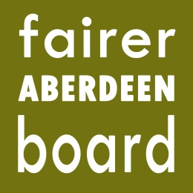

Fairer Aberdeen Board
6pm, Thursday 10th September
Town House

Agenda

- Apologies
- Minute of meeting 21st March 2015
- Minute of meeting 21st May 2015
- Additional funding to Community Support Fund
- Fairer Aberdeen Board workshops
- Maximising Income review group recommendations – report to be tabled
- Cummings Park Community Flat – verbal update
- AOCB

