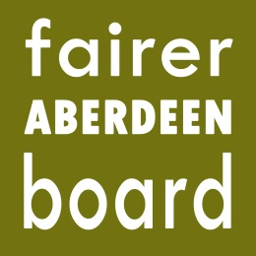

Fairer Aberdeen Board
10am, Saturday 21st March
Inspire, Beach Boulevard

Agenda

9.30 – 10am Arrival, refreshments and breakfast
- Apologies
- Funding allocation for Support Team, Community Support Fund
And Employment Support Fund – to be tabled
- Financial Inclusion review proposal – to be tabled
- Applications for funding 2015-16

We hope to be finished by 3pm at the latest, and lunch will be provided.

