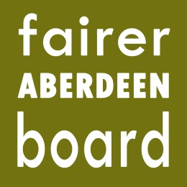

Fairer Aberdeen Board
6pm, Thursday, 29th October, 2015
Town House

Agenda

- Apologies
- Somebody Cares Application

Enclosed are additional papers relating to the above application. Please note these include CONFIDENTIAL emails and are for Board members information only.

