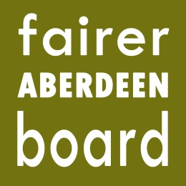
Fairer Aberdeen Board

6pm, Thursday 15th January 2015
Committee Room 5
Town House

AGENDA

- Apologies
- Note of meeting held on 27th November 2014
- Matters arising
- Applications for remaining 2014-15 funding
- Meeting dates for considering applications for 2015-16
- Meeting dates for the rest of the year
- AOCB
- Date of next meeting

