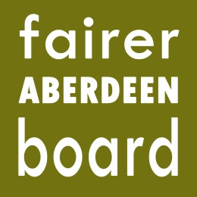
Fairer Aberdeen Board

6pm, Thursday 27th November 2014
Committee Room 5
Town House

AGENDA

- Apologies
- Note of meeting held on 13.3.14
- Matters arising
- Annual Report 2013-14
- 6 month report 2014-15
- Financial report
- Northfield Welding project update
- AOCB
- Date of next meeting

