Model for Improvement Toolkit

PDSA: Plan-Do-Study-Act

HELP SHEET 3

Why would I use this tool?

PDSA is the action component of the Model for Improvement and is a fundamental tool in improvement work.

PDSA allows the team to create new knowledge by conducting small tests of change with a minimum of risk, and build confidence in the impact of the changes proposed. Ideas with positive impact can be continued on a larger scale (PDSA ramps) to implementation while ideas that do not have a positive impact are discontinued. PDSA can be used effectively to engage staff who may be reluctant to change.

How would I use this tool differently at different stages of the Model for Improvement?

PDSA cycles can be useful in almost every phase of your improvement journey.

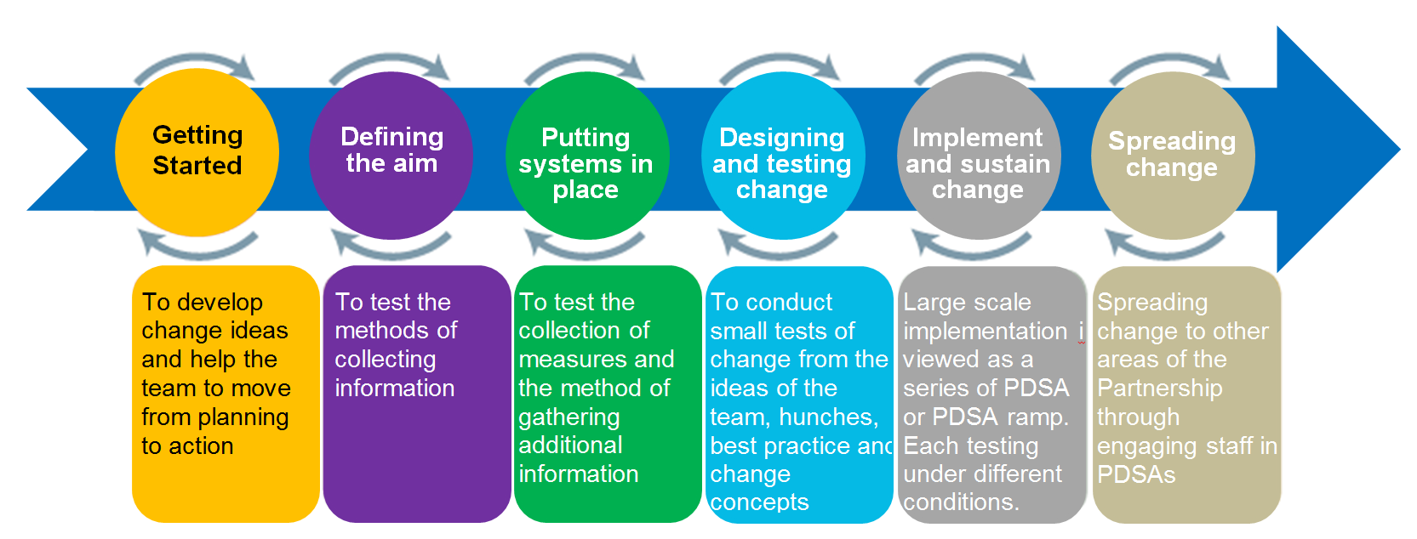
How do I use this tool?

PDSAs are carried out in a step-by-step process to build knowledge and create sustainable change.

Step 1: Plan
- Be specific about the aim of the test.
- Make predictions about what will happen and why, as this reflects beliefs about the operation of your system.
- Answer Who? What? When? Where? Questions specifically, and include a data collection plan.

Step 2: Do
- Carry out the test.
- Document the outcome of the test and other observations, positive and negative.

Step 3: Study
- Analyse the data.
- Compare the data to your predictions.
- Discuss what has been learned.

Step 4: Act
- Depending upon the results, decide whether to adapt, adopt or abandon the next test.
- Start to prepare for the next PDSA cycle.

What do I need to use this tool?
Timing

PDSAs can be done rapidly if you are clear on what you are trying to accomplish. It will depend on the frequency of the change being tested, hourly, daily, weekly?

Materials

PDSA Template
Setup

Can be done as a team or an individual

What tips and tricks will be useful in facilitating this tool?

Always complete the test in writing, including your predictions; this gives the tool structure, encourages thoughtfulness and increases the chance of success, especially when developing a change.

PDSA test cycles are best performed on a small scale – if you’re thinking “all” customers, think one or two customers. If you’re thinking “all” staff, think one staff member. If you’re thinking months, think weeks or days.

Although it is ideal to work with willing participants in carrying out a test, this approach also can work to create willingness to try something new when there is a reluctance to change.

The PDSA cycle should be determined by the team based on:

- Confidence that the change will result in an improvement, and
- The readiness of staff to accept the change.

Small tests are rarely stand alone; therefore, you should start to prepare the next test based upon your predictions. Often a change idea will go through multiple PDSA cycles as data is collected and the idea is refined (this is called a PDSA ramp); large-scale tests of changes may require multiple concurrent PDSA ramps before implementation.

PDSA template
IMPROVEMENT PROJECT TITLE

OUTCOME IMPROVEMENT GROUP
PDSA No.X, DATE

AIM OF PROJECT Overall aim of the improvement project

AIM OF PDSA Specific aim of this PDSA

PLAN

Describe test
Person responsible? When to be done? Where?

What questions do we want answered?
What measures do you have that will tell you if the test is a success?

No. | Measures
1
2
3
4

List the tasks needed to set up this test of change?
Tasks? Personal responsible? Timescale?

Predict what will happen when the test is carried out
Predictions may be positive or negative

DO
Was the test carried out? Describe what happened? Any problems or unexpected events?

Data recorded:

Measure No. | Result
1
2
3
4

STUDY

Lessons learned from the results? How do the results compare to the predictions?

ACT

Describe the modifications to the plan for the next cycle

For more information, email CommunityPlanning@aberdeencity.gov.uk

