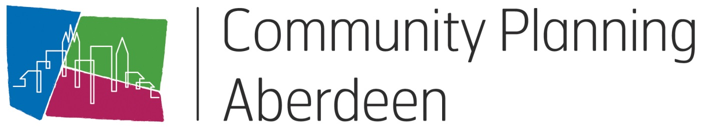

Model for Improvement Toolkit

**Annotated Run Chart**

HELP SHEET 5

**Why would I use this tool?**

Analysing data over a period of time makes it easier to assess the impact of imporvement changes. A graphical display of results through a run chart is very useful to show changes in measures across the life cycle of a project. Run charts are useful regardless of how much data you have collected. They are simple to produce and interpret, and they are guided by simple rules.

Run charts should be set up at the start of an improvement project and updated with new data as the project unfolds. Measurements are taken at frequent points in time and connected with a line. This provides a graphical display of variation across time, and can help a team see if their changes have led to improvement. An annotated run chart (see Figure below) has comments with arrows pointing to times when different ideas for improvement were tested. This helps explain any sudden changes in quality that may have occurred.

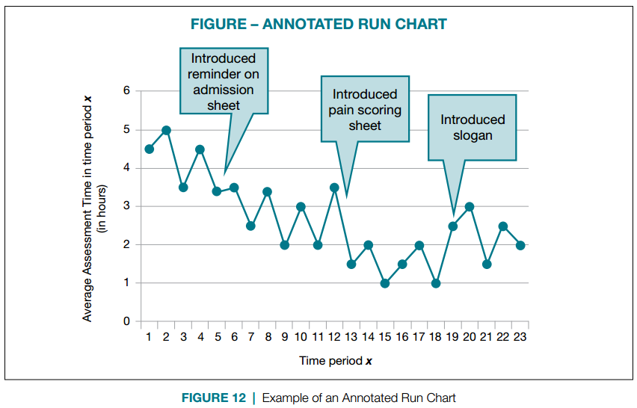

**How would I use this tool differently at different stages of the Model for Improvement?**

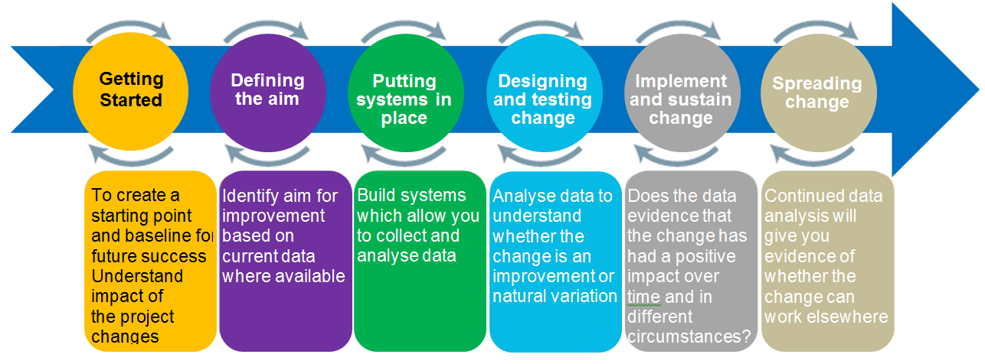

**How do I use this tool?**

1. As you gather your data, create a graph where the measure of quality is on the vertical axis and time is on the horizontal axis connect each data point with a line
2. Show your target for improvement by drawing a horizontal line across the graph, labeled ‘target’
3. Show the median point of your data by drawing a horizontal line across the graph at the level where half the data points are above, and half are below that line
4. Annotate the run chart with comments to tell the story of the different improvements the team has tried

Improvement teams can recognize significant changes — hopefully, improvements — by carrying out two simple tests on a run chart (see Figure below):

1. Are there six or more consecutive points above the median?

2. Are there six consecutive points moving upward or downward?

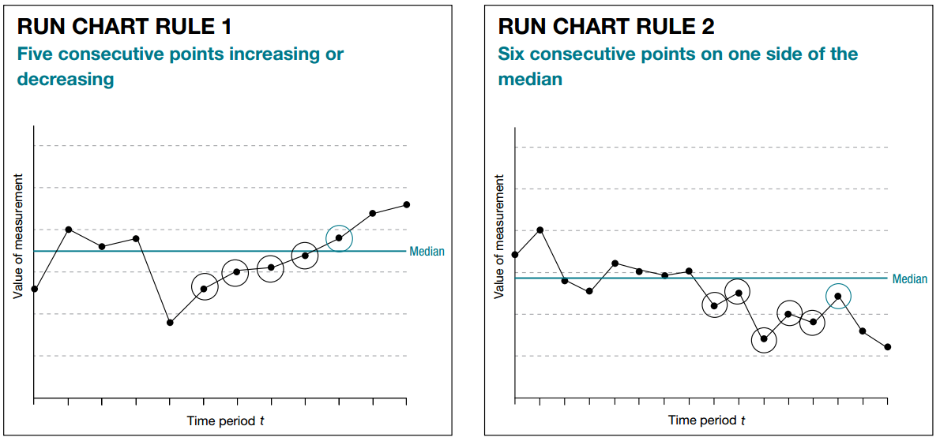

If we see evidence of either of these rules in our chart, it indicates that a significant change has occurred within the process. Now, the Improvement Team’s task is to maintain progress and continue to improve. Once a run chart has more than 11 points, consider turning it into a [control chart](https://qi.elft.nhs.uk/resource/control-charts/).

**What do I need to use this tool?**

**Materials**

Microsoft Excel

Template run chart



**Timing**

The time taken to set up the charts at the beginning of the project will depend on the number of measures. However updates will be quick to do thereafter.

**Setup**

<https://www.youtube.com/watch?v=J-PaQymHkhg>

OR

<https://www.youtube.com/watch?v=os17KYZAnd0>

**What tips and tricks will be useful in facilitating this tool?**

* Plot data over time
* Track a few key measures over time — this is the single most powerful strategy a team can use
* Try not to aggregate data (e.g., show consecutive individual customer times, rather than the percentage of patients reaching a target over a one-month period) • Display the data as soon as possible after the event

For more information, email [CommunityPlanning@aberdeencity.gov.uk](mailto:CommunityPlanning@aberdeencity.gov.uk)