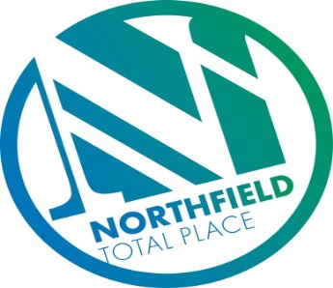

Northfield Total Place
Locality Partnership Board Meeting
Northfield Academy
Wednesday 9.30am – 11.30am 13th December 2017

AGENDA

- Welcome/introductions/membership update
- Apologies
- Minutes of previous meeting
- Matters arising/Action Tracker update
- British Red Cross– Connecting Communities
- Governance
- Tests of Change –
    - Spare Room update
    - Positive Destinations
    - Locality Voice
- Jobs Fair
- AOCB
- Date of next meeting

