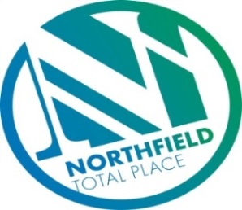

Northfield Total Place
Locality Partnership Board Meeting
Northfield Academy
Wednesday 9.15am – 11.15am 28th March 2018

AGENDA
Your Data
Aberdeen City Council holds your contact details for the purposes of two way communication. We do not share your details with a third party. If you do not wish us to hold your details, please let us know and I will delete your details. Bear in mind however that you will not receive future communications relating to these meetings. Your details will be held for as long as you attend the meetings and up to 6 months after.

- 9:15am - Welcome/introductions
- 9:20am - Apologies
- 9:25am - Minutes of previous meeting
- 9:30am - Matters arising/Action Tracker update
  - Mastrick Housing office, automatic machine to pay rent, has anyone been consulted on this?
- 9.45am - Tests of Change –
    - Circles of Community
    - Spare Room
    - Positive Destinations – (DART)
    - Locality Voice
    - Unpaid work team
    - Gaming
- 10:35am - Domestic Abuse
- 10:40am - AOCB
- 10:50am - Date of next meeting

