**Sustainable Food City Partnership Aberdeen**

**(SFCPA) Meeting** 31.05.17

**Present:**   
Dave Kilgour Aberdeen City Council  
Hilary Bell NHS Grampian  
Sinclair Laing Aberdeen City Council  
Cath Pilley The Allotment Market Stall (TAMS)  
Brian Menzies Enscape Consulting Ltd.  
Dave Simmers CFINE  
Lesley Dunbar Councillor, Aberdeen City Council  
Flora Douglas Hon. Lecturer/ Associate (Global Centre for Development) – University of Aberdeen, Visiting fellow - University of Bournemouth

**In Attendance:**Laura Penny Sustainable Food Cities Co-ordinator

**Apologies**:   
Jenny Gordon Aberdeen Health & Social Care Partnership  
Sandy McKinnon FoodStory Cafe  
Fiona Young Tillydrone Community Flat  
Angela Mitchell Soil Association

**Minute of meeting:**

* **Welcome**
* **Nomination of Chairperson:**

Dave Simmers nominated Cllr Lesley Dunbar, Dr Flora Douglas seconded.  
No other nominations were put forwards.

Cllr Dunbar appointed as Chair and Chaired the remainder of the meeting.

* **Minute of Last Meeting:**

Minutes Agreed.

Updates on Actions from last meeting:

* **Governance Structure**:   
  Dave Kilgour provided an up to date structure for the Community Planning Partnership, and confirmed that the SFCPA will report to the new ‘Sustainable City Group’ as below, with crossover into other groups:

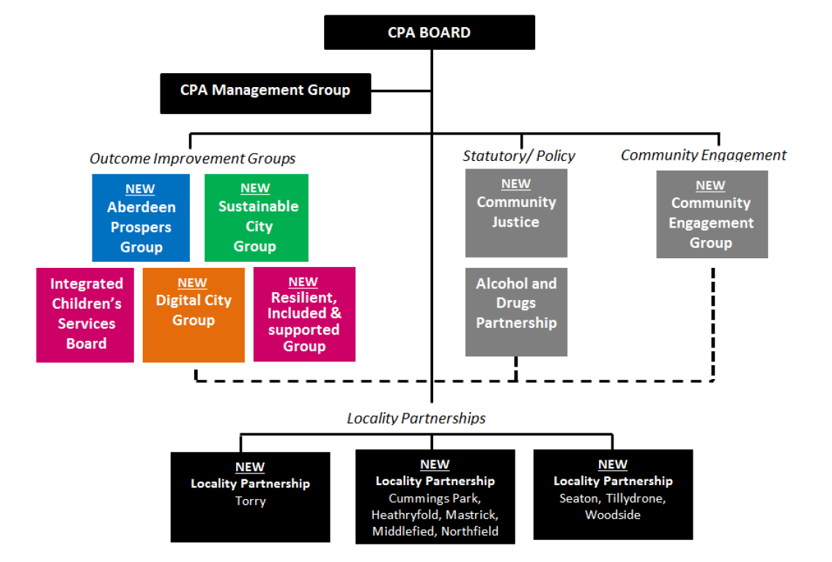

* **‘Holiday Hunger’ projects**:

Dave K updated on this. Work is being proposed in Bramble Brae, Seaton Projects, and areas in Tullos. The idea is to develop a programme of free food and fun activities during the school holidays. It’s being taken forward by the locality managers at ACC. Ideally many partners will be involved, with potential links to; AFC Community Trust, CFINE, ACC catering team etc.

The pilot took place during the Easter Holidays in Bramble Brae School. It was very positive, with involvement from AFC Community Trust. A summary/ evaluation of the pilot, including a short video created by SHMU, is available:

<https://wetransfer.com/downloads/eb729b1b54b1171885b8296b395432c020170608093430/217f61cb8504c94171c893c9f5079fe120170608093430/78f61a>

Cath Pilley added that TAMS are working on a similar idea in Seaton, where children would have the opportunity to pick local vegetables and cook with them.

**Action: Dave K to circulate the Easter Holiday Pilot summary document.**

* **European Social Funding**:

Sinclair has discussed options for funding sources with this team. They have given some options, but are checking more and will get back to him. He asked that if any food-related applications come through them to flag them up so that we are aware of them.

* **Matters Arising:**
* **Partnership Name:** There was a need to confirm the acronym being used, SFPA or SFCPA, so that there is consistency. Sustainable Food City Partnership Aberdeen (SFCPA) was agreed upon.

**Action: Laura will update any documents to ensure all read SFCPA.**

It was agreed that this name is for the partnership only and that a brand/identity for the approach needs to be developed. This could be an opportunity to engage with both the wider partnership as well as the public. The option of hosting a competition for brand and logo designs/ideas was discussed. The timeline on this is yet to be confirmed. If a competition is run, the partnership will decide on the outcome.

**Action: Laura to create Social Media pages for the partnership.**

* **ACC Food Growing funding:**

£145k has been assigned to food growing initiatives in the regeneration areas of Aberdeen. This is for delivering on the ground and innovative projects, alongside the Food Growing Strategy.

A mapping process has begun, sourcing ‘quick win’ projects i.e. established groups ready to take on work/ existing projects looking to expand. A set of criteria has been developed to show transparent decision making in where the money is spent. The criteria assess demand, sustainability, accessibility etc.

Neil from CFINE met with ACC officers to discuss an initiative in Sheddockley, as well as potential options at ‘The Grove Nursery’ site. These are on the table of ideas going forward.

Dave S added that using the money for capital – i.e. diggers, fences, security etc. is not a problem, but a challenge lies in advancing the community element of this. It will be difficult to maintain and sustain the community element, and if this is neglected the project will not be as successful.

Sinclair clarified that the criteria assesses the sustainability of projects (in terms of maintaining them ongoing) i.e. if there is an established group willing to take on the project.

Cllr Dunbar added that ‘The Grove Nursery’ does good work in terms of bringing communities of Aberdeen together. It would be good to deliver the same style of growing and community work in other locations – Stewart Park for example. The unpaid work team are based at the Stewart Park, and could perhaps be utilised for clearing/preparing land. Could aim to promote the growing of food rather than flowers.

Sinclair mentioned that options to increase the money through match-funding etc. are being explored.

Cllr Dunbar drew attention to the Health Improvement Fund which offers £2k for food related projects. This could be something we encourage each group to apply for themselves, but it was agreed it would be more beneficial if we could connect with larger organisations (e.g. NHS Grampian) who could match-fund/ contribute a larger sum.

Dave K asked if there was opportunity to use the money towards land e.g. near the hospital, Dr’s clinics etc. Cllr Dunbar suggested the opportunity to link into ‘Green Prescribing’ – NHS Health Improvements/ AH&SCP might have an interest in this.

**Action: Sinclair to contact Judith Proctor/ Tom Cowan on this topic.**

* **Action Plan implementation**
* A draft action plan was tabled at the meeting. This pulled together action points from both the ‘EAT Aberdeen’ event and the Esmee Fairburn Foundation application. This forms the basis of the SFCPA action plan, but still needs significant work to complete it.

It was agreed that each of the sub/theme groups will set key outcomes for their priority area of work. The action plan will then be refined to include this input.  
**Action: From today, the groups/SFCPA contacts who have been designated to lead each priority will look at the action plan and bring back more robust actions to the next meeting.**

It was asked whether it would be useful for each sub-group to have a memorandum of understanding to ensure they know what is expected of them and to keep everyone on the same page, regardless of what organisation they are from.

Each group must decide what they need to help lay out rules of engagement. Some groups may already have created such a document, whereas for others this might not work. Each group can determine their own needs.

**Action: The lead of each group (or SFCPA Co-ordinator if the group has not yet been established?) to determine whether a Memorandum of Understanding will be beneficial to the group.**

* **Assigning SFCPA leads for each sub-group:**

|  |  |  |
| --- | --- | --- |
| **Priority** | **SFCPA Lead Contact** | **Group to progress work** |
| 1: Promoting healthy and sustainable food. | Hilary Bell  (NHS Grampian) | To be confirmed |
| 2: Tackling food poverty, diet-related ill health and improve access to healthy food. | Dave Simmers (CFINE) | Food Poverty Action Aberdeen (FPAA) |
| 3: Building community food knowledge, skills, resources and projects | Jenny Gordon  (AH&SCP) | Aberdeen City Food Network |
| 4: Reducing waste and the ecological footprint of the food system. | Pete Lawrence (?)  (ACC Waste Team)  (Not currently on the partnership) | ACC Waste Team?  FareShare? TAMS? |

***The above priorities will be the initial focus of the partnership, with the following two developing as the approach progresses:***

|  |  |  |
| --- | --- | --- |
| **Priority** | **SFCPA Lead Contact** | **Group to progress work** |
| 5: Transforming catering and procurement | Angela Mitchell (?)  (Soil Association) | Potentially a city-wide food procurement group. |
| 6: Promoting a vibrant and diverse food economy. | ? | Cllr Dunbar suggested the SFCPA contact Cllr Laing in relation to the City Region Deal as there is a priority on Food & Drink. This could provide a link to Opportunity North East (ONE).  Also potential to set up a group made up of restaurant owners, representing the diverse food economy in Aberdeen: Musa, Moonfish café, Foodstory, Social Bite etc.  Other potential links:  Aberdeen Food Assembly,  Slow Food Aberdeen,  Cults/ Deeside Food Festival,  Aberdeen Inspired (Adrian Watson)  Aberdeen Vegan Festival. |

**Action: Laura to contact ACC Waste Team to discuss leading actions as a sub-group.**

**Action: Laura to follow up with Angela Mitchell regarding establishment of procurement group, defining what her role would be.**

**Action: Laura (with Dave K/ Cllr Dunbar?) to contact Cllr Jenny Laing on behalf of SFCPA.**

**Action: Dave K to set up meeting with Craig Innes on food procurement.**

It was agreed that the above roles should be reflected in the SFCPA Terms of Reference.  
**Action: Laura to re-circulate the SFCPA Terms of Reference.**

**Action: Dave K and Sinclair** **to add roles and responsibilities of each member of the partnership, indicating who is a member/ advisor.**

* **Discussion of SFCPA & Sugar Smart Co-ordinator Role:**
* SFCPA Co-ordinator role**:**

This role will be tied into the SFCPA Action Plan, as well as linking to the criteria set for achieving an SFC Bronze/ Silver Award.

Key tasks will include; learning from other SFC Network members, researching experience, gathering case studies of good practise etc.

The initial co-ordination of subgroups will also be required, including a degree of admin assistance etc. as they are established. (This may not be necessary for already established groups e.g. FPAA)

* Sugar Smart role:

Laura gave feedback from Sugar Smart Workshop in Liverpool, where she met other SFC Network members also preparing Sugar Smart Campaigns.

The key points were:

1. It is essential to have city-wide partner organisations who pledge their commitment and can run their own Sugar Smart projects in their organisations.
2. The Sugar Smart Campaign could potentially gather a lot of media attention (with personalised messages from Jamie Oliver etc.), and can also tap into an audience that we may not have access to otherwise. This could be beneficial for the advertisement of the SFCPA, but we must ensure it doesn’t dominate. Sugar Smart can be used as an opportunity to raise awareness about Aberdeen’s SFC approach.
3. We must be practical about what is achievable, and the work must relate to the needs of Aberdeen city.

A separate group will be set up to bring the Sugar Smart campaign forward. **Action: Laura, Hilary and Jenny to meet to progress this, and bring firmed-up actions back to the SFCPA.**

It was agreed that the partnership will select a few key projects to deliver on. Involvement from partners/ ‘Champions’ leading within their organisations will be essential. Potential links with AFC Community Trust, Sport Aberdeen, NHS Grampian, ACC etc. Information also to be sent out to wider SFC network to gather interest and commitment. There is a link to ‘Holiday Hunger’ to be developed.  
**Action: Laura to set up meeting with Ally Prockter (AFC Community Trust) to discuss plans for Sugar Smart campaign**, **Dave K to input regarding ‘Holiday Hunger’ links.**

* **SFCPA/ Sugar Smart Launch Event**
* It was agreed that it would be beneficial to host a launch event for the Aberdeen SFC approach with a Sugar Smart launch being a theme within that. This could be a Civic Reception, with attendance from the Lord Provost.

**Action: Laura (and Dave K) to contact Alistair Ross to organise this, check dates to ensure Lord Provost can attend.**

The event will be held in August/ September. By that point there should be clarity on who is taking forward each key theme (Inc. Sugar Smart), and clarity about what the offer in terms of joining the wider partnership is, as well as a ‘brand/ identity’ having been developed. The Action Plan will also be firmed up by that stage and can be presented to the attendees for consideration.

It was mentioned that it may be worth approaching a celebrity chef to be involved in the launch.

* **Sustainable Food Cities Conference 2017**
* Laura booked 3 tickets to this event; it was agreed that Laura, Lesley Dunbar and Hilary Bell would attend the event (12-13th June). Laura has been asked by Leon Ballin (Sustainable Food Cities) to give a short presentation on Aberdeen’s approach in becoming an SFC Network Member.

**Action: Laura, Lesley & Hilary to feedback to SFCPA about the conference.**

* **A.O.B:**
* Sinclair has contacted ‘Greenspace’ and will report back with progress on links to be made between them and the SFCPA.
* Dave S and Laura will be presenting at an ‘Eco Town’ event at WoodGroup on the 8th June which is being hosted by Business in the Community.
* **Next Meeting:**

The next SFCPA meeting will be held roughly 3 weeks before the launch event to firm up plans, and will be organised by email. Cllr Dunbar mentioned she will be on A/L between 1st-15th Aug.

