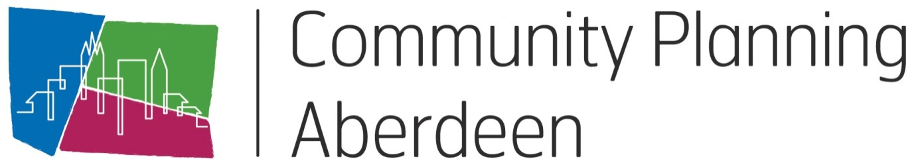

Model for Improvement
Information Pack

Contents

- Programme | 3
- Introduction | 4
- Project Charters | 5
- Driver Diagrams | 11
- Plan-Do-Study-Act Cycles | 14
- Data Measurement Plan | 19
- Annotated Run Charts | 23
- Improvement Glossary | 27
9. Additional Resources | 29

Model for Improvement Bootcamp

PROGRAMME
Tea and coffee on arrival
Welcome and purpose of today
Model for Improvement
Introduction to the Council and CPA’s chosen improvement methodology
Getting started with your improvement projects
What are you trying to accomplish?
Exercise 1: Writing an aim statement
How will we know that a change is an improvement?
Exercise 2: Identifying improvement measures
Comfort Break
What change can you make that will result in improvement?
Exercise 3: What are your change ideas?
Project charters
Exercise 4: Begin your project charter
Driver diagrams
Exercise 5: Driver diagrams
Using driver diagrams as a brainstorming tool
Exercise 6: Complete your project charter
Lunch
Tests of change using Plan, Do, Study, Act (PDSA)
Using the PDSA cycle to test changes by turning ideas into action and connecting action to learning
Exercise 7: The Airplane Challenge
The airplane challenge is a practical demonstration of how to use the PDSA cycle to learn and improve
Scaling up successful changes
Exercise 8: Complete your own PDSA plan
Collecting and using data
Using data to understand whether your changes have resulted in improvement
Comfort Break
Exercise 9: Create your own run chart
Using run charts to help you understand the variation in your data and the impact of changes
Reporting for improvement
Wrap up
Close

Introduction

What is the Model for Improvement?
The Model for Improvement has been adopted by Community Plannng Aberdeen as the chosen methodology for taking a structured approach to improvement. The model can be applied to any area of business and is designed to break down change into manageable chunks. Each small part is then tested to make sure that the things we are aiming to improve are actually improving.

Designed by the Institute of Health Improvement (IHI), it has been widely used by the Scottish Government and NHS to deliver improvements and is currently being rolled out across local government; specifically in the area of Early Years. Aberdeen’s Integrated Children’s Services Partnership has a number of improvement projects underway using this methodology.

The Model for Improvement
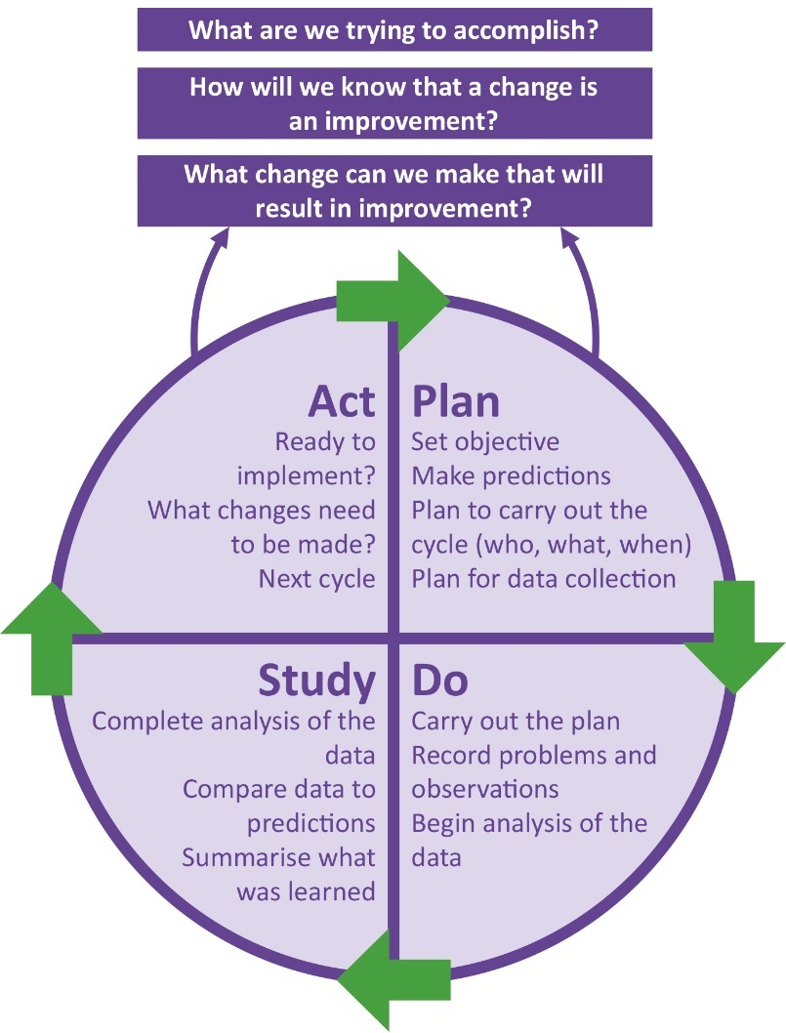
Aim: The aim should be time-specific and measurable; it should also define the specific population of patients or other system that will be affected.

Measures: Teams use quantitative measures to determine if a specific change actually leads to an improvement.

Changes: Ideas for change may come from those who work in the system or from the experience of others who have successfully improved.

Plan-Do-Study-Act Cycles: The Plan-Do-Study-Act (PDSA) cycle is shorthand for testing a change in the real work setting — by planning it, trying it, observing the results, and acting on what is learned. This is the scientific method adapted for action-oriented learning.

Improvement Project Charter

Why would I use this tool?
The Improvement Project Charter is the first step in the execution of your improvement project. It establishes the purpose, scope, measures and targets necessary to achieve success. It identifies key members of the improvement team as well as the Executive Sponser of the project. Support from the organisation leadership will help team members maintain their focus and momentum and protect them from being overloaded with other work.

An Improvement team can use this tool to plan its project, communicate with leadership and keep track of the changes being made. The Improvement Project Charter is a “live” document to be used throughout the improvement project. It is used to answer and clarify the very first question in the Model for Improvement: “What are we trying to accomplish?” The Improvement Charter is a tool that will help the Improvement Team to continuously monitor system performance, in particular during the “Designing and Testing Solutions” phase.

When would I use this tool differently at different stages of the Model for Improvement?
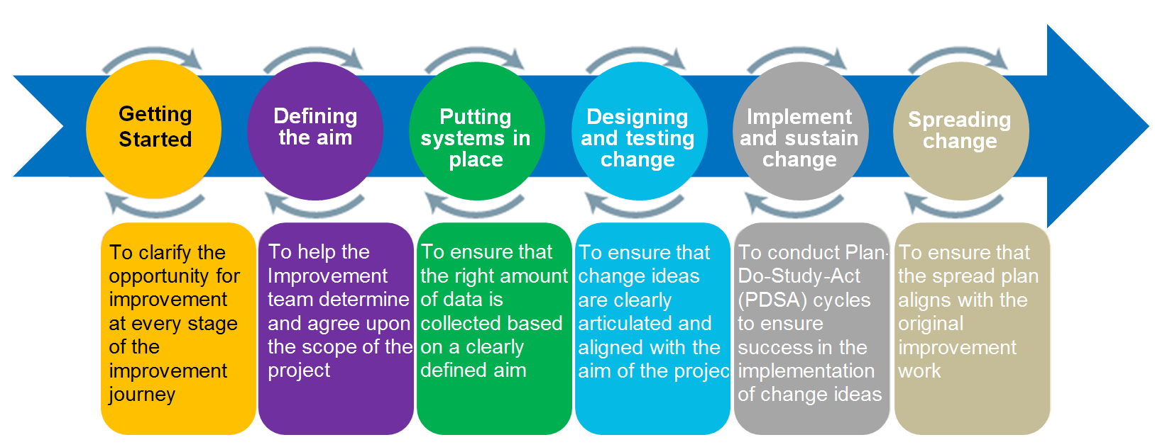

How do I use this tool?
- Gather your improvement team to discuss the opportunities for improvement that have been presented or discovered. Engage the team and other staff to discuss the background, nature and extent of the problem. Ensure that the Improvement Charter is shared with your Executive Sponsor
- Define your aim statement (how much, by when), ensuring it is SMART: Specific, measurable, achievable, realistic, timely.
- Create a timeline for each phase of your improvement project.
- Begin to define the measures that will be used to demonstrate progress. Connect measures to the goals and out-comes of the charter.
- Use the Improvement Charter at every team meeting to ensure that your activities continue to be aligned with the aims and scope of the project.

What do I need to use this tool?
Materials

Improvement Project Charter Template
Timing

It may take a couple of meetings to clearly define the scope and improvement aims of the project

Setup

The charter should be completed as a team and signed off by the relevant Outcome Improvement Group

What tips and tricks will be useful in facilitating the use of this tool?
- Engage the Improvement team at the start, rather than presenting them with a completed document for review
- Early engagement of the Improvement Team will help build momentum and generate consensus and a sense of purpose regarding aims that have been outlined in the Improvement Project Charter
- Ensure that the Improvement Project Charter is used at every meeting to provide a focus for discussion and ensure that the team regularly reflects upon its aims.
- Keep a record of ideas generated by both staff and Improvement team members.

Improvement project charter template

Improvement Project Title:

Executive Sponsor (Chair of Outcome Improvement Group):

Project Lead:

Aim statement (What are we trying to accomplish? Over what time? Numerical target for improvement?)

Link to Local Outcome Improvement Plan:

Business Case (Benefits to customers? Does this support prevention and early intervention? Are costs reduced now or in the future by addressing this issue? What published research can you draw on as evidence?)

Measures: (How will we know if a change is an improvement?)

Change ideas (What can we do that will result in improvement?)

Potential Barriers

Project Team:

Improvement Project Charter Assessment Form

Project Lead: Project Name:

Name of Assessor:

Assessment

1: Not at all 2: To a small extent 3: Somewhat 4: To a large extent 5: To a very great extent or n/a

WHAT ARE WE TRYING TO ACCOMPLISH?
Aim relates to the LOIP/ Locality Plans.
Charter description clearly states need for improvement.
Expected impact on organisation and/ or customer is clear
Improvement clearly points to process, product or service or sub-system improvement
Expected outcomes are clear and the team will know when it has completed the project
Specific, numerical goals to be attained.
Project can be completed within time frame
Total: _ out of possible 35
HOW WILL WE KNOW A CHANGE IS AN IMPROVEMENT?
An appropriate family of measures is identified
Measures identified are directly related to the project description, objectives, and goals
Historical data exist on performance of the process or product to be improved
Outcome, process, and balancing measures are specified
Measures can be collected at intervals frequent enough to assess progress on the project

Improvement in the project measures can reasonably be expected within project time frame
Total: _ out of possible 30
WHAT CHANGES CAN WE MAKE WHICH WILL RESULT IN IMPROVEMENT?
Specific issues to investigate and/or alternatives to consider are given
A concept design or change package is identified
Project constraints are defined including what is NOT to be addressed
Project is tied to specific processes or sub-systems
Initial activities or PDSA cycles are suggested
Total: _ out of possible 25

TEAM MEMBERSHIP
All appropriate subject matter knowledge is represented on the improvement team
Process owner (authority to make changes) is represented or Sponsor of team
People with detailed knowledge of the targeted system are on the team
Patients, customers or suppliers are on the team
TOTAL RATING
Total: _ out of possible 20
Total Evaluation Rating
> 85 Good Project charter definition
66-85 Consider improving or clarifying the project charter (see low ratings)
< 65 Rework or Re-evaluate the need for this improvement charter

Driver Diagrams

Why would I use this tool?
A Driver Diagram helps translate a high-level improvement goal into a logical set of related goals and sub-projects. The tool helps organise change concepts and ideas as an improvement team answers the question “what changes can we make that will result in an improvement?” Driver Diagrams are used to test theories about cause and effect and are meant to be updated throughout the project.

Example Driver Diagram

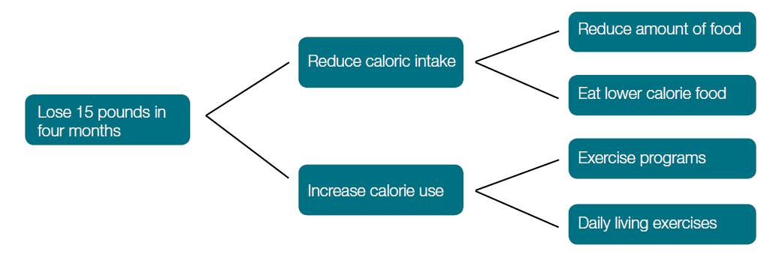

Driver Diagrams Explained

Aim or Outcome: Driver Diagrams start with a clearly defined and SMART (Specific, measurable, achievable, realistic, timely) goal.

Primary Drivers: The overall aim is linked to those factors that are believed to have a direct impact. For example, in order to lose weight we need to reduce caloric intake and increase effective caloric use. These are referred to as primary drivers because they drive the achievement of your main outcome.

Secondary Drivers: To have an effect on primary drivers, we need to carry out clearly defined actions, namely: reduce the amount of food, eat lower calorie food, join an exercise program, and increase our daily living activities (i.e. take the stairs instead of the elevator).

How would I use this tool differently at different stages of the Model for Improvement?
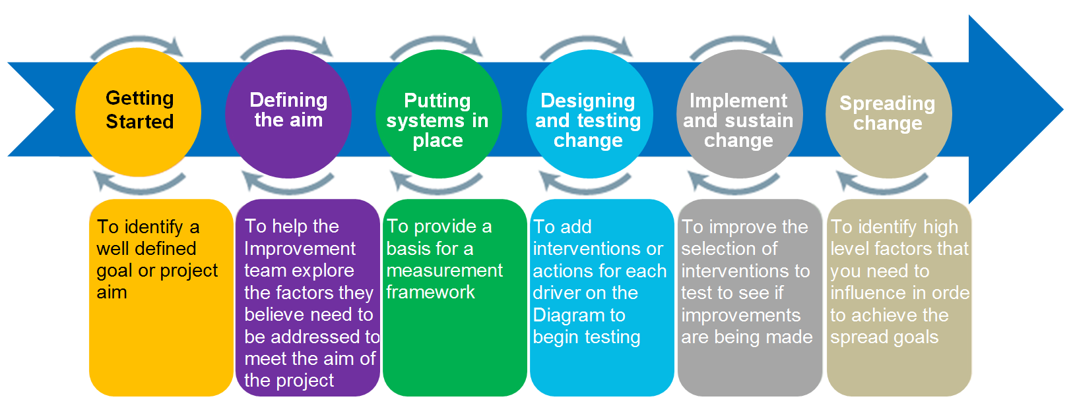

How do I use this tool?
- Convene a meeting with the improvement team and content matter experts
- Start by identifying a clearly defind goal
- Brainstorm “What changes can we make that will result in an improvement?”
- Cluster the ideas together to see if any groups of ideas represent a common driver
- Expand the groups to see if new drivers come to mind
- Localically link together the groups into a driver diagram format
- Divide which drivers and interventions you want to measure and add to the diagram

What do I need to use this tool?
Materials

Driver diagram template
Timing

Driver diagrams are ‘live’ tools and will change over time as you make changes to your system

Setup

Before beginning it is important to be clear about the aim of the improvement project. Complete as a team

What tips and tricks will be useful in facilitating the use of this tool?
- A Driver Diagram will represent the problem as seen by the group and a way to communicate the change strategy to others
- Work backwards from change concepts if that helps.
- Creating a Driver Diagram with a team ensures that all team members understand the goals and how they can contribute to achieving them
- Driver diagrams will vary from place to place – there is no definitive “right answer” as your situation may be very different from that of other organisations

Driver diagram template
You can create a simple driver diagram template using SmartArt in word. See link to video demonstration. Alternatively, just use pen and paper!
Primary Drivers
Changes to be tested to deliver the drivers

Secondary Drivers

What we are trying to achieve

PDSA: Plan-Do-Study-Act

Why would I use this tool?
PDSA is the action component of the Model for Improvement and is a fundamental tool in improvement work.PDSA allows the team to create new knowledge by conducting small tests of change with a minimum of risk, and build confidence in the impact of the changes proposed. Ideas with positive impact can be continued on a larger scale (PDSA ramps) to implementation while ideas that do not have a positive impact are discontinued. PDSA can be used effectively to engage staff who may be reluctant to change.

How would I use this tool differently at different stages of the Model for Improvement?
PDSA cycles can be useful in almost every phase of your improvement journey.
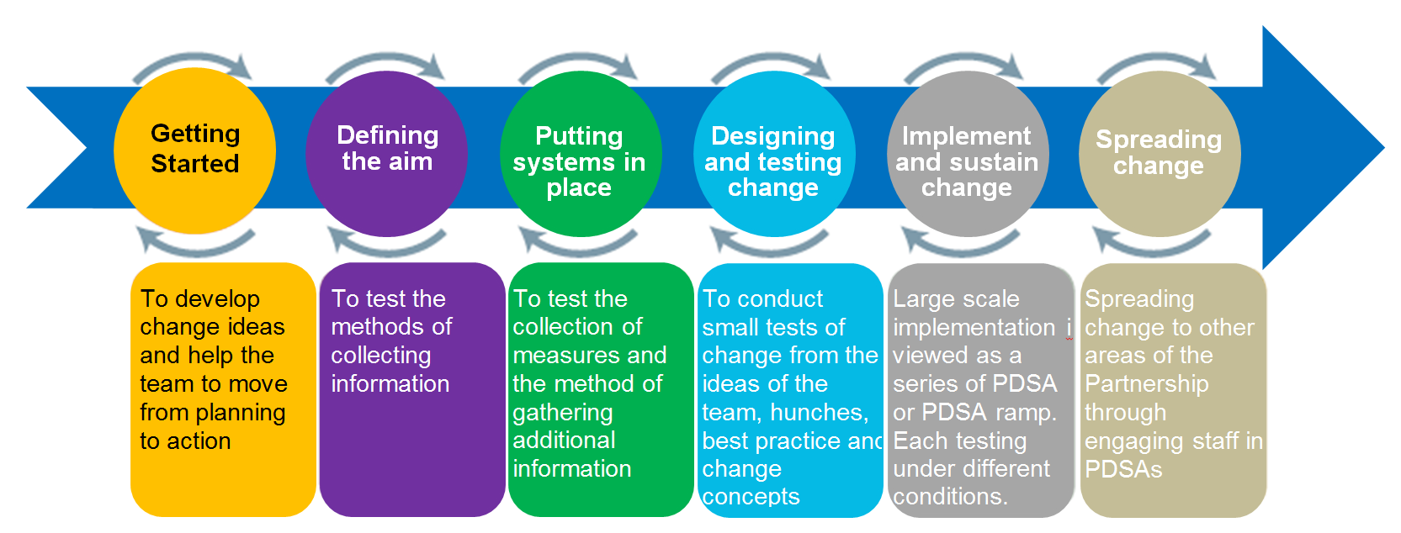
How do I use this tool?
PDSAs are carried out in a step-by-step process to build knowledge and create sustainable change.

Step 1: Plan
- Be specific about the aim of the test.
- Make predictions about what will happen and why, as this reflects beliefs about the operation of your system.
- Answer Who? What? When? Where? How? Questions specifically, and include a data collection plan with your measures.
Step 2: Do
- Carry out the test.
- Collect the data and document the outcome of the test and other observations, positive and negative. Note any deviations from the plan, e.g. lack of staff, weather, etc.
Step 3: Study
- Analyse the data and compare it to your predictions.
- Discuss what has been learned, what didn’t go to plan, do you need to run the test again?
Step 4: Act
- Depending upon the results, decide whether to adapt, adopt or abandon the next test.
- Start to prepare for the next PDSA cycle.
- Document the changes you are going to make
What do I need to use this tool?
Materials

PDSA Template
Timing

PDSAs can be done rapidly if you are clear on what you are trying to accomplish. It will depend on the frequency of the change being tested, hourly, daily, weekly?

Setup

Can be done as a team or an individual

What tips and tricks will be useful in facilitating this tool?
Always complete the test in writing, including your predictions; this gives the tool structure, encourages thoughtfulness and increases the chance of success, especially when developing a change.

PDSA test cycles are best performed on a small scale – if you’re thinking “all” customers, think one or two customers. If you’re thinking “all” staff, think one staff member. If you’re thinking months, think weeks or days.

Although it is ideal to work with willing participants in carrying out a test, this approach also can work to create willingness to try something new when there is a reluctance to change.

The PDSA cycle should be determined by the team based on:
- Confidence that the change will result in an improvement, and
- The readiness of staff to accept the change.
Small tests are rarely stand alone; therefore, you should start to prepare the next test based upon your predictions. Often a change idea will go through multiple PDSA cycles as data is collected and the idea is refined (this is called a PDSA ramp); large-scale tests of changes may require multiple concurrent PDSA ramps before implementation.

PDSA No. DATE:

AIM OF PROJECT Overall aim of the improvement project

AIM OF PDSA Specific aim of this PDSA

PLAN
Describe test
What questions do we want answered?
What measures do you have that will tell you if the test is a success?

No. | Measures
1
2
3
4
5
6

List the tasks needed to set up this test of change?
Tasks? Personal responsible? Timescale?

Predict what will happen when the test is carried out
Predictions may be positive or negative

DO
Was the test carried out? Describe what happened? Any problems or unexpected events?

Data recorded:

Measure No. | Result
1
2
3
4
5
6

STUDY
Lessons learned from the results? How do the results compare to the predictions?

ACT
Describe the modifications to the plan for the next cycle

Example PDSA Plan

BEDTIIME READING FOR VULNERABLE CHILDREN
AIM OF PROJECT 90% of the children attending Children and Families Centre will receive a bedtime story on one or more nights per week by November 2016.
AIM OF PDSA Mum B from vulnerable family reads bedtime story to Child B
PDSA No. 3 - This is the third mum we have tested with.
PLAN
Describe test
The test will be whether simply explaining the benefits of bedtime reading to mum, providing a book loved by the child and asking mum to read to the child over the course of a week (Monday to Friday) is enough to result in the child receiving a bedtime story.

What questions do we want answered?
- Did mum read during the week of the test (Mon 7 April to Fri 11 April)?
- If no, why not?
- If yes, how many times did mum read to the child during the week?
- Was the child in bed for the story?
- Did the reading relax the child in preparation for sleep?
- Did the child enjoy the experience? Reasons for yes or no?
- Did mum enjoy the experience? Reasons for yes or no?
- Would mum want to continue with bedtime reading? How often?
- Would mum want to change the book?
- Capture general observations, comments, and anecdotes.

List the tasks needed to set up this test of change? | Person responsible | When to be done | Where to be done
- Introductory chat with mum to explain the benefits of bedtime reading  - Gain commitment from mum to be involved in bedtime reading project  - Follow up chat with mum to reinforce key messages about bedtime reading and task her with reading to the child during the week  - Provision of book loved by the children at the centre for purpose of bedtime reading  - Follow up with mum and child to record findings and answers to the questions | Diane Sinclair | 4/04/16  4/04/16  7/04/16  7/04/16  16/04/16 | Children and Family Centre
Predict what will happen when the test is carried out
- Predict that mum will read a story to the child due to the one to one chat on the benefits of bedtime reading and provision of the book
- Predict that mum will find it easier to carry out bedtime reading during the week rather than at the weekend

DO
An introductory chat took place with mum to outline the benefits of bedtime reading, explain the aim of the project and to gain commitment to bedtime reading. Mum chose a book to read to the child ‘See you later, alligator’ which the family was allowed to take home. The book has a puppet integrated within the pages of the book. Mum was asked to read the story to the child during the week (Monday to Friday).
Results
Questions | Answers – Mum B (16 April 2016)
Did mum read during the week of the test (Mon 7 April to Fri 11 April)? | Yes
If yes, how many times did mum read to the child during the week? | Four times: Monday, Tuesday, Wednesday, Thursday
Was the child in bed for the story? | Yes
Did the reading relax the child in preparation for sleep? | Yes, when the puppet was not used
Did the child enjoy the experience? Reasons for yes or no? | Yes, but did not like the puppet so it was not used as part of the story. He especially enjoyed the rhyming part of the story and tried to join in.
Did mum enjoy the experience? Reasons for yes or no? | Yes. Mum does do bedtime reading normally, but usually only reads a book about Thomas the Tank Engine. She enjoyed the change.
Would mum want to continue with bedtime reading? How often? | Yes, every day on a week night (mon-thurs)
Would mum want to change the book? | Yes, she would like to change the book tomorrow
Capture general observations, comments, and anecdotes. | Money is very tight with the family. Although mum currently does bedtime reading she has very limited access to resources and was eager to be involved in the project as it would provide here with new books.

STUDY
The test succeeded. As predicted, mum found it easier to read to the child during the week rather than at the weekend. In PDSA 1 and 2 there was a focus on the mum and child choosing the book together and spending some time looking through the book before deciding to take it home. In this case mum chose the book for the child. The child did not like the puppet element of the book as it frightened him. Luckily mum was able to use the book without the puppet as she only had one other book available to her. This is an important reminder that vulnerable families have limited resources and that it is useful to encourage mum and child to choose the book together.

ACT
The next cycle will build on the lessons learned from the first three PDSAs which are: that bedtime reading during the week is easier to establish than at the weekend; that it is important that a variety of books are available and that mum and child choose the book together; that the one to one coaching is important and that further PDSAs should continue to nurture the pare
Data Measurement Plan

Why would I use this tool?
Data collection is crucial for effective, evidence-based improvement work. The Measurement plan is a checklist for examing the data collection process in all its aspects: what, how, where, when and by whom. Engaging all team members through a clear, shared plan creates understanding of the outcomes you are trying to accomplish, making it easier to implement and monitor results.

How would I use this tool differently at different stages of the Model for Improvement?
The Measurement Plan is an important tool that assists the improvement team at every stage.
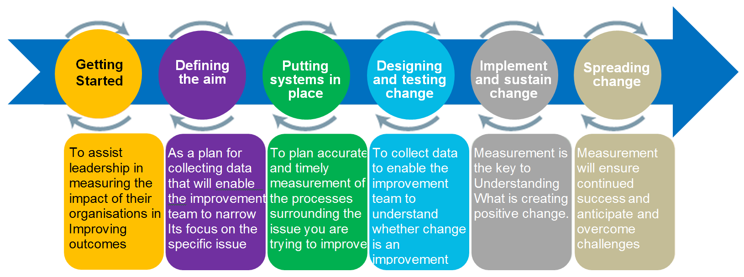

How do I use this tool?
- Bring together the Improvement Team and ensure you have representation from the staff that will be accessing the data for the plan.
- Complete the “What?” “How?” “When?” “Where?” and “Who?” sections of the Measurement Plan tool.

- Make sure to identify whether the measure is a process, outcome or balancing measure. Don’t forget to indicate the unit of measure for your data (minutes, hours, percentage, etc.).

What do I need to use this tool?
Materials

Microsoft Excel
Project charter

Timing

30-40 minutes

Setup

Familiarity with Microsoft Excel

What tips and tricks will be useful in facilitating this tool?

- The Measurement Plan should be created as soon as the team identifies its improvement aim and has mapped the process it wants to improve.
- Use lots of clarifying questions, and try not to debate hunches – a great answer to “How much data do we need?” is “Just enough.”
- Automate the collection process if possible.
- Always explore existing data sources.
- Ensure that the measurement plan is directly linked to the aim statement in the charter.

Measurement Plan Template
Name of measure  Indicate whether it’s an Outcome (O), Process (P) or Balancing (B) measure and specify type of measure (e.g. percentage / count / rate / variable / days or cases between). | Concept being measured and why it’s important to look at this  What is the purpose of this measure? | Operational definition  Clear, precise definition of the measure and how it is calculated. Include numerator and denominator if it’s a % or rate. What / who is included or excluded? | Data collection  Who is collecting it? How often and when? Where is the data coming from? What’s the sampling method and sample size (if used)? | Where are we and where do we want to be?  Baseline info and goal for this measure
e.g. Outcome  Percentage of children reaching developmental milestone in language and literacy | This measure will enable us to understand children’s developmental progress in language and literacy | % = Number of children reaching developmental milestones in language and literacy divided by total number of children in the early education and childcare class. All children in the class are included. | All children’s language and literacy skills will be assessed each month by their key worker. The key worker will record the outcome on each child’s individual overview every month for every child in their group. The Senior Early Years Practitioner will collate results for the whole class every month on the class overview | 1 October 2017 = 40% of children were reaching their developmental milestone in language and literacy.  Aim = 95% of children by 30 June 2018
e.g. Process  Percentage of children attending Talking Time  sessions | This measure will help us to understand the level of attendance at this evidenced based intervention programme | % = Number of children attending Talking Time divided by the number of children in the early education and childcare class | Senior Early Years Practitioner will record the total number of children who attend the Talking Time group every day in the identified section on the class register. | 1 October 2017 = 0% of children attend each Talking Time session  Aim = By 31 December 90% of children will be attending each Talking Time session

Different types of measures
There are three types of measures that can be used to support our improvement projects.

Outcome measures reflect the impact of changes on, for example, a pupil, a group of children or parents. An outcome measure shows us if we are on track to achieve our improvement aim, and what changes have a positive impact, such as fewer referrals or exclusions.

Improvement measures allow you to look at your existing data; for example a child’s progress tracking data and encourages you to ask “what are we doing about it?”

Examples are improved attainment for a young person or group of young people, increased attendance at community meeting, customer satisfaction level. Think creatively about what you track: for instance, an improved outcome may be evidenced from a reduction in negative factors.

Process measures relate to the changes we put in place to achieve our aim. These measures help us understand if interventions are being carried out as often / reliably as we planned to or assumed they were.

If we fail to see the outcome we seek there are two explanations: our theory is incorrect i.e. the process does not achieve the outcome expected; or the theory is right but things are not happening as reliably as thought. If we don’t deliver the interventions we think are necessary why would we expect to see the outcome we hope for? Process measurement allows us to separate these two possibilities.

Examples include, time spent on a particular task, number of events held (of those we planned to do), number of people attending training.

Balancing measures show whether unintended consequences have been introduced elsewhere in the system. For example the aim of an improvement might be to improve the attainment of the lowest 20% of young people by coaching them in class.

As a balancing measure you might wish to track if the additional time spent with these pupils has a negative impact on the attainment or behaviour of the rest of the class. increase in crime rates in a different area, decrease in footfall at other attractions, increase in complaints about change ideas.

You may not know what your balancing measures will be before you begin your improvement. The complexity of the work may mean the knock-on effect happens elsewhere, for this reason make sure you are sharing what you are doing and keep communication open. If other people identify a change – be it positive or negative – you can address and monitor it early.

Annotated Run Chart

Why would I use this tool?
Analysing data over a period of time makes it easier to assess the impact of imporvement changes. A graphical display of results through a run chart is very useful to show changes in measures across the life cycle of a project. Run charts are useful regardless of how much data you have collected. They are simple to produce and interpret, and they are guided by simple rules.

Run charts should be set up at the start of an improvement project and updated with new data as the project unfolds. Measurements are taken at frequent points in time and connected with a line. This provides a graphical display of variation across time, and can help a team see if their changes have led to improvement. An annotated run chart (see Figure below) has comments with arrows pointing to times when different ideas for improvement were tested. This helps explain any sudden changes in quality that may have occurred.
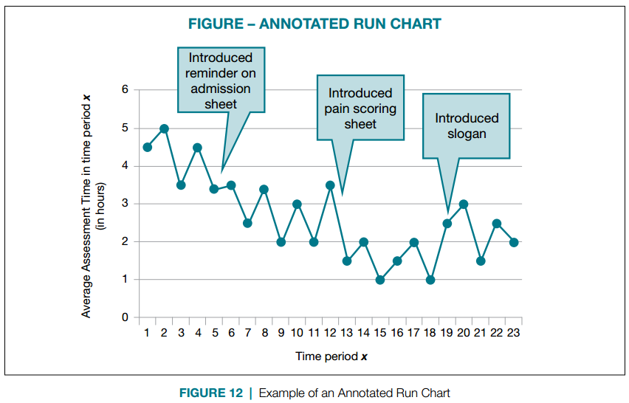

How would I use this tool differently at different stages of the Model for Improvement?

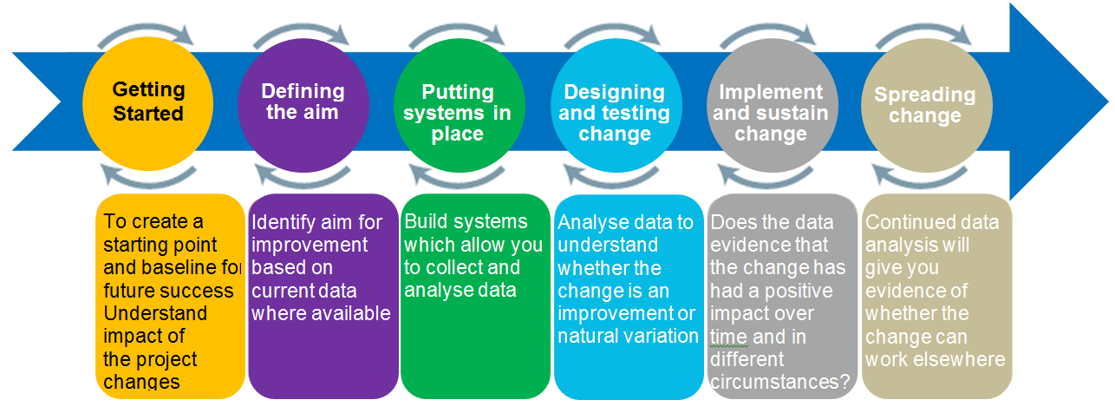

How do I use this tool?
- As you gather your data, create a graph where the measure of quality is on the vertical axis and time is on the horizontal axis connect each data point with a line
- Show your target for improvement by drawing a horizontal line across the graph, labeled ‘target’
- Show the median point of your data by drawing a horizontal line across the graph at the level where half the data points are above, and half are below that line
- Annotate the run chart with comments to tell the story of the different improvements the team has tried

Improvement teams can recognize significant changes — hopefully, improvements — by carrying out two simple tests on a run chart (see Figure below):

1. Are there six or more consecutive points above the median?
2. Are there six consecutive points moving upward or downward?

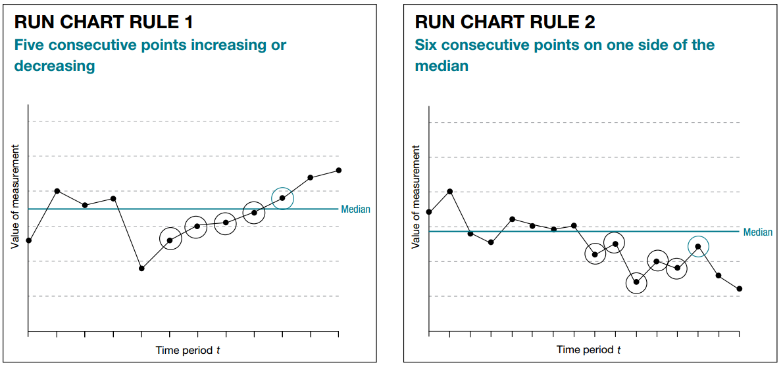

If we see evidence of either of these rules in our chart, it indicates that a significant change has occurred within the process. Now, the Improvement Team’s task is to maintain progress and continue to improve. Once a run chart has more than 11 points, consider turning it into a control chart.

What do I need to use this tool?
Materials

Microsoft Excel
Timing

The time taken to set up the charts at the beginning of the project will depend on the number of measures. However updates will be quick to do thereafter.

Setup
https://www.youtube.com/watch?v=J-PaQymHkhg
OR
https://www.youtube.com/watch?v=os17KYZAnd0

What tips and tricks will be useful in facilitating this tool?
- Plot data over time
- Track a few key measures over time — this is the single most powerful strategy a team can use
- Try not to aggregate data (e.g., show consecutive individual customer times, rather than the percentage of patients reaching a target over a one-month period). Display the data as soon as possible after the event

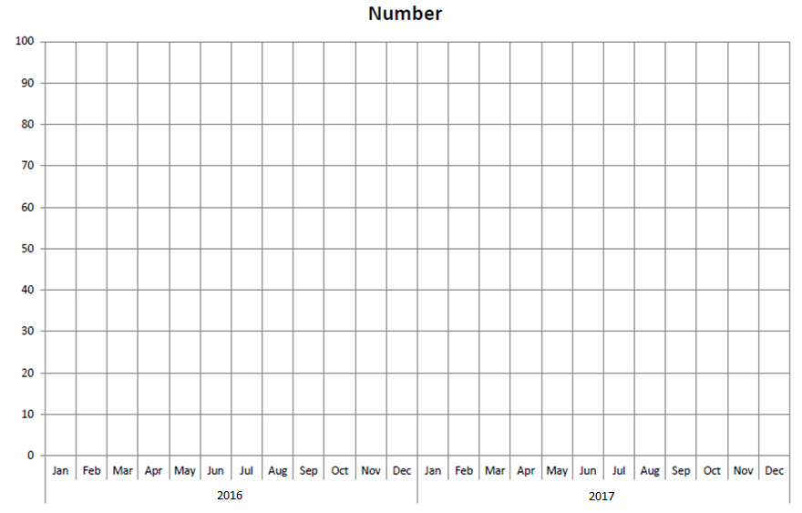
Exercise 8: Creating your own Run Chart

Improvement Glossary

Aim or Aim Statement: A written, measurable, and time-sensitive statement of the expected results of an improvement project.

Annotated Run Chart: A line chart showing results of improvement efforts plotted over time.
The changes made are noted on the line chart at the time they occur. This allows the viewer to connect changes made with specific results.

Change Idea: A general idea for changing a process that will be tested in your improvement project.

Early Adopter: In the improvement process, an opinion leader within the organisation who brings in new ideas from the outside, tries them, and uses positive results to persuade others in the organisation to adopt the successful changes.

Implementation: Taking a change and making it a permanent part of the system. A change may be tested first and then implemented throughout the organisation.

Improvement Team: The group of individuals, usually from multiple disciplines, that drives and participates in the improvement process.

Measure: A focused, reportable unit that will help a team monitor its progress towards achieving its improvement aim. Key measures should be focused, clarify your team’s aim, and be reportable. A measure is used to track the delivery of proven interventions and to monitor progress over time. Improvement measures can be divided into three classifications: outcome, process, and balancing.

Measurement Plan: A specific description of the data to be collected, the interval of data collection and the subjects from whom the data will be collected. It emphasizes the importance of gathering samples of data and how to obtain “just enough” information

Model for Improvement: An approach to process improvement which helps teams accelerate the adoption of proven and effective changes. A framework for improvement that involves asking three key questions - What are we trying to accomplish? How will we know that a change is an improvement? What changes can we make that will result in an improvement?

PDSA Cycle: A structured trial of a process change:
- Plan - a specific planning phase
- Do - a time to try the change and observe what happens
- Study - an analysis of the results of the trial
- Act - devising next steps based on the analysis
This PDSA cycle will naturally lead to the Plan step of a subsequent cycle.

PDSA Ramp: one change idea that is composed of multiple PDSA cycles.

Process Change: A specific change in a process in the organisation. More focused and detailed than a change concept, a process change describes what specific changes should occur.

Process Mapping: Activities involved in defining exactly what an organisation or part of an organisation does, who is responsible, to what standard a process should be completed and how success can be determined.

Quality Improvement (QI): QI is a formal approach to the analysis of performance and systematic efforts to improve it. There are various methods or models of QI such as total quality management (TQM), continuous quality improvement (CQI), Six Sigma, LEAN, and more. All QI models are aimed at improving performance.

Run Chart: A graphic representation of data over time, also known as a ‘time series graph’ or ‘line graph’. This type of data display is particularly effective for process improvement activities.

Spread: The intentional and methodical expansion of the number and type of people, units, or organisations using the improvements.

Test: A small-scale trial of a new approach or a new process. A test is designed to learn if the change results in improvement and to fine-tune the change to fit the organisation and patients. Tests are carried out using one or more PDSA cycles.

Additional resources

We have a range of resources available on our website. These include access to a variety of helpful websites on improvement, YouTube videos and some e-learning materials from the NHS.
We also have a KHub specifically for Improvement Practitioners who are part of Community Planning Aberdeen.
If you have any further questions please email us at communityplanning@aberdeencity.gov.uk.

