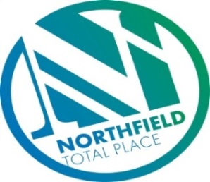

Northfield Total Place
Locality Partnership Board Meeting
Northfield Academy
Wednesday 9.15am – 11.15am 29th August 2018

AGENDA
Your Data
Aberdeen City Council holds your contact details for the purposes of two way communication. We do not share your details with a third party. If you do not wish us to hold your details, please let us know and I will delete your details. Bear in mind however that you will not receive future communications relating to these meetings. Your details will be held for as long as you attend the meetings and up to 6 months after.

- 9:15am - Welcome/introductions
- 9:20am - Apologies
- 9:25am - Minutes of previous meeting
- 9.30am - Universal Credit Presentation(30 mins) – Angela Kazmierczak and Kirsty Jarman (DWP)
- 10am - Progress through Positive Partnership – Angela Taylor
- 10.15am - Tests of Change –
    - Unpaid work team (FG)
    - Circles of Community (FG)
    - Spare Room (MS)
    - Positive Destinations – (GLC) Good Life Choices (AD)
    - Locality Voice (FG)
    - Gaming (MG)
    - Food and Fun (KD)
- 10:45am – Middlefield Triangle Redevelopment
- 10:50am - Locality Plan Annual Update
- 11am - AOCB
- 11:10am - Date of next meeting and close

