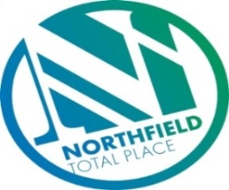

Northfield Total Place
Locality Partnership Board Meeting
Northfield Academy
Wednesday 9.15am – 11.15am 7th November 2018

AGENDA
Your Data
Aberdeen City Council holds your contact details for the purposes of two way communication. We do not share your details with a third party. If you do not wish us to hold your details, please let us know and I will delete your details. Bear in mind however that you will not receive future communications relating to these meetings. Your details will be held for as long as you attend the meetings and up to 6 months after.

- 9:15am - Welcome/introductions
- 9:20am - Apologies
- 9:25am - Minutes of meeting on 29th August 2018
- 9.30am - Locality Plan Tracker review
- 9.35am - Fran Smith, Community Builder
- 9.40am - H&SCP areas – (3 from 2019)
- 10am – Middlefield Triangle Redevelopment and Haudagain – (Housing)
- 10.10am – Police Scotland Update (Inspector Main)
  - Oldtown/Marchburn Engagement Event on 31st October - feedback
  - Report back from NYAG

- 10.20am - Tests of Change
  - (GLC) Good Life Choices (AD)
  - Gaming (HG)
  - Food and Fun (FG)
  - Unpaid work team (FG)
  - Circles of Community (FG)
  - Spare Room (MS)

- 10:45am - Locality Plan Annual Report Update (FG)
- 11am – Northfield Partnership Forum (FG)
  - Links to Locality Board
  - Inspection
  - CLD Plan

- 11.10am – AOCB
- Northfield Community Council – appeal for interest
- 11:15am - Date of next meeting and close

