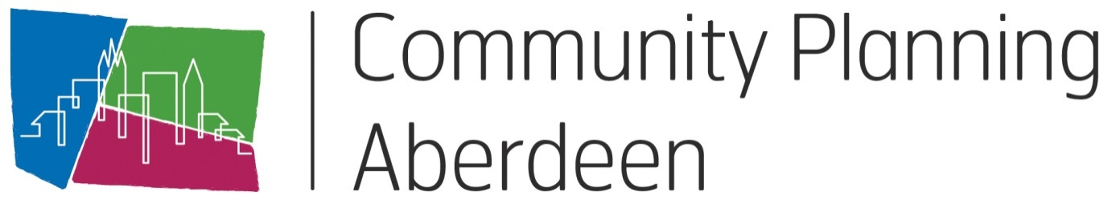

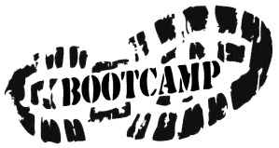

Model for Improvement
Information Pack

Contents

- Programme | 3
- Introduction | 4
- Project Charters | 5
- Driver Diagrams | 10
- Plan-Do-Study-Act Cycles | 11
- Data Measurement Plan | 15
- Run Charts | 17
- Improvement Glossary | 18
9. Additional Resources | 20

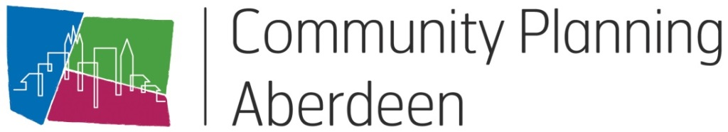

Model for Improvement Bootcamp

PROGRAMME
Tea and coffee on arrival
Welcome and purpose of today
Model for Improvement
Introduction to the Council and CPA’s chosen improvement methodology
Getting started with your improvement projects
What are you trying to accomplish?
Exercise 1: Writing an aim statement
How will we know that a change is an improvement?
Exercise 2: Identifying improvement measures
Comfort Break
What change can you make that will result in improvement?
Exercise 3: What are your change ideas?
Project charters
Exercise 4: Begin your project charter
Driver diagrams
Exercise 5: Driver diagrams
Using driver diagrams as a brainstorming tool
Exercise 6: Complete your project charter
Lunch
Tests of change using Plan, Do, Study, Act (PDSA)
Using the PDSA cycle to test changes by turning ideas into action and connecting action to learning
Exercise 7: The Aeroplane Challenge
The aeroplane challenge is a practical demonstration of how to use the PDSA cycle to learn and improve
Scaling up successful changes
Exercise 8: Complete your own PDSA plan
Collecting and using data
Using data to understand whether your changes have resulted in improvement
Comfort Break
Exercise 9: Create your own run chart
Using run charts to help you understand the variation in your data and the impact of changes
Reporting for improvement
Wrap up
Close

Introduction

What is the Model for Improvement?
The Model for Improvement has been adopted by Community Plannng Aberdeen as the chosen methodology for taking a structured approach to improvement. The model can be applied to any area of business and is designed to break down change into manageable chunks. Each small part is then tested to make sure that the things we are aiming to improve are actually improving.

Designed by the Institute of Health Improvement (IHI), it has been widely used by the Scottish Government and NHS to deliver improvements and is currently being rolled out across local government; specifically in the area of Early Years. Aberdeen’s Integrated Children’s Services Partnership has a number of improvement projects underway using this methodology.

The Model for Improvement

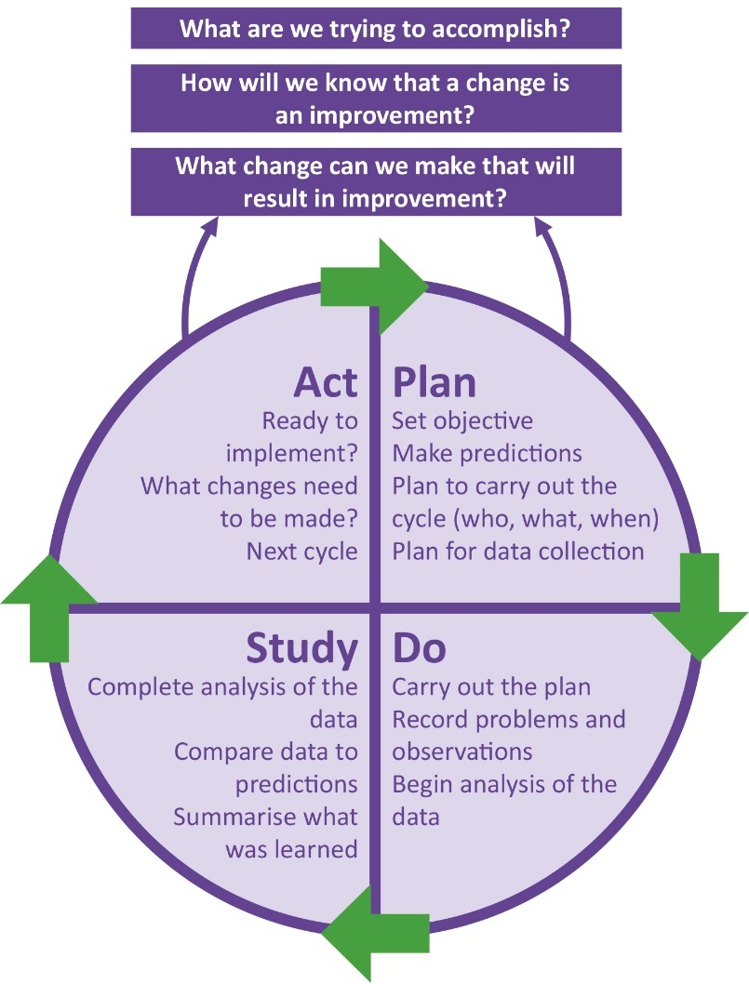
Aim: The aim should be time-specific and measurable; it should also define the specific population of patients or other system that will be affected.

Measures: Teams use quantitative measures to determine if a specific change actually leads to an improvement.

Changes: Ideas for change may come from those who work in the system or from the experience of others who have successfully improved.

Plan-Do-Study-Act Cycles: The Plan-Do-Study-Act (PDSA) cycle is shorthand for testing a change in the real work setting — by planning it, trying it, observing the results, and acting on what is learned. This is the scientific method adapted for action-oriented learning.

Improvement Project Charter and Project Stage Assessment Tool

Improvement Project Charter

Improvement Project Title:

Executive Sponsor (Chair of Outcome Improvement Group or Locality Partnership):

Project Lead:

Aim statement (What are we trying to accomplish? Over what time? Numerical target for improvement?)

Link to Local Outcome Improvement Plan:

Why is this important (The rationale/business case for the improvement project: Does this support prevention and early intervention? Benefit to clients/ stakeholders/ residents? Are costs reduced now or in the future by addressing this issue? What published research can you draw on as evidence?)

Measures: (How will we know if a change is an improvement?)

- Outcome measures
- Process measures
- Balancing measures

Change ideas (What changes can be made that will result in improvement?)

Potential risks and/or barriers to success & actions to address these

Project Team:

Outline Project Plan - Set out your initial plan about the timeline for your project.
(This should be reviewed regularly)
Project Stage | Actions | Timescale
Getting Started  (Project Score 1-3) | What initial activities are required to get started? (Forming the improvement team; developing the project charter; gathering and analysing baseline data; understanding the current system) | When do you expect to complete this stage?
Designing and Testing Changes  (Project Score 4-7) | What activities are required to start testing changes? (Identifying changes and prioritising; engagement with customers & colleagues; Identifying the people, place to start testing) | When do you expect to complete this stage?
Implementing and sustaining changes that demonstrate improvement  (Project Score 7-10) | What actions would be required to implement and sustain the changes that have resulted in improvement? (Training?; Changes to procedures?; changes to resources?) | When do you expect to complete this stage?
Spreading Changes  (Project Score 9-10) | What actions are required to reach the full scale of the project? (Engagement of other teams/colleagues; other locations?) | When do you expect to complete this stage?

Improvement Project Stage Assessment Tool

Score | Stage of Project | Description
1 | Project area identified and agreed | Project has been identified as a priority from the Local Outcome Improvement Plan or Locality Plan
2 | Project Charter and team in place | Draft Improvement Project Charter has been developed (rationale, initial aims, scope, resources, timescales, measures, expected outcomes) and project team formed.
3 | Understanding baseline of current system | Current system is being analysed- applying tools such as process mapping; cause & effect diagrams etc to understand processes and people, including readiness for change and analysis of baseline data
4 | Project Charter is endorsed by Community Planning Aberdeen Management Group | Knowledge of the system and other evidence of what could work have been brought together into a theory of change. This has been articulated in a final Improvement Project Charter which has been shared with the appropriate strategic leadership group e.g. Community Planning Aberdeen Management Group. (A driver diagram may also be developed to support this stage.)
5 | Change ideas and project measures developed | Range of specific change ideas developed further, measurement plans established and initial PDSAs are being planned
6 | Testing underway | Testing strategy developed and is being deployed. Data being gathered and analysed (e.g. through use of run charts)
7 | Initial indications of improvement | Anecdotal evidence or feedback that changes are resulting in improvement can be reported.
8 | Improvements achieved | Evidence of improvements shows in project measures and has been reported to Community Planning Aberdeen Management Group. Implementation and Spread plans are being developed and deployed.
9 | Sustainable improvement | Implementation plans have been deployed for key changes. Spread plans are developed if appropriate. Data indicates sustainability of impact of changes implemented in system.
10 | Project complete | The aim has been met or exceeded and improvement sustained and spread where appropriate. Changes are now part of business as usual.

Improvement Project Charter Assessment Form

Project Lead: Project Name:

Name of Assessor:

Assessment

1: Not at all 2: To a small extent 3: Somewhat 4: To a large extent 5: To a very great extent or n/a

WHAT ARE WE TRYING TO ACCOMPLISH?
Aim relates to the LOIP/ Locality Plans.
Charter description clearly states need for improvement.
Expected impact on organisation and/ or customer is clear
Improvement clearly points to process, product or service or sub-system improvement
Expected outcomes are clear and the team will know when it has completed the project
Specific, numerical goals to be attained.
Project can be completed within time frame
Total: _ out of possible 35
HOW WILL WE KNOW A CHANGE IS AN IMPROVEMENT?
An appropriate family of measures is identified
Measures identified are directly related to the project description, objectives, and goals
Historical data exist on performance of the process or product to be improved
Outcome, process, and balancing measures are specified
Measures can be collected at intervals frequent enough to assess progress on the project

Improvement in the project measures can reasonably be expected within project time frame
Total: _ out of possible 30
WHAT CHANGES CAN WE MAKE WHICH WILL RESULT IN IMPROVEMENT?
Specific issues to investigate and/or alternatives to consider are given
A concept design or change package is identified
Project constraints are defined including what is NOT to be addressed
Project is tied to specific processes or sub-systems
Initial activities or PDSA cycles are suggested
Total: _ out of possible 25

TEAM MEMBERSHIP
All appropriate subject matter knowledge is represented on the improvement team
Process owner (authority to make changes) is represented or Sponsor of team
People with detailed knowledge of the targeted system are on the team
Patients, customers or suppliers are on the team
TOTAL RATING
Total: _ out of possible 20
Total Evaluation Rating
> 85 Good Project charter definition
66-85 Consider improving or clarifying the project charter (see low ratings)
< 65 Rework or Re-evaluate the need for this improvement charter

Driver diagram template
You can create a simple driver diagram template using SmartArt in word. See link to video demonstration. Alternatively, just use pen and paper!
Primary Drivers
Changes to be tested to deliver the drivers

Secondary Drivers

What we are trying to achieve

PDSA: Plan-Do-Study-Act Plan
PDSA No. DATE:

AIM OF PROJECT Overall aim of the improvement project

AIM OF PDSA Specific aim of this PDSA

PLAN
Describe test
What questions do we want answered?
What measures do you have that will tell you if the test is a success?

No. | Measures
1
2
3
4
5
6

List the tasks needed to set up this test of change?
Tasks? Personal responsible? Timescale?

Predict what will happen when the test is carried out
Predictions may be positive or negative

DO
Was the test carried out? Describe what happened? Any problems or unexpected events?

Data recorded:

Measure No. | Result
1
2
3
4
5
6

STUDY
Lessons learned from the results? How do the results compare to the predictions?

ACT
Describe the modifications to the plan for the next cycle

Example PDSA Plan
INCREASE PHYSICAL ACTIVITY IN TILLYDRONE
AIM OF PROJECT Increase by 50% the number of people by who report undertaking 30 mins of exercise, five times a week in Tillydrone by October 2019
AIM OF PDSA Increase attendance at walking group for new parents
PDSA No. 2 – we tested with four parents initially.
PLAN
Describe test
The test will be to see if by changing the time of the walk to after school drop off time will increase the number of parents attending.
What questions do we want answered?
- Has the change of time increased uptake?
- Will the starting point at the primary school at that time encourage more parents to attend?
- Did participants feel better for having walked?
- Capture general observations, comments, and anecdotes.
- Will we reach our goal of 6 people attending the walking group?
List the tasks needed to set up this test of change? | Person responsible | When to be done | Where to be done
- Put posters up in primary school and other locations (e.g. local shop, sport centre and community centre)  - Gain commitment from other parents to publicise by word of mouth at other groups to be involved in bedtime reading project  - Set up event on Facebook and publicise on locality group page | Mum 1, Walk Leader, Community Development Officer  Community Development Worker  Community Development worker | 8/3/2019  8/3/2019  28/2/2019 | Primary School
Predict what will happen when the test is carried out
- Predict that two more parents will join the group as will see other parents from school.
- Other parents will be interested but cannot join due to other commitments.
DO
The change of time had an impact and four new mums participated. There was more interest from others at the school who said they would like to join next time. The route wasn’t the easiest for those with a pram or buggy. However, the weather meant that two of the previous participants didn’t join due to risk of rain.

STUDY
The test succeeded. We exceeded our prediction and other parents wanted to join but publicity of the walk hadn’t reached them. The parents all reported better and more active in a group situation with low impact exercise. The route needs to be changed slightly as the pavements were not very flat in areas, so it was hard to get prams and buggy’s over tree roots. A suggestion was made to include another primary school on the way from a parent whose child attends.
ACT
The next cycle will build on the lessons learned from the first two, that after an event that people are already out for means that more people are likely to join. The route will be adapted by the walk leader and will be slightly longer to incorporate the other school.

Data Measurement Plan

Name of measure  Indicate whether it’s an Outcome (O), Process (P) or Balancing (B) measure and specify type of measure (e.g. percentage / count / rate / variable / days or cases between). | Concept being measured and why it’s important to look at this  What is the purpose of this measure? | Operational definition  Clear, precise definition of the measure and how it is calculated. Include numerator and denominator if it’s a % or rate. What / who is included or excluded? | Data collection  Who is collecting it? How often and when? Where is the data coming from? What’s the sampling method and sample size (if used)? | Where are we and where do we want to be?  Baseline info and goal for this measure
e.g. Outcome  % of people reporting 30 mins of exercise, 5 times per week | This measure will enable us to see if local residents are becoming more active | % = Number of people reporting 30 mins of exercise, 5 times a week divided by total number of people completing the question in the monthly household survey. | Monthly survey of 50 households in the Tillydrone area (as part of wider community data collection process). | 1 October 2018 = 10% of respondents reported exercise 30 mins, five times a week.  Aim = Increase by 50% the number of people who report undertaking 30 mins of exercise, five times a week in Tillydrone by October 2019.
e.g. Process  # of people attending fitness activities each week in Tillydrone Hub | This measure will help us to understand the level of attendance at fitness activities in the Hub each week | # = Number of individual people attending the fitness activities held at Tillydrone Hub every week. | Individual attendance records are collated weekly on a Monday to provide the number of individuals who have attended fitness activities for the previous week. | 1 October 2018 = 40 individual people attended classes over the previous week.  Aim = By 31 December 2018 a minimum of 70 individual people will attend classes every week at the Tillydrone Hub.

Different types of measures
There are three types of measures that can be used to support our improvement projects.

Outcome measures reflect the impact of changes on, for example, a pupil, a group of children or parents. An outcome measure shows us if we are on track to achieve our improvement aim, and what changes have a positive impact, such as fewer referrals or exclusions.

Improvement measures allow you to look at your existing data; for example a child’s progress tracking data and encourages you to ask “what are we doing about it?”

Examples are improved attainment for a young person or group of young people, increased attendance at community meeting, customer satisfaction level. Think creatively about what you track: for instance, an improved outcome may be evidenced from a reduction in negative factors.

Process measures relate to the changes we put in place to achieve our aim. These measures help us understand if interventions are being carried out as often / reliably as we planned to or assumed they were.

If we fail to see the outcome we seek there are two explanations: our theory is incorrect i.e. the process does not achieve the outcome expected; or the theory is right but things are not happening as reliably as thought. If we don’t deliver the interventions we think are necessary why would we expect to see the outcome we hope for? Process measurement allows us to separate these two possibilities.

Examples include, time spent on a particular task, number of events held (of those we planned to do), number of people attending training.

Balancing measures show whether unintended consequences have been introduced elsewhere in the system. For example the aim of an improvement might be to improve the attainment of the lowest 20% of young people by coaching them in class.

As a balancing measure you might wish to track if the additional time spent with these pupils has a negative impact on the attainment or behaviour of the rest of the class. increase in crime rates in a different area, decrease in footfall at other attractions, increase in complaints about change ideas.

You may not know what your balancing measures will be before you begin your improvement. The complexity of the work may mean the knock-on effect happens elsewhere, for this reason make sure you are sharing what you are doing and keep communication open. If other people identify a change – be it positive or negative – you can address and monitor it early.

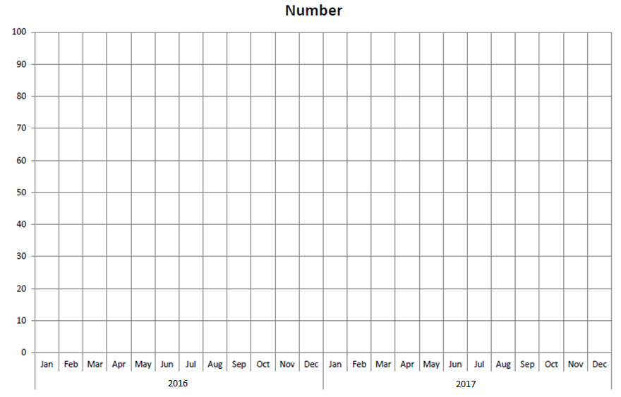
Run Chart

Improvement Glossary

Aim or Aim Statement: A written, measurable, and time-sensitive statement of the expected results of an improvement project.

Annotated Run Chart: A line chart showing results of improvement efforts plotted over time.
The changes made are noted on the line chart at the time they occur. This allows the viewer to connect changes made with specific results.

Change Idea: A general idea for changing a process that will be tested in your improvement project.

Early Adopter: In the improvement process, an opinion leader within the organisation who brings in new ideas from the outside, tries them, and uses positive results to persuade others in the organisation to adopt the successful changes.

Implementation: Taking a change and making it a permanent part of the system. A change may be tested first and then implemented throughout the organisation.

Improvement Team: The group of individuals, usually from multiple disciplines, that drives and participates in the improvement process.

Measure: A focused, reportable unit that will help a team monitor its progress towards achieving its improvement aim. Key measures should be focused, clarify your team’s aim, and be reportable. A measure is used to track the delivery of proven interventions and to monitor progress over time. Improvement measures can be divided into three classifications: outcome, process, and balancing.

Measurement Plan: A specific description of the data to be collected, the interval of data collection and the subjects from whom the data will be collected. It emphasizes the importance of gathering samples of data and how to obtain “just enough” information

Model for Improvement: An approach to process improvement which helps teams accelerate the adoption of proven and effective changes. A framework for improvement that involves asking three key questions - What are we trying to accomplish? How will we know that a change is an improvement? What changes can we make that will result in an improvement?

PDSA Cycle: A structured trial of a process change:
- Plan - a specific planning phase
- Do - a time to try the change and observe what happens
- Study - an analysis of the results of the trial
- Act - devising next steps based on the analysis
This PDSA cycle will naturally lead to the Plan step of a subsequent cycle.

PDSA Ramp: one change idea that is composed of multiple PDSA cycles.

Process Change: A specific change in a process in the organisation. More focused and detailed than a change concept, a process change describes what specific changes should occur.

Process Mapping: Activities involved in defining exactly what an organisation or part of an organisation does, who is responsible, to what standard a process should be completed and how success can be determined.

Quality Improvement (QI): QI is a formal approach to the analysis of performance and systematic efforts to improve it. There are various methods or models of QI such as total quality management (TQM), continuous quality improvement (CQI), Six Sigma, LEAN, and more. All QI models are aimed at improving performance.

Run Chart: A graphic representation of data over time, also known as a ‘time series graph’ or ‘line graph’. This type of data display is particularly effective for process improvement activities.

Spread: The intentional and methodical expansion of the number and type of people, units, or organisations using the improvements.

Test: A small-scale trial of a new approach or a new process. A test is designed to learn if the change results in improvement and to fine-tune the change to fit the organisation and patients. Tests are carried out using one or more PDSA cycles.

Additional resources

We have a range of resources available on our website. These include access to a variety of helpful websites on improvement, YouTube videos and some e-learning materials from the NHS.
We also have a KHub specifically for Improvement Practitioners who are part of Community Planning Aberdeen.
If you have any further questions please email us at communityplanning@aberdeencity.gov.uk.

