**Quality Improvement Practitioner**

**Learning**

**Programme**

**Learning Session 2**

**Contents**

|  |  |
| --- | --- |
| **Programme Outcomes and Habits of an Improver** | 3 |
| **Driver Diagrams** | 4 |
| **Meaurement for Improvement** | 9 |
| **Plan-Do-Study-Act Cycles** | 18 |
| **The Skittles Challenge** | 20 |

**Programme Outcomes and Habits of an Improver**

**Programme Outcomes**

* Develop confidence & capability in Quality Improvement
* Lead an improvement project
* Develop skills to teach others

**Habits of an Improver**

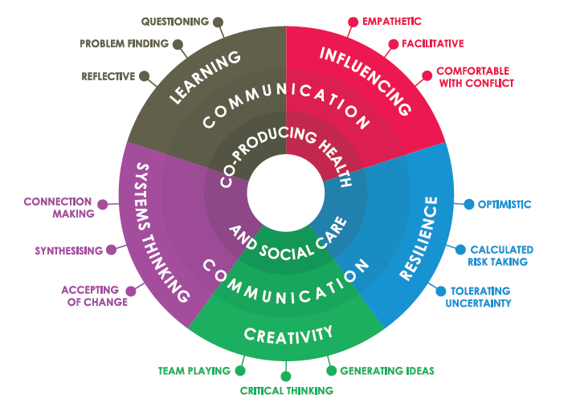

Lucas, B (2015) The habits of an improver. Available at: <http://www.health.org.uk/sites/default/files/TheHabitsOfAnImprover.pdf>

**Driver Diagrams**

# Overview

A Driver Diagram helps translate a high-level improvement goal into a logical set of related goals and sub-projects. The tool helps organise change concepts and ideas as an improvement team answers the question “what changes can we make that will result in an improvement?” Driver Diagrams are used to test theories about cause and effect and are meant to be updated throughout the project.

The Driver Prioritisation Tool can help you to understand the status of the drivers and help to make decisions about which improvement projects should be prioritised.

**Example Driver Diagram**

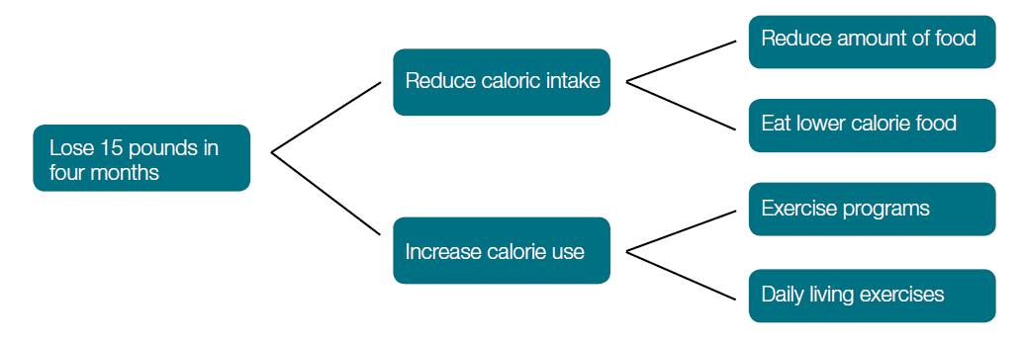

**Driver Diagrams Explained**

Aim or Outcome: Driver Diagrams start with a clearly defined and SMART (Specific, measurable, achievable, realistic, timely) goal.

Primary Drivers: The overall aim is linked to those factors that are believed to have a direct impact. For example, in order to lose weight we need to reduce caloric intake and increase effective caloric use. These are referred to as primary drivers because they drive the achievement of your main outcome.

Secondary Drivers: To have an effect on primary drivers, we need to carry out clearly defined actions, namely: reduce the amount of food, eat lower calorie food, join an exercise program, and increase our daily living activities (i.e. take the stairs instead of the elevator).

**How do I use this tool?**

1. Convene a meeting with the improvement team and content matter experts
2. Start by identifying a clearly defind goal
3. Brainstorm “What changes can we make that will result in an improvement?”
4. Cluster the ideas together to see if any groups of ideas represent a common driver
5. Expand the groups to see if new drivers come to mind
6. Logicaly link together the groups into a driver diagram format
7. Decide which drivers and interventions you want to measure and add to the diagram

# Tips and tricks

* Driver diagrams are a ‘live’ tool. They will change over time as you make changes to your system.
* A driver diagram will represent the problem as seen by the group and a way to communicate the change strategy to others
* Work backwards from change concepts if that helps.
* If you can make your drivers measurable you have created a measurement framework for determining progress towards your overall goal
* Creating a driver diagram with a team ensures that everyone understands your goal and how they can contribute towards achieving it
* Driver diagrams will vary from place to place - there is no definitive ‘right’ answer as your local situation may be very different from other parts of the country

**Whiteboard clip from Dr R Lloyd on Driver Diagrams**

<http://www.ihi.org/education/IHIOpenSchool/resources/Pages/AudioandVideo/Whiteboard9.aspx>

NHS Institute for Innovation & Improvement, May 2012

**Driver Assessment Tool**

When you have completed your driver diagram, the driver assessment tool can be used to make decisions about how to prioritse your improvement efforts.

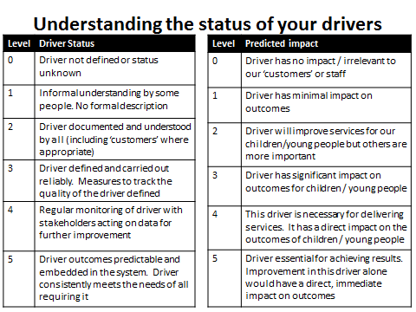

**How do I use this tool?**

1. Convene a meeting with the improvement team and content matter experts
2. Ask each individual to assess the **status of each driver** using the Driver Assessment Tool
3. Each individual should score each driver by using the scale in the tool

(from 0 to 5)

1. Ask each individual to assess the **predicted impact** of each driver using the Driver Assessment Tool
2. Each individual should score each driver by using the scale in the tool

(from 0 to 5)

1. Ask each individual to share the scores provided.
2. The team should focus on the drivers that score lowest in the driver status and highest in the predicted impact. Most impact will be achieved if improvement projects are focussed on drivers that score 0 or 1 in terms of driver status and 4 or 5 in terms of predicted impact.

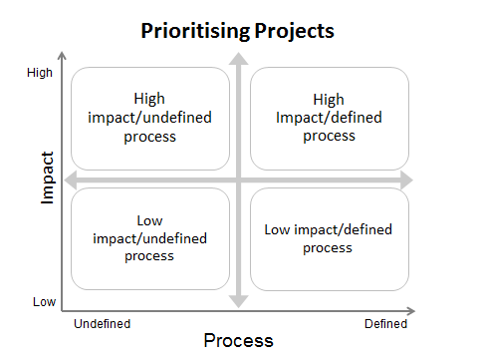

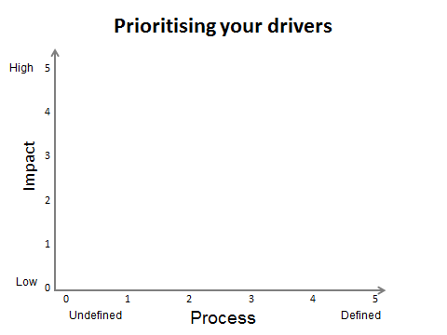

**Driver Diagram Example**

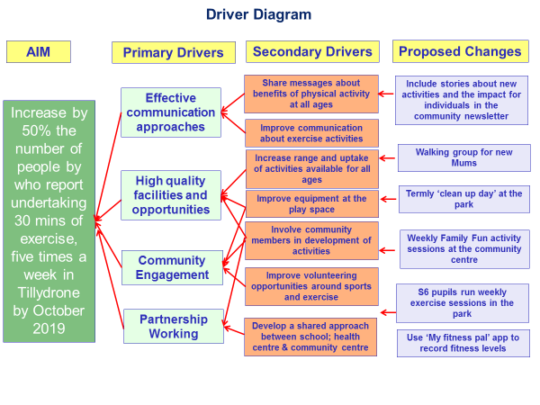

**Measurement for Improvement**

**What is Measurement for Improvement?**

There are three different types of measurements which are commonly used and it is helpful to understand the differences between what they achieve and how they use data. The three types of measurement:

1. **Measurement for Judgement** – Data is commonly gathered to support performance management, support improvement plans or inspections/audits etc. This helps public service agencies to assess performance. The data is compared against set criteria like improvement plan targets or National Care Standards / Key Performance Indicators.
2. **Measurement for Research** – The data to be gathered is defined at the start of the project and is tightly controlled by researchers. Those collecting data can rarely learn from it in real-time as it may introduce bias into the findings. Seeking ways to find a new “universal truth” can be slow and costly. Because funding is often one off, researchers may track additional information, “just in case”.
3. **Measurement for Improvement** – Data for improvement is gathered, reflected on and acted on in real-time (daily, weekly or monthly) by teams working on improvement projects. The data to be gathered is defined by those working on the improvement project, it is primarily used to help them learn about the issue they are working on and to assess what impact any changes are having. The data gathered is only that which is required to learn from – there is no ‘just in case’ data collection. Sometimes data for improvement is not part of a formally-reported data set, but is used locally to inform and drive improvement.

Key point

**Real-time analysis and adaptation, leading to improvement as you go, is fundamental to measurement for improvement**

While all these forms of measurement are essential it is the third category, measurement for improvement, that we focus on as improvers.

When planning improvement work, measurement for improvement helps decide –

* What "better" looks like?
* How will we recognise “better” when we see it?
* How do we know if the changes we are making are helping us improve?

Once improvement work has begun, measurement for improvement informs learning. It helps you answer the following questions –

* Is the team on track to achieve the improvement aim?
* What changes are having a positive impact?
* What changes are having a negative impact?
* Are the team reliably and consistently doing the things you need to do?
* What does your improvement story look like over time?

Some of the wider benefits of this type of measurement are:

1. It is defined and owned by those who are most affected by an improvement issue. This means the data can be used to tell the story of improved outcomes. Measures chosen are specific to each context.
2. It is focused on helping everyone learn about what works and what doesn’t in their setting, helping organisations to do more of what works and less of what doesn’t.
3. It provides real-time feedback – effective measurement is gathered and analysed regularly, helping get a clearer idea of the impact changes are having while they are happening.
4. It is used to support learning, not for judgement. We use measurement to guide progress towards an improvement aim, not to decide who is doing well and who is not.
5. Collecting data can often be straightforward enough for all to be involved (e.g. children are often involved in data collection in school improvement project, to track and learn about their own improvement journey, encouraging involvement in their own development and learning.)

**Different Types of Measures**

There are three types of measures that can be used to support our improvement projects.

**Outcome measures** reflect the impact of changes. An outcome measure shows us if we are on track to achieve our improvement aim, and what changes have a positive impact.

Improvement measures allow you to look at your existing data; *and* encourages you to ask “what are we doing about it?”

**Process measures** relate to the changes we put in place to achieve our aim. These measures help us understand if interventions are being carried out as often / reliably as we planned to or assumed they were.

**Insanity: doing the same thing over and over and expecting different results.**

**Albert Einstein**

If we fail to see the outcome we seek there are two explanations: our theory is incorrect i.e. the process does not achieve the outcome expected; or the theory is right but things are not happening as reliably as thought. If we don’t deliver the interventions we think are necessary why would we expect to see the outcome we hope for? Process measurement allows us to separate these two possibilities.

Process measurement also allows us to see whether we are making interventions consistently for all relevant ‘customers’, and if there are any barriers to address.

Key point

**By understanding what we did, when we did it and how effectively we did it, we get a much better understanding of what approaches work, and which don’t.**

**Balancing measures** show whether unintended consequences have been introduced elsewhere in the system. For example the aim of an improvement might be to improve the attainment of the lowest 20% of young people by coaching them in class. As a balancing measure you might wish to track if the additional time spent with these pupils has a negative impact on the attainment or behaviour of the rest of the class. The aim of improvement might be to increase nursery attendance by 30%, as a balancing measure you might wish to track the children’s progress, to check if any change in the staff-child ratio is impacting their development.

You may not know what your balancing measures will be before you begin your improvement. The complexity of the work may mean the knock-on effect happens elsewhere, for this reason make sure you are sharing what you are doing and keep communication open. If other people identify a change – be it positive or negative – you can address and monitor it early.

**Developing a Family of Measures**

To really make measurement work for us we need to develop a family of outcome, process and balance measures. Most successful projects have between 3-8 measures.

* If we only develop an outcome measure, we won’t know for sure if the activities and processes we think helped us improve were delivered, or have evidence to reflect on of what got in the way.
* If we only develop process measures then we will never know if what we are doing is having a positive impact.
* Without balancing measures we risk not seeing the wider system we work within, the “bigger picture” beyond the changes we make.

Developing a family of measures helps us understand all aspects of our improvement work. A good family of measures should have at least one outcome measure and a mix of process and balance measures. Measurement is important but don’t overdo it. We want just enough measures to help us learn, and we want that data to be available easily without it getting in the way of our day-to-day work. You may find you have to test your way to measurement: new pieces of work may not have obvious components to measure, or it might not be clear how you would go about collecting the data. Developing knowledge about how, when and what to measure is just as much a part of improvement work as trialling an intervention. Use the PDSA cycle to help develop data gathering and recording processes.

Key point

**Don’t ask *“what will we measure?”***

**Ask *“what do we need to know?”* then figure out if you can measure it.**

**How to Select the Right Measures for your Project**

Once you’ve decided to develop your measures it can be really helpful to use the steps outlined in the measurement journey diagram below. This section of the paper talks through each stage.

**A Measurement Journey**

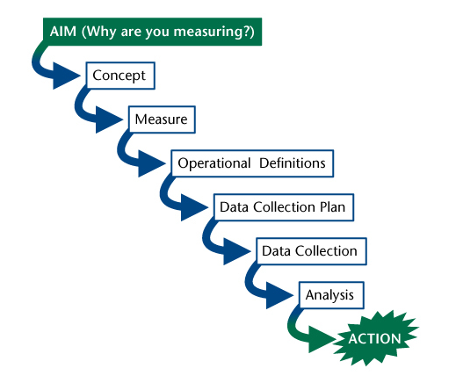

*Source: Lloyd, R. Quality Health Care. Jones and Bartlett Publishers, Inc., 2004: 62-64.*

1. **Aim –** Our improvement aim is the starting point for developing helpful measures. A good aim will focus us on the ‘What, how and by when?’ of our improvement project. From an aim statement we can define the types of outcomes we want to achieve and begin to think about the processes we will need to put in place to achieve this.
2. **Concept –** what **big ideas** or components do we wish to develop measures for?  The best way to identify these is to review your change ideas[1]. You may have recorded these in your [driver diagram](http://www.qihub.scot.nhs.uk/knowledge-centre/quality-improvement-tools/driver-diagram.aspx)[2] or QI planning document..
3. **Measure –** How do we turn these concepts into **measures**? Each of the concepts needs to be turned into something we can count and record: as a number, percentage or rate. It is worthwhile making sure you spend some time on this step. Using discussions with colleagues and subject matter experts who have done, or are doing, similar work can really help pin this down.
4. **Operational definitions –** A crucial step when developing measures is ensuring that everybody involved in your improvement work is using the same definition for each measure and gathers the data in the same way: this is called an operational definition.

Without a clear operational definition used consistently by everyone involved in your project you will not be able to get an accurate understanding of your improvement project. A good operational definition will describe what data is to be used, this would include actual events (and also from what potentially larger number of all possible events if we need to calculate a proportion or percentage). It should also specify the ‘per something’ if we are using a rate. The definition should say when the data is to be gathered (e.g. at a set timescale, or when specific activities take place). If results depend on something being “appropriate” or “complete” it is useful to list criteria or a required checklist of what that really means. Subject matter expertise and discussion is vital to draft, and agree, definition statements.

1. **A data collection plan**[3] is important before we start collecting data (although we can use PDSA cycles to refine the process(es)). For each measure, decide who will collect data, what data they will collect, where they will collect it, when and how often. It can be helpful to think about whether the data already exists, for example, attendance is already tracked on a school register or behaviour is already tracked in a significant incident log. Use existing data to help simplify the process if you can. Before finalising you might want to try collecting some data to find out what is possible, again you can use PDSA cycles to refine what you will measure. Do not let this delay improvement work you should get a sense of whether data is available within a few weeks.

Will we count every event or take a sample? Samples are often sufficient. The more frequently collection occurs the faster it is possible to demonstrate improvement but small samples are more sensitive to random variation.

Finally, how are you going to store the data? Over time storing it on a computer can be helpful but in the early stages just getting started using paper and pen may be sufficient.

1. **Data collection –** With all the steps above completed we then need to collect the required data.
2. **Analysis –** In parallel with the data collection plan we need to consider how the team will **analyse** their data and **present** it in ways that people can connect with, so that action can be taken. Is someone on the team confident and willing to do the analyses and prepare the charts? Who will receive and review the results? How often? **Visual display of quantitative data***[4]* is important. Graphs are almost always easier for people to engage with than tables of numbers. This is because they make patterns much clearer. However generating familiarity with the charts chosen can take time and it is advisable to try and adopt a basic design that people can become used to looking at week-on-week. An important consideration for the improvement team is agreeing how you will review data, and then test out changes so that you can improve data gathering, analysis and review.

Do not discount the merit of qualitative data alongside quantitative: observations from people can reinforce and bring to life numerical data. It is also possible to convert non-numeric, observational information into quantitative, for instance personal experience can be tracked on a scale and then allocated a corresponding number of points.

**What Does Data Look Like? Using Run Charts to Understand Improvement**

One of the most useful aspects of measurement for improvement is that we gather data and use it in real-time. While other forms of measurement are extremely useful in many ways, they often focus on measures gathered at specific points in time and this can limit our ability to understand our changes while we are making them. Measurement for improvement involves gathering measures as often as we can: the more often we gather and use data, the more often we can reflect to learn and understand the impact of our work. With measurement for improvement we also focus effort on presenting data in simple formats so that we can easily understand, and easily share, our improvement story. We do this by using **Run Charts**, a simple and effective way to collect and use your data[5]. These charts show every data point that you have measured and, when up-dated regularly, can help tell us if we are improving, what changes are having an impact and if our improvement is sustainable.

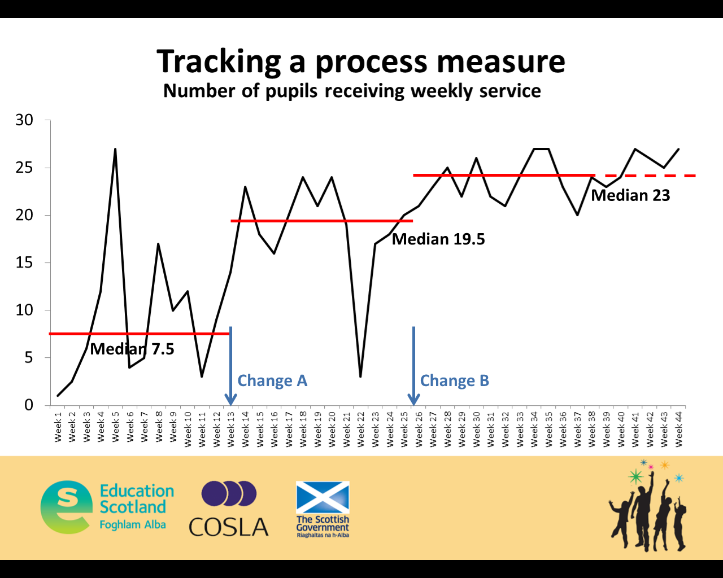

**What can we record that will guide our improvement effort?**

* Counts – e.g. number of children
* Rates – e.g. number of children per class
* Percentages – e.g. % of children reaching goal, % of women accessing maternity care
* Values – e.g. time, distance

**Case Study**

Some examples of the data from an improvement project being used in different ways are shown below to give you an overview of the benefits of presenting and showing data in real-time.

This image shows the outline of an improvement project based on literacy in a primary school. As you can see there is a clear aim, a small family of measures including an outcome and a process measures, and we have pulled out the key change idea that the school wanted to measure.

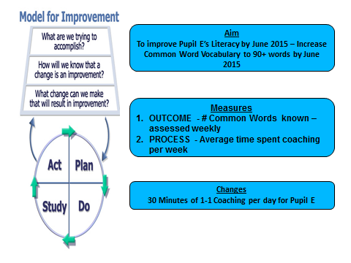

*Source:

Langley GL, Moen R, Nolan KM, Nolan TW, Norman CL, Provost LP. [*The Improvement Guide: A Practical Approach to Enhancing Organizational Performance*](http://www.ihi.org/resources/Pages/Publications/ImprovementGuidePracticalApproachEnhancingOrganizationalPerformance.aspx) (2nd edition). San Francisco: Jossey-Bass Publishers; 2009.

The school set out to use measurement for improvement to help them understand if they were achieving their aim, and what the impact of their change ideas was. They were gathering data regularly and collating it in a table. When they started to present their measures it looked like the table below. The teachers involved found it hard to read and to understand what their improvement story was. That’s because tables, while they can be useful for storing detailed information, do not show patterns very well.

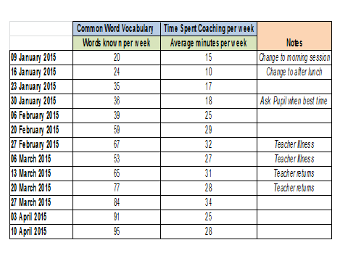

So, the team decided to use a chart to try and demonstrate their improvement story. They took the key data for their outcome measure and created the chart below. They used data from two points in time that they felt showed that there had been a real improvement for Pupil E.

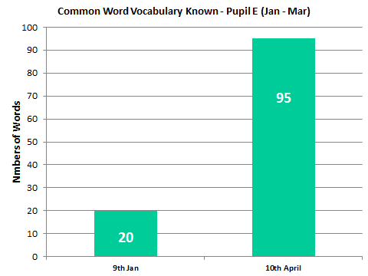

Again, the team were not happy with what the measures were telling them when presented. They felt that while there was clear evidence of improvement, that there wasn’t any story in the charts. You couldn’t tell how quickly Pupil E had improved, what may have caused the improvement or if this was a sustained change. So, the team decided to use **Run Charts** to show their improvement story. They created a run chart for both the outcome measure and process and looked at them together. These charts show the same data as we saw in the table and the bar chart, but in an easier to read and more meaningful format.

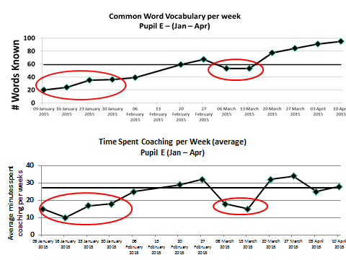

What the team saw using the run-charts was that the outcome measure showed the pupil’s improvement was almost constant over the time they were gathering data. What they saw from the process measures was that when the process measure showed the teacher wasn’t able to spend close to an average of 30 minutes coaching per day, the pupils learning was slower, or even showed signs of regression (see the data circled for January and March).

The team were able to use this learning to identify what was causing the dips and resolved the issue as soon as possible. Without a linked process measure they may not have known this was happening, may not have resolved the issue and would not have achieved their improvement aim. None of this information could be gleaned from looking at two data points i.e. the before and after data. The richness of learning is a result of seeing, from analysis of data over time, when and why variation is occurring and what difference it makes. Adding annotations to highlight when changes were made, or what else could have caused a fluctuation would further enhance these run charts.

**Example Measurement Plan**

|  |  |  |  |  |
| --- | --- | --- | --- | --- |
| **Name of measure**  Indicate whether it’s an Outcome (O), Process (P) or Balancing (B) measure and specify type of measure (e.g. percentage / count / rate / variable / days or cases between). | **Concept being measured and why it’s important to look at this**  What is the purpose of this measure? | **Operational definition**  Clear, precise definition of the measure and how it is calculated. Include numerator and denominator if it’s a % or rate. What / who is included or excluded? | **Data collection**  Who is collecting it? How often and when? Where is the data coming from? What’s the sampling method and sample size (if used)? | **Where are we and where do we want to be?**  Baseline info and goal for this measure |
| e.g. Outcome  Percentage of children reaching developmental milestone in language and literacy | This measure will enable us to understand children’s developmental progress in language and literacy | % = Number of children reaching developmental milestones in language and literacy divided by total number of children in the early education and childcare class. All children in the class are included. | All children’s language and literacy skills will be assessed each month by their key worker. The key worker will record the outcome on each child’s individual overview every month for every child in their group. The Senior Early Years Practitioner will collate results for the whole class every month on the class overview | 1 October 2017 = 40% of children were reaching their developmental milestone in language and literacy.  Aim = 95% of children by 30 June 2018 |
| e.g. Process  Percentage of children attending Talking Time  sessions | This measure will help us to understand the level of attendance at this evidenced based intervention programme | % = Number of children attending Talking Time divided by the number of children in the early education and childcare class | Senior Early Years Practitioner will record the total number of children who attend the Talking Time group every day in the identified section on the class register. | 1 October 2017 = 0% of children attend each Talking Time session  Aim = By 31 December 90% of children will be attending each Talking Time session |
|  |  |  |  |  |
|  |  |  |  |  |

Establishing measures that directly relate to the area you want to improve will guide your improvement journey. You will benefit from having a range of measures for your improvement work.

Outcome measures will let you know whether you are progressing towards the aim.

Process measures will inform how reliably the improvement activities are being applied – e.g., compliance with an intervention

Balancing measures help you to understand any unintended impact on another aspect of the system, either positive or negative.

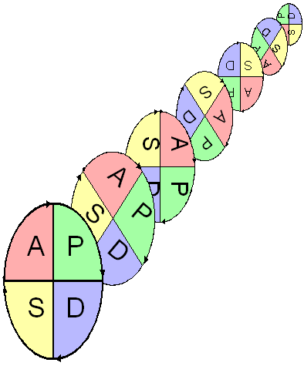

Cycle 1:

Cycle 3:

Cycle 2:

Cycle 5:

Cycle 4:

Cycle 5:

Cycle 3:

Cycle 2:

Cycle 1:

Cycle 1:

Cycle 3:

Cycle 4:

Cycle 5:

**Plan-Do-Study-Act (PDSA) Cycles**

Project Aim

Aim:

DRIVER

Aim:

DRIVER

Aim:

DRIVER

Cycle 4:

Cycle 2:

Cycle 8: Theory:

Questions:

Prediction:

Learning & Actions:

**Measure(s):**



*Learning from data*

Cycle 2: Theory:

Questions:

Prediction:

Learning

Actions:

Cycle 5: Theory:

Questions:

Prediction:

Learning & Actions:

Cycle 3: Theory:

Questions:

Prediction:

Learning:

Actions:

Cycle 4: Theory:

Questions:

Prediction:

Learning:

Actions

Cycle 6 Theory:

Questions:

Prediction:

Learning & Actions:

Cycle 1: Theory being tested:

Questions to ask:

Prediction:

Learning from test:

Actions:

Cycle 7: Theory:

Questions:

Prediction:

Learning & Actions:

**The Skittles Challenge**

|  |  |  |  |  |  |  |
| --- | --- | --- | --- | --- | --- | --- |
| The Skittles Challenge    **PLAN DO STUDY ACT** | | | | | | |
|  | Aim of test | Theory/ plan | Predict number left | Number left (actual) | Observations | What we will do next time |
| Attempt 1 | Discover how many we will be left with if we start at the top of the pyramid? | Removing top skittle will help us achieve the aim | 1 |  |  |  |
| Attempt 2 |  |  |  |  |  |  |
| Attempt 3 |  |  |  |  |  |  |
| Attempt 4 |  |  |  |  |  |  |

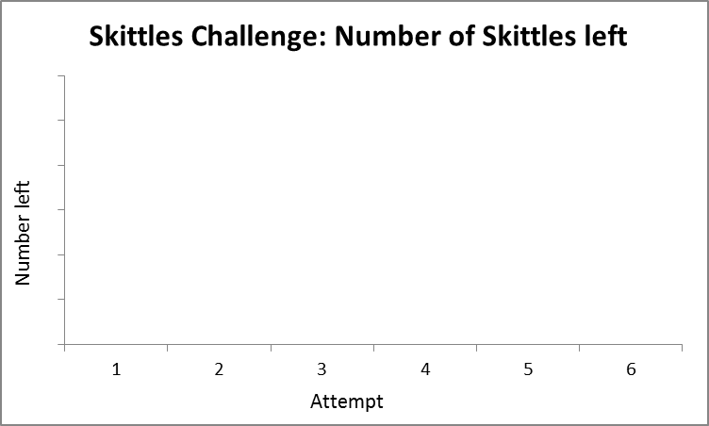

1. For a more complete discussion of these points see <http://www.qihub.scot.nhs.uk/knowledge-centre/quality-improvement-tools/measurement-plan-framework.aspx>

   And download <http://www.qihub.scot.nhs.uk/media/340181/2012-06-15_measurement_improvement_journey_process.pdf>
2. http://www.qihub.scot.nhs.uk/knowledge-centre/quality-improvement-tools/driver-diagram.aspx
3. For a more detailed consideration of these points see <http://www.qihub.scot.nhs.uk/knowledge-centre/quality-improvement-topics/measurement-for-improvement/collecting-data.aspx>
4. The NHS Scotland Quality Improvement Hub has produced "[Making the numbers meaningful for quality improvement: Visual display of quantitative data](http://www.qihub.scot.nhs.uk/knowledge-centre/quality-improvement-tools/making-the-numbers-meaningful-for-quality-improvement.aspx)". This contains some hints and tips to make data and graphs easier to interact with. See <http://www.qihub.scot.nhs.uk/knowledge-centre/quality-improvement-tools/making-the-numbers-meaningful-for-quality-improvement.aspx>
5. More information on Run Charts, including what constitutes a run chart and how to analyse them can be found here: IHI Whiteboard: Run Chart 1 <https://www.youtube.com/watch?v=YQd1QoMHYwU>