**Quality Improvement Practitioner**

**Learning**

**Programme**

**Learning Session 3**

**Contents**

|  |  |
| --- | --- |
| **Programme Outcomes and Habits of an Improver** | 3 |
| **Measurement for Improvement** | 4 |
| **Understanding Variation** | 6 |
| **Run Charts** | 7 |

**Programme Outcomes and Habits of an Improver**

**Programme Outcomes**

* Develop confidence & capability in Quality Improvement
* Lead an improvement project
* Develop skills to teach others

**Habits of an Improver**

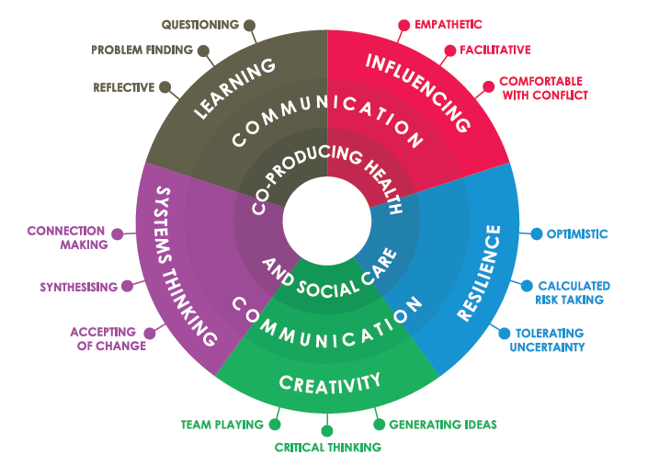

Lucas, B (2015) The habits of an improver. Available at: <http://www.health.org.uk/sites/default/files/TheHabitsOfAnImprover.pdf>

**Measurement for Improvement**



**Reason for Measurement**

**Why Are We Measuring?**

There are three main reasons why we measure. We measure data for improvement, accountability and research purposes. Understanding what and why we are measuring is important as it determines the approach of the measurement process.

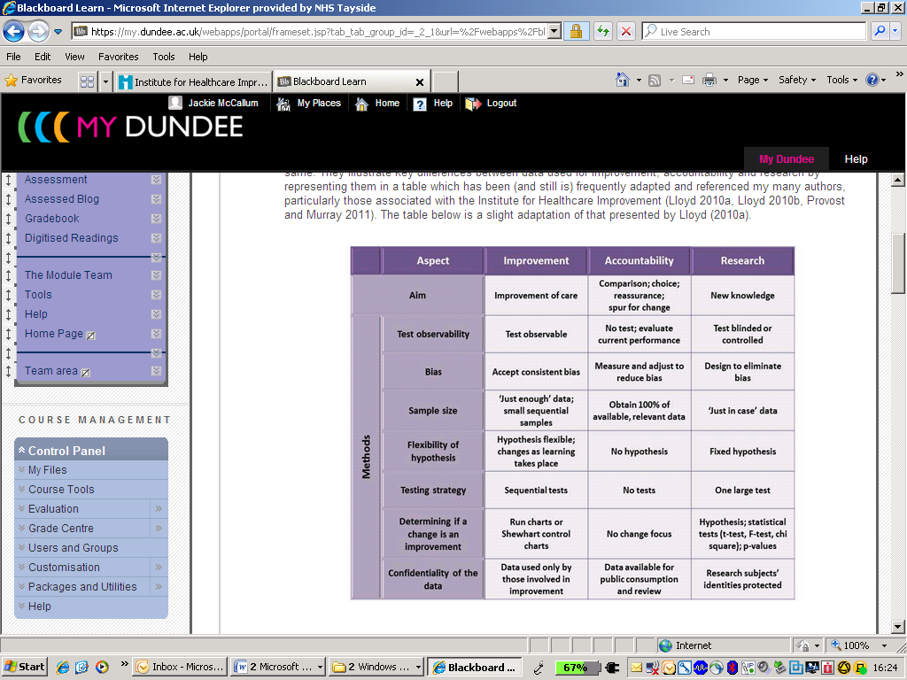

**Measurement for Improvement**

Improvement is not about measurement; however, effective measurement and data collection plays an important role. The key purpose of measurement for improvement is for learning. Teams need measures to give them feedback that the changes they are making are having the desired effect and are resulting in improvement.

Using data to answer the questions posed in the plan for each PDSA cycle:

* What data can be collected to answer the questions in the cycle?
* Quantitative data on the impact of a particular change
* Qualitative data (feedback from those involved in the test) to help refine the change
* Collect useful data, not perfect data - the purpose of the data is learning, not evaluation
* Record what went well and what didn’t work so well during the test of change
* Use sampling as part of the plan to collect the data to reduce the workload

Guidelines for collecting Data for Improvement:

* A few key measures that clarify the aim of the improvement effort and make it tangible should be regularly reported throughout the life of the project (daily, weekly, or monthly, depending on the length of time for the project)
* Plot data visually on the key measures over time using run or control charts
* Make use of existing databases and data already collected for developing measures
* Whenever feasible, integrate data collection for measurement into daily work routine
* Only collect what you need – there is a lot of information obtainable however the aim is to keep things simple!

Integrate Data Collection for Measures in Daily Work:

* Include the collection of data with another current work activity wherever possible
* Develop an easy-to-use data collection form or make Information Systems input and output easy for clinicians
* Clearly define roles and responsibilities for on going data collection
* Importantly, set aside time to review data with all those that collect it

**Understanding Variation**

Variation exists in all our processes. This offers a huge challenge in both understanding the variation which lies in processes and in managing this variation. Indeed, a quote that is frequently referred to and attributed to W. Edwards Deming states;

"If I had to reduce my message for management to just a few words,

I'd say it had to do with reducing variation".

You will all be able to identify variation in the processes in your workplace. For example:

* the number of appropriate referrals to a service within a given time period
* weekly/monthly compliance with best practice standards
* % of DNAs (did not attends) per month
* number of errors or incidents per week

When observing any of these systems or processes you should expect that the data will vary randomly over time. For example, when observing referrals per week, you may have 55 in week 1, 47 in week 2 and so on....

The use of tools which provide a visual representation of variation such as run and control charts provide much more opportunity for learning than traditional ways of viewing data such as tables. Variation is a measure of quality in a process and a key strategy in quality improvement is to therefore manage variation. Teams therefore need to understand the variation inherent in their systems and processes (Provost and Murray 2011)

**Run Charts**

Run charts are primarily used to understand whether changes made have resulted in improvement.

“A run chart is a graphical display of data plotted in some type of order” (Provost et al. 2008).

Their use in improvement activities are to:

* Establish if a change resulted in improvement
* Display data to make process performance visible
* To inform if any improvement noted is being sustained

A run chart is a simple analytical tool which is commonly used by quality improvement professionals but often goes under-utilised by health and social care staff generally (Perla et al 2011). A run chart can be created without complicated formulae or even a computer....a pen and paper is all that is required. A run chart is essentially a plot of data over time. The unit of time (e.g. day, week or month) is plotted on the horizontal or x-axis and the measure (e.g. % cycle time, number of cases) is plotted on the vertical or y-axis. The centre line on a run chart is the median line. Run charts may include a goal or target line. The following graphic illustrates key elements of a run chart:

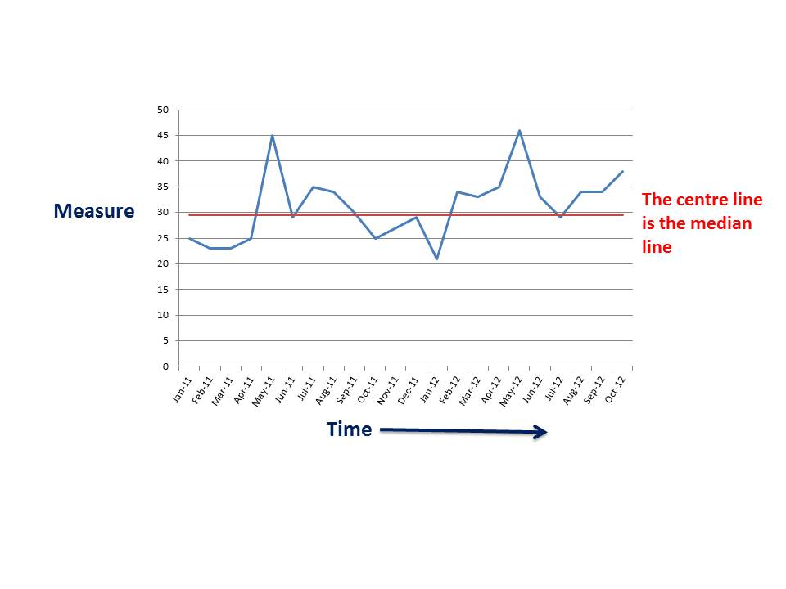

Run charts can be created as soon as data is available to facilitate learning as early as possible. The median should be calculated and added to the chart.

**What is a run?**

A run is defined as one or more consecutive data points on the same side of the median. Some points fall right on the median, making it hard to decide which run these points belong to. Data points that fall on the median are not included. To count the number of times the sequence of data points crosses the median and add “1”.

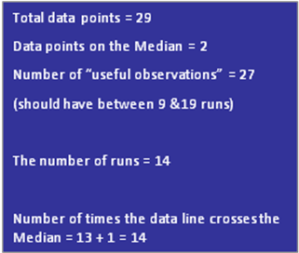

How many runs are on this chart?



Run charts should also include baseline data (around 6 data points) to establish the performance of the process before any changes have been tested / implemented. This enables teams to communicate their rationale for change and to identify if the changes they have made have resulted in an improvement.

Adding annotation to run charts indicating unusual events or changes being tested enables teams to tell the story of their improvement journey. The following example of a run chart illustrates the improvement journey of a team aiming to improve the inpatient management of diabetic patients with low blood sugars.

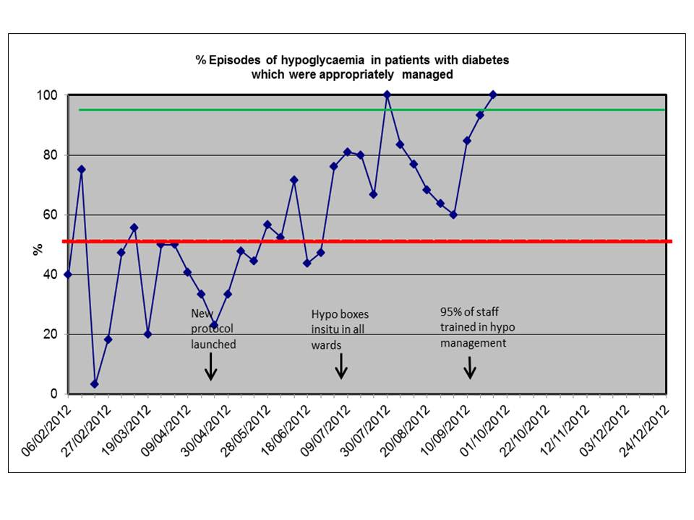

Run charts enable teams to visualise and understand the variation in their data over time. The key to interpreting run charts is to establish if something non-random is happening in the process. If teams are seeking to evidence improvement in their processes there needs to be a signal of non-random variation. This signal can be objectively determined by applying probability based rules. These rules are described by Perla et al (2011) and Provost and Murray (2011) as:

1. **Shift:** 6 or more consecutive points either all above or all below the median line. Values which lie on the median line do not make or break a shift
2. **Trend**: 5 or more consecutive points either all ascending or all descending. Where the value of two or more consecutive points is the same, only count the first point and ignore the repeating values. Like values do not make or break a trend.
3. **Run: too many or too few runs or crossings of the median line**. A run is a series of one or more points on one side of the median line. An easy way to count the number of runs is to count the number of times the data crosses the median line and add 1. The number of runs which should be present in a dataset can be determined using a table of critical values – see below.
4. **Astronomical point**: an unusually large or small number in the data. This point is obviously unusual in the dataset. Every dataset will have a high and low value but an astronomical data point will be blatantly different to the other values and will be acknowledged as such by the team.

The charts below illustrate the rules explained above.

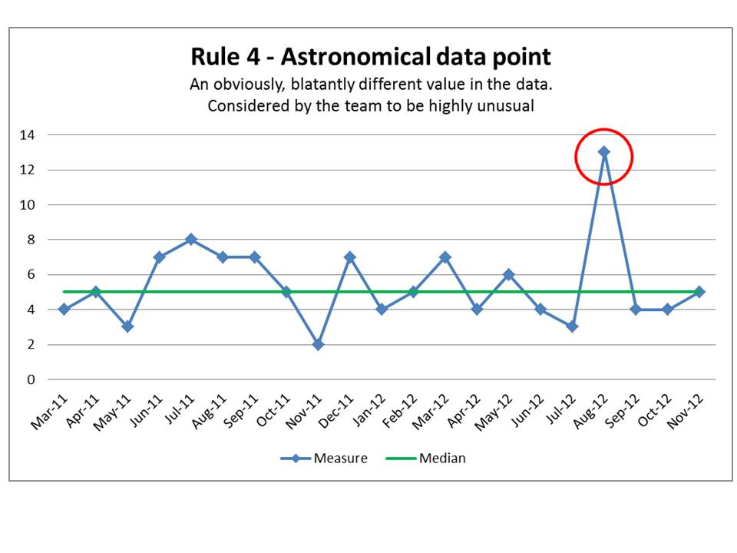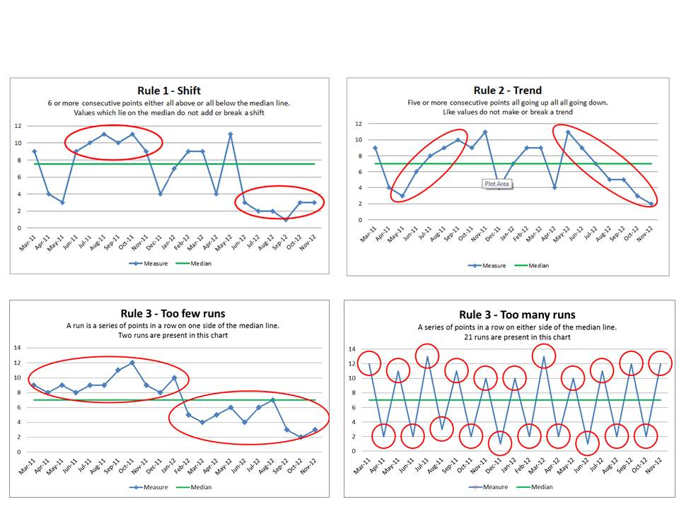

It is worth noting that run charts do have their limitations. Although application of the run chart rules enables teams to identify signals of non-random variation, run charts do not tell teams:

* why non-random variation is present
* if the system needs improved i.e. if the performance is acceptable
* how the process should be redesigned or improved
* if the process is stable

Teams need to use their knowledge of the processes they are striving to improve to interpret and derive meaning from their run charts. A signal of non-random variation in their run charts indicates that something out of the ordinary has occurred. This 'something out of the ordinary' may be as a result of a special event (e.g. high staff sickness levels; exceptional weather conditions; flu epidemic) or may be the result of changes the teams have tested. Equally, where there is no signal of non-random variation in the data following a test of change, the team would conclude that the change did not result in an improvement. This answers the second question in the Model for Improvement....'how will we know that a change is an improvement?'

Adapted from resources provided by Tayside Centre of Organisational Excellence

http://www.t-coe.org.uk/_page.php?id=79

**Run Chart Rule Three - Expected Number of Runs**

To use the runs table, firstly count the number of data points that do not fall on the median on the run chart. Then using the table below locate this number of data points in the “Number of data points” column. Looking across this row, you will see that the table displays the lower number of runs and the upper number of runs that you can have without indicating a non-random signal of change.

|  |  |  |  |  |  |  |
| --- | --- | --- | --- | --- | --- | --- |
| **Number of Data Points** | **Lower Limit for Number of runs** | **Upper Limit for Number of Runs** |  | **Number of Data Points** | **Lower Limit for Number of Runs** | **Upper Limit for Number of Runs** |
| **10** | **3** | **9** |  | **34** | **12** | **24** |
| **11** | **3** | **10** |  | **35** | **12** | **24** |
| **12** | **3** | **11** |  | **36** | **13** | **25** |
| **13** | **4** | **11** |  | **37** | **13** | **25** |
| **14** | **4** | **12** |  | **38** | **14** | **26** |
| **15** | **5** | **12** |  | **39** | **14** | **26** |
| **16** | **5** | **13** |  | **40** | **15** | **27** |
| **17** | **5** | **13** |  | **41** | **15** | **27** |
| **18** | **6** | **14** |  | **42** | **16** | **28** |
| **19** | **6** | **15** |  | **43** | **16** | **28** |
| **20** | **6** | **16** |  | **44** | **17** | **29** |
| **21** | **7** | **16** |  | **45** | **17** | **30** |
| **22** | **7** | **17** |  | **46** | **17** | **31** |
| **23** | **7** | **17** |  | **47** | **18** | **31** |
| **24** | **8** | **18** |  | **48** | **18** | **32** |
| **25** | **8** | **18** |  | **49** | **19** | **32** |
| **26** | **9** | **19** |  | **50** | **19** | **33** |
| **27** | **10** | **19** |  | **60** | **24** | **37** |
| **28** | **10** | **20** |  | **70** | **28** | **43** |
| **29** | **10** | **20** |  | **80** | **33** | **48** |
| **30** | **11** | **21** |  | **90** | **37** | **54** |
| **31** | **11** | **22** |  | **100** | **42** | **59** |
| **32** | **11** | **23** |  | **110** | **46** | **65** |
| **33** | **12** | **23** |  | **120** | **51** | **70** |

Acknowledgement to Bob Lloyd IHI