Quality Improvement Practitioner
Learning
Programme

Learning Session 4

Contents

Programme Outcomes and Habits of an Improver | 2
Features of Testing, Implementation and Spread | 3
Implementing Questions | 4
Implementing a Change | 5
Implementation Planning | 6
Facilitating Spread | 7

Programme Outcomes and Habits of an Improver

Programme Outcomes
- Develop confidence & capability in Quality Improvement
- Lead an improvement project
- Develop skills to teach others

Habits of an Improver

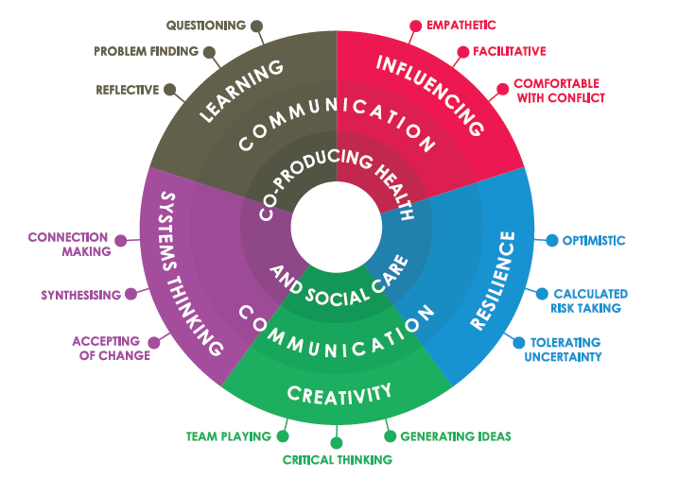

Lucas, B (2015) The habits of an improver. Available at: http://www.health.org.uk/sites/default/files/TheHabitsOfAnImprover.pdf

Features of Testing, Implementation and Spread

Many of these features are common to different stages of an improvement project. The lists below summarise the most typical features of each stage.

Testing
- Failure is a useful, natural part of the improvement process.
- Choose changes that do not need a long process of approval.
- Change is not permanent.
- Learn what works in your system.

Implementation
- The change becomes part of the routine operation of the unit.
- Develop unit-wide processes and infrastructure to maintain the improvement.
- Assign accountability for maintaining the improvement in the unit.
- Create education and training for the unit.

Spread
- Provide mentors as a resource for people in the target population.
- Identify the target population for the change outside the unit.
- Identify key audiences within the target population.
- Work out how to explain the benefits of a change beyond the unit.
- Generate tools and resources to help make a change easy to adopt or adapt beyond the unit.

All
- Use PDSA cycles
- Make predictions and identify whether those predictions are met.

Implementing Questions (to support ‘new’ to normal’

Before you consider implementation of a change consider whether you have:
- Completed testing under differing circumstances?
- Measurement showing sustained improvement in a test site?
- Confidence that this is a positive change?
- Changed support structures, processes and systems to incorporate the new work?
- Removed structures, processes and systems that are no longer required?

Some specific things to consider in detail to prepare for implementation are:

Clear description of the change(s) | - What are the ‘key ingredients’ of the intervention?  - What steps (in what order) are needed to make the new way work? Are the steps supported by a process map?  - Which (if any) interacting processes need to change?
Top Tips from testing | - How has learning from testing been captured? Were changes to culture required?
Narrative | - What inspiring examples of the approach and its success can be shared to build ‘will’?  - How will we share these stories?
Numerical data | - What annotated time-series (run) charts, relating changes made to improvement seen, are available?
Training | - What training in the new approach(es) is in place?
Measurement Plans | - What (process and outcome) measures will we continue to gather to support the work?  - How will data be collected and shared?
Supports and Resources | - What permanent support structures are required? Includes policies, timetables, contracts etc  - What materials & equipment, required to make the change routine, need to be reliably available? (e.g. learning resources/ forms)
Review and on-going testing | - How will we keep our changed process under review?  - How do we build knowledge (e.g. of PDSA) to help those involved keep testing adaptations to the work?  - How will we record further changes?

Be aware that implementation:
- Is often the least fun, most important stage – without it the old way creeps back in
- Needs leadership to support and sustain
Implementing a Change
Common ‘restraining forces’ include:
- ‘We’ve met our goals’.
- Assumption that the improvement would hold without further work.
- Resources shifted to other priorities.
- Lack of senior management support.
- Failure to learn about implementation through PDSA cycles.
- Infrastructure not in place.

Influencing stakeholders
Create the will
- Create dissatisfaction with the current state.
- Communicate project progress and direction regularly.
- Communicate confidence in success.
- Embrace the messiness of life.
Provide information on why the change is being made
- Empathise with anxiety – don’t expect to eliminate it.
- Show how the change supports aims of the department or organisation.
- Put the change in historical perspective.
- Link the change to the needs of patients, family, carers, community.
- Reframe the change as an opportunity.
- Provide a channel for questions and comments.
Provide specific information on how the change will affect people
- Share results from testing and implementation cycles.
- Be prepared for questions.
- Study rational objections and be prepared to address them.
- Include members of the team who were involved in test cycles in presentations to wider stakeholder groups.
Get consensus on resources and other support for implementation
- Prepare a project plan with clear timescales.
- Ask senior stakeholders to publicly support the change.
- Express confidence in those being asked to carry out the change.
Publicise the change
- Use stories, pictures.
- Summarise key points and agreements when they occur.
- Show appreciation for those developing, testing and implementing change

Implementation Planning
Component of Implementation | Consider | Lead | PDSA Cycle # | Objective of PDSA cycle
Standardisation | - Map the new process  - Standardise key steps in the process  - Clarify individual responsibility/authority  - Define some simple rules to guide practice
Documentation | - Assign responsibility for keeping it up to date  - Use for ongoing education and training
Training | - Formal or informal  - Broader and more long-term than for testing  - Link training to the service need
Measurement | - Plan visible measurement of key outcome measures  - Plan measurement of key process steps  - All measurement over time
Resourcing | - May require more resources than testing  - Plan resource request and allocation  - Plan ongoing ownership

Facilitating Spread (through adaptive integration)

Prepare the soil:
- Leadership commitment and constancy of purpose
- Awareness of a need/dissatisfaction with current picture
- Constant communication to build awareness of ideas that seem to meet the need
- Recognise & embrace complexity
- Emphasise importance of testing in each new context (area/year group/ school) to allow adaptation
- Build the capacity to test

Prepare the seed:
- Be clear about what is proposed. Have a ‘seed’ package containing: a description of the key ingredients of the change; inspiring stories and (time-series) data relating interventions to improvement

Plan for Adoption / Spread
What? | What are essential ingredients/key components?  What adaptations are permitted/ necessary?
How? | What are your spread processes and reporting structures?
Who? | What scale? Which teams? What places? Which people?
When? | Time Frame and time line for Spread

Some ‘How’ questions
- What role do existing communication and reporting mechanisms have in progressing to Spread?
- What infrastructure/resources are needed (paperwork, IT support?)
- What training and support is needed to make the idea happen, and to enable testing and local re-shaping
- What role will local Line Managers be expected to play?
- Whose role will it be to collate data across other teams? How will data be shared?

Beat the 7 Spreadly Sins!
- Don’t do one big pilot, then pause to reflect and rollout: test adaptations in each site
- Don’t have local heroes who you expect to do it all
- Don’t just rely on vigilance and hard work: sustain gains and support with infrastructure
- Don’t be rigid: allow local adaptation (of non-key components) to get integrative adoption
- Don’t make the initial test team the spread team
- Don’t measure everything, quarterly: focus – little and often
- Don’t spread without first having a reliable process

