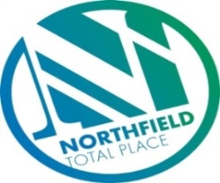

Northfield Total Place
Locality Partnership Board Meeting
Northfield Academy
Wednesday 9.15am – 11.15am 16th January 2019

AGENDA
Your Data
Aberdeen City Council holds your contact details for the purposes of two way communication. We do not share your details with a third party. If you do not wish us to hold your details, please let us know and I will delete your details. Bear in mind however that you will not receive future communications relating to these meetings. Your details will be held for as long as you attend the meetings and up to 6 months after.

- 9:15am - Welcome/introductions
- 9:20am - Apologies
- 9:25am - Minutes of meeting on 7th November 2018
- 9.30am - Locality Plan Tracker review – progress
  - Byron Square – Painting Programme

- 9.35am - Fran Smith, Community Builder - Presentation
- 9.50am – Middlefield Triangle Redevelopment and Haudagain – (Housing)
- 10.00am – Police Scotland Update (Inspector Main)
- 10.20am - Tests of Change
  - (GLC) Good Life Choices (AD)
  - Gaming (HG)
  - Unpaid work team (FG)
  - Circles of Community (FG)

- 10:35am – Food and Fun – Evaluation/update (MS)
- 10:45am - Locality Plan Annual Report Update (MS)
- 11am – Northfield Partnership Forum (FG)
  - Links to Locality Board
  - Inspection

- 11.10am – AOCB
- Participatory Budgeting (FG)
- Health and Social Care Partnership Areas
- 11:15am - Date of next meeting and close

