Progress Report | CPA Improvement Programme 2019-21 Quarterly Update Report
Lead Officer | Angela Scott, Chair of CPA Management Group and Chief Executive of Aberdeen City Council
Report Author | Michelle Cochlan, Corporate Strategy and Community Planning Manager
Date of Report | 14 June 2019
Governance Group | CPA Board – 1 July 2019

Purpose of the Report
This report provides an update on the projects within the Local Outcome Improvement Plan 2016-26 which have started, or are due to start, to deliver the Partnership’s 15 Stretch Outcomes by 2026. This report also includes new charters for approval for project initiation.

Summary of Key Information
1 BACKGROUND

1.1 The refreshed Aberdeen City Local Outcome Improvement Plan (LOIP) was approved by Community Planning Aberdeen Board on 26 Feb 2019. It introduces 15 Stretch Outcomes to be delivered by 2026 and 125 shorter term improvement projects which will initiated over 2019 to 2021.

1.2 The Community Planning Aberdeen Outcome Management and Improvement Framework sets out how CPA ensures effective, systematic and collaborative scrutiny of progress towards the achievement of outcomes within the LOIP. These arrangements include quarterly reporting to the CPA Board on progress made in taking forward the LOIP improvement projects. This report includes an update on the LOIP projects which have started or are scheduled to start this quarter. This report also includes new charters for approval before project initiation.

2 PROJECT UPDATES

2.1 There are a small number of improvement projects which were initiated following the first Local Outcome Improvement Plan 2016 and have continued into the refreshed LOIP. Progress against these improvement projects is included in the Section IV of this report – see community justice group projects.

3 NEW PROJECT CHARTERS

3.1 This report includes 11 of 22 project charters which were due to be submitted to the CPA Board in July, as per the CPA Improvement Programme 2019-21, approved by the Board on 1 May 19. The remaining 11 charters originally scheduled to be submitted to the CPA Board in July have been postponed to a later date. See project updates in section i-v for details.

3.2 New project charters go through a quality assurance process with the Community Planning Team, with input from Public Health and the Council’s Office of Data Analytics. The project charters in section vi of this report answer positively to the following questions and are presented to the CPA Board for approval:

1. Is the project aim consistent with aim in the LOIP?
2. Is there a sound business case explaining why the project is important?
3. Is it likely that the changes being tested will achieve the aim? Public health input on proven interventions.
4. Will the measures demonstrate whether a change is an improvement? Comments on data?
5. Is there a mix of partners involved in this project?
6. Clear outline project plan?

4 ACHIEVING PACE THROUGH RAPID CHANGE CYCLES

4.1 The Partnership uses a project scoring mechanism to understand the progress that projects are making. At the point of submitting a project charter to the Board for endorsement, the project has reached a score of 4 on the scale, which means foundation work for the project is now complete. Subject to approval by CPA Board of the project charters presented in this report, project teams will now proceed to designing and testing their change ideas; and gathering data to understand impact.

Score | Stage of Project
1 | Project area identified and agreed
2 | Draft Outline Project Charter and team in place
3 | Understanding baseline of current system (Data and practice)
4 | Project Charter endorsed by CPA Board
5 | Change ideas and project measures developed
6 | Testing underway
7 | Initial indications of improvement
8 | Improvements achieved
9 | Sustainable improvement
10 | Project complete

4.2 Whilst the majority of the improvement projects in the LOIP have aims set for 2021, through the application of the quality improvement methodology adopted by CPA, we are aiming to see initial indications (score 7) of improvement early on in a project. This will give us the confidence that the changes we are testing are the right ones for scaling up our testing.

4.3 The improvement methodology uses ‘Plan’, ‘Do’, ‘Study’, ‘Act’ (PDSA) cycles to test change ideas on a small scale and assess impact before wholesale implementation. Once changes are designed, these cycles should start and be repeated on an increasing scale fairly rapidly to build confidence that the change works. This will depend on the frequency of opportunity for testing. For example, if we are testing a change to how we greet a customer coming into our buildings, then there are multiple opportunities to test our change ideas with many people in just one day. It is therefore possible to see improvement in a very short period of time. Opportunities for testing other change ideas may be less frequent, i.e. daily, weekly, monthly or in some cases longer.

4.4 The project plans included in the charters give an indication of the timescales each project team is working to in the design and test of changes. At the end of the project (on achievement of the project aim or end of testing period) the project team will be required to prepare a project end report for the CPA Board. This report will evaluate overall achievement and seek permission to either implement the changes permanently, spread the changes, or abort the project.

5 NEXT STEPS

5.1 Projects which are approved for initiation by CPA Board on 1 July will proceed to the designing and testing stage. Progress will be reported to CPA Board as part of the next quarterly update report in September 2019.

5.2 Jonathan Smith, Chair of CPA Community Engagement Group (CEG) has written to the Chairs of the Outcome Improvement Groups to invite them to meet to discuss how the CEG can support them to enhance the co-design and co-production of the LOIP improvement projects with communities. This will ensure that project teams are taking into account ideas for change from communities themselves and increase opportunities for innovation.

Recommendations for Action
It is recommended that members of the CPA Board:

i) consider the updates provided on live improvement projects (community justice projects;
ii) approve the new charters included in section vi of this report for project initiation;
ii) approve the rescheduling of all other charters which were due to be submitted to CPA Board in July.

Opportunities and Risks
Successful delivery of the Local Outcome Improvement Plan 2016-26 requires a robust programme management approach to the delivery of the 120 improvement projects in the refreshed LOIP. It has been agreed that we will take a phased approach to the initiation of the projects in the LOIP to help ensure we are channelling our resources to those projects which are most likely to have the biggest impact; and/ or set the foundation for further improvement activity over the next two to three years. However, there will be no compromise on pace and therefore the timely iniation of planned projects is essential.
Consultation
The following people were consulted in the preparation of this report:
CPA Management Group
Chairs of Outcome Improvement Groups
LOIP Project Managers
James Simpson, Performance & Strategy Development Officer
Sacha Will, Improvement Programme Manager

Background Papers
The following papers were used in the preparation of this report.

Local Outcome Improvement Plan 2016-2026 (Refreshed 26 February 2019)

CPA Improvement Programme 2019-21

Contact details:
Michelle Cochlan
Community Planning Manager
01224 522791
MCochlan@aberdeencity.gov.uk

(I) ECONOMY JULY UPDATE

Lead Outcome Improvement Group: Aberdeen Prospers

- No. project charters due: 4
- No. project charters ready: 1
- No. project charters postponed: 3
- No. project charters outstanding: 0
- No. projects live: 0
- Total No. of LOIP projects: 14

Charter Status | Ready | Postponed

Stretch Outcome 1
10% increase in employment across priority and volume growth sectors by 2026

Project Charters Due | Charter submitted to CPA Board
Increase the number of SVQ level 4 qualifications achieved in ICT and Digital by 10% by 2021 |  | Postponed to September. Draft charter in place. Feedback from QA process to be addressed. Further change ideas to be developed following a Digital Skills meeting on 28 June. (See Charter 1.1)

Stretch Outcome 2
90% of working people in Living Wage employment by 2026

Project Charters Due | Charter submitted to CPA Board
Increase employer sign up to the Real Living Wage by 2021. and year on year to achieve Real Living Wage City Status by 2026 |  | Postponed to December. Project team are conducting initial research to inform change ideas. Now scheduled for CPA Board in December.
Increase the impact and measured value of Partnership wide community benefits programme by 2022. |  | Yes. Charter approved (subject to amendment) by CPA Management Group on 27 May. Feedback now addressed.  (See Charter 2.1)
Increase the % of people in Aberdeen who feel comfortable using digital tools by 2021 |  | Postponed to December. Project team are exploring definition of ‘people who feel comfortable’ and gathering baseline information. Now scheduled for CPA Board in December.

(II) PEOPLE (CHILDREN & YOUNG PEOPLE) JULY UPDATE

Lead Outcome Improvement Group: Integrated Children’s Services

- No. project charters due: 13
- No. project charters ready: 6
- No. project charters postponed: 7
- No. project charters outstanding: 0
- No. projects live: 0
- Total No. of LOIP projects: 41

Charter Status | Ready | Postponed

Stretch Outcome 3
95% of children (0-5 years) will reach their expected developmental milestones by the time of their child health reviews by 2026

Project Charters Due | Charter submitted to CPA Board
Increase the number of families who request additional support and receive an offer of an appropriate service within 30 days of receipt of the Child’s Plan, to 80%, by 2021 |  | Yes. Charter approved by CPA Management Group on 27 May 19. (See charter 3.1)
Reduce the number of babies exposed to second-hand smoke (at 6-8 week review) by 10% by 2022 |  | Postponed to September. Charter delayed due to change to project manager.
Reduce the number of pregnant mothers who smoke by 10% by 2022 |  | Postponed to September. Charter delayed due to change to project manager.
Increase the number of pregnant young people who are able to remain in education during pregnancy by 50%, by 2022 |  | Postponed to September. Charter delayed due to change to project manager.
Increase in the MMR vaccine uptake for children at 24 months by 3.9%, by 2020 |  | Postponed to September. further work required with the current and required stakeholders
Increase the number of 27-30 month reviews completed for eligible children by 5.2%, by 2021 |  | Postponed to September. further work required with the current and required stakeholders
Reduce the rate of teenage pregnancies [under 16s] by 3%, by 2021; and Reduce the rate of teenage pregnancies [under 16s] in the CPP locality areas by 10% by 2021 |  | Postponed to September. further work required with the current and required stakeholder.

Stretch Outcome 4
90% of children and young people will report that they feel mentally well by 2026

No charters due

Charter Status | Ready | Postponed

Stretch Outcome 5
95% of care experienced children and young people will have the same levels of attainment in education, emotional wellbeing, and positive destinations as their peers by 2026

Project Charters Due | Charter submitted to CPA Board
Increase the number of care experienced young people accessing a positive and sustained destination by 25% by 2022 |  | Yes. Charter approved (subject to amendment) by CPA Management Group on 27 May. Feedback now addressed.  (See charter 5.1)
Increase in the number of inhouse foster and kinship placements by 2021 |  | Yes. Charter approved (subject to amendment) at special CPA Management Group meeting on 12 June. Feedback now addressed.  (See charter 5.2)

Stretch Outcome 6
95% of children living in our priority localities will sustain a positive destination upon leaving school by 2026

Project Charters Due | Charter submitted to CPA Board
Increase the no. young people who effectively transition from primary school to secondary school by 2021 |  | Yes. Charter approved (subject to amendment) by CPA Management Group on 27 May. Feedback now addressed.  (See charter 6.1)
Increase the number of young people living in Quintiles 1,2 and 3 engaged in a family approach who achieve a sustained positive destination to 90% 2022 |  | Yes. Charter approved, subject to amendment, by CPA Management Group on 27 May 19. Feedback now addressed.  (See charter 6.2)
Increase the number of young people taking up foundation apprenticeships to 142 by 2021 |  | Yes. Charter approved, subject to amendment, by CPA Management Group on 27 May 19. Feedback now addressed.  (See charter 6.3)
Increase the number of opportunities for parents and carers to gain an insight into how to meaningfully contribute to the educational progress of their children and young people by 30% by 2021 |  | Postponed to September. Draft charter in place. Feedback from QA process to be addressed.  (See charter 6.4)

Stretch Outcome 7 Child Friendly City which supports all children to prosper and engage actively with their communities by 2026 No charters due

(III) PEOPLE (VULNERABLE ADULTS) JULY UPDATE

Lead Outcome Improvement Group: Community Justice Group

No. project charters due: 2
No. project charters ready: 2
No. project charters postponed: 0
No. project charters outstanding: 0
No. projects live: 3
Total No. of LOIP projects: 24

Charter Status | Ready | Postponed

Stretch Outcome 8
Stretch Outcome 8. 25% fewer young people (under 18) charged with an offence by 2026 (Community Justice Group/ ICS)
No charters due

Stretch Outcome 9
25% fewer people receiving a first ever Court conviction each year by 2026

Live Projects | Start-  End | Progress Scale | Changes being tested
9.1  Increase the number of cases of people appropriately diverted from prosecution by 2021.  Project Manager: Claire Duncan, HSCP | Apr 18 – Mar 21 | 6 | • Map of data sharing processes  • Single point of contact in Police Scotland Aberdeen Division and CJSWS  • Data recording mechanism by CJSW  • Training/awareness-raising input on Diversion from Prosecution
Improvement Data

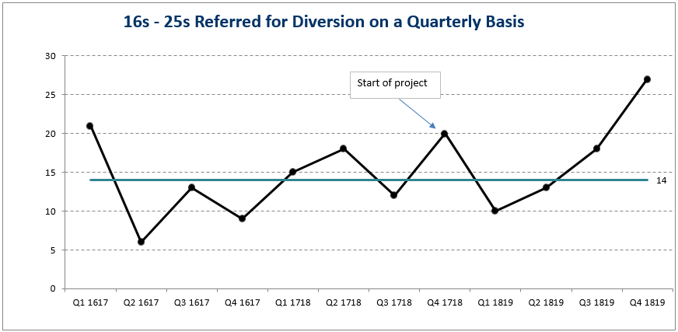
This project started in April 2018 and has continued into the refreshed LOIP. The run chart above shows the number of referrals from the PF per quarter for the 16 – 25 age group.

The actual baseline period for the project was 2015-16, when there were on average just below 20 referrals for Diversion for this age group per quarter (77 referrals in total). The average for 2018-19 was also just under 20 referrals per quarter (78 in total). So the project has not achieved its target aim (of a 10% increase). However, indications are that improvement has been seen during 2018-19, compared to the two previous years, although it is not as yet possible to apply a specific ‘run chart rule’ to confirm this.

Further detailed information/conclusions will be provided to the next meeting of the Management Group.

Stretch Outcome 10
2% fewer people reconvicted within one year of receiving a community or custodial sentence by 2026

Project Charters Due | Charter submitted to CPA Board
Increase the number of individuals who are involved in cuckooing* incidents who undertake effective interventions or who are referred to relevant support services in priority localities by 2021. |  | Yes. Charter approved by CPA Management Group on 27 May 19. (See charter 10.3)
Increase the uptake and retention of people in the Justice System with drug and alcohol problems in specialist services by 100% by 2021. |  | Yes. Charter approved (subject to amendment) at special CPA Management Group meeting on 12 June. Feedback now addressed.  (See charter 10.4)

Live Projects | Start-  End | Progress Scale | Changes being tested
10.1  Increase the number of family members of people in HMP Grampian and HMYOI Polmont who received appropriate and timely support from Families Outside, Family Centre & Help Hub (Action for Children), and Alcohol & Drugs Action by 20% by 2021.  Project Manager: Susan Morrison, ACVO/ Pam Simpson, HMP Grampian | May 18 – Mar 21 | 6 | Awareness-raising:  • Regular specific training for prison staff, including Booking Line and peer mentors  • Leaflets/posters/cards including information about three key agencies (  • YouTube channel/clips about family issues/support  • Role of solicitors  • Role of Police/Referral at point of arrest  Focus on Children and Young People:  • Appropriate pre- and post-visit feedback mechanism for children  Collaborative Working between 3 key agencies:  • Common questionnaire for use across 3 key agencies
Improvement Data

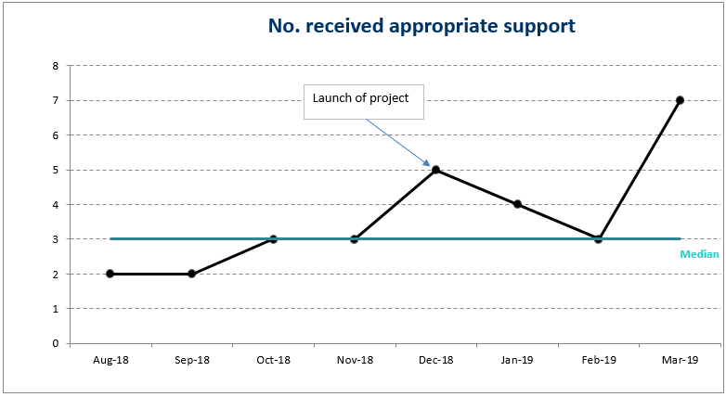
This project started in May 2018 and has continued into the refreshed LOIP. The run charts above show the number of individuals who received ‘appropriate and timely support’, from data collated on the project’s Common Questionnaire which is being used across all three organisations involved. The median figure has remained at 3 (the same as for the benchmarking period) for the first three months of the project.

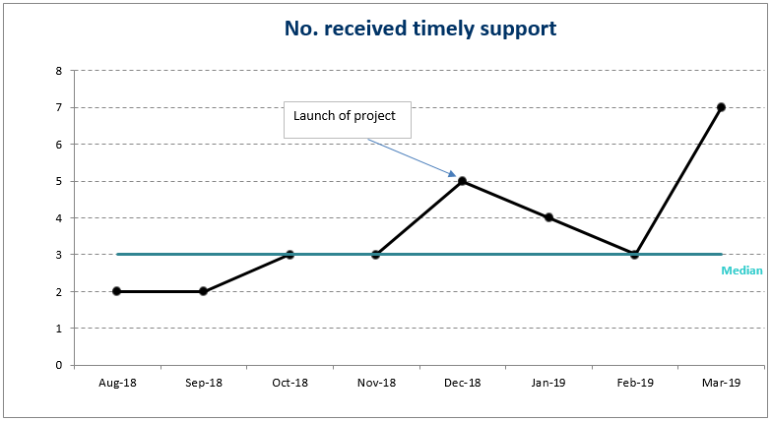
Further detailed information/conclusions will be provided to the next meeting of the Management Group.

Live Projects | Start-  End | Progress Scale | Changes being tested
10.2  Increase no. of individuals who are on a custodial sentence, CPO Supervision or Diversion from Prosecution are being supported to make progress on the Employability Pipeline by 2021.  Project Manager: Nicola Graham, SDS | Feb 18 – Mar 21 | 7 | Pathways are in Place  • Training/awareness-raising events for statutory partners and other employers  • Single point of contact identified by employer organisations  • My Way to Employment Handbook for partners  • Briefing note for employers – with tear-off slip  Individuals are engaged  • Flyer for individuals  • Initial Assessment Form  • ‘Lead Professional’ identified for each individual  • Personal Mentor identified for each individual  • Regular meetings involving Lead Professional, Personal Mentor, individual, and others as appropriate  • Spreadsheet to record individual profile data
Improvement Data

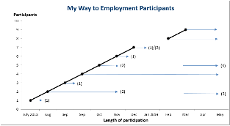
This project started in Feb 2018 and has continued into the refreshed LOIP.

Individuals are engaged
The run chart above shows the individuals who agreed to participate in MWTE, and the duration of their engagement. In total nine individuals participated/continue to participate:

- Five individuals are currently continuing to engage. Of these, two have returned to prison but were re-engaged with there.
- Three individuals had started off positively but then ceased to engage. Efforts are being made to re-engage with these individuals.
- One individual ceased to engage and returned to custody. The project is endeavouring to re-engage this individual while in custody.

The reasons for individuals ceasing to engage are varied. Common issues included people returning to custody, health issues (e.g. drug and alcohol-related, and mental health), lack of confidence/motivation, struggling to break the cycle of not being in work etc.

Notes: (1) Ceased to engage (2) Returned to custody (3) Re-engaged

Pathways are in place/Engagement with Employers

Input at 8 employers’ events including two organised specifically by the project team (22/2/18 and 29/9/18)
Event on 29/9 resulted in further meeting arranged with SFRS to discuss specific opportunities
Employers Briefing Note given out at 3 of these events
9 out of 9 statutory partners have now identified single points of contact
Additional opportunities for awareness raising being pursued with Chamber of Commerce, Federation of Small Businesses, and other employers.
Further detailed information/conclusions will be provided to the next meeting of the Management Group.

Lead Outcome Improvement Group: Resilient, Included, Supported Group

No. project charters due: 2
No. project charters ready: 1
No. project charters postponed: 1
No. project charters outstanding: 0
No. projects live: 0
Total No. of LOIP projects: 17

Charter Status | Ready | Postponed

Stretch Outcome 11
Healthy life expectancy (time lived in good health) is five years longer by 2026

Project Charters Due | Charter submitted to CPA Board
Increase uptake of a range of activities that enable people with long term conditions to manage their health and well-being by 2021. |  | Yes. Charter approved at special CPA Management Group meeting on 12 June.  (See charter 11.1)
Extend link working approach across primary care to support 3,000 people to attain their own identified outcomes by 2021. |  | Postponed to September. Charter considered at special CPA Management Group meeting on 12 June. Feedback to be addressed.  (See charter 11.1)

Lead Outcome Improvement Group: Alcohol and Drugs Partnership

No. project charters due: 0
No. project charters received: N/A
No. project charters postponed: 6
No. project charters outstanding: 0
No. projects live: 0
Total No. of LOIP projects: 11

Stretch Outcome 12
Rate of harmful levels of alcohol consumption reduced by 4% and drug related deaths lower than Scotland by 2026

No charters due

(IV) PLACE JULY UPDATE

Charter Status | Ready | Postponed

Lead Outcome Improvement Group: Sustainable City Group

No. project charters due: 1
No. project charters ready: 2
No. project charters postponed: 0
No. project charters outstanding: 0
No. projects live: 0
Total No. of LOIP projects: 9

Stretch Outcome 13
No one in Aberdeen will go without food due to poverty by 2026

Project Charter Received | Charter submitted to CPA Board
Increase community food growing in schools, communities and workplaces by 2021 |  | Yes. Charter approved at special CPA Management Group meeting on 12 June.  (See charter 13.1)

Stretch Outcome 14
Addressing climate change by reducing Aberdeen’s carbon emissions by 42.5% by 2026 and adapting to the impacts of our changing climate

Project Charters Due | Charter submitted to CPA Board
Community led resilience plans in place for areas most vulnerable to flooding by 2021; and  Community led resilience plans in place across all areas by 2026 |  | Yes. Charter approved by CPA Management Group on 27 May 19 (See Charter 14.1)

Stretch Outcome 15
38% of people walking and 5% of people cycling as main mode of travel by 2026

No charters due

(V) COMMUNITY ENGAGEMENT JULY UPDATE

Lead Outcome Improvement Group: Community Engagement Group
No. project charters due: 0
No. project charters ready: N/A
No. projects live: 1
Total no. of projects planned: 3

(VI) NEW CHARTERS JULY UPDATE

1 | Increase the impact and measured value of Partnership wide community benefits programme by 2022 | See charter 2.1
2 | Increase the number of families who request additional support and receive an offer of an appropriate service within 30 days of receipt of the Child’s Plan, to 80%, by 2021 | See charter 3.1
3 | Increase the number of care experienced young people accessing a positive and sustained destination by 25% by 2022 | See charter 5.1
4 | Increase in the number of inhouse foster and kinship placements by 2021 | See charter 5.2
5 | Increase the no. young people who effectively transition from primary school to secondary school by 2021 | See charter 6.1
6 | Increase the number of young people living in Quintiles 1,2 and 3 engaged in a family approach who achieve a sustained positive destination to 90% 2022 | See charter 6.2
7 | Increase the number of young people taking up foundation apprenticeships to 142 by 2021 | See charter 6.3
8 | Increase the number of individuals who are involved in cuckooing* incidents who undertake effective interventions or who are referred to relevant support services in priority localities by 2021. | See charter 10.3
9 | Increase the uptake and retention of people in the Justice System with drug and alcohol problems in specialist services by 100% by 2021. | See charter 10.4
10 | Increase uptake of a range of activities that enable people with long term conditions to manage their health and well-being by 2021 | See charter 11.1
11 | Increase community food growing in schools, communities and workplaces by 2021 | See charter 13.1
12 | Community led resilience plans in place for areas most vulnerable to flooding by 2021; and Community led resilience plans in place across all areas by 2026 | See charter 14.1

