10.3 Cuckooing

Improvement Project Title:
Multi-Agency Cuckooing Response

Executive Sponsor (Chair of Outcome Improvement Group or Locality Partnership):
Chair of Community Justice Group

Project Lead:
DI Fionnuala McPhail, Police Scotland

Aim statement
Increase to 30% the number of individuals who are involved in cuckooing incidents who undertake effective interventions or who are referred to relevant support services (as a % of all those identified as being involved in cuckooing incidents) in priority localities by 2021.

Link to Local Outcome Improvement Plan:
This project aim is included in the LOIP under Stretch Outcome 10: 2% fewer people reconvicted within one year of receiving a community or custodial sentence by 2026.

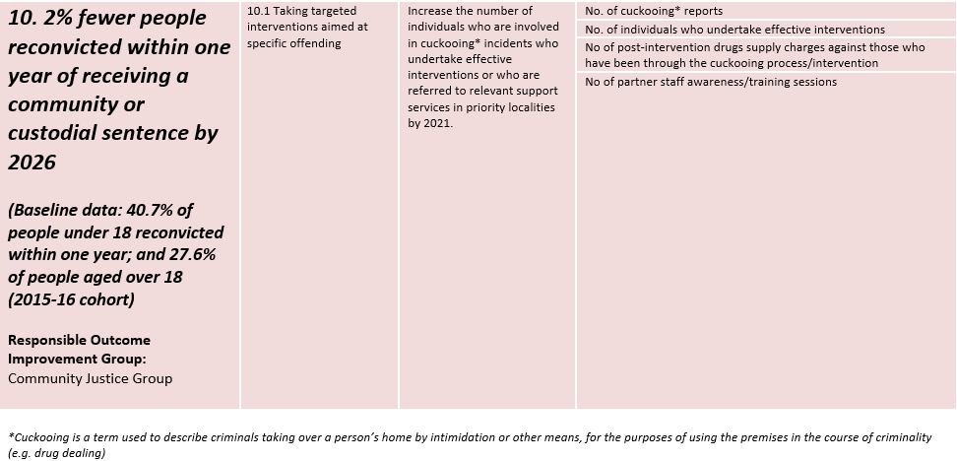

Why is this important?
*'Cuckooing' in Policing terms is described as taking over a person’s home by intimidation or other means, including the use of violence, by an Organised Crime Group (OCG) for the purposes of utilising the premises in the course of criminality. The term ‘cuckooing’ is taken from the Cuckoo bird who invades the nests of other birds and utilises it for its own purposes.
Serious organised crime gangs from areas such as Liverpool, West Midlands and London travel to other parts of the country, including Aberdeen City. These individuals will then take over the property to assist with their illegal operation, be it for storing or dealing drugs. This is often achieved through the use of threats and actual violence towards the occupants or their loved ones.

The occupier of the house is often a vulnerable member of the community either through addiction, age, mental health or other vulnerabilities which makes them a target for such crime groups. Such victims may already be in contact with service providers who regularly have meetings with them or attend at the premises being utilised by the crime group.

The project, which is a new initiative in Aberdeen, aims to identify individuals who are ‘victims’ of cuckooing and then to offer advice and support to help them get out of the situation they have found themselves in, and to try and protect and maintain their tenancy, by referral to appropriate services (eg addictions, mental health, housing services). The intention is to protect these individuals and support them to improve outcomes, and to disrupt the activities of serious organised crime groups. Any concerns relating to child protection would be considered an emergency and dealt with immediately (rather than as part of the Cuckooing initiative). While some individuals are living in fear as a result of cuckooing, and will more easily engage with offers of support, others are more challenging to engage as they feel they are benefitting from the situation, in terms of the ‘rewards’ they may be receiving, eg drugs. Enforcement approaches are applied where appropriate.

Nine individuals were identified as involved in cuckooing in priority localities between February and April 2019 (the baseline period), of which two undertook relevant interventions or were referred to relevant support services, two were closed as their circumstances are no longer relevant to cuckooing, five are currently still under assessment and consideration of referral. In the project Aim, ‘undertaken relevant interventions or who are referred to relevant support services’ includes engagement with any one of the partners/services involved in the project.

The Cuckooing Initiative has been successfully operating in the Peterhead and Fraserburgh areas for the past year with officers from Police Scotland working with the Housing Sector, Criminal Justice Social Work and Community Substance Misuse Services to support these people.

The initial stage of the cuckooing initiative in Aberdeen will be tested in the Seaton, Tillydrone and Kittybrewster areas, with the aim of expanding city-wide during the course of the project.

Education of members of the public, Police Officers, key partners and other agencies is central to the initiative and it runs alongside traditional Police enforcement against the OCGs, reducing their opportunity to use cuckooing and further disrupting their criminal activities to facilitate the overarching aim of identifying and safeguarding vulnerable persons.

This project is consistent with the national strategy to tackle Serious and Organised Crime known as ‘Letting Our Communities Flourish’, published by the Serious and Organised Crime Multiagency Task Force. This focuses on four objectives:

- DIVERT - individuals (particularly young people) from engaging in or using the products of serious organised crime.
- DISRUPT - the activities of serious organised crime groups.
- DETER - through measures to protect communities, businesses and the public sector from serious organised crime.
- DETECT - by boosting capacity and improving co-ordination to give serious organised criminals no place to hide.

Benefits:
- Staff are upskilled to identify potential victims that may not have been obvious previously (Police, LA, Health).
- The community is more aware of what cuckooing is, and can assist to protect its members (Community Stakeholders).
- Support is provided to most vulnerable in community (the individual).
Measures: (How will we know if a change is an improvement?)
- Number of individuals who are involved in cuckooing* incidents who undertake effective interventions or who are referred to relevant support services (eg SMS/Housing/GP) (LOIP)
- Number of cuckooing incidents reported to Police (LOIP)
- Number of partner awareness sessions (LOIP)
- Number of (joint) visits to individuals (‘victims’)
- Number referred to alcohol/drug services
- Number of vulnerable adults (eg elderly, having mental health issues) assisted by relevant services
- Number of post-intervention drugs charges against those who have been through the cuckooing process (LOIP)
- Number of ‘offenders’ displaced to other areas

Change ideas (What changes can be made that will result in improvement?)
- ‘Core Contacts’ (single points of contact from partner organisations) and record same.
- Awareness-raising sessions for professionals/partners.
- Mechanisms for raising awareness with public/local communities (eg leaflet drops, SHMU radio/newsletters)
- Process for Police to coordinate joint visits to individuals
- Joint partner visits aimed at engaging with individuals identified as potentially being ‘victims’
- Process for partners to refer individuals on to relevant support as appropriate
- ‘Lead professional’ approach for individuals involved
- Steps to protect individuals as relevant to individual circumstances, to increase chances of individual engaging
- Police document to record data/information about individuals (victims) identified as being involved
- Regular ‘operational’ cuckooing meetings involving partners (Cuckooing Initiative Operational Group) to review incidents
- Info-sharing agreement

Potential risks and/or barriers to success & actions to address these
Demand unknown (start small and upscale)
Lack of understanding (awareness sessions for wider; bespoke training for those involved)
Project Team:
Fionnuala McPhail, Police Scotland (Proactive CID)
Graeme Skene, Police Scotland (Intervention Unit)
Brian Cumming, Police Scotland (Community Safety)
Hazel Flett, CJSW (Senior, Women’s Centre/Strategic Support)
John Donaghey, NHS Grampian (Lead Nurse Mental Health and Learning Disability)
Jane Hogg, Aberdeen City Council (Senior Housing Officer)
Simon Rayner, NHS Grampian (Development Manager, Integrated Services)
Rhona Stewart, Aberdeen City Council (Adult Social Work, Integrated Drugs Team)
Adam Keenan, Aberdeen City Council (Consultant Social Worker, Integrated Children’s and Family Service)
Morag Wiseman, AHSCP (Adult Social Work – Duty Team)
Claire Bloomfield, NHS Grampian (Senior Health Intelligence Analyst)
Val Vertigans, Community Justice Officer

Outline Project Plan - Set out your initial plan about the timeline for your project.
(This should be reviewed regularly)
Project Stage | Actions | Timescale
Getting Started  (Project Score 1-3) | Project team established and draft charter. | End April 2019 - complete
Designing and Testing Changes  (Project Score 4-7) | Change ideas being identified, data / intelligence has informed priority areas for initial testing, testing being taken forward. | December 2019
Implementing and sustaining changes that demonstrate improvement  (Project Score 7-10) | Testing of training/awareness-raising taking place as part of the project. Changes to procedures of partners involved. | May 2020
Spreading Changes  (Project Score 9-10) | Training/awareness raising will be a key part of spreading the project to wider areas of the city, eg with relevant Housing, Social Work teams, etc | May 2021

