2.1 Community Benefits

Improvement Project Title: Community Benefits Co-Design Improvement Project
Executive Sponsor: Chair of Aberdeen Prospers
Project Lead: Lori Manson
Aim statement (What are we trying to accomplish? Over what time? Numerical target for improvement?) Increase the impact, levels of community/partner participation and measured value of collaborative, Partnership wide community benefits by 2022
Link to Local Outcome Improvement Plan (LOIP):
The refreshed LOIP published in 2019 identifies 15 stretch outcomes to break down the overall vision and ambitions to reduce poverty into manageable, thematic programmes of work. This Improvement Project sits under stretch outcome 2 within the Economy theme.
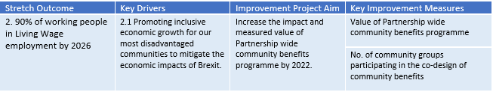
It is expected that the nature, content and thematic focus of individual ideas & initiatives will contribute to a broad range of LOIP priority outcomes.
This will be measured in the aims and outcomes in the Framework of individual Community Benefit Projects, and will be encouraged to contribute to Strategic Aims, as well as locally identified Community Needs and Aspirations.

Why is this important?
Community benefits clauses, when included within contracts or framework agreements, require the successful bidder to deliver some form of social, economic or environmental benefit in addition to the core purpose of the contract. Provided requirements remain proportionate and relevant to the contract they are associated with, there are a variety
of themes that can be addressed as shown in the table below. Full information can be found in the Community Benefits and Sustainable Procurement Policy.
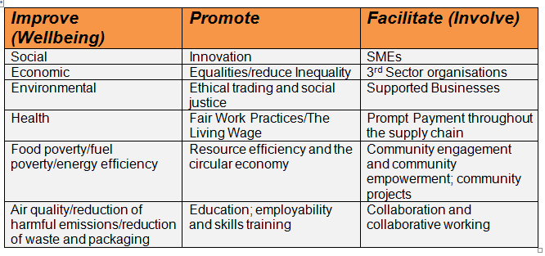
This project will look to improve how communities and partner organisations participate with the process and how their input can add value, shaping the desired outcomes associated with community benefit clauses.
Intelligence contributed by communities will ensure requirements sought are welcomed, aligned to local need and wherever possible, build on existing initiatives. The impact of community benefits activity will also be maximised through improved coordination and collaboration across the wider Community Planning Partnership.

The timing is particularly opportune to initiate this improvement project, due to:
- Development of a strong Community Planning Partnership in the city.
- Significant investment across the city at this time through the programmes such as the City Centre Master Plan, Local Development Plan and City Region Deal.
- The Community Empowerment Act has increased communities’ confidence in their place, how they can engage and contribute, and this project offers the opportunity to further this.
Measures: (How will we know if a change is an improvement?)
- % of contracts which incorporate co-designed community benefits
- No. of community benefit ideas/initiatives logged from communities
- % of community benefit outcomes matched with a local community initiative/project or local/national priority
- Value of community benefits measured in terms of outcomes for communities in general/particular priority groups – (e.g. employment and training; social and environmental wellbeing measures)
- % of community proposals successfully transposed into agreed community benefit options
- No. of community groups/ individuals participating in co-design of community benefits
- Customer (i.e. community representatives engaged) and community feedback and levels of satisfaction of both the process and the outcome
Change ideas (What can we do that will result in improvement?)
- Establishment of community co-design project group
- Apply Participatory Budgeting approach to community benefits co-design
- Use of procurement documentation to further encourage contractors to engage with communities upon contract mobilisation
- Improvement Project Team to host a mini-conference on community benefits to seek commitment for a coordinated approach
Potential Barriers
- Contracting organisation buy-in to the concept / initiative
- Lack of consistency across public sector partners
- Lack of take up of community benefits by community groups / residents
- Visibility of procurement pipeline and future opportunities
Project Team:
Ishbel Lavery, Lead Contact Aberdeen Prospers, Aberdeen City Council
Jonathan Smith, Aberdeen Civic Forum
Lori Manson, City Growth, Aberdeen City Council
Paul Tytler, Early Intervention & Community Empowerment, Aberdeen City Council
Stuart Calderwood, Commercial & Procurement Shared Service, Aberdeen City Council
Susan Morrison, ACVO
Jacqueline Craig, Police Scotland

Outline Project Plan

Project Stage | Actions | Timescale
Getting Started  (Project Score 1-3) | -Project team established  -Draft charter developed  -Charter submitted to CPA Board | Complete  Complete  July 2019
Designing and Testing Changes  (Project Score 4-7) | -Design changes for initial testing  -Test changes with Tillydrone Community Hub Construction Contract  -Community benefit ideas generated sent to participants for prioritisation  -Final community benefits incorporated within the tender documents  -Evaluate overall results and plan further contracts, including partner contracts, for testing changes  -Hold mini-conference to share case study/ process map and lessons learned to encourage further partners to test changes to increase community benefits | July 2019  Sep to Oct 2019  Nov 2019  Dec 2019  Jan 2020  April 2020
Implementing and sustaining changes that demonstrate improvement  (Project Score 7-10) | -Agree change ideas tested which are proven to work that we will seek to embed permanently  -Continue to gather data on no. contracts which incorporate community benefits as a result of changes implemented  - Assess whether improvement levels are sustained | Dec 2020
Spreading Changes  (Project Score 9-10) | -Assess opportunities for spreading change to other areas where applicable | Jan 2021

