5.1 Care Experienced Children Positive Destinations

Improvement Project Title: Improving Education Outcomes for Care Experienced Children and Young People
Executive Sponsor: Rob Polkinghorne (ICS Board Chair)
Project Lead: Larissa Gordon (LAC Virtual Headteacher) ACC
Aim statement:

Increase the number of care experienced young people accessing a positive and sustained destination by 25% by 2022.

Baseline to be established

Link to Local Outcome Improvement Plan:

Stretch Outcome 5:

95% of care experienced children and young people will have the same levels of attainment in education, emotional wellbeing, and positive destinations as their peers by 2026

Why is this important
“Official statistics show that looked after children do far less well at school and when they leave school than other children from similar backgrounds. We say this is a simply unacceptable situation. Our key goal is to play a big part in narrowing the educational attainment gap for all looked after children.
We believe in building on the rich capacities, skills and aspirations of all looked after children. We work with teachers, carers and other professionals to ensure that every child receives the high quality and well-rounded education they deserve.” CELCIS website.
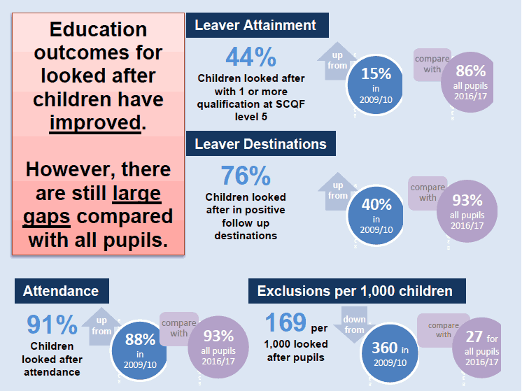

Source: Education outcomes for looked after children: 2016 to 2017. Scottish Government.
The vision for the Local Authority as outlined in the recently refreshed Local Outcome Improvement Plan (LOIP) is that by 2026, Aberdeen City will be a place where all people can prosper, regardless of their background or circumstances. This reflects the desire to help all people, families, businesses and communities to do well, succeed and flourish in every aspect. To achieve this vision we are committed to tackling the issues that exist in our society which prevent equal opportunity for all to lead a happy and fullfilling life.

The refreshed LOIP brings a sharpened focus on outcomes for those we have Corporate Parent responsibilities for and as an Education Service our newly established vision is to develop strong partnerships that will ensure that Aberdeen is a high achieving City of Learning which:

- Offers nurturing, relevant learning opportunities for all
- Strengthens the resilience of all
- Celebrates aspiration, ambition and innovation with all

As Corporate Parents, we must realise this vision and ensure equity of outcomes for all children and young people looked after by Aberdeen City Council.

The aim is an overarching strategic aim. How each school in Aberdeen deliver this will be dependent on their context and the particular needs of those children and young people within their school. However, each school will be expected to deliver on the changes identified within the project.

Measures:

Outcome measures

- % of looked after young people in positive destinations
- Comparative data over time will evidence sustainability
- % achievement in Curriculum for Excellence Levels for reading for Looked After children (data is collected at agreed points throughout the year. Each school provides this information)
- % school attendance of Looked After children and young people (reported on monthly and collated by the Virtual School head teacher – live data used)

Process measures

- Number of Looked After Children considered for / involved in an enhanced transition P6 / P7 (to monitor impact of new ASN Transition Guidance).

Balancing measures

- % of looked after young people in unemployment or unknown destination
- Number of exclusion incidents for looked after children and young people (reported on monthly and collated by the Virtual School Head teacher – live data used)
- Number of Looked After children and young people attending school on a part time basis (reported on monthly and collated by the virtual school head teacher – live data used)

Change ideas

- Emerging Literacy Programme – students from Aberdeen University supporting children with the programme in Primary 1-3 schools
- MCR Pathways – structured mentoring programme in Secondary schools from S1 through to leaving (commissioned service) Testing will start on 6 identified secondary
- Improving Attendance by monitoring and tracking attainment & exclusions in all schools (Aberdeen City; out of Authority & Residential schools) for all individual looked after children. Providing indicators to support early intervention.
- Early Action System – target & support winter leavers to head into more sustainable positive destinations
- Publish Transitions guidance

Potential risks and/or barriers to success & actions to address these

- Ongoing difficulties with Teaching staff resources – current recruitment drive targeting potential teaching staff from other countries
- Curriculum Offer – Work stream of Developing Young Workforce, Quality Improvement Manager to address this
- Knowledge & skill set of teaching and support staff – learning offer from Osiris to provide high quality professional learning. General Teaching Council have agreed to support the development of coaching and mentoring skills

Project Team:
- Larissa Gordon, Virtual Head Teacher, ACC
- Rosie Hardwick, Business Intelligence, ACC
- Primary Head Teachers (1)
- Secondary Head Techers (1)
- Peter Melrose, Who Cares Scotland
- Carol Sneddon, Opportunities for All Manager, ACC
- Aisling Campion, Educational Psychologist
- Katie MacPhee, Depute Principal, Educational Psychologist
- Children’s Social Worker
- Consultant Social Worker
- Craig Singer, Development Manager
- Kelly Hickman, Improvement Adviser, ACC
- Linda Gray, LAC Nurse NHS
- Carron McKellor, Police
- Maggie Hepburn, ACVO

Outline Project Plan
Project Stage | Actions | Timescale
Getting Started  (Project Score 1-3) | - Project team established  - Initial baseline data established  - Draft charter developed  - Charter submitted to CPA Board | Complete  September 2019  Complete  July 2019
Designing and Testing Changes  (Project Score 4-7) | - PDSA carried out with St Machar Academy  - Schools identified to be included in the project  - Project plan shared with Head Teachers  - Test Changes using PDSA with Hazelhead Academy / Northfield Academy / Lochside Academy / Dyce Academy / Harlaw Academy  - Evaluate overall achievement to date and plan further PDSAa or move to implementation in all academies | Completed by September 2019  Complete  June 2019  Started October 2019  August 2021
Implementing and sustaining changes that demonstrate improvement  (Project Score 7-10) | - Agree change ideas tested which are proven to work that we will seek to embed permanently  - Continue to gather data  - Assess whether improvement levels are sustained | August 2021  August 2021  August 2022
Spreading Changes  (Project Score 9-10) | Assess opportunities for spreading change to Primary sector | August 2022

