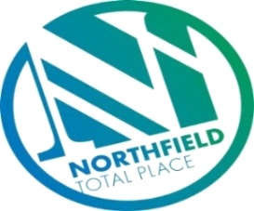

Northfield Total Place
Locality Partnership Board Meeting
Manor Park Community Wing
Wednesday 9.15am – 11.15am 3rd July 2019

AGENDA
Your Data
Aberdeen City Council holds your contact details for the purposes of two way communication. We do not share your details with a third party. If you do not wish us to hold your details, please let us know and I will delete your details. Bear in mind however that you will not receive future communications relating to these meetings. Your details will be held for as long as you attend the meetings and up to 6 months after.

- 9:15am - Welcome/introductions
- 9:20am - Apologies
- 9:25am - Minutes of previous meeting
- 9.30am - Locality Plan Tracker review – progress
- Byron Square – Painting Programme

- 9.35am - Alcohol & Drug Partnership Projects and Funding
- 10.05am – Middlefield Triangle Redevelopment, Haudagain and Manor Walk new build housing – (MS)
- 10.10am – Police Scotland & NYAG update (Inspector Main)
- 10.25am - Tests of Change & New Improvement Projects (FG)
- 10:35am – Food and Fun –Update (MS)
- 10.45am – Northfield Partnership Forum (FG)
- Links to Locality Board

- 11.00am – Community Council updates.
- 11.10am - AOCB
- 11:15am - Date of next meeting and close

