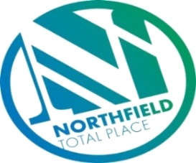

Northfield Total Place
Locality Partnership Board Meeting
Manor Park Community Wing
Wednesday 9.15am – 11.15am - 28 August 2019

AGENDA
Your Data
Aberdeen City Council holds your contact details for the purposes of two way communication. We do not share your details with a third party. If you do not wish us to hold your details, please let us know and I will delete your details. Bear in mind however that you will not receive future communications relating to these meetings. Your details will be held for as long as you attend the meetings and up to 6 months after.

- 9:15am - Welcome/introductions
- 9:20am - Apologies
- 9:25am - Minutes of previous meeting
- 9.30am – Farrans/Jacobs UK – Update on Haudagain Road Improvement Scheme
- 9.50am - Locality Plan Tracker Review – progress
- Byron Square Painting Programme
- Unpaid Workers Scheme
- 10.00am – Middlefield Triangle Redevelopment and Manor Walk new build housing update– (MS)
- 10.10am – Police Scotland & NYAG update (Inspector Main)
- 10.20am - Tests of Change, Feedback from Special LOIP meeting (7/8/19) & New Improvement Projects (FG)
- 10:40am – Food and Fun – Update (MS)
- 10.50am – Northfield Partnership Forum (FG)
- Links to Locality Board

- 11.00am – Community Council updates.
- 11.10am - AOCB
- 11:15am - Date of next meeting and close

