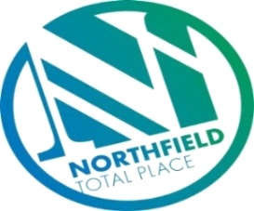

Northfield Total Place
Locality Partnership Board Meeting
Manor Park Community Wing
Wednesday 9.15am – 11.15am 8th January 2020

AGENDA
Your Data
Aberdeen City Council holds your contact details for the purposes of two-way communication. We do not share your details with a third party. If you do not wish us to hold your details, please let us know and I will delete your details. Bear in mind however that you will not receive future communications relating to these meetings. Your details will be held for as long as you attend the meetings and up to 6 months after.

- Welcome and Introductions All
- Minutes of Meeting 30th October 2019 Chair
- Approval
- Actions
- Matters arising

- Simon Rayner, NHS Alcohol & Drugs Partnership – presentation and update on localities funding.
- Farrans – Update on A92/A96 Haudagain Improvement Project
- LOIP/Locality Improvement Project Updates FG
- Annual Report Update – 18/19 draft enclosed FG
- U Decide 20/21 FG
- Report back from Northfield Partnerships
- NYAG/Police Update Police Scotland
- Partnership Forum FG
- Food & Fun update MS
- Community Learning and Development Inspection feedback FG
- Community Council Updates
- Mastrick, Sheddocksley and Summerhill
- Northfield
- AOCB

