**COMMUNITY JUSTICE ABERDEEN**

ASSESSMENT OF NEED/DEMAND

DRAFT 4 – Updated Sept 2018

Report compiled by Policy Coordinator, Community Justice Redesign

Contents

|  |  |  |
| --- | --- | --- |
|  |  | **Page** |
|  | **Introduction** | 3 |
| Section One | **What is Community Justice?** | 5 |
| Section Two | **Key Findings** | 6 |
| Section Three | **Setting the Context**  A The National Context  B Community Planning Aberdeen’s Strategic Assessment/Local Outcomes Improvement Plan 2016  C Other Local Issues relevant to Community Justice  D PESTELO Analysis, Opportunities and Risks | 13  13  14  16  19 |
| Section Four | **What does Offending in Aberdeen look like?**  A Overview of (police recorded) crimes committed in Aberdeen, where they are being committed, and the home areas of the perpetrators  B Young People who Offend  C Reconviction Rate Data  D Victim Data | 20  20  47  48  48 |
| Section Five | **Who is committing these offences? What do we know about these individuals? What are their characteristics?**  - Issues which contribute to the likelihood of an individual reoffending in Aberdeen - a profile of those who offend | 50 |
| APPENDIX 1 | Definition of Community Justice | 58 |
| APPENDIX 2 | PESTELO Analysis of Community Justice in Aberdeen and Opportunities and Risks | 60 |
| APPENDIX 3 | Relevant National Strategies etc | 64 |
| APPENDIX 4 | Composition of Crime Categories | 65 |
| APPENDIX 5 | Postcode Information | 67 |
| APPENDIX 6 | The general causes of crime and the factors that can contribute to offending/reoffending | 69 |

**INTRODUCTION**

From 1st April 2017 responsibility for strategic planning and delivery of community justice has been taken forward by partners in each local authority area. In addition a national body – Community Justice Scotland - was formed to oversee the new arrangements, give assurance to Ministers and promote the benefits of ‘community justice’. The Community Justice (Scotland) Act 2016 (‘the Act’) underpins these arrangements.

The emphasis of this new local model lies in a collaborative approach between partner organisations, communities, and the individuals who are involved with the ‘Justice System’ and their families. It aims to encompass all those who may be able to contribute to improving outcomes for individuals, families and communities, including organisations/services which may not traditionally have been involved with community justice. Communities lie at the heart of this new model, and the local strategic planning and delivery of services through Community Planning Partnerships (“CPPs”) are central to the new arrangements.

The Act sets out a list of statutory Community Justice Partners which must publish a Community Justice Outcomes Improvement Plan for each local area. In preparing the plan, the partners must assess the extent to which national Community Justice outcomes – as set out in the new national Outcomes and Performance Improvement Framework - are being achieved locally, whether they require to be a priority for action, and what action they intend to take to achieve or maintain them. The new national outcomes are set out below:

|  |
| --- |
| Person-centred Outcomes:   * **Individual’s resilience and capacity for change and self-management are enhanced;** * **People develop positive relationships and more opportunities to participate and contribute through education, employment and leisure activities;** * **Life chances are improved through needs, including health, welfare, housing and safety, being addressed.**   Structural Outcomes:   * **Communities improve their understanding and participation in community justice;** * **Partners plan and deliver services in a more strategic and collaborative way;** * **People have better access to the services they require including welfare, health and wellbeing, housing and employability;** * **Effective interventions are delivered to prevent and reduce the risk of further offending.** |

This report aims to assess the ‘needs’ of those involved in the Justice System in Aberdeen, and therefore the services /support required to be in place to help individuals move to more positive outcomes, at the different stages of the Justice System. This will help to inform discussions with partners and stakeholders, including community representatives, as to which priority Outcome areas and related actions should form part of Aberdeen’s Community Justice Outcomes Improvement Plan, in working towards the Vision for Community Justice in Aberdeen (developed from feedback from a Partnership Event held on 11th November 2015):

|  |
| --- |
| * **Our Citizens have a better understanding of, and are included and involved in, Community Justice** * **Our Organisations and Services work together to achieve shared outcomes** * **The interests of people harmed are central to our plans and activities** |
| In working to achieve this Vision, our Organisations and Services both statutory and non-statutory, will:   * Improve their understanding of each other’s roles, responsibilities and aims; * Strive to work together efficiently, effectively and coherently; * Take collective responsibility for the achievement of shared outcomes; * Work together to manage risk at an appropriate level; * Have a common focus on prevention and early intervention in all activities; * Take a person-centred approach to helping people address their needs; * Support and involve families where possible and appropriate; * Be bold, be smart, and do things differently, as well as build on good practice where possible; * Treat people with respect; and * Take an open, honest, fair and professional approach. |

Aberdeen, the Community Justice Outcomes Improvement Plan is embedded into the CPA [Local Outcome Improvement Plan 2016-26](https://communityplanningaberdeen.org.uk/wp-content/uploads/2016/08/Final-LOIP-24-April-17.pdf).

**SECTION ONE – WHAT IS COMMUNITY JUSTICE?**

Community Justice has been defined by Scottish Government (from the new National Strategy) as “the collection of individuals, agencies and services that work together to support, manage and supervise people who have committed offences, from the point of arrest, through prosecution, community disposal or custody and alternatives to these, until they are reintegrated into the community. Local communities and the third sector are a vital part of this process which aims to prevent and reduce further offending and the harm that it causes, to promote desistance, social inclusion, and citizenship**[1][1]**”

A legislative definition of **Community Justice** can be found in the new [Community Justice (Scotland) Act 2016](http://www.legislation.gov.uk/asp/2016/10/contents/enacted), and is summarised at Appendix 1.

Community Justice’ includes the provision of the specific, and chiefly statutory, services provided by Criminal Justice Social Work Services (“CJSWS”) which cover:

* Early Intervention activities, including Diversion from Prosecution and Bail Supervision;
* Provision of Criminal Justice Social Work Reports to Courts, prisons and Parole Board;
* Supervision of individuals on Community Sentences; and
* Statutory Throughcare (CJSWS involvement in Integrated Case Management of individuals given a custodial sentence of four years or more, or sex offenders on shorter sentences, and statutory supervision of such prisoners on release, including parole, non-parole, life licences, etc. Support is also provided to families).

Individuals convicted of serious offences and assessed as being of significant risk to the public are also managed in the community through close working between key partners, where they have been given a community sentence or on release from prison.

In Aberdeen, the Criminal Justice Social Work Service is part of the Health and Social Care Partnership.

A range of other partners and services are also involved in delivering ‘Community Justice’ outcomes, including Police Scotland, the Scottish Prison Service, a range of local authority services, the Scottish Courts and Tribunals Service, NHS, Health and Social Care Partnerships, Skills Development Scotland, the Scottish Fire and Rescue Service, the Crown Office and Procurator Fiscal Service, Third Sector organisations, Alcohol and Drugs Partnerships and other partnerships.

**SECTION TWO – KEY FINDINGS**

*NB Fuller information about these Key Findings can be found in the rest of the report.*

**1 High Level Data - Aberdeen**

**Recorded Crime**:

Crimes reported to the Police reduced by 43**%** between 2007-08 and 2017-18. There was a reduction of 10% in recorded crime from 2016-17 to 2017-18.

(From Police Scotland published [Management Information Council Area Report Q4 2017-18](http://www.scotland.police.uk/assets/pdf/138327/232757/445136/management-info-council-area-report-q4?version=1)

[NB It should be borne in mind that not all crime/offending is reported to the Police.]

**Direct Measures**:

The following Direct Measures were given by the Police and Crown Office & Procurator Fiscal Service in 2017-18 (unless otherwise indicated):

* 859 Police Anti-Social Behaviour Fixed Penalty Notices in 2016-17 (1,162 in 2015-16);
* 1314 Recorded Police Warnings (747 in 2016-17)
* 1,219 Fiscal Fines, Penalties and Compensation in 2016-17 (1,656 in 2015-16);
* 106 referred by the PF for Diversion from Prosecution (specialist support/treatment) (96 in 2016-17)
* 76 Fiscal Work Orders commenced.

**Different Disposals**:

In relation to Criminal Justice Social Work Reports requested by courts during 2017-18 (during which year **1,071 Reports** were submitted (1,182 in 2016-17) for **816 individuals** (905 in 2016-17)):

* 50% (50% in 2016-17) resulted in individuals being given a Community Payback Order;
* 17% (18% in 2016-17) resulted in individuals receiving a Custodial Sentence; and
* 33% (32% in 2016-17) resulted in individuals receiving other disposals including other community sentences, monetary penalties, admonition, etc.

Criminal Justice Social Work Reports are provided by Criminal Justice Social Work Services on the request of courts to give background information about an individual, and advice to help the court make a decision on which sentence to impose, such as a fine, community sentence or imprisonment.

(NB Data relates to Reports and not individuals. A CJSW Report would be requested unless the sentence being considered is a CPO Level 1 Unpaid Work and Other Activity Requirement only, or a lower tariff disposal. (If an individual is under 18, then a Report would still be requested in this instance.))

**Community Payback Orders** (“CPOs”):

In 2017-18, **1,154** new CPOs were given to **895** individuals in Aberdeen.

[NB Some individuals will have received more than one CPO.]

CPOs are the main ‘community sentence’ which can be given by a court in Scotland. CPOs are made up of one or more Requirements including Supervision, Unpaid Work and Other Activity, Compensation, Programme, Residence, Mental Health Treatment, Drug Treatment, Alcohol Treatment and Conduct. With the exception of a Level 1 Unpaid Work Requirement, all the other Requirements must be given with a Supervision Requirement. CPOs are managed/supervised by the Criminal Justice Social Work Service.

**Individuals in Custody**:

**310** people from Aberdeen were in custody as at 1st August 2018, of whom:

* 49 were on remand;
* 286 were males and 24 were females;
* 17 were under the age of 21 (all males);

69% of people from Aberdeen who were in custody as at 1st August 2018 were in HMP & YOI Grampian. HMP Grampian opened its doors in March 2014 and was the country’s first ‘community-facing’ prison, intended to cater for adults and young people, both male and female, from the north of Scotland. Males aged under 21 are currently residing in HMYOI Polmont in the central belt. There are individuals from Aberdeen in almost every prison establishment across the country. Women may spend periods of time in HMP Cornton Vale, the national prison for women, to undertake specific programmes, etc. Supporting individuals prior to and on release can be more challenging where they are not incarcerated locally.

**2 Offending – what and where?**

Analysis was undertaken of the three year average for numbers of crimes committed in areas of Aberdeen in 12 respective crime categories, per 10,000 of their population, between 2013-14 and 2015-16. The crime categories are: Anti social Behaviour/Public Order; Domestic Assault; Non Domestic Assault; Housebreaking; Drug Offences; Vehicle Crime; Sexual Offences (contact); Sexual Offences (non contact); Shoplifting; Theft; Violence (Attempted Murder and Assault & Robbery); and Weapon Offences.

With the exception of Ashgrove, the neighbourhoods highlighted above are regarded by Community Planning Aberdeen as being ‘of particular concern’.

The **Woodside** neighbourhood is above the Aberdeen City average in each crime category measured. The **City Centre** and **Torry** are above average for 11 out of the 12 crime categories, (all except ‘Housebreaking’ for the City Centre, and ‘Shoplifting’ for **Torry**), and **Ashgrove**, **Cummings Park** and **George Street** are above the average for ten out of the 12 categories.

The City Centre had the highest three year average number of crimes recorded per 10,000 population for all crime categories except Housebreaking, Vehicle Crime and Violence (Attempted Murder and Assault & Robbery).

Heathryfold, however, which is also an area of concern, averaged above the City three-year average in only three crime categories: Housebreaking, Vehicle Crime, and Violence (Attempted Murder and Assault & Robbery).

**3 Offending – which areas are the perpetrators from?**

*NB A list of neighbourhoods forming part of Aberdeen postcode areas can be found at Appendix 5.*

* For every crime category, the top three postcode areas of perpetrators against whom charges were made were **AB16**, **AB24** and **AB11** (with the exception of charges for Sexual Offences, where the postcode of individuals with the second highest number of charges was AB15 (AB24 did not feature in the ‘top 3’ for these offences.)
* For eight of the crime categories, the highest number of charges was made against perpetrators from **AB16** postcode areas.

AB16 and AB24 include the following neighbourhoods identified by Community Planning Aberdeen as being ‘of concern’: Heathryfold; Middlefield; Northfield and Cummings Park (AB16); and Seaton; Tillydrone and Woodside (AB24). Torry is in AB11. Further information about these areas can be found in Section 3(B) of this report and in the full CPA Strategic Assessment.

**4 Offending by young people (under 18)** (between 2013-14 and 2017-18)**:**

**Numbers of crimes, and young people perpetrating crimes**

* Detected CrimeFiles committed by young people **reduced by 46%**;
* Number of 8 to 15 year olds accused reduced from 483 in 2013-14 to 428 in 2017-18, and 16 – 17 year olds reduced from 498 to 270;
* **Males** accounted for **65%** of all young people accused;
* In 2017-18, 522 young people were accused of one crime each, 65 were accused of two crimes, and 70 were accused of three or more. The maximum number of CrimeFiles relating to one young person was 28.

**Kinds of crimes committed by young people:**

* The most common crimes committed by 8 to 15 year olds included Common Assault, Breach of the Peace, Urinating, Anti-Social Behaviour Offences, Threatening or Abusive Behaviour and Drinking offences;
* 16 and 17 year olds commit more ‘Group 3’ offences compared to other crime groups, eg Housebreaking, Shoplifting, Thefts and Thefts of and from Motor Vehicles ‘Theft of Motor Vehicle’ offences compared with other crimes.

**5 People harmed by offending (Scotland)**

(From the [Scottish Crime & Justice Survey 2016-17](https://www.gov.scot/Resource/0053/00533870.pdf).)

* The risk of being a victim of crime was higher for adults living in the **15% most deprived areas** in Scotland (19.4%), compared to those living in the rest of Scotland (12.3%).
* The risk of **property crime and violent crime** was higher for those living in Scotland's 15% most deprived areas. However, the proportion of those in the 15% most deprived areas experiencing property crime and violent crime has fallen from just over one-in-four (26.0%) to just under one-in-five (19.4%) since 2008/09
* The risk of being a victim of any crime **decreased with age**. One fifth (19.5%) of 16 to 24 year olds experienced property or violent crime, compared with a 7.2% of those aged 60 or over.
* In Aberdeen the same proportion of people experienced five or more crimes in the 20% most and least deprived areas – although a third of all crimes were experienced by individuals in the least deprived areas. (8% of crimes were experienced by individuals in the most deprived areas.) *(From SCJS 2014-15)*

**6 What do we know about the people who are perpetrating the offending?**

- ‘Profile’ information in relation to issues that may contribute to the likelihood of an individual reoffending if they experience these problems.

**At the point of arrest** (individuals referred to Alcohol and Drugs Action at Kittybrewster Custody Suite during the period January to May 2016):

* 36 had **alcohol** issues;
* 39 had issues with **drugs**;
* 22 had issues with **alcohol and drugs**.

**Individuals Diverted from Prosecution** (diversion by Procurator Fiscal to social work or other provider during 2017-18):

Of 106 cases commenced:

* 31 were aged 16 – 17;
* 23 were **Unemployed**;
* 18 were Employed or Self-Employed;
* Six were in Full Time Education;
* One was not seeking employment;
* 58 were categorised as ‘Other’ (Retired, supported by family, caring for home/family or long-term sick/disabled.

**Criminal Justice Social Work Reports submitted during 2017-18** (A total of 1,071 Reports were submitted for 816 individuals (902 males and 169 females)):

(Criminal Justice Social Work Reports are provided by Criminal Justice Social Work Services on the request of courts to give background information about an individual, and advice to help the court make a decision on which sentence to impose, such as a fine, community sentence or imprisonment.)

**Age/Sex Profile (number of CJSWS Reports)**:

* 2 were aged under 16 (all males);
* 60 were aged 16 – 17 (56 males and 4 females);
* **263** were aged **18 – 25** (216 males and 22 females);
* **360** were aged **26 – 35** (302 males and 58 females);
* **297** were aged **36 – 50** (248 males and 49 females);
* 80 were aged 51 – 65 (69 males and 11 females);
* 9 were aged 65+ (all males).

**Employment Status (number of CJSWS Reports)**:

* **619** were **Unemployed**;
* 190 were Employed or Self-Employed;
* 10 were in Full Time Education;
* 44 were not seeking employment;
* 208 were categorised as ‘Other’ (Retired, supported by family, caring for home/family or long-term sick/disabled.

**Individuals for whom Level of Service Case Management Inventory Risk/Needs Assessments were undertaken by Criminal Justice Social Work** (For individuals prosecuted at court for whom a Criminal Justice Social Work Report is requested by the court – averages over the three years from 2013-14 to 2015-16. Information is as provided by clients, with background information being sought from file reviews, previous reports, etc):

Companions/Leisure

* 70% had not participated in a formal activity in the last 12 months (eg sports club, church)
* 50% had some criminal friends, with whom they spent leisure time

Education/Employment

* 58% were currently unemployed
* 56% left school at the minimum leaving age, and 32% left without any qualifications

Drugs/Alcohol Issues

* 32% currently had an alcohol problem, or had had in the last 12 months
* 28% currently had a drug problem, or had had in the last 12 months

Antisocial Behaviour

* 64% had an official record of assault or violence
* 47% were assessed as having a pattern of generalised trouble (eg marked on at least four of the following: financial problems; three or more address changes in the last year; never employed for a full year; left school at minimum age; suspended or expelled from school at least once; poor relationship with parents)

Family/Marital

* 44% had an unsatisfactory relationship with parents, and 32% had a parent, sibling, spouse or close relative with a criminal record
* 45% had an unsatisfactory marital or equivalent situation

Other Issues

* 45% had financial problems
* 35% had been the victim of physical assault in the last 12 months
* 28% had been the victim of family violence, including physical, sexual or emotional abuse and/or neglect in the last 12 months
* 33% had low self-esteem

**Information about people in prison**

*NB It is not currently possible to extract data from HMP Grampian’s systems to ‘profile’ the population in terms of* *health/mental health/substance misuse, housing, employment, education, etc. However a pilot system is being put in place (from April 2016) to capture some of this information.*

In relation to 160 individuals liberated from HMP & YOI Grampian during the six months from April to September 2017:

* 54% were unemployed on admission;
* 8% were employed

From the SPS Prisoner Survey 2015 (overall prisoner response rate of 55%):

* Of those who specified, **45% had lost their tenancy/accommodation** when they went to prison, and just under 30% did not know where they would be staying upon their release
* Two in five reported being **drunk** at the time of their offence, and the same proportion reported being **under the influence of drugs**

From data provided by HMP Grampian to Aberdeen ADP for a Performance Report relating to **2017-18** – out of a total number of Aberdeen admissions for the year of 428:

* 42 believed to have an **alcohol problem** (38 male and four female)
* 226 believed to have a **drug problem** (201 male and 25 female)
* 161 believed to have an **alcohol and drug problem** (131 male and 30 female)

**7 Data Gaps**

Although some information has been provided in this report, it is evident that there a gaps, including in the following areas:

* Profiling information about individuals at the point of detention by Police Scotland;
* Information/data about health, and mental health/wellbeing, of individuals involved in the Justice System in Aberdeen has not yet been sourced;
* National published ‘Reconviction Rate’ statistics are not currently available for Aberdeen – these are published on a ‘Court’ basis – but this issue is being addressed by Scottish Government (although it could be some time before relevant data is available, particularly given the fact that Reconviction data covers a period post sentence/release from prison);
* As yet there is inconsistency in the time periods covered by data collected.

**SECTION THREE – SETTING THE CONTEXT**

Section Three begins by setting the national context in terms of issues relevant to Community Justice, and then goes on to highlight key relevant issues from Aberdeen’s Local Outcomes Improvement Plan Strategic Assessment. This Section also sets out other local issues impacting particularly on Community Justice and refers to the PESTELO Analysis undertaken and Opportunities and Risks of Community Justice Redesign (at Appendix 2).

**A National Context**

Key current national issues impacting on Community Justice (excluding Community Justice Redesign) include:

* National Community Justice Strategy and Performance Framework

The Community Justice (Scotland) Act 2016 introduced the requirement for Scottish Ministers to publish a national Strategy and Performance Framework for Community Justice, which Community Justice Partners locally must have regard to when developing Community Justice Outcomes improvement Plans. These can be found at: <http://www.gov.scot/communityjusticestrategy>

* Review of Funding Formula

The national formula via which the statutory ‘Section 27’ funding for Criminal Justice Social Work Services is allocated to local authorities has been reviewed. The revised approach is to be introduced to coincide with the redesign of Community Justice from 1st April 2017. This funding will continue to be ringfenced.

* Reform of approach to Women in Custody

Following the 2012 report and recommendations made by the Commission on Women Offenders, Scottish Government has been considering and consulting on a revised approach to the imprisonment of women. Plans have been unveiled to create a new small national prison alongside five smaller community-based units accommodating up to 20 women across the country. HMP & YOI Grampian at Peterhead will remain the destination for most women from Aberdeen who are sentenced to custody.

Additional issues include:

* Review of ‘Presumption Against Short Sentences’;
* Focus on Gender-based Abuse – introduction of additional legislation in relation to a ‘domestic abuse’ offence;
* Focus on historic Child Abuse;
* Consideration of extension of use of electronic monitoring.

National strategies relevant to Community Justice can be found at Appendix 3.

**B Community Planning Aberdeen’s Local Outcome Improvement Plan 2016 - 26**

Community Planning Aberdeen completed a Strategic Assessment to inform a revised Local Outcomes Improvement Plan in Spring 2016. The Assessment and related Dashboard can be found at: <http://communityplanningaberdeen.org.uk/strategic-assessment-and-dashboard/>

A [Population Needs Assessment](https://communityplanningaberdeen.org.uk/wp-content/uploads/2018/08/PNA-DRAFT-V3-1.pdf) is being developed to inform a revision of LOIP priorities (as at September 2018).

Making communities safer is at the heart of what Community Planning Aberdeen does. Key relevant issues from the 2016 Strategic Assessment and Dashboard include the following.

Population/Demographics

The estimated population of Aberdeen is 228,990; Aberdeen is the eighth largest local authority in Scotland in terms of population size. Over the past five years the greatest population growth has been seen in:

* Kingswells/Sheddocksley;
* Airyhall/Broomhill/Garthdee;
* Tillydrone/Seaton/Old Aberdeen.

Around 29% of the population are in their 20s and early 30s.

Economy/Employment/Housing

Aberdeen is heavily reliant on the oil and gas sectors, and the oil and gas slump has hit the city hard, with a wider impact on hotels, airport business, etc. The number of out-of-work benefit claimants has increased sharply – it was 58% higher in November 2015 than it was in November 2014. There is a shortage of affordable housing.

Deprivation

Almost 17,000 people (7.7% of the City’s population) live within some of the most deprived areas of Scotland. 22 of the 267 SIMD datazones in Aberdeen are in the 15% most deprived areas of Scotland, and three are among the 5% most deprived.

Community Planning Aberdeen recognises the following as areas of particular concern:

* Cummings Park;
* Heathryfold;
* Middlefield;
* Northfield;
* Seaton;
* Tillydrone;
* Torry;
* Woodside.

George Street and the Harbour area are also worth of consideration for concerted partnership working.

Young People

Almost one in five children are living in poverty – around 6,000 children across the City. This is most concentrated in the George Street area, where the ratio is one in three. The largest number of children are living in poverty in the following areas:

* Northfield/Mastrick North;
* Tillydrone/Seaton/Old Aberdeen;
* Torry/Ferryhill.

Young people from disadvantaged backgrounds are more likely to end up in a negative destination, though the trend is reducing. School attendance rates are lower where there is a higher proportion of children from deprived areas.

As at 31st July 2014 there were 577 Looked After Children in Aberdeen, the majority of whom were boys. Around 25% were under the age of six. In 2014-15 34 children had experienced three or more placements in the previous 12 months. Approximately 25% of Looked After Children live in residential accommodation.

The lowest percentage of 16 to 19 year olds participating in education, employment or training are from Hanover, the City Centre and Middlefield.

Alcohol and Drugs

People living in more disadvantaged communities are more likely to die of an alcohol-related condition than in less disadvantaged communities.

The highest numbers of alcohol-related admissions to hospital over the three year period to 31st March 2015 were from the following areas:

* Tillydrone;
* Woodside;
* Seaton;
* Torry;
* Heathryfold and Middlefield;
* Mastrick.

There are approximately 3,100 problem drug users in Aberdeen, of which around two thirds are males.

The Scottish Crime and Justice Survey 2012-13 found that in three out of five violent crimes, victims perceived the perpetrator to be under the influence of alcohol, and in 29% of violent crimes, victims perceived the perpetrator to be under the influence of drugs.

Mental Health

NHS Grampian has the lowest number of staff for general psychiatric services per 100,000 population of all the mainland NHS boards in Scotland, and the second lowest for Children and Adolescent Mental Health (“CAMH”).

Perceptions of Safety

In the Scottish Household Survey 2014, 95% of those who participated from Aberdeen rated their neighbourhood as a very good or fairly good place to live, and 83% indicated feeling very or fairly safe walking out alone.

Crime Rates

The number of crimes reported to the Police in Aberdeen reduced by 43% between 2005-06 and 20014-15, and by almost 10% in the year from 2013-14 to 2014-15 (From Scottish Government’s publication ‘Recorded Crime in Scotland 2014-15 <http://www.gov.scot/Publications/2015/09/5338/0>)

*[NB There was a slight (3%) increase in crimes reported in the year 2014-15 to 2015-16, which mainly reflects proactive policing (eg for Drug Supply/Possession) and increased reporting of historical crimes as a result of recent high profile arrests/trials (eg in relation to sex offences). (From Scottish Government’s publication ‘Recorded Crime in Scotland 2014-15* [*http://www.gov.scot/Publications/2016/09/2960/0*](http://www.gov.scot/Publications/2016/09/2960/0)*)]*

Crimes of dishonesty in the city decreased in the most recent year, although shoplifting increased by 11% (against the national trend). The rate of crimes of dishonesty for Aberdeen remains significantly above the Scottish average.

The issue of most concern to the residents of Aberdeen City is Violence, followed by Drug Dealing/Misuse. This is despite a continued decrease in the number of violent offences in Aberdeen in 2014-15. Less than 20% of people considered that Antisocial Behaviour and Vandalism were priority issues in their area, although antisocial behaviour was the most commonly recorded incident in the City.

Domestic abuse continues to rise – in 2014-15 there were almost 3,100 incidents recorded, an increase of 13.9% on the previous year.

Further information about crime rates in different parts of the city can be found in Section 3 of this report.

**C Other Local Issues relevant to Community Justice**

Police Direct Measures

The below table shows the number of Direct Measures given by Police Scotland in Aberdeen during 2015-16. (Source: <http://www.gov.scot/Topics/Statistics/Browse/Crime-Justice/Datasets/DatasetsCrimProc/EXSTAT/Expstats?refresh=0.668893675037814>)

|  |  |
| --- | --- |
| **Type of Direct Measure** | **Number** |
| Police Anti-Social Behaviour Fixed Penalty Notices | 1,162 |
| *Police Recorded Police Warning/Formal Adult Warnings | 213 |

*Recorded Police Warnings replaced Formal Adult Warnings in January 2016

Fiscal Direct Measures/Alternatives to Prosecution

The below table shows the number of Direct Measures given by the Crown Office and Procurator Fiscal Service in Aberdeen during 2015-16.

|  |  |
| --- | --- |
| **Type of Direct Measure** | **Number** |
| #Fines, Penalties & Compensation | 1,656 |
| $Diversion from Prosecution (for specialist support/treatment) | 110  *- 63 aged 16 and 17*  *- 14 aged 18 to 25*  *- 33 aged 26+* |
| $Fiscal Work Orders | 37 |

#Source: <http://www.gov.scot/Topics/Statistics/Browse/Crime-Justice/Datasets/DatasetsCrimProc/EXSTAT/Expstats?refresh=0.668893675037814>)

$Source: CJSWS Aggregate Return 2015-16

Court Disposals

The below table shows the outcomes for individuals for whom Criminal Justice Social Work Reports were requested by the Courts during 2015-16. A Criminal Justice Social Work Report is provided by Criminal Justice Social Work Services to courts to give background information about an individual, and advice to help the court make a decision on which sentence to impose, such as a fine, community sentence or imprisonment.

(NB Numbers relate to Reports and not individuals. A CJSW Report is likely to be requested unless the likely outcome is a Community Payback Order Level 1 Unpaid Work and Other Activity Requirement only. (If an individual is under 18, then a Report would still be requested in this instance.))

|  |  |  |  |
| --- | --- | --- | --- |
| **Main Outcome** | **Number of Reports (Male)** | **Number of Reports (Female)** | **Total number of Reports** |
| Custody | (20%) 212 | (7%) 17 | (18%) 229 |
| Restriction of Liberty Order | (0%) 7 | 0 | (0%) 7 |
| Community Payback Order | (53%) 549 | (51%) 118 | (52%) 667 |
| Other* | (26%) 276 | (41%) 95 | (29%) 371 |
| **TOTAL** | **1,044** | **230** | **1,274** |

* includes Other Community Penalty, Monetary Penalty, Deferred, Warrant for Apprehension/Recall, Admonition, Absolute Discharge, Other, Outcome not yet Known

Community Payback Orders (CPOs)

The following table shows the number of CPOs and related Requirements (which form part of a CPO) which commenced each year and were managed by Criminal Justice Social Work over the last three years:

NB CPOs were introduced in February 2011. A CPO is made up of one or more Requirements including Supervision, Unpaid Work and Other Activity, Compensation, Programme, Residence, Mental Health Treatment, Drug Treatment, Alcohol Treatment and Conduct. With the exception of a Level 1 Unpaid Work Requirement, all the other Requirements must be given with a Supervision Requirement.

|  |  |  |  |
| --- | --- | --- | --- |
|  | **2013-14** | **2014-15** | **2015-16** |
| **Number of New CPOs** | 1,011 | 1,103 | 1,132 |
| **Total Requirements** | 1,542 | 1,509 | 1,506 |
| **Supervision Requirements** | 511 (33%) | 425 (28%) | 487 (32%) |
| **Unpaid Work Requirements** | 906 (59%) | 971 (64%) | 933 (62%) |
| **Other Requirements** | 125 (8%) | 107 (7%) | 81 (5%) |

NB Numbers refer to CPOs and not individuals.

It can be seen from the table above that the figures have remained reasonably consistent over the three years, and that the vast majority of Requirements given are Supervision and/or Unpaid Work. Many issues (eg substance misuse) can be addressed under a Supervision Requirement without necessitating the restrictions of a separate, specific Requirement.

Numbers of Aberdeen residents in Custody

The following table gives an indication of the numbers of individuals in custody, including those on remand and those convicted, as at the dates shown. (NB SPS were unable to provide this data for 2013 and 2014 due to technical difficulties.)

|  |  |  |  |  |
| --- | --- | --- | --- | --- |
|  | **At 25th Apr 2012** | **At 1st Apr 2015** | **At 1st Apr 2016** | **At 1st Feb 2017** |
| Adult Males | 330 | 293 | 277 | 256 |
| Males Under 21 | 38 | 20 | 25 | 18 |
| TOTAL MALES | 368 | 313 | 307 | 274 |
|  |  |  |  |  |
| Adult Females | 20 | 24 | 23 | 13 |
| Females Under 21 | 1 | 3 | 0 | 0 |
| TOTAL FEMALES | 21 | 27 | 23 | 13 |
| **TOTAL** | **389** | **340** | **325** | **287** |

Numbers of Liberations from Custody during 2015-16

On average, 43 individuals from Aberdeen were liberated from prison each month during 2015-16, of which just under a quarter (on average) were liberated each month from being on remand. A total of 389 individuals were liberated during the year from sentences of less than four years (an average of 32 per month), and 18 individuals in total were released after long term sentences of four years or more.

March 2016 was the month with the highest number of liberations (51), following the least number in the month before (32).

i) Other Local Issues (excluding Community Justice Redesign) include:

* Problem Solving Court

Aberdeen Criminal Justice Social Work Service and partners are piloting a ‘problem solving’ approach aimed at women at Aberdeen Sheriff’s Court. This approach involves regular review meetings between the Sheriff and the offender. The pilot is to be extended to men aged between 16 and 25 from August 2016.

* Women’s Services: Connections Women’s Centre

Aberdeen’s Criminal Justice Social Work Service received funding to establish a ‘one stop shop’ for women involved with the Criminal Justice system. The Centre delivers a range of services including the Connections Groupwork Programme, a “Connections Café”, links to women in custody, and input from a range of partner services.

* Young Men in Custody

Young men from Aberdeen who are in custody remain in HMYOI Polmont rather than in HMP & YOI Grampian, which impacts on the ability of local services to link in with individuals during their time in custody and prior to release (although some young men do return to Grampian for a short period prior to release).

**D PESTELO Analysis and Opportunities and Risks**

A PESTELO Analysis of Community Justice in Aberdeen can be found at Appendix 2 of this report. (This includes the following perspectives: Political; Economic; Social; Technological; Environmental; Legal and Organisational.). This is followed by a breakdown of the opportunities and risks of Community Justice Redesign.

**SECTION FOUR – WHAT DOES ‘OFFENDING’ IN ABERDEEN LOOK LIKE?**

Section Four moves on to provide an overview of (police recorded) crimes committed in Aberdeen, in terms of where they are being committed, and the home areas of the perpetrators. Again, links are made with the Single Outcome Agreement/Local Outcomes Improvement Plan. This Section also includes data/information in relation to reconvictions. Offending by Young People in Aberdeen is considered, and data relating to Victims is highlighted.

A Overview of (police recorded) crimes committed in Aberdeen, where they are being committed and the home areas of the perpetrators

The following information pertains to offending and offenders for crimes committed in neighbourhoods of Aberdeen City. They have been separated in to twelve crime categories. Details of the composition of each crime category are located at Appendix 4 of this report.

A breakdown of each category, in terms of the average number of crimes per 10,000 of population over the three years from 2013-14 to 2015-16, together with figures for the area where identified offenders reside, is provided within respective sections.

Details are displayed in a chart showing the share of offenders charged living in Aberdeen City or Aberdeenshire as well as those from elsewhere and those where a postcode was not recorded.

A further breakdown of the home postcode of Aberdeen City based offenders is provided thereafter, detailing the number of charges in the three years and percentage share of City-wide offending. NB This information relates to the number of charges, not the number of individuals.

Throughout the analysis of the information in this section, where an area has also been identified by Community Planning Aberdeen as an ‘**area of particular concern**’ or worthy of consideration for concerted partnership working, the name is highlighted in **blue**.

**Murder**

Numbers were too small to produce data in the same format as the other crime categories. There have been five murders in the three year period, three in 2015/16 and one each in the fiscal years preceding.  Three took place in the City Centre neighbourhoods, one in George Street and the other in Cults.

**Fraud**

It was not possible to extract meaningful data in relation to fraud due to the number of different kinds of activities covered, eg, document fraud, overcharging for work, bogus workmen, people running off without paying taxi fares, etc etc.

**Postcode Information**

In terms of home postcode areas of individuals against whom charges were made, it was not possible to make a distinction between charges for Contact and Non Contact Sexual Offences, and there were therefore 11 rather than 12 crime categories in this regard.

For every crime category, the top three postcode areas of perpetrators against whom charges were made were **AB16**, **AB24** and **AB11**, with the exception of charges for Sexual Offences, where the postcode of individuals with the second highest number of charges was AB15 (AB24 did not feature in the ‘top 3’ for these offences.)

For eight of the crime categories, the highest number of charges was made against perpetrators from **AB16** postcode areas. AB16 came ‘2nd’ in the rankings for the Domestic Assault and Drugs crime categories, and ‘3rd’ for Shoplifting. **AB24** came out top for these three crime categories, and was second highest for all other crime categories except Sexual Offences, for which it didn’t appear in the ‘top 3’.

AB16 and AB24 include the following neighbourhoods identified by Community Planning Aberdeen as being ‘of concern’: Heathryfold; Middlefield; Northfield and Cummings Park (AB16); and Seaton; Tillydrone and Woodside (AB24). Torry is in AB11. Further information about these areas can be found in Section 3(B) of this report and in the full CPA Strategic Assessment.

**Overview Table**

The table below lists neighbourhoods that recorded above the Aberdeen City 3 Year Average for respective crime categories, per 10,000 of their population, between 2013/14 and 2015/16.



The **Woodside** neighbourhood is above the Aberdeen average in each crime category measured. The City Centre and **Torry** are above average for 11 out of the 12 crime categories, (all except ‘Housebreaking’ for the City Centre, and ‘Shoplifting’ for **Torry**), and Ashgrove, **Cummings Park** and **George Street** are above the average for ten out of the 12 categories.

The City Centre had the highest three year average number of crimes recorded per 10,000 population for all crime categories except Housebreaking, Vehicle Crime and Violence (Attempted Murder and Assault & Robbery).

**Heathryfold**, however, which is also an ‘area of particular concern’, averaged above the City three-year average in only three crime categories: Housebreaking; Vehicle Crime; and Violence (Attempted Murder and Assault & Robbery).

The Hilton, Kincorth and Old Aberdeen areas are above the Aberdeen City average for only one crime category. For Hilton this is ‘Housebreaking’, for Kincorth it is ‘non-contact sexual offences’ and for Old Aberdeen it is ‘Violence’, which includes Attempted Murder and Assault and Robbery.

Further analysis is given below in relation to the specific crime categories, including home postcode of perpetrators for each category.

*NB A list of the neighbourhoods covered by the postcode areas can be found at Appendix 5.*

**Anti Social Behaviour/Public Order**



As might be expected, the City Centre area has averaged the most crimes per 10,000 population over the three years from 2013-14 to 2015-16, at 1,817. This is considerably higher than any other area: **Middlefield** has the next highest average, at 486, then **Woodside** at 480, **Torry** at 444 and **Cummings Park** at 442. The Aberdeen City 3 year average is 244.

Although above the Aberdeen City 3 year average, the average figures for **Northfield** and **Tillydrone** have reduced considerably over the three years, and particularly over the last 12 month period. This may well be linked to partnership working which has been undertaken in those areas, including diversionary activity led by Police Scotland and the Scottish Fire and Rescue Service.

*Offender Postcodes* (*ASB/Public Order*)

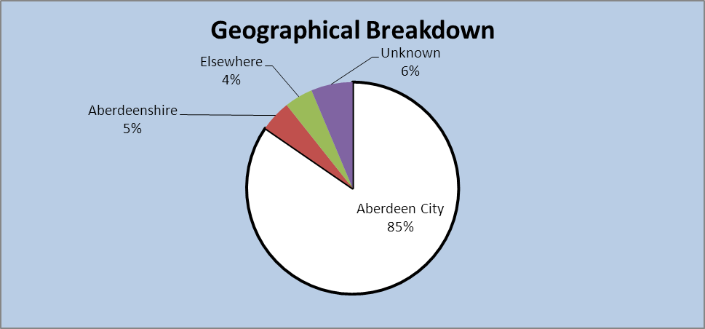

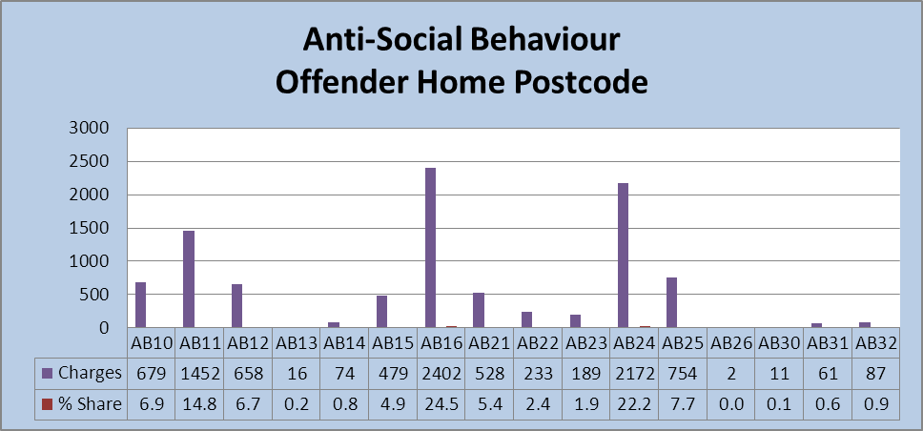

|  |
| --- |
| **Perpetrators**:  11,583 charges were made against individuals for ASB/Public Order offences over the three years. Charges were made chiefly against individuals from the AB16 and AB24 postcode areas of Aberdeen, followed by AB11. |

**Domestic Assault**



The City Centre averaged the most domestic assault offences over the three years, at 200 per 10,000 population per year. The next highest was **Woodside** with 124, followed by **Tillydrone** with 112, **Middlefield** with 110 and **Torry** with 102. The average for Aberdeen City as a whole was 46 per 10,000 population per year. Other areas above the Aberdeen City average across the three years were: **George Street**; **Cummings Park**; **Seaton**; Summerhill; Stockethill; Mastrick; Froghall; Hanover; and Bucksburn. Although not above the City average for all three years, **Northfield**, Ashgrove, Garthdee and Kincorth were all above the Aberdeen City average for at least one of the three years from 2013-14 to 2015-16, with **Northfield** above the average for two of the three years.

*Offender Postcodes (Domestic Assault)*

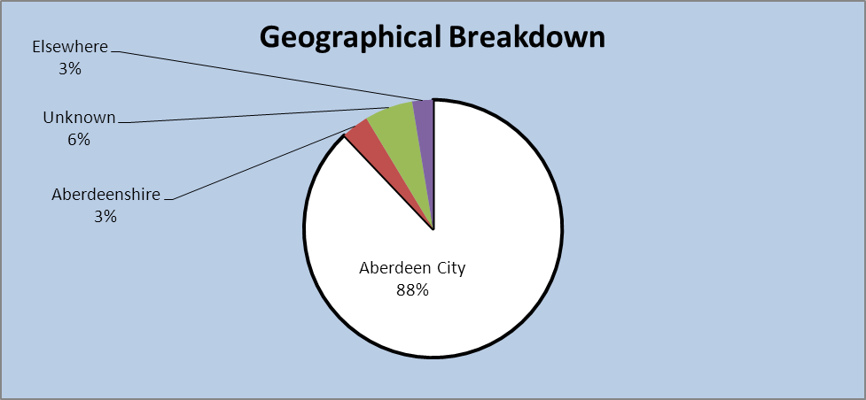

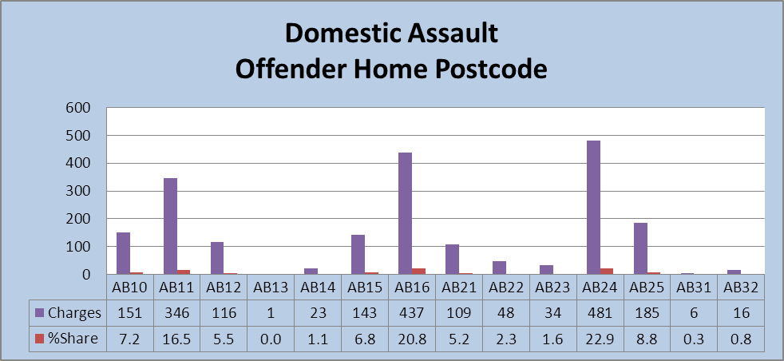

|  |
| --- |
| **Perpetrators**:  2,384 charges were made against individuals for domestic assault offences over the three years, with charges being made against individuals chiefly from the AB24, AB16 and AB11postcode areas of the City. |

**Non-Domestic Assault**



The vast majority of offences took place in the City Centre area – an average of 1,111 per 10,000 population over the three years – although there was a steady annual reduction. **Cummings Park** had the next highest average, with 218, followed by **Woodside** with 154. The Aberdeen City average was 91.

Mastrick had an above average number of offences per 10,000 population in 2015-16, and showed a gradual increase in numbers over the three years.

*Offender Postcodes (Non Domestic Assault)*

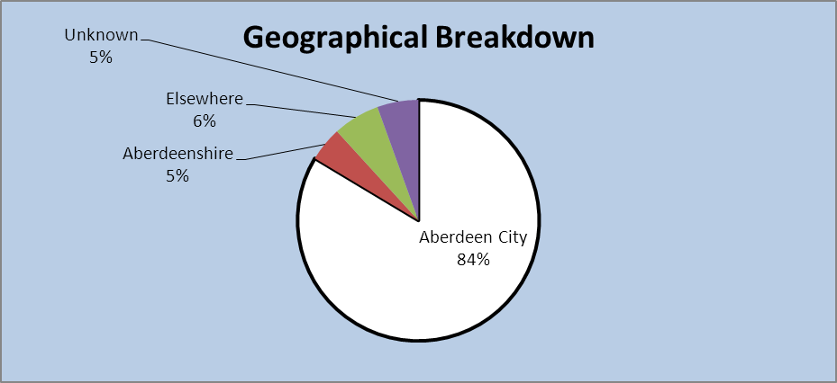

|  |
| --- |
| **Perpetrators**:  Charges were made against perpetrators chiefly from the AB16 postcode area, followed by AB24 and AB11, with 4,935 charges made in total over the three years. |

**Housebreaking:**



**Heathryfold** experienced the highest average number of housebreaking offences per 10,000 population over the three year period by some margin, at 103, followed by **Torry** with 73 and **Cummings Park** with 62. The City average was 35.

Although not having above the City average across the three years, the figure for Mannofield was higher than average for two of the three years, and a number of areas had a higher than average number of offences for one of the three years: Old Aberdeen; Hanover; Ashgrove; Mastrick; City Centre; Balgownie; **Tillydrone**; Kincorth and **Middlefield**.

*Offender Postcodes (Housebreaking)*

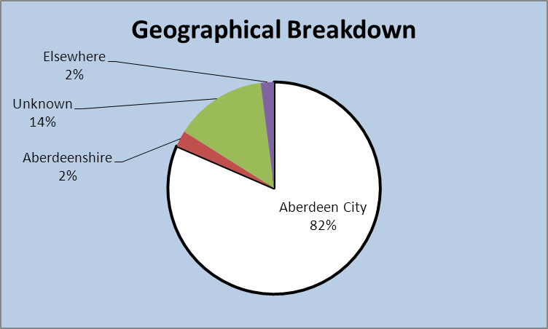

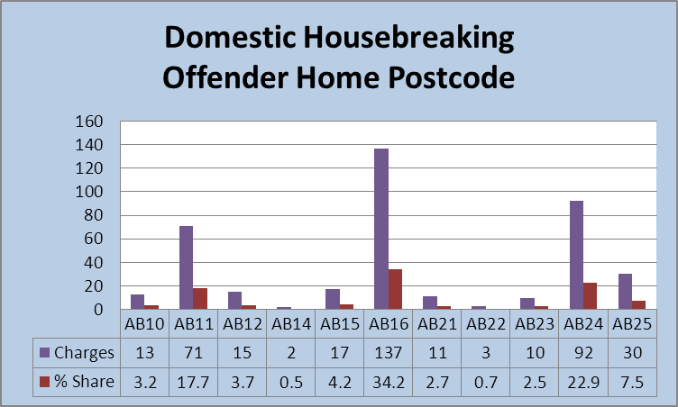

|  |
| --- |
| **Perpetrators**:  492 charges were made across the three years. Most charges were made against individuals from AB16, AB24 and AB11. |

**Drug Offences**



As might be expected, the City Centre had the highest average number of Drug Offences per 10,000 population over the three years, at 655. This was significantly higher than any other area. **George Street** had the next highest number, at 188, and then **Woodside** with 166 and **Seaton** with 161. Other areas with an average above that of the figure for the whole City were: **Torry**; **Tillydrone**; **Cummings Park**; **Middlefield**; Stockethill; Hanover; and Ashgrove.

The average number of offences for Stockethill increased considerably over the three years, from 44 to 139.

*Offender Postcodes (Drugs)*

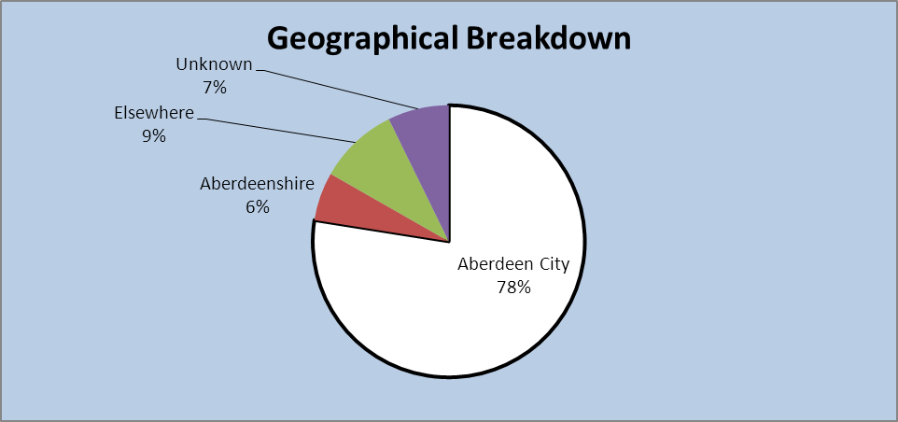

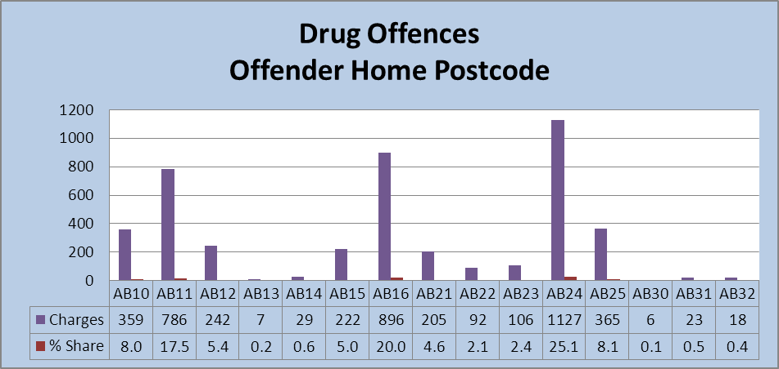

|  |
| --- |
| **Perpetrators**:  5,790 charges were made over the three years. Most charges were made against individuals from the AB24, AB16, and AB11 postcode areas. |

**Vehicle Crime**



**Woodside**, Ashgrove and Bucksburn experienced the highest average numbers of vehicle crimes per 10,000 over the three years, closely followed by Hazlehead, Hanover, Stockethill, **Cummings Park**, the City Centre, Midstocket and **Heathryfold**. However, the average number of such offences (per 10,000) reduced over the three years in all these areas, except in Midstocket, where the number of offences remained fairly constant.

The average number of offences in West End, Sheddocksley, **Torry** and Mastrick were above the City average, and showed an increase in the year from 2014-15 to 2015-16.

*Offender Postcodes (Vehicle Crime)*

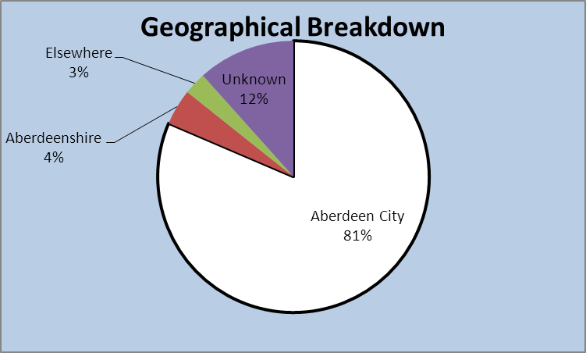

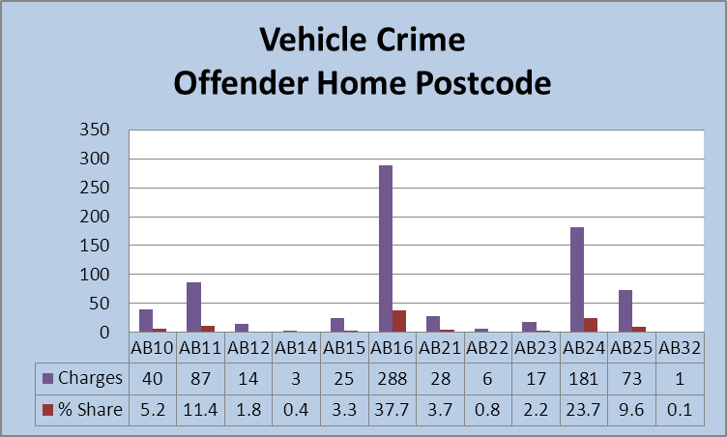

|  |
| --- |
| **Perpetrators**:  Across the three years, 937 charges were made. A significant number of the charges were made against individuals from the AB16 postcode (c290) followed by the AB24 postcode (c180). |

**Sexual Offences – Contact**



The City Centre showed the highest average number of contact sexual offences per 10,000 population over the three years (50), followed by **Middlefield** with 41. These areas were considerably higher than the next highest which was **Northfield** with 19. The City average was nine.

Of all the areas with a figure higher than the City average per 10,000, the following areas showed an increase over the three years: City Centre; **Middlefield**; **Northfield**; **Torry**; Ashgrove; **George Street**; and Froghall. The most significant increases were seen in **Middlefield** and Ashgrove. The average number for **Woodside** showed a significant decrease in 2015-16 from the previous years.

**Sexual Offence (Non-Contact)**



The City Centre showed the highest three-year average number (per 10,000) at 31, followed by **Cummings Park** with 26, and then **Middlefield** with 19. Only ten of the City’s 37 neighbourhoods had an average number of offences per 10,000 which was below the City average for all three of the years.

*Offender Postcodes (Sexual Offences) – NB it was not possible to make a distinction between postcodes relating to Contact and Non Contact Sexual Offences.*

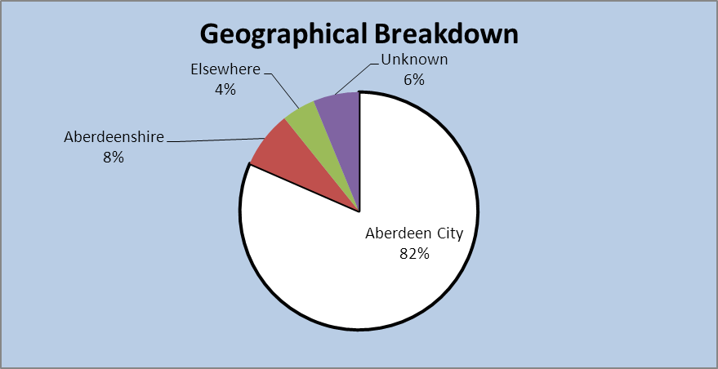

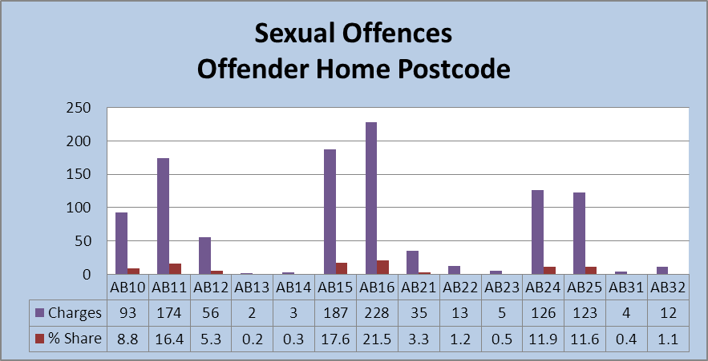

In the three fiscal years, a total of 1,301 charges were made.

|  |
| --- |
| **Perpetrators**:  1,301 charges were made over the three years. Charges were made against individuals chiefly from the AB16, AB15 and AB11 postcode areas. |

**Shoplifting**



As might be expected, the City Centre had by far the highest average number of offences per 10,000 population across the three years, at 1,335. Next highest was Ashgrove, with 317, Garthdee, with 2017, and Hanover, with 185.

*Offender Postcodes (Shoplifting)*

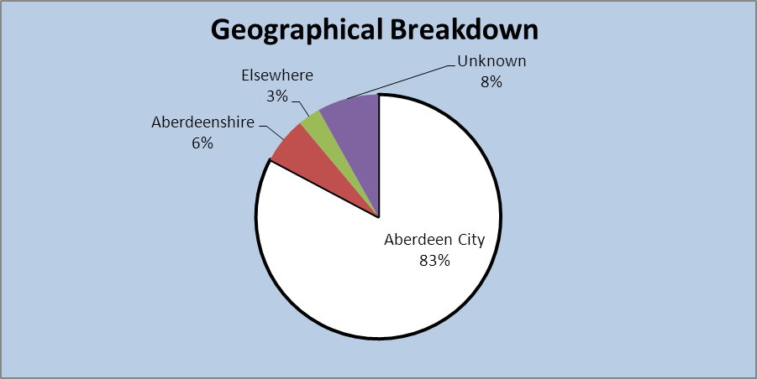

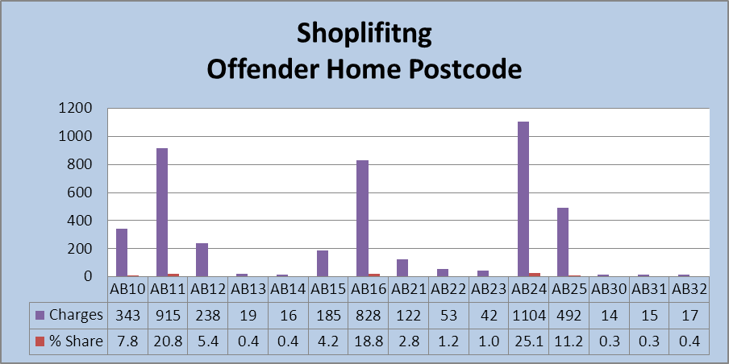

|  |
| --- |
| **Perpetrators**:  Postcode areas of those against who charges were made were chiefly AB24 (c1,100), AB11 (c900) and AB16 (c825). 5,320 charges were made over the three years. |

**Other Theft**



The City Centre had the highest average of Theft offences at 774, significantly higher than Midstocket, with the next highest, at 182, followed by **Seaton** with 162.

*Offender Postcodes (Theft)*

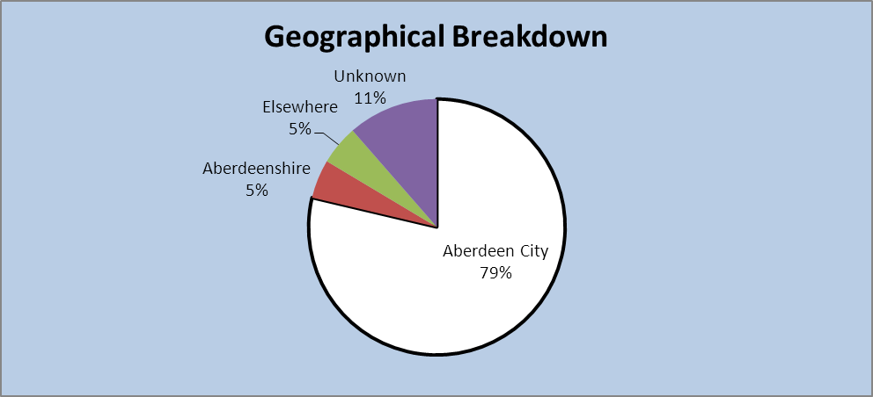

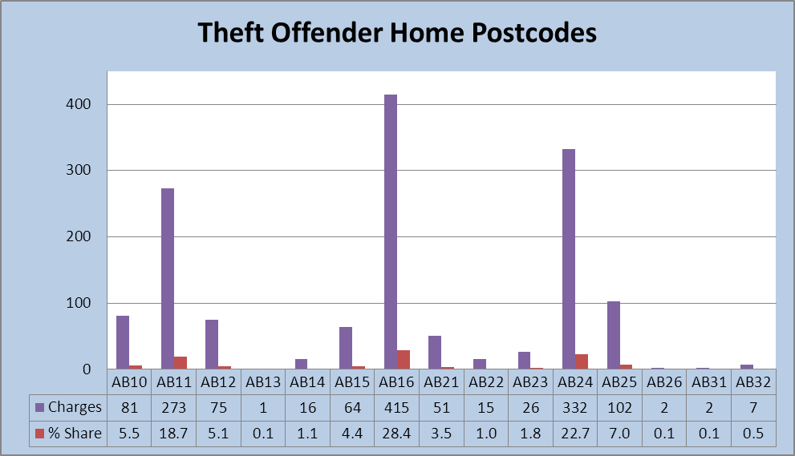

|  |
| --- |
| **Perpetrators**:  Charges were made against individuals mainly from AB16, AB24 and AB11 postcode areas. 1,858 charges were made. |

**Violence** (Attempted Murder and Assault)



**Woodside** had the highest average number of these offences, with 22, with the figure for the City Centre at 18. The City average for such offences was 5.

A number of areas had no offences of this nature for any of the three years: Culter; Cults; Dyce; and Oldmachar.

*Offender Postcodes (Violence)*

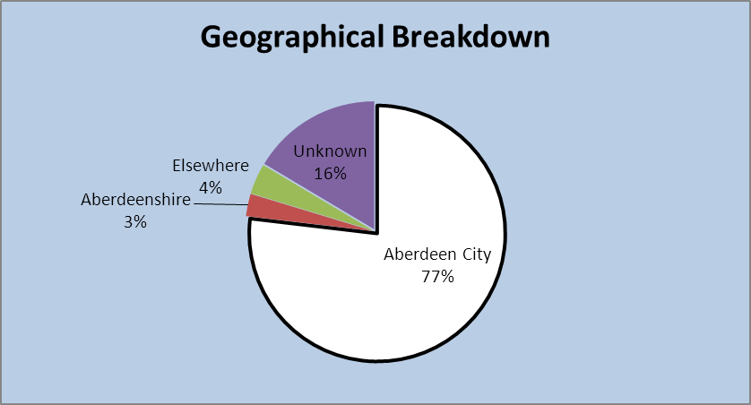

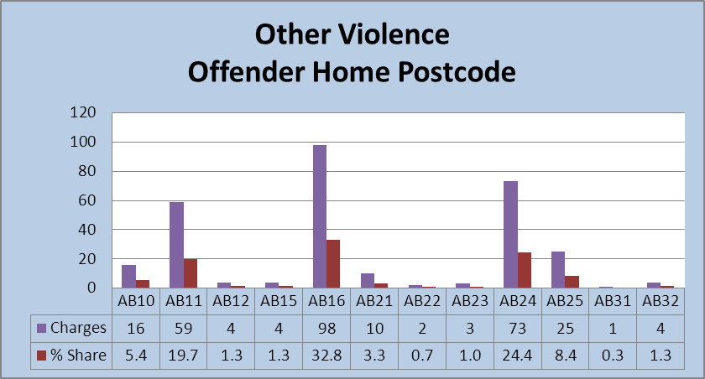

|  |
| --- |
| **Perpetrators**:  A total of 389 charges were made over the three years, with perpetrators mainly from the AB16, AB24 and AB11 areas. |

**Weapons**



The highest average number of offences was in the City Centre, which has seen a gradual increase to 52 per 10,000 population over the three years. The next highest was **Woodside** with 17. Of those areas with an average higher than the whole city figure, **George Street** has seen the most significant increase, from 4.2 per 10,000 population in 2013-14 to 23.5 in 2015-16.

**Cummings Park** had an average figure of 26 in 2013-14, but has had an average of ‘0’ for the two subsequent years.

*Offender Postcodes (Weapons)*

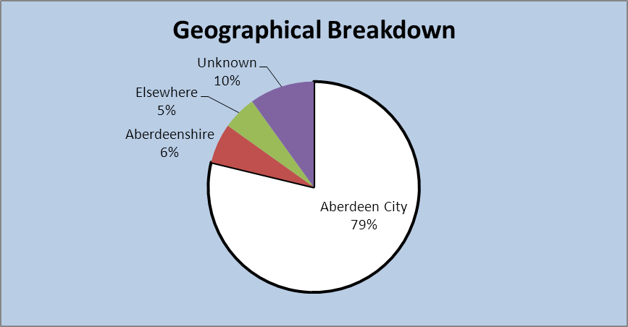

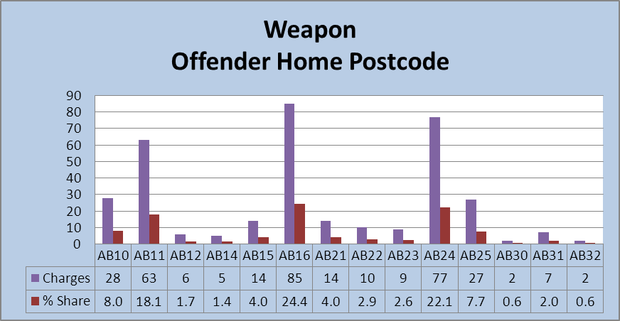

In the three fiscal years, a total of 443 charges were made.

|  |
| --- |
| **Perpetrators**:  Across the three years 443 charges were made. Charges were made against perpetrators chiefly from AB16, AB24 and AB11. |

B Offending by Young People

Key findings from ‘Police Scotland – Aberdeen City Division, Comparative Report on Juvenile Offenders 2015/2016’:

* Over the five fiscal years prior to and including 2015-16, the number of offences and CrimeFiles have decreased year on year. The number of detected offences in 2015/16 are 42% lower than 2011/12. The number of juveniles committing offences decreased by 38% from 2011-12 to 2015-16. However, there was a slight increase in number between 2014-15 and 2015-16 from 995 to 1,050.
* The number of detected offences committed by **8 - 15 year olds** has decreased from 2,181 in 2011-12 to 1,085 in 2015-16. This is a 50% reduction. The number of juveniles identified as accused aged 8 to 15 years has decreased from 865 in 2011-12 to 528 in 2015-16, a 39% decrease.
* The number of detected offences committed by **16 - 17 year olds** has decreased from 1,586 in 2011-12 to 1,084 in 2015-16. This is a 32% reduction. The number of juveniles identified as accused aged 16 - 17 years shows a steady decrease over the five-year period from 765 in 2011-12 to 522 in 2015-16. This is a reduction of 32%.
* It has been identified that 864 unique individuals were responsible for juvenile offending in 2015-16. (186 individuals committed offences in both age groups.)
* In each of the five years from 2011-12 to 2015-16, the most detected offences committed by eight to 15 year olds included **Common Assault, Breach of the Peace, Urinating, Anti-Social Behaviour Offences, Threatening or Abusive Behaviour and Drinking offences**.
* Group 3 crimes were most commonly committed by 16 and 17 year olds. These included **Housebreaking, OLPs (Opening a Lockfast Place), Shoplifting, Thefts and Thefts of and from Motor Vehicles**.
* Over the five years, the number of **vehicle offences** ("Theft of Motor Vehicle" and "Allowed to be carried within a stolen vehicle") has steadily decreased from 114 in 2011-12 to 31 in 2015-16. 16 and 17 year olds commit vehicle crime more than 8 to 15 year olds.
* Over the five years, 4,208 males were accused of committing crimes compared with 1,834 females. **Males account for 70% of all juvenile accused**.
* Five young people were identified by Police Scotland as the accused for at least 20 CrimeFiles each, with one individual identified for 50 CrimeFiles. 602 individuals were identified for only one CrimeFile each.
* Over the five years, **sexual offences** committed by juveniles have shown an inconsistent trend. There were 65 such offences in 2015-16. Across the five years, 68% of these crimes were committed by eight to 15 year olds. The number of ‘**sexting**’ offences has changed little over the years, with 11 such offences in 2015-16.
* Over the five years, the Willows **Children’s Home** was recorded most on CrimeFile (118 times), although only five times in 2015-16. (It is not possible to confirm whether those who committed the offences were resident in the relevant homes.) Over the five-year period, the number of CrimeFiles in which a 'Children's Home' was recorded as the locus fluctuated and there is no visible trend.

C Reoffending (Reconviction Rates data)

National statistics are published annually regarding the number and percentage of individuals who are reconvicted within one year of the date of sentencing (for non-custodial sentences) or the release date for custodial sentences. The data is presented by a range of offender characteristics, by CJA and by local authority area. Currently the data for Aberdeen is included with that of Aberdeenshire (it is collected by reference to Courts) – provision of local authority level data for all areas is being looked at nationally. The most recent data can be found at the following link:

[Reconviction Rates 2013-14](http://www.gov.scot/Topics/Statistics/Browse/Crime-Justice/Datasets/ReconvictOffendDatasets/reconbyoffend1314)

D Victim Data

The results of the Scottish Crime and Justice Survey 2014/15 (“SCJS”) (<http://www.gov.scot/Resource/0049/00496532.pdf> (page 41, section 4.2.3)) show that the risk of being a victim of crime varies by area characteristics. The risk of being a victim of crime was higher for adults living in the 15% most deprived areas in Scotland (21.2%), compared to those living in the rest of Scotland (13.4%). Similarly, the SCJS 2014/15 data shows that the risk of property crime and violent crime was higher for those living in Scotland's 15% most deprived areas.

For those living in the most deprived areas, the risk of being a victim of crime saw a statistically significant decrease from 26.0% in 2008/09 to 21.2% in 2014/15, but no change between 2012/13 (21.3%) and 2014/15 (21.2%). For the rest of Scotland, the risk of crime in 2014/15 (13.4%) is lower than in 2008/09 (19.4%) and 2012/13 (16.1%).

The risk of being a victim of any crime decreased with age. One fifth (20.4%) of 16 to 24 year olds were at risk of being a victim of crime, compared with a 6.8% risk for those 60 or over.

Locally, more in-depth analysis of SCJS data for 2014-15 highlighted the following:

* Overall in Aberdeen, **80.5%** had experienced no crimes. This ranged from 73.3% in the top 20% most deprived areas to 85.7% in the top 20% least deprived.
* The same proportion of people experienced **five or more crimes** in the 20% most and least deprived areas - although in the least deprived areas, a third of all crimes were experienced by these individuals. (8% of crimes were experienced by these individuals in the most deprived areas.)
* People in socially rented accommodation are also more likely to be a victim of crime than those who own their own property.

**SECTION FIVE – WHO IS COMMITTING THESE OFFENCES? WHAT DO WE KNOW ABOUT THESE INDIVIDUALS, WHAT ARE THEIR CHARACTERISTICS?**

Section Five talks more specifically about the issues which contribute to the likelihood of an individual reoffending in Aberdeen by attempting to paint a profile of those who offend based on data collected at different stages of the Justice System. There are a range of issues which evidence suggests may contribute to the likelihood of an individual offending/reoffending, and background information about these can be found at Appendix 6. National and local data is drawn on to highlight issues relevant to individuals involved in the Justice System in Aberdeen.

**i) At point of detention by Police Scotland**

Operation Gains (Pilot aimed at proactively targeting domestic abuse perpetrators through enforcement, while identifying and developing partnership diversionary/ harm reduction referral solutions and support for victims. The operation will focus on victims and perpetrators who are associated with substance misuse.)

Of 112 women with whom face to face contact was made during the pilot, five presented with drug/alcohol issues.

Arrest Referral (Individuals are referred by Police Scotland to Alcohol & Drugs Action (“ADA”) at the Custody Suite, Kittybrewster) *(NB awaiting confirmation that this is Aberdeen clients only)*

During the period Jan 2016- May 2016:

* 97 individuals seen (85 Male, 12 Female);
* 32 attended a follow up appointment;
* 18 have yet to respond re a follow up;
* 46 did not attend a follow up appointment or have declined one;
* 25 were previously known to ADA;
* 72 have never had previous contact with ADA;
* 36 had alcohol issues;
* 39 had issues with drugs;
* 22 had issues with alcohol and drugs.

ADA operate a 7 day drop in at their city centre premises, and some of those who did not attend their follow up appointment may in fact re-present at the service at a later date. (Ways to capture this are being investigated).

[NB The below information is from Aberdeen Criminal Justice Social Work Service (“CJSWS”) Aggregate Return to Scottish Government 2015-16]

**ii) Individuals Diverted from Prosecution**

The below table shows the age, sex and employment status of individuals who commenced Diversion from Prosecution during 2015-16. (Children’s Services are responsible for Diversion cases for most 16 and 17 year olds.)

|  |  |  |  |
| --- | --- | --- | --- |
|  | **Males** | **Females** | **Total** |
| No individuals cases commenced  *- of which aged 16-17*  *- aged 18-25*  *- aged 26-65*  *- aged 65+* | **75**  *50*  *10*  *13*  *2* | **35**  *13*  *4*  *18*  *0* | **110**  *63*  *14*  *31*  *2* |
| Employment:  - in full time education  - employed/self employed  - unemployed  - on govt-sponsored training scheme  - not seeking employment  - other | 3  6  12  1  12  41 | 0  3  6  0  4  22 | 3  9  18  1  16  63 |

**iii) Information from Criminal Justice Social Work Reports to Court**

The below information is from Criminal Justice Social Work Reports submitted to courts by Aberdeen CJSWS during 2015-16. A Criminal Justice Social Work Report is provided by Criminal Justice Social Work Services to courts to give background information about an individual, and advice to help the court make a decision on which sentence to impose, such as a fine, community sentence or imprisonment.

The criminal justice social work report (CJSWR) in its current format was introduced across Scotland from February 2011 to ensure a consistent provision of information, including the social worker's professional assessment. This report (called a social enquiry report prior to 2011) is intended to assist in the sentencing process and to complement the range of other considerations, such as victim information and narratives from the procurator fiscal. In particular, the CJSWR provides information on social work interventions and how these may prevent or reduce further offending. A CJSWR must be requested:

* before imposing a custodial sentence for the first time or where a person is under 21
* when imposing a community payback order with a supervision requirement or level 2 unpaid work requirement (over 100 hours), community service order or probation order with unpaid work
* when imposing a drug treatment and testing order.

The data below excludes Supplementary Reports, but includes ‘Section 203’ Reports (Section 203 of the Criminal Procedure (Scotland) Act 1995 requires all courts except District Courts to obtain a report before sentence in respect of any convicted offender under supervision by order of a court. The report must cover "the circumstances of the offence and the character of the offender, including his behaviour while under supervision or, as the case may be subject to the order so specified in relation to him".)

**NB During 2015-16, 1,274 Reports were submitted for 971 individuals (793 males and 178 females). The below data relates to Reports rather than individuals. (Some individuals will have been the subject of more than one Report.)**

Age and Sex: age and sex of individuals according to CJSW Reports submitted during 2015-16 (as at the date of submission of Reports).

|  |  |  |  |
| --- | --- | --- | --- |
| **Age** | **Number of Reports (Male)** | **Number of Reports (Female)** | **Total number of Reports** |
| Under 16 | 0 | 0 | 0 |
| 16 – 17 | 47 | 19 | 66 |
| 18 – 25 | 318 | 47 | 365 |
| 26 – 35 | 325 | 84 | 409 |
| 36 – 50 | 277 | 65 | 342 |
| 51 – 65 | 68 | 11 | 79 |
| Over 65 | 9 | 4 | 13 |
| TOTAL | 1,044 | 230 | 1,274 |

Employment:

a) Employment status of individuals according to CJSW Reports submitted to courts during 2015-16 (as at the date of submission of Reports).

|  |  |  |  |
| --- | --- | --- | --- |
| **Employment Status** | **Number of Reports (Male)** | **Number of Reports (Female)** | **Total number of Reports** |
| Full time education | 14 | 0 | 14 |
| Employed/Self employed | 275 | 44 | 319 |
| **Unemployed** | **660** | **164** | **824** |
| On government-sponsored training scheme | 1 | 0 | 1 |
| Not seeking employment | 45 | 12 | 57 |
| Other | 49 | 10 | 59 |
| **TOTAL** | **1,044** | **230** | **1,274** |

b) Employment status of individuals who commenced Community Payback Orders and Drug Treatment and Testing Orders during 2014-15 (from CPO Unit Return to Scottish Government):

|  |  |  |  |  |  |  |  |
| --- | --- | --- | --- | --- | --- | --- | --- |
|  | TOTAL | Full time Education | Employed/ Self Employed | Un-employed | Govt sponsored  Training scheme | Economically inactive | Others# |
| **CPOs** | 1,113 | 11 | 278 | 679 | 0 | 33 | 112 |
| **DTTOs** | 7 |  |  | 6 |  | 1 |  |

# Retired, supported by family, carers, permanently sick/disabled

**iv) Information from Level of Service/Case Management Inventory (LS/CMI) Risk Needs Assessments undertaken by Criminal Justice Social Work**

The LS/CMI is a comprehensive instrument that aims to support practitioners to conduct a thorough review of a person’s circumstances, difficulties and strengths that leads to a plan of intervention. Advancing practice that adheres to the principles of risk, needs and responsivity, the LS/CMI is based on research and has been developed following extensive consultation with practitioners.

LS/CMI was introduced in Scotland from October 2010, and is the common method of risk assessment within Criminal Justice Social Work and the Scottish Prison Service.

Relevant parts of the LS/CMI assessment are undertaken by CJSWS for all individuals prosecuted at Court for whom a Criminal Justice Social Work Report is requested by the Court. Those who go on to receive a community-based disposal additionally receive a fuller and more thorough risk/need assessment once sentenced, and those who receive a custodial sentence are also more fully assessed by Prison-Based Social Work. Responses are as given by clients, with background information being sought from file reviews, previous reports, etc.

**Key findings in relation to clients assessed using LS/CMI in Aberdeen** (average over 3 years) from 2013-14 to 2015-16:

|  |
| --- |
| **Leisure/Recreation**:   * **70% had not participated in formal organised activity** in the last 12 months (eg sports club, church); * **62% could make better use of their time**. |

|  |
| --- |
| **Companions:**   * **65% had some criminal acquaintances**, although these may not be close friends; * **50% had some criminal friends**, with whom they spent leisure time; * **44% had few ‘anti-criminal’ friends**. |

|  |
| --- |
| **Education/Labour Market:**   * **58% were currently unemployed** (This includes individuals still at school/college, homemakers, pensioners, and individuals in receipt of disability benefit); * **56% left school at the minimum leaving age**, with no further formal education; * **32% left school without qualifications**. |

|  |
| --- |
| **Alcohol/Drug Problems**:   * **57% had had an alcohol problem in the past**; * 32% currently had an alcohol problem, or had had in the past 12 months; * 34% of individuals were assessed as no evidence of a current alcohol problem; * **51% had had a drug problem in the past**; * 28% currently had a drug problem, or had had in the past 12 months; * 44% of individuals were assessed as no evidence of a current drug problem; * **For 49% of individuals who had a current drug and/or alcohol problem, use of alcohol or drugs has contributed or could contribute to violation of law**. |

|  |
| --- |
| **Antisocial Behaviour**:   * **64% had an official record of assault or violence** (This may include where there was no actual conviction due to eg charges withdrawn after attending counselling); * **47% were assessed as having a pattern of generalised trouble** (eg marked on at least four of the following: financial problems; three or more address changes in the last year; never employed for a full year; left school at minimum age; suspended or expelled from school at least once; poor relationship with parents); * **44% had a ‘criminal attitude’** (Eg were supportive of crime, unfavourable towards convention, or had a poor attitude towards their supervision/ intervention); * **30% had shown early and diverse anti-social behaviour** (Severe problems of adjustment in childhood, plus: had an official record of assault/violence; or had escaped from a correctional facility; or caused early termination of prior community supervision). |

|  |
| --- |
| **Family/Marital**:   * **44% had an unsatisfactory relationship with parents**; * **45% had an unsatisfactory marital or equivalent situation**; * **32% had parent, sibling, spouse or close relative with a criminal record**. |

|  |
| --- |
| **Other Issues:**   * **45% had financial problems** (Severe difficulties, with no means of support, or minor difficulties which needed to be explored further); * **35% had been the victim of physical assault** (In the last 12 months, by non-familial others); * **28% had been the victim of family violence, including physical, sexual or emotional abuse and/or neglect** (In the last 12 months); * **33% had low self-esteem**; * **32% had accommodation problems** (Personal dissatisfaction with accommodation, or accommodation may promote association with criminal others). |

Learning Disabilities

As at 17th August 2016, three clients of CJSW were also clients of Aberdeen City’s Learning Disabilities services. Two were on Unpaid Work Orders (Community Payback Orders) and one was a client of the Caledonian Women’s Service (for victims of domestic abuse).

A further 19 clients had answered ‘Yes’ to an LSCMI question regarding Learning Difficulties (those with an IQ of less than 70 or there is a significant impairment to the activities of daily living) but were not clients of Learning Disabilities services.

**iii) Information/Data held by SPS**

Age and sex: Aberdeen prison population (across all establishments) as at 1st July 2016, including remand and convicted (from monthly SPS stats):

|  |  |  |  |  |  |  |  |  |  |  |  |
| --- | --- | --- | --- | --- | --- | --- | --- | --- | --- | --- | --- |
| **Male** | | | | **Female** | | | | **All** | | | |
| **21+** | **18-20** | **U18** | **All** | **21+** | **18-20** | **U18** | **All** | **21+** | **18-20** | **U18** | **All** |
| 256 | 17 | 1 | 274 | 13 | 0 | 0 | 13 | 269 | 17 | 1 | 287 |

The below table shows where these individuals were residing as at 1st July:

|  |  |  |
| --- | --- | --- |
| **Establishment** | **Males** | **Females** |
| HMP Grampian | 184 | 13 |
| HMYOI Polmont | 20 | - |
| Other Establishments | 70 | 0 |
| **TOTAL** | **274** | **13** |

It is not currently possible to extract data from HMP Grampian’s systems to ‘profile’ the population in terms of health/mental health/substance misuse, housing, employment, education, etc. However, a pilot system is being put in place (from April 2016) to capture some of that information.

It is commonly recognised that around 85% of people coming into Prison have some form of substance issue and around 50% have some level of mental health issue. This is even higher within the women population. Information also shows that around 90% of under 21’s had been drunk or drinking at the time of their offence.

This is based on historical SPS wide data rather than specific Aberdeen City, however there is not likely to be much of a difference in this area.

Except where indicated otherwise, the below information is from the SPS Prisoner Survey 2015. The survey achieved an overall prisoner response rate of 55%. Of these, 92% were male and 8% were female.

Housing/Accommodation

Six in ten (61%) reported they were a lodger before going to prison, 37% lived in private rented accommodation and, 36% were council tenants. Almost half of prisoners who specified said that they lost their tenancy/accommodation when they went to prison (45%). Over a quarter did not know where they would be staying upon their release (29%). One fifth specified they would be a council tenant (19%) while 12% said they would be in private rented accommodation and a further 9% said they would be a lodger.

Alcohol and Drug Use

Two in five prisoners who completed a questionnaire reported being drunk at the time of their offence (41%), a decrease of 4% since 2013. Two in five respondents reported being under the influence of drugs at the time of their offence (40%) and 38% stated their drug use was a problem for them on the outside. Around one sixth of prisoners reported that they committed their offence to get money for drugs (17%) and one in five were receiving treatment for drug use before they were imprisoned (21%).

The following table is an extract from the ADP Performance Report for Quarter 4 2015-16:

|  |  |  |  |  |  |
| --- | --- | --- | --- | --- | --- |
|  | DATA FROM HMP & YOI Grampian | **2015/16** | | | |
|  |  | **Quarter 1** | **Quarter 2** | **Quarter 3** | **Quarter 4** |
| **1.** | Total number of new prisoners admitted to HMP & YOI Grampian over the quarter (male / female) |  |  | 137 (120/17) | 161  (134/27) |
| **2.** | Total number of new prisoners admitted to HMP & YOI Grampian over the quarter who come from Aberdeen City (male / female) |  |  | 77  (70/7) | 104  (77/27) |
| **3.** | Total numbers of new prisoners admitted to HMP & YOI Grampian from Aberdeen City over the quarter who after prison admission screening are believed to have an alcohol and / or drug problem Broken down into a) alcohol; b) drugs; and c) alcohol & drugs (male / female) |  |  | a)9/2  b)20/1  c) 15/6 | a) 10/2  b)31/10  c)36/15 |
| **4.** | Total number from 3 above who are then given appropriate interventions – Broken down into a) alcohol; b) drugs; and c) alcohol & drugs (male / female) |  |  | a) 7/1  b)14/1  c)11/3 | a)9/2  b)31/10  c)36/8 |
| **5.** | Total number from 3 above who were already being seen in alcohol and / or drug treatment services prior to their admission to HMP & YOI Grampian (male / female) |  |  | 25  (20/5) | 74  (56/18) |
| **6.** | Total number from 3 above who are new to alcohol and / or drug treatment services (i.e. they were not engaged with alcohol and / or drug services prior to their admission to HMP & YOI Grampian) (male / female) |  |  | 24  (19/4)** | 30  (21/90)** |
| **7.** | Total number of prisoners from Aberdeen City released from HMP & YOI Grampian over the quarter with naloxone |  |  | 27 | 6 |

** Some had been seen in services previously but had disengaged

[In 2014-15 Police Scotland recorded 1672 drug-related crimes in Aberdeen, a rate of 73 per 10,000 of population. The national figure is 68.9 per 10,000 population.

From [Drug-related Recorded Crime 2014-15](http://www.scotpho.org.uk/behaviour/drugs/data/social-harm).]

APPENDIX 1

**‘Community Justice’: Definition in Community Justice (Scotland) Act 2016**

S1 - Meaning of “Community Justice”:

* giving effect to bail conditions, community disposals and post-release control requirements;
* managing and supporting(1) persons(2) with a view to them not offending in future, or if that’s not realistic, reducing future offending by them;
* arranging relevant general services(4) in ways which facilitate persons(2) accessing and using them;
* preparing persons who have been convicted of offences and sentenced to imprisonment or detention in penal institutions for release; and facilitating the provision of relevant general services likely to be needed immediately on release.

(1) S1(2) **Supporting** includes:

- advising and guiding;

- providing opportunities to participate in, and helping to access, activities designed to eliminate or reduce future reoffending;

- providing, and helping to access, emotional and practical support designed to eliminate or reduce future offending;

- helping to access and make use of relevant general services.

(2) S1(2B) - **Persons** to be managed and supported in the community:

* person who has been convicted of an offence;
* person who has been subject to the making of a ‘relevant finding’(3);
* person given an alternative to prosecution;
* person arrested on suspicion of having committed an offence;
* covers acts occurring anywhere in the world, and persons subject to recognised EU supervision measures;
* covers persons aged 16 and 17 and subject to a compulsory supervision order under Children’s Hearings (Scotland) Act.

(3) S1(4) - Definition of ‘**relevant finding**’:

* person acquitted under s51 of Criminal Procedure (Scotland) Act 1995, ie ‘unable by reason of mental disorder to appreciate the nature/wrongfulness of the conduct’;
* person acquitted by reason of insanity;
* person found unfit for trial under s53 of the above Act, but found to have committed the offence;
* person found by a court to be under a disability but who committed the offence.

(4) S1A(3) - Definition of ‘**general services**’:

* including services and support in relation to:

a) housing;

b) employment;

c) education;

d) children;

e) physical or mental health (including in particular alcohol and drug treatment services);

f) social welfare;

g) any other matter which does or may affect the likelihood of future offending by persons(2) in the community.

APPENDIX 2

PESTELO Analysis of Community Justice in Aberdeen, and Opportunities and Risks

1 PESTELO Analysis

**Political**

* The Community Justice (Scotland) Act 2016 was passed in February 2016, prior to the Scottish Parliamentary elections. To date there is no evidence of a change in the direction of travel with regards to Community Justice Redesign.

**Economic**

* The UK Comprehensive Spending Review is likely to impact on local area budgets (for services), although funding for Criminal Justice Social Work Services is ring-fenced.
* The current ‘economic downturn’, and particularly challenges being faced by the oil industry, is impacting on the job market in Aberdeen. This has implications for linking people who have offended/been convicted, or are at risk of offending/being convicted, into the job market, which can be instrumental in reducing the likelihood of further offending.
* The current economic climate has led to increased numbers of people living in poverty, which can be one of the contributory factors to leading to offending behaviour. House prices etc in Aberdeen have remained buoyant despite issues facing the oil industry, with associated challenges for those living in poverty.

**Social**

* There is significant stigma attached to individuals who have been involved with the criminal justice system which can impact on their ability to (re)integrate into communities and live a life where they are not socially ‘penalised’ for their previous offending (for which they have already paid the price in terms of the outcome of their prosecution). Collective efforts of all partners and stakeholders to countering such stigma must be a key objective.
* One way in which such stigma is actively addressed is through the work undertaken by individuals on Community Payback Orders with an Unpaid Work Requirement. Criminal Justice Social Work Services consult with community bodies and representatives about work which can be undertaken to contribute to local communities. In undertaking such work, individuals ‘pay back’ to their communities, communities benefit from ‘free’ work being undertaken, and individuals benefit by learning new skills (both physical and social) and by enhancing their links with the community. In Aberdeen, individuals undertake a wide range of Unpaid Work projects for communities and community groups, including projects to improve churches, tidying graveyards, taking and assisting elderly individuals living in sheltered housing on supermarket shopping trips, etc.
* There are a number of ways in which Welfare Reform is impacting, including: with regards to the need to apply for benefits digitally (individuals may not have the necessary technology or related knowledge); timing issues with regards to receipt of benefits (particularly housing benefit) on leaving prison; loss of benefits as a penalty for non-compliance with ‘job-seeking’ requirements (challenges for individuals living ‘chaotic’ lifestyles), etc.

**Technological**

* The Scottish Courts and Tribunals Service has been developing technology which enables defence agents to video-link in with clients in HMP & YOI Grampian and other establishments from the Sheriff’s Court in Aberdeen. Reminders are also sent electronically to witnesses being called to court cases. These developments contribute significantly to the efficient implementation of the justice system locally – the sooner an individual’s case is considered and an appropriate course of action decided-upon by the Procurator Fiscal or by the Court, the greater the impact on the individual, in terms of ‘linking the punishment with the crime’.
* Video-link technology also enables Aberdeen families to link in with offenders in HMP & YOI Grampian at Peterhead from the offices of Apex Scotland in the city centre.
* During 2013-14 the Scottish Government consulted on the ‘Development of Electronic Monitoring in Scotland’, and continues to look at how advances in the use of technology can be used in the monitoring of offenders.

**Environmental**

* ?

**Legal**

There are a number of pieces of legislation relevant to Community Justice which are currently being considered by the Scottish Parliament, or have recently been enacted. These include the following.

* Community Justice (Scotland) Act 2016

The Act, which was passed by Parliament in February 2016, underpins the redesign of Community Justice (see above).

* Criminal Justice (Scotland) Act 2016

Includes provisions in relation to: arrest and custody; proposals to abolish the ‘corroboration’ rule (subsequently withdrawn); solemn court procedure; sentencing; and appeal procedures. [Passed in December 2015.]

* Community Empowerment (Scotland) Act 2015

Introduced a range of provisions, including requiring Scottish Ministers to determine national outcomes for Scotland, putting ‘Community Planning’ on a statutory footing, and enabling the participation of community bodies in the improvement of outcomes. Local strategic planning and delivery of services are central to the new model of Community Justice. (Enacted in July 2015.]

* The Prisoners (Control of Release) (Scotland) Act 2015

Ends automatic early release for some prisoners: sex offenders sentenced to determinate custodial sentences of four years or more; and other offenders sentenced to determinate custodial sentences of ten years or more. The Bill also allows the Scottish Prison Service, acting on behalf of the Scottish Ministers, to release sentenced prisoners up to two days early where this will help facilitate community reintegration (eg by allowing for early access to key public services). [Enacted in August 2015.]

* Rehabilitation of Offenders

Scottish Government undertook a consultation between May and August 2015 on proposals to reform the Rehabilitation of Offenders Act 1974 to allow more people with previous criminal activity to be able to move away from their past offending behaviour and to reduce the length of time most people will have to disclose their previous criminal activity. [Amendments to legislation came into force in September 2015.]

Scottish Government is also consulting about further proposals relevant to Community Justice:

* Presumption Against Short Sentences

There is a current ‘presumption’ (provided by the Criminal Justice and Licensing (Scotland) Act 2010) that prison sentences of three months or less will not be given “unless the court considers that no other method of dealing with the person is appropriate”. Evidence suggests that short prison sentences are ineffective in rehabilitating offenders and in reducing their risk of reoffending, and that community sentences may be more effective as they can provide more opportunities to address underlying causes of offending. Scottish Government is currently consulting on proposals to extend the presumption against short sentences to up to 12 months, and also on whether a more radical review is required. The implications of such changes, for Criminal Justice Social Work Services, other partners, and communities, will need to be addressed. [Consultation closes on 16th December 2015.]

**Organisational**

* Community Justice Redesign will see the abolition of the Northern Community Justice Authority, and the transfer of responsibility for the strategic planning and delivery of community justice in Aberdeen to statutory Community Justice Partners, as described above.
* Additional organisational changes will result from the integration of Health and Social Care, and from the implementation of the Community Empowerment (Scotland) Act 2015.

2 Opportunities and Risks

**i) Opportunities**:

Redesign of Community Justice:

The redesign of Community Justice to a focus on local responsibility for strategic planning and delivery of services, with people and communities being central to this, provides a number of real opportunities which include:

* To establish collaboratively, and based on evidence, local priorities and realistic and achievable plans which meet local needs;
* To ensure services are evidence-based, to be in a position to measure their effectiveness in achieving desired outcomes, and to continuously strive for improvement, using innovative approaches where appropriate;
* For partners locally to work more closely and collaboratively and in a coordinated way:

- sharing information appropriately and effectively where possible;

- reducing duplication; and

- building on and developing community capacity,

in order to achieve an improved targeted and holistic approach to supporting individuals and families as appropriate;

* To benefit from effective collaboration in terms of more efficient use of resources, and explore alternative avenues of funding;
* To benefit from increased involvement of Third Sector organisations which can offer specific expertise;
* To seek opportunities for increased contributions of organisations and services not traditionally involved, to enhance the holistic approach;
* To focus on early intervention and prevention, and on opportunities to divert individuals away from formal measures and to provide valid alternatives to custody;
* To improve engagement with people and communities:

- in contributing to the development of more effective services;

- in working to change stereotypes and reduce stigma; and

- to improve opportunities for the integration of individuals who have offended into communities;

* To promote and share good practice locally.

**ii) Risks**:

Redesign of Community Justice:

* National Community Justice Partners are unable to meet the challenge of linking in with 32 local areas and so struggle to engage with the Community Justice agenda in Aberdeen;
* Transition funding is not continued;
* Community justice partners don’t engage in the new model.

APPENDIX 3

**RELEVANT NATIONAL STRATEGIES ETC**

* [Equally Well](http://www.gov.scot/Resource/Doc/229649/0062206.pdf) (2008): Report of the Ministerial Task Force on Health Inequalities
* [The Road to Recovery](http://www.gov.scot/Resource/Doc/224480/0060586.pdf) (2008): National drugs strategy for Scotland
* [Changing Scotland’s Relationship with Alcohol: A Framework for Action](http://www.gov.scot/Resource/Doc/262905/0078610.pdf) (2009)
* [Strategic Guidance for CPPs: Community Learning and Development](http://www.gov.scot/Resource/0039/00394611.pdf) (2011)
* [National Parenting Strategy](http://www.gov.scot/resource/0040/00403769.pdf) (Oct 2012)
* [Mental Health Strategy for Scotland 2012-2015](http://www.voxscotland.org.uk/webfm_send/153)

The Scottish Government’s mental health strategy to 2015 sets out a range of key commitments across the full spectrum of mental health improvement, services and recovery to ensure delivery of effective, quality care and treatment for people with a mental illness, their carers and families. A section on ‘**Mental Health and Offending**’ starts on page 48 of the report and sets out commitments being taken forward as a result of the Report of the Commission on Women Offenders, around working with women with borderline personality disorder, and also in relation to the use of the Community Payback Order Mental Health Requirement.

* [The Keys to Life](http://keystolife.info/wp-content/uploads/2014/05/the-keys-to-life-full-version.pdf): Improving Quality of Life for People with Learning Disabilities (2013)

Page 111 onwards covers issues in relation to the **Criminal Justice system**, including Victims and Witnesses, those who are suspected or accused of committing a crime, changes to be made by the Criminal Justice (Scotland) Bill (see below), Young People in the criminal justice system, and prison health, and makes a number of recommendations for organisations involved in the criminal justice system.

* [Equally Safe](http://www.gov.scot/Resource/0046/00463546.pdf): Scotland's strategy for preventing and eradicating **violence against women and girls** (Jun 2014)
* [Report of the Smith Commission](https://www.smith-commission.scot/wp-content/uploads/2014/11/The_Smith_Commission_Report-1.pdf) for further devolution of powers to the Scottish Parliament (Nov 2014)
* [Preventing Offending: Getting it right for Children and Young People](http://www.gov.scot/Resource/0047/00479251.pdf): Youth Justice Strategy for 2015-20 (Jun 2015)

APPENDIX 4

**COMPOSITION OF CRIME CATEGORIES**

**ASB/Public Order**

* Threatening or Abusive Behaviour
* Vandalism
* Fireraising (not Muirburn)
* Malicious Damage
* Breach of ASBO
* Breach of the Peace

**Domestic Assault**

* Serious Assault (with Domestic Marker)
* Common Assault (with Domestic Marker)

**Non Domestic Assault**

* Serious Assault (no Domestic Marker)
* Common Assault (no Domestic Marker)

**Housebreaking**

* Attempted Housebreaking with intent to enter & steal (domestic prop -non-dwell)
* Housebreaking with intent to steal, (domestic prop - dwelling)
* Theft by Housebreaking, (domestic prop, dwelling)
* Theft by Housebreaking, (domestic prop, non- dwelling)
* Housebreaking with intent to steal, (domestic property, non- dwelling)
* Attempted Housebreaking with intent to enter & steal (domestic prop -dwelling)

**Drug Offences**

* Possession with intent to Supply
* Production, manufacture, cultivation of drugs
* Illegal importation of drugs
* Drugs, other offences
* Possession of Drugs

**Vehicle Crime**

* Theft, from a motor vehicle not elsewhere classified
* Theft of vehicle & contents including taking and driving away
* Theft by Opening Lock fast Place from a motor vehicle
* Opening Lock fast Place with intent to steal from a motor vehicle
* Attempted Theft of a motor vehicle
* Attempted Opening Lock fast Place with intent to steal from a motor vehicle

**Sexual Offences (Contact)**

**Sexual Offences (Non-Contact)**

**Shoplifting**

* Theft by Shoplifting

**Theft**

* Theft (not elsewhere classified, excluding motor vehicle)

**Violence**

* Attempted Murder
* Assault & Robbery

**Weapon Offences**

* Possession of Offensive Weapon
* Offensive weapon (public place, bladed article)
* Restriction of Offensive Weapon

APPENDIX 5

**MATCHING ABERDEEN POSTCODES TO NEIGHBOURHOODS**

|  |  |
| --- | --- |
| **Postcode** | **Neighbourhoods** |
| AB10 | City Centre  George Street  West End  Rosemount  Ferryhill  Braeside, Mannofield, Broomhill and Seafield  Garthdee |
| AB11 | City Centre  Hanover  Ferryhill  Torry |
| AB12 | Torry  Kincorth, Leggart and Nigg  Cove |
| AB13  AB14 | Cults, Bieldside and Milltimber  Culter |
| AB15 | West End  Braeside, Mannofield, Broomhill and Seafield  Rosemount  Midstocket  Hazlehead  Summerhill  Kingswells  Cults, Bieldside and Milltimber  Mastrick  Sheddocksley  Garthdee |
| AB16 | Stockethill  Midstocket  Hilton  Mastrick  Northfield  Sheddocksley  Cummings Park  Heathryfold  Middlefield |
| AB21 | Dyce  Bucksburn  Kingswells  Danestone  Oldmachar  Woodside  Denmore |
| AB22 | Danestone  Balgownie and Donmouth  Oldmachar |
| AB23 | Denmore  Balgownie and Donmouth |
| AB24 | Seaton  Old Aberdeen  Woodside  Tillydrone  Froghall, Powis and Sunnybank  Hanover  Hilton  City Centre |
| AB25 | George Street  City Centre  Rosemount  Stockethill  West End  Midstocket  Ashgrove  Hilton  Froghall, Powis and Sunnybank |
| AB31  AB32 | Culter  Cults, Bieldside and Milltimber |

APPENDIX 6

**THE GENERAL CAUSES OF CRIME AND THE FACTORS THAT CAN CONTRIBUTE TO OFFENDING/REOFFENDING**

In Section Two the reader is reminded about the key causes of crime and the factors which can contribute to offending and reoffending. It also talks about high level factors which may deter crime and reduce opportunities for offending. Although the new model of Community Justice, and the ‘Community Justice (Scotland) Act 2016 which underpins it, are focussed on reducing reoffending, it is imperative that all concerned remain cognisant of the factors which contribute to offending in the first place.

i) Causes of Crime

[From: [What Works to Reduce Crime?: A Summary of the Evidence](http://www.gov.scot/Resource/0046/00460517.pdf) (Justice Analytical Services, Scottish Government 2014)]

Evidence shows that offending behaviour can be the “result of a natural disposition which has its roots in biology”. However, research has also shown that environmental and social factors also shape behaviour (shown diagrammatically on the following page):

* The importance of **parenting** is crucial in the development of self-control (the lack of which may contribute to offending behaviour);
* The impact of **trauma**: offending can be linked to abuse and neglect;
* The wider social context in which a family resides is also important – living in “**disorganised and deprived neighbourhoods**” can lessen the impact of good parenting (from the Edinburgh Study of Youth Transitions and Crime);
* The **school environment** is crucial in ensuring positive outcomes and also providing a diversionary role – attachment to school is key, and **exclusion** may lead to a negative pattern of offending behaviour;
* **Cognitive behavioural approaches** are effective in reducing crime.

Key factors in adulthood include:

* Strong societal attachments in the form of **stable employment** and **good familial relationships** (especially marital) are key factors in promoting law abidance. (Assistance may be required with education/motivation in order to enable individuals who have offended to move towards employment);
* Offending behaviour may be linked to **drug and alcohol misuse** (though this may be rooted in low levels of self-control, which brings us back to the importance of parenting).

The [Edinburgh Study of Youth Transitions and Crime](http://www.esytc.ed.ac.uk/) also highlights the following issues.

1. Involvement in serious offending by young people is strongly linked to their experiences of multiple aspects of vulnerability and social adversity, including:

* Victimisation;
* Poverty;
* Self-harming behaviours;
* Being bullied;
* Social marginalisation; with
* School exclusion being the factor most strongly linked to persistent serious offending.

2 The early identification of at-risk children is imprecise, and inappropriate use of formal controls risks recycling young people around the justice system, irreversibly stigmatising them, with negligible beneficial effect.

3 Pathways out of offending are facilitated or impeded by critical moments in the early teenage years, particularly experience of exclusion from school.

4 Appropriately targeted diversionary strategies can increase desistance from serious offending.

The Study’s findings suggest that efforts to reduce youth crime should include:

* Targeting resourcing at deprived neighbourhoods;
* Supporting children and families in those neighbourhoods; and
* Finding innovative ways to keep such young people in secondary education.

Poverty and Crime

The [Scottish Justice Matters journal of November 2015](http://scottishjusticematters.com/the-journal/poverty-inequality-and-justice-november-2015/) focused on ‘Poverty, Inequality and Justice’.

The journal refers to the fact that “In almost all policy debates about justice, poverty is acknowledged as the backdrop to inequalities (as, for example, in health or education) and a persistent factor in the lives of the vast majority of those who come into contact with the criminal justice system.”

The journal includes content from both academics and practitioners, and key themes emerge:

* The voices of people in poverty are silenced;
* The justice system entrenches people in poverty and exacerbates crime; and
* Crime and victimisation are concentrated in deprived neighbourhoods.

Reading of the journal is recommended.

**Addressing the underlying causes of crime**

ii) Deterring Offending

Evidence suggests that:

* **Increasing police numbers** may be effective in reducing crime - dependent on how police are deployed and targeted. Evidence suggests that increasing patrols in crime hotspots has been shown to be associated with a reduction in crime;
* Also important is the **degree to which the criminal justice system and its institutions are perceived as legitimate**;
* **Restorative justice approaches** which attempt to deter potential offenders by highlighting the social costs of crime and the impact upon the victim and wider society provides potential, with some evidence to suggest that this approach is effective;
* An assets-based approach to **collective efficacy** (the extent to which a community is cohesive and able to work together to achieve goals) may render positive results, by involving communities themselves in the design and implementation of initiatives to reduce crime.

iii) Reducing Opportunities for Offending

* **Environmental issues**, eg street lighting, avoiding overcrowding at public events, effective urban planning etc;
* **Restriction of** **access to weapons, drugs and alcohol**;
* **Diversionary activities** - help engage young people in positive activities which may lead to the provision of greater social support, positive role models and other protective factors.

iv) What works to Reduce Reoffending

[From: [What Works to Reduce Reoffending – a Summary of the Evidence](http://www.gov.scot/Resource/0047/00476574.pdf) (Justice Analytical Services, Scottish Government 2015)]

Factors which can reduce reoffending:

* **Age** is an important factor in people giving up crime, with the majority of offenders having desisted from crime by the time they reach their mid-twenties/early thirties;
* **Quality social ties formed through stable employment and marriage** can also promote desistance;
* there can be **differences in the process of desistance between men and women**;
* The evidence into the effectiveness of prison in reducing reoffending is mixed at best;
* **Community sentences are more effective in reducing reoffending than short-term prison sentences**;
* **Diverting young people** away from the criminal justice system can be effective in reducing their reoffending and can be associated with positive long-term impacts in people’s lives such as **reduced drug use in adulthood**;
* The Risk-Need-Responsivity (RNR) model approach typically involves **targeting the criminogenic needs of offenders** and treatment which, for cognitive elements, often uses cognitive-behavioural therapy. This can lead to modest reductions in reoffending especially **when interventions are rigorously implemented and combined with support in solving practical problems**;
* **Holistic interventions** that address multiple criminogenic needs are more likely to be effective in reducing reoffending. This is particularly the case for young people and women who offend;
* A **respectful, participatory and flexible relationship with a supervisor** can trigger the motivation for an individual to change and thus help to promote desistance;
* **Unpaid Work tasks involving contact with the beneficiaries** are more likely to be effective than menial tasks;
* **Restorative justice** conferencing can have a positive impact in reducing the frequency of reoffending for adult offenders (mixed results for young offenders);
* **Deterrence-based interventions** have not been found to have a positive impact in reducing reoffending, but may even lead to increased offending.

1. [1] This strategy relates primarily to adults. For children and young people, see the Youth Justice Strategy for Scotland  <http://www.gov.scot/Publications/2015/06/2244>