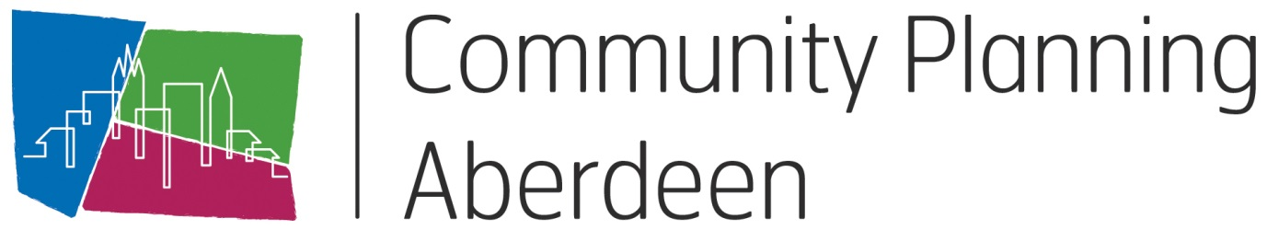
Meeting of Torry Locality Partnership
7th October 2020, 6pm – 8pm
Team’s virtual meeting

AGENDA
- Energy Transition Zone - Information and Awareness Sessions

- Creation of a Patient Participation Group for Torry Medical Practice

- Torry Recovery Plan

- Torry Hub

- 258 North Balnagask Road (Foundation Centre)

- Raising Local Awareness of Locality Partnership (Branding)

- Outstanding improvement Projects

- Report back from groups
- Torry Youth Action Group (Anti-social Behaviour)
- Partnership Forum
- Locality Empowerment Group (successor to Health and Social Care Partnership Locality Leadership Group)

- AOCB

- Date and time of next meeting

