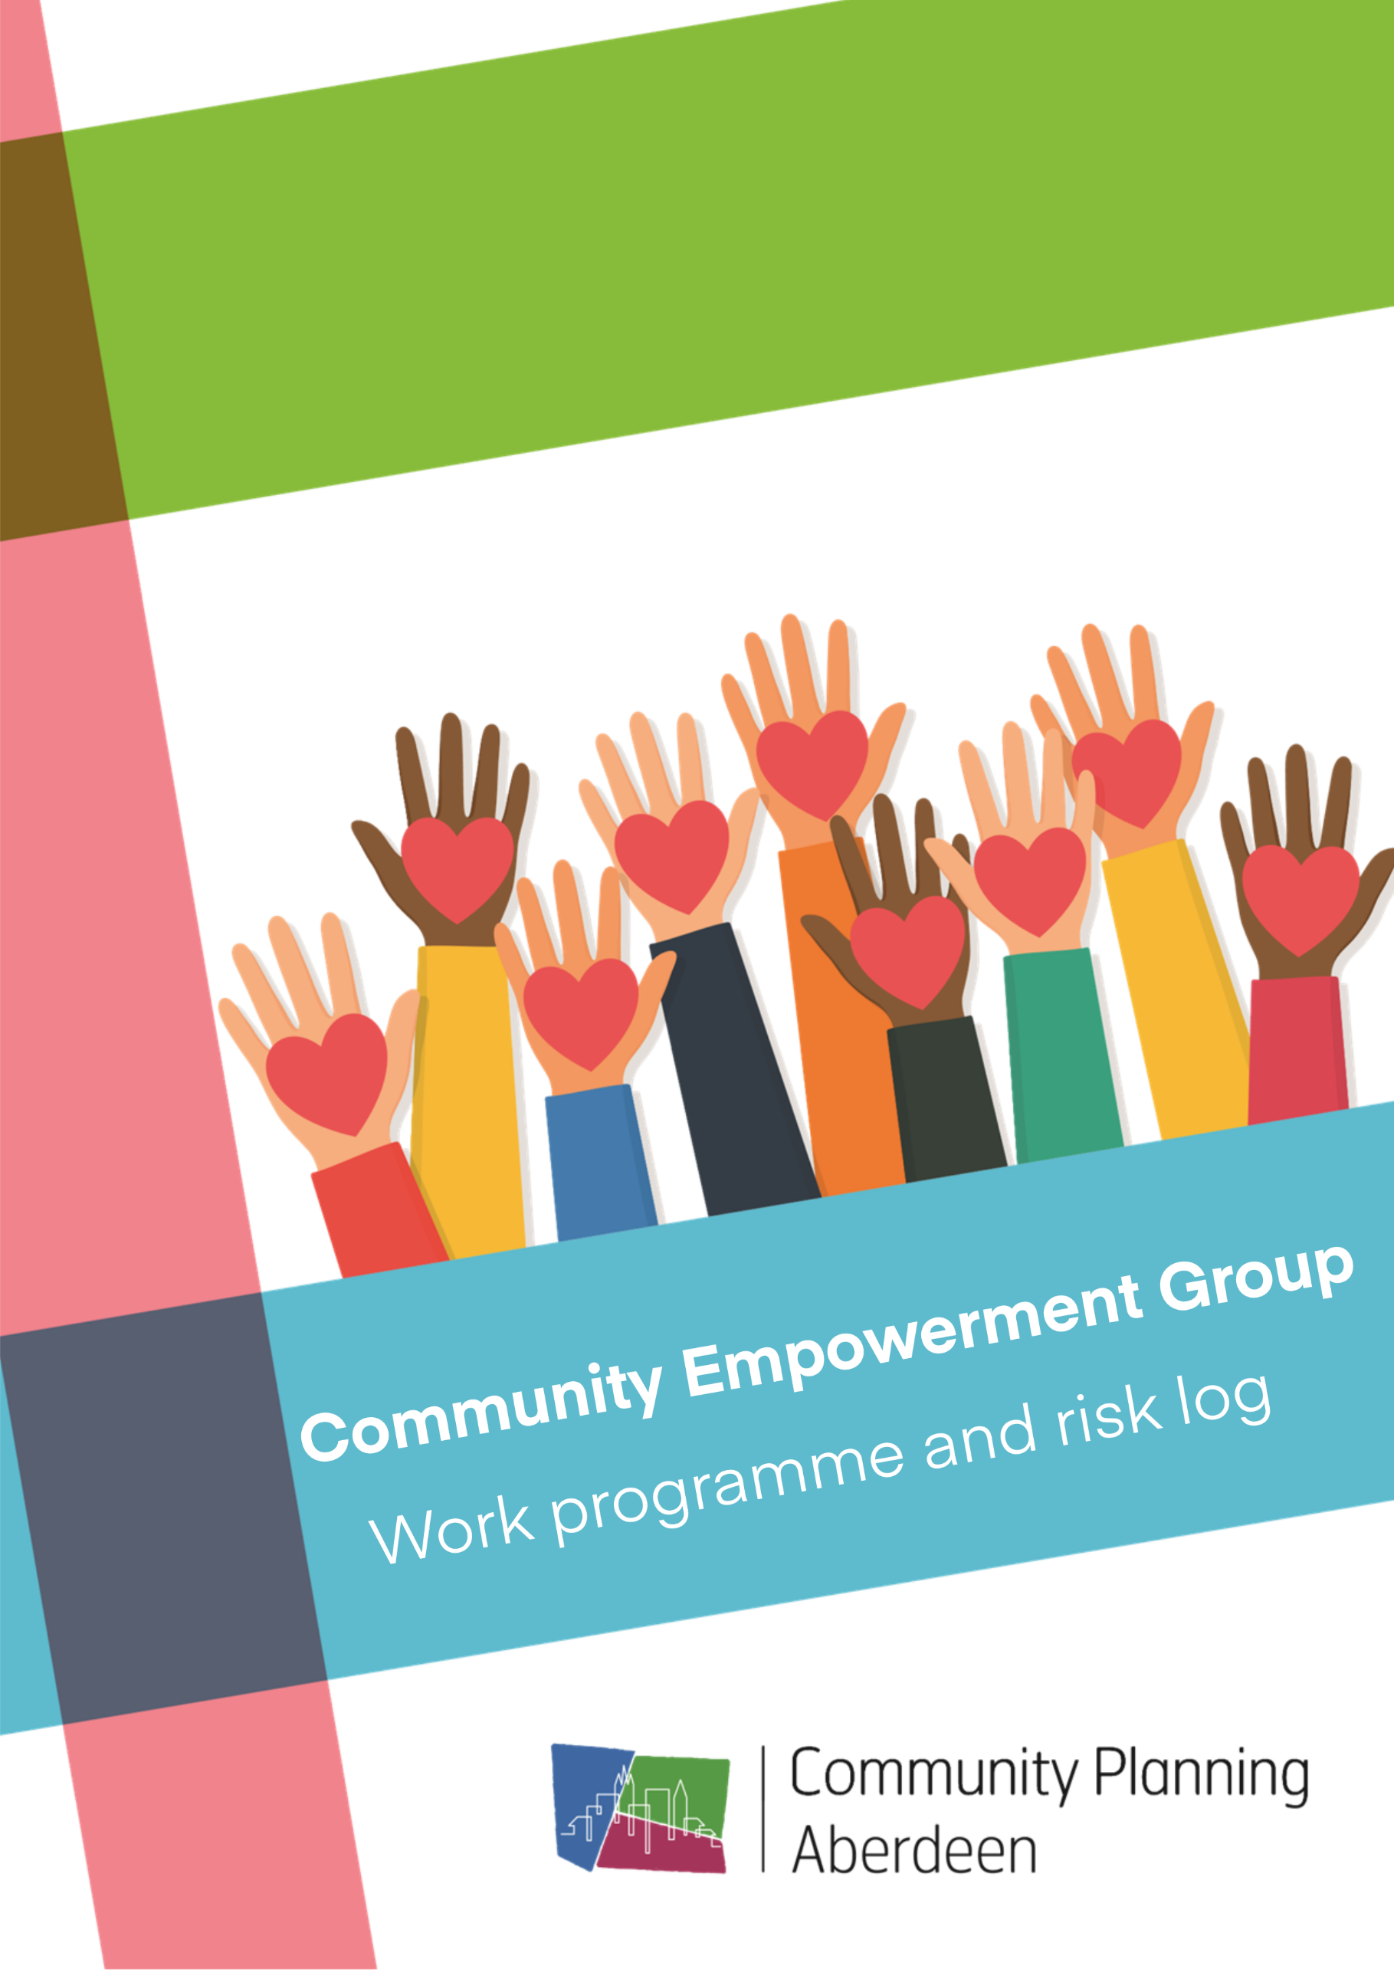
August 2021
Contents

1 Action Plan 3
2 Improvement Projects 7
3 Outcomes Framework 8
4 Risk and Issues Log 9

Appendix 1 – Prioritisation Workshop 10

1 Action Plan

Workstream​ | Key Actions​ | Lead Responsibility​ | Timescale​ | RAG​ | Notes/ progress​
Locality Planning | Evaluation of Locality Empowerment Groups to provide baseline engagement  Oversee transition to new integrated locality planning model and production of community led locality plans following Phase1 Review of Locality Planning  Locality Empowerment Groups/ Priority Neighbourhood Partnerships - Community Connectors/ Community Ideas  Oversee Phase 2 Review of Locality Planning – Connecting with wider communities | Shamini Omnes, ACHSCP  Michelle Cochlan, ACC  Shamini Omnes, ACHSCP  Colin Wright, ACC  Gordon Edgar, AHSCP  Rachel Harrison, ACC  Michelle Cochlan, ACC | May 21  July 21  Ongoing  October 21 |  | Infographic and benefits maximisation framework shared with members. Provides an example of how we might evaluate progress against our strategy.  In progress  To be initiated following publication of LOIP/ Locality Plan
Connecting Communities into Community Planning Aberdeen | Increased community engagement in the refresh of the LOIP via the public values simulator  Engaging with community groups and connectors on simulator results and draft LOIP/ Locality Plans  Development of Aberdeen Responsible Business Community Network  Strengthen role of funded groups/ participatory budgeting/ FAF as community connectors  Quarterly Extended Community Empowerment Group Meetings | Martin Wyllie, ACC  All  Michelle Cochlan, ACC  Maggie Hepburn, ACVO  Tanita Addario, ACC  Maggie Hepburn, ACVO Susan Thom, ACC  Michelle Cochlan, ACC  Jonathan Smith, Civic Forum  Maggie Hepburn, ACVO | March 21  May to July 21  October 21  TBC  Sep 21 |  | Results being considered by OIGs and LEGs/ PNPs  Consultation on draft LOIP scheduled for May/ June  Online CSR platform launched October 20. Follow up event to be held Nov/ Dec 21  Roots to sustainability work  ACVO producing promotional materials
Engagement, Participation & Empowerment Strategy | Review of the current Engagement, Participation and Empowerment Strategy. Including:  Review terminology around seldom heard/ hard to reach groups and revise details of these groups  Review to include analysis of current reach into communities. E.g. protected characteristics, harder to reach groups.  National Standards for Community Engagement? Action TBC  PB as a tool | Dave Blac, GREC  Fiona Clark, ACC  Maggie Hepburn, ACVO  Darren Bruce, PS | Sep-Dec 21 |  | Exercise has been initiated by Dave through Equalities Participation Group
Community Learning and Development Plan | Review governance arrangements for CLD to address feedback from last CLD inspection and confirm role of CEG  Development of Revised CLD Plan | Fiona Clark, Aberdeen City Council  Colin Wright | September 21  September 21 |  | Workshop held to understand current challenges. Follow up meeting with Caroline Johnston to be arranged by Fiona
Participation Requests and Asset Transfer | Support for communities to make participation requests/ asset transfer | Maggie Hepburn, ACVO  Wendy Henderson, Independent Sector |  |  | Looking at what other areas are doing on this
Share and Explore Innovation and Best Practice in Community Empowerment | Online Simulator  Place standard tool? Action TBC  Community Voices | Martin Wyllie  Colin Wright, Aberdeen City Council  Martin Wyllie | Adopted  TBC  Ongoing
City Voice | Oversee production of next City Voice Questionnaire to support availability of LOIP/ Locality Plan data and Community Empowerment | Anne McAteer, Aberdeen City Council | June/ July 21 |  | Underway

2 Improvement Projects
To be identified from data analysis/ outcomes framework.

Aim​ | Rationale​ | Project Manager​ | Changes ​ | Data​
Aberdeen Responsible Business – Aim TBC | ​ | ​Tanita Addario | ​TBC | Aberdeen Responsible Businesses working with CPA - 12

3 Outcomes Framework

The following indicators of community empowerment will be incorporated into the Aberdeen Outcomes Framework https://communityplanningaberdeen.org.uk/outcomesframework/

Initial indicators to be identified but will also be considered as part of the review of the Participation, Engagement and Empowerment Strategy.

Indicator | Baseline | Current​ | Trend ​ | Action/ Improvement Project
 | ​ | ​ | ​ | ​

4 Risk and Issues Log

Control Strength: | A | Working effectively | B | Requires development | C | Not effective | D | Broken down

Risk | Controls | Control Owner | Strength | Improvement Actions | Timescale

Appendix 1 Community Empowerment Group Workshop
