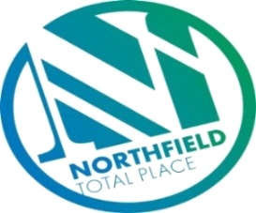

Northfield Total Place
Locality Partnership Board Meeting
Manor Park Community Wing
Wednesday 9.15am – 11.15am 4th March 2020

AGENDA
Your Data
Aberdeen City Council holds your contact details for the purposes of two-way communication. We do not share your details with a third party. If you do not wish us to hold your details, please let us know and I will delete your details. Bear in mind however that you will not receive future communications relating to these meetings. Your details will be held for as long as you attend the meetings and up to 6 months after.

- Welcome and Introductions All
- Minutes of Meeting 8th January 2020 Chair
- Approval
- Actions
- Matters arising

- Farrans Update Angela Newlands & Tristram Browne
- LOIP/Locality Improvement Project Updates Fiona Gray
- U Decide 20/21 – progress report Fiona Gray
- Report back from Northfield Partnerships
- NYAG/Police Update Police Scotland
- Partnership Forum Alex Priest
- Community Council Updates
- Mastrick, Sheddocksley and Summerhill
- Northfield
- Priorities for Locality Plan – notes from Special Meeting 14th August 2019 ALL
- AOCB
- Date and time of next meeting

