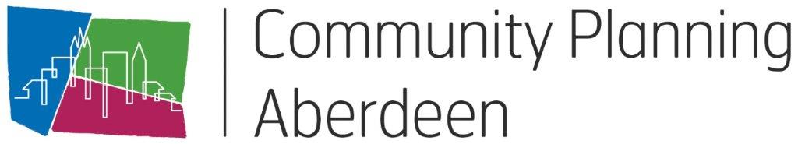
ACRONYM BUSTER

Partner Organisations |  |  |  |  |  | Groups and Boards
ACC |  | Aberdeen City Council |  |  |  | CPA | Community Planning Aberdeen
ACHSCP |  | Aberdeen City Health and Social Care  Partnership |  |  |  | CPAB | Community Planning Aberdeen Board
AAP |  | Active Aberdeen Partnership |  |  |  | CPAMG | Community Planning Aberdeen Management Group
ACVO |  | Aberdeen Council for Voluntary Organisations |  |  |  | IJB | Integration Joint Board, Aberdeen City Health and Social Care Partnership
BAC |  | Bon Accord Care |  |  |  | CEG | Community Empowerment Group
GREC |  | Grampian Regional Equality Council |  |  |  | CEN | Community Empowerment Network
NHSG |  | National Health Service Grampian |  |  |  | AP | Aberdeen Prospers Outcome Improvement Group
NESCOL |  | North East Scotland College |  |  |  | ICS | Integrated Children’s Services Board
PS |  | Police Scotland |  |  |  | RIS | Resilient, Included, Supported Group
SDS |  | Skills Development Scotland |  |  |  | SC | Sustainable City Group
SE |  | Scottish Enterprise |  |  |  | ADP | Alcohol and Drugs Partnership
SFRS |  | Scottish Fire and Rescue Service |  |  |  | CJG | Community Justice Group
NESTRANS |  | North East Scotland Transport |  |  |  | VAWP | Violence Against Women Partnership
RGU |  | Robert Gordon University |  |  |  | LEGs | Locality Empowerment Groups
UoA |  | University of Aberdeen |  |  |  | PNPs | Priority Neighbourhood Partnerships
Documents |  |  |  |  |  | Teams
LOIP | Local Outcome Improvement Plan |  |  |  | CLD |  | Community Learning & Development
LP | Locality Plan |  |  |  | CP |  | Community Planning
IP | Improvement Programme |  |  |  | LP |  | Locality Planning
PC | Project Charter |  |  |  | O365 |  | Microsoft Office 365
DPIA | Data Protection Impact Assessment |  |  |  | Teams |  | Collaboration & Meeting App
EHRIA | Equalities and Human Rights Impact  Assessment
ISA | Information Sharing Agreement
Others |  |  |  |  | Others
MEOC | Making Every Opportunity Count |  |  |  | CEYP |  | Care Experienced Young People
BAU | Business as Usual |  |  |  | RSL |  | Registered Social Landlord
BAME | Black, Asian and minority ethnic group

