Improvement Project Updates Guide

Guidance for Project Managers

Now that your project charter has been approved, you will need to share progress on your project with CPA Management Group and Board on a monthly basis, until the project is complete. This should be no more than two pages.

The update report is a short summary of progress towards achieving the overall project aim, including details of what changes you have tested between reporting periods and the improvement data which tells you whether your changes are making a difference.

Reporting Timescales

Improvement progress updates from project managers are required for CPA Management Group/Board on the following dates in 2024:

- 6 Mar
- 15 May
- 7 Aug
- 9 Oct

Report Format

We have set up a report template for you on Sharepoint (you will have received a separate link to access this). This means that you will be able to go into the document at any time to update the information on your project and we will use the latest version in the folder for submitting to the Management Group and Board. We will send you a reminder to help you ensure that projects are updated on time.

The report is designed to focus on the outcomes of the project, rather than a general update on activity. The report will be pre-populated for you with details of the project aim, start date and end date. It is important that projects show impact at both city wide and locality level.
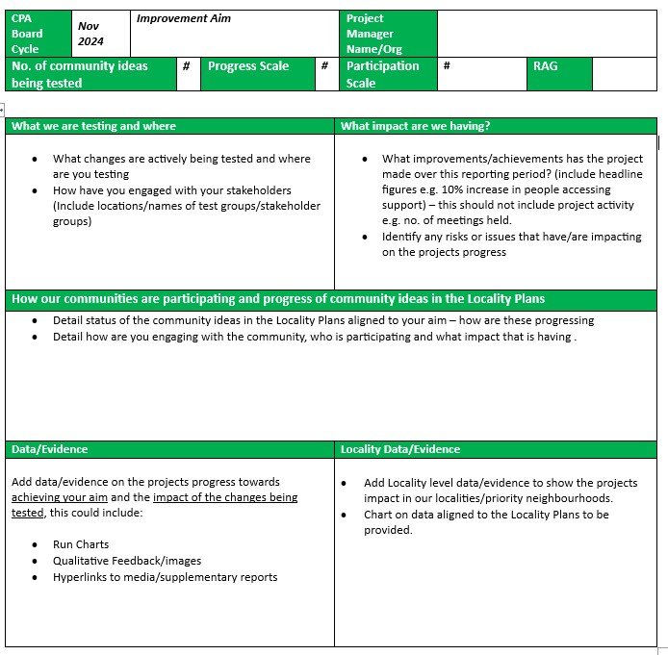

We need you to keep this up to date with the latest information on progress.
Progress Scale: Use the progress scale to evaluate where you are on your improvement journey. All projects that have been approved by the CPA Board will be at a minimum of stage 4.
Score | Stage of Project | Description
1 | Project area identified and agreed (complete for all LOIP projects) | Project has been identified as a priority from the Local Outcome Improvement Plan or Locality Plan
2 | Draft Outline Project Charter and team in place | Draft Improvement Project Charter has been developed (rationale, initial aims, scope, resources, timescales, measures, expected outcomes) and project team formed.
3 | Understanding baseline of current system (Data and practice) | Current system is being analysed- applying tools such as process mapping; cause & effect diagrams etc to understand processes and people, including readiness for change and analysis of baseline data
4 | Project Charter endorsed by CPA Board | Knowledge of the system and other evidence of what could work have been brought together into a theory of change. This has been articulated in a final Improvement Project Charter which has been shared with the CPA Board. (A driver diagram may also be developed to support this stage.)
5 | Change ideas and project measures further refined and prioritised | Range of specific change ideas developed further, measurement plans established and initial PDSAs are being planned
6 | Testing underway | Testing strategy developed and is being deployed. Data being gathered and analysed (e.g. through use of run charts)
7 | Initial indications of improvement | Anecdotal evidence or feedback that changes are resulting in improvement can be reported.
8 | Improvements achieved | Evidence of improvements shows in project measures and has been reported to Community Planning Aberdeen Management Group. Implementation and Spread plans are being developed and deployed.
9 | Sustainable improvement | Implementation plans have been deployed for key changes. Spread plans are developed if appropriate. Data indicates sustainability of impact of changes implemented in system.
10 | Project complete | The aim has been met or exceeded and improvement sustained and spread where appropriate. Changes are now part of business as usual.
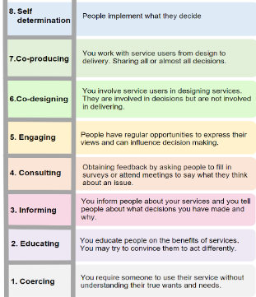
No. of community ideas being tested: This section should detail the number of community ideas from the locality plans aligned to your project that are being actively tested.

Empowerment Ladder Rung: This section should detail which rung on the ladder of empowerment your community engagement is on. The ladder represents the interactions between your project and all people and evidences levels of community empowerment. Read the community engagement helpsheet for guidance on the ladder.

Project RAG: This section should detail if your project is on track (green), at risk (amber) or off track (red) in terms of your project plan. If at risk, or off track, please use the Issues/Risks & how we will overcome them section to provide detail on the risks/issues which are resulting in the project not being on track.

What we are testing and where: In this section use the table to list the change ideas outlined in your charter which have been/or are being tested. If no changes are being tested at this time the project team should provide a brief explanation for why. For each change idea, you should also specify which locality you are testing in and who (which group) you are testing with.

Are our Changes Resulting in an Improvement: This section should be no more than 100 words and should provide a brief overview of whether your changes are helping you to achieve the aim, making a brief reference to the improvement data to back up your statement. If you have any infographics, videos, reports on the outcome of your tests of change, share them in this section.

This section should provide a brief overview of any issues/risks that are impacting on you achieving the aim, and that you want to escalate to the OIG/Management Group for support.

How our communities are participating and progress of locality ideas: This section should detail the status of the community ideas in the Locality Plans aligned to your aim – You will find the ideas aligned to your project within the Improvement Programme 2024-26. It should also detail how are you engaging with the community, who is participating and what impact that is having.

Improvement Data: The Improvement data section is critical to understand whether your changes are resulting in improvement. There should always be a chart to show progress towards your overall aim as well as the impact of the changes you are testing. This data should be provided at a City wide as well as locality level so that we know the impact of the changes on each locality. The section enables you to display progress using the key improvement measures for your project. We have pre-populated the report for you with basic level QI charts for the project outcome measure and any other relevant measures published in the LOIP. There are also blank charts in the report for you to add any additional data which demonstrates the impact (good or bad) of the changes you are testing.

The report is produced using Word, but you will be able to update your data/ charts from this application. This means that you can make all your updates in one place. See how below.

Editing the Improvement Data Sections
To change the chart title:
Left click on ‘Measure Title’ then left click again to edit the text box:
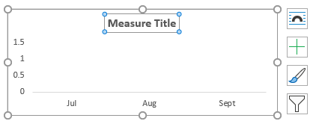
To add/change data:
- Click once anywhere on the chart you wish to edit, and the following icons will appear to the right of your chart
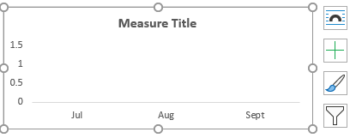
- Right click on the chart area and select Edit Data; then edit data in Excel:
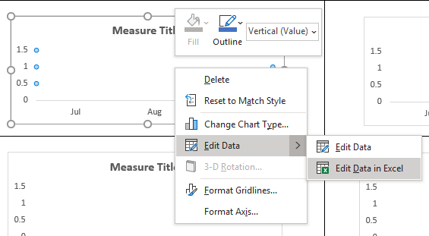
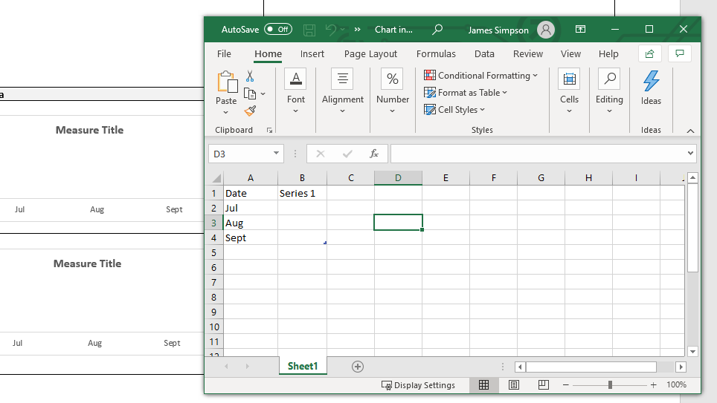
The following popup will appear to allow you to edit the details as an Excel sheet:

- Once you have entered/changed the data, close the window and the Excel sheet will populate the chart.
Other Uses for the Improvement Data quadrants
If no data is yet available for a measure, a quadrant could include: A photograph of the tests being undertaken; or stakeholder feedback on the project.
These quadrants should not be used to provide further contextual detail; change ideas; issues and barriers or progress of the project as a whole
See exemplar of a completed template overleaf.

CPA Board Cycle | Nov 2024 | Aim | Increase by 20% the number of registered young carers accessing support from the Young Carers service by 2025. (Sept 23) |  |  | Project Manager Name/Org | Carole Chambers, Barnardo’s
No. of community ideas being tested |  |  | 1 | Progress Scale | 6 | Participation Scale | 6
EXAMPLE PROJECT UPDATE: NOT REAL DATA
What we are testing and where | What impact are we having?
- Promotion/providing ‘think young carer’ training to outside organisations (city wide)  - Developing a wider range of choice/opportunities that meet our young carers interests (Community idea from North, South and Central Locality Plans).  - Promotional campaign to raise awareness of the opportunity to volunteer/befriend young carers and support the ability to support increase in referrals (city wide). | Positive impact.  - The number of young carers accessing support has increased from April 23 – Oct 2023 from 116 –134  - There has been an increase in both males and females but more significantly in males (and increase of 13 from 64-75)  - The number of opportunities for support has increased from 47-84 over this time  - 5 different agencies across the city have been trained and the promotion re self-directed referral for young carers, this has seen an increase in the number of self-referrals and referrals from agencies
How our communities are participating and progress of locality ideas
There is 1 community idea from the Locality Plans aligned to this project (as highlighted above). 2 young carers from each locality have supported the design and testing of the change ideas above, in particular change 2. Their feedback has been pivotal to the further design/adaptation of the changes for example, changes to the training so that it truly reflected their voice and experience as a young carer and change of time/location of new opportunities to ensure as accessible and meeting the needs of all. Four existing community groups have been engaged in the expansion of opportunities and they are now each providing new opportunities for young carers as identified as requested by young carers, for example art support group now available for carers in north locality, music group in central and drop in club in the south locality.
Data/Evidence | Locality Data/Evidence
Feedback from young carers, family and staff  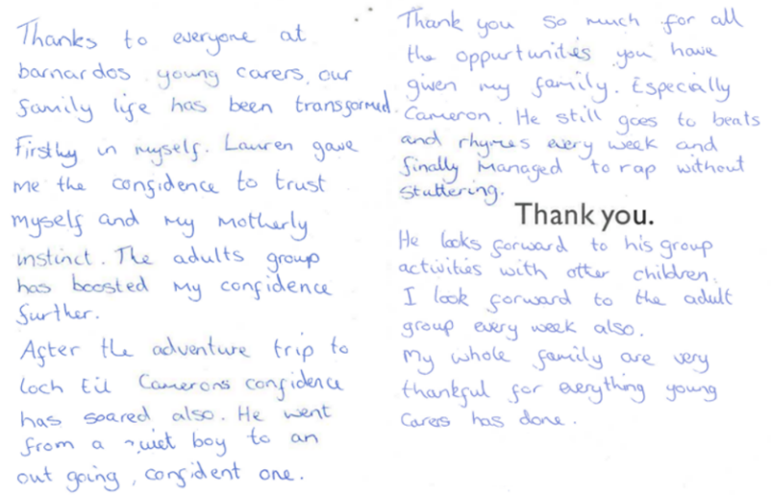 | General Feedback  - “The groups provided for young carers are great. My daughter now has a place where she feels happy and accepted. Thank you”  - “Young Carers Service has been so valuable to our family. Allowing us to do things we never would have done, supporting us and building confidence”  - “The event at Pittodrie was awesome and great to see the kids having such a fun time! The group has been great support for my kids and wife, and we would be lost without you guys”  - “The holiday groups gave my child respite from her caring role and allowed her experiences we cannot provide.

