How to Establish a Good Work-related Research Question and Find Answers

This guidance provides a structured approach to formulating work-related research questions and finding answers. It introduces three key frameworks: PICO, PEO, and SPICE, each suited to different research designs. It emphasizes the importance of systematic literature searching, using academic databases, and maintaining a search log. It also highlights the need for defensible, auditable decisions supported by rigorous evidence gathering. The guidance is based on a seminar by Paul Manson, Information Specialist at the University of Aberdeen, and is part of the Learning Together for Better Lives seminar series. Recordings are available here.

Scope
This guidance is for use where you are searching for evidence in academically published research to inform strategy, policy, interventions, etc. This may be in addition to what is evident in ACC service data and other routinely collected data or where no such data exists. If you plan to conduct research by designing and gathering new data, this guidance will help with the initial stages but should not be used in place of real research design.

Purpose
Defensible, auditable decisions are supported by rigorous evidence gathering and reporting from multiple types of sources. In public health, including the social determinants of health, academic research is an important source of evidence. It tends to be extremely specific, looking at, for example, one intervention for one symptom of one disease in one group in one region and comparing it to one alternative intervention. Academic research is also voluminous. So, crafting your search query and plan are critical to ensuring that your search results include all of what they should and do not include irrelevant results that increase your workload. In short, a loose search in a search engine is too weak an approach for any decisions based on its findings to be defensible and auditable.

Shaping a Question
A research question should define or clarify what you are looking for, be practicable in your time and resource limits, novel (i.e. no one has asked it before and shared their findings), ethical and neutral.
Not so good question: | Better question: | Why?
We know the PTB test is highly effective for diagnosing patients with OM; can you find evidence to support this? | What evidence is there for the use of the PTB test for diagnosing patients with suspected OM? | The edit makes the question more neutral
In children (under 16) does attending sports classes improve behaviour? | Does attending football classes improve attentiveness in P4-7 children? | The edit makes the question more specific so the results will be more manageable

Question Frameworks
Research questions should include some key components; using a framework helps to ensure they do. Which framework is most appropriate depends on the research topic. Three common frameworks are shown below, but others also exist.

PICO
PICO is the most used framework and stands for Population (or problem), Intervention, Comparator and Outcome. It is so common that some publication databases include the PICO components in their search interfaces.
For asylum seekers learning a language, are group classes or immersive learning better when measured by the Language Comfort Scale?

PEO
This framework uses Population/problem, Exposure, Outcome. It is used where there is no distinct comparator in the research design (but the outcome will offer some comparison with other practices).
In homeless persons, how does the assignment of a named case worker affect the rate of homelessness?

SPICE
This framework uses Setting, Population/perspective, Intervention, Comparison and Evaluation. SPICE suits qualitative (non-numerical) and/or broader topics.
In care homes, do staff think music-based or non-music-based groups have a greater effect on residents’ quality of life?

General approach to literature searching
Before you search specific databases, you should have the following general approach. Be aware that free resources do not have strong search tools.
- Be systematic
- Do not expect instant results
- Work from your question
- Check citations where they sound relevant (i.e. let one result provide you others; ‘snowballing’)
- Filter the initial results lists by title, then abstract (which is like an executive summary) and then by the full text
Academic research papers reflect the type of research work that was done. Often this is ‘primary’ or ‘empirical’ research, where researchers create/gather new data from experimentation, observation or similar. There are also Evidence Review database sites, where the researcher compiles an analysis of multiple primary papers (so they tend to be less up to date than the latest primary research); case studies; books and book chapters; and official findings (this final type you will find more easily using general search engines). Expect to find all of these in your search results unless your question is in an under-researched area.
You may also want to keep a log of where you searched, when, what queries you used, numbers of results and the lists of results. You will find repetition across databases and quickly forget what exactly you did and where, risking wasting time repeating and reworking. This log will also mean that your process is documented and auditable.

Search Tips
Be aware that a search will not necessarily search the full text of all the articles in a database, because that would make it slow and produce lots of only superficially relevant results. A search will usually search titles and abstracts (executive summaries). Different site’s searches will have their own versions of these tips.
- Use quotation marks for exact phrases; “public libraries”. If you do not use them the search tool will return results that include your words without requiring the words to be together.
- If you want to search by the trunk of a word, use the asterisk: Aberdeen* will count as Aberdeen and Aberdeenshire.
- Some sites will let you use OR, meaning the results will be publications that contain one of more of your words; Aberdeen OR Aberdonian.
- Some sites will let you nest your search terms: Aberdeen AND (“fuel poverty” OR “transport poverty”).
- There is often an Advanced Search interface that will let you be more specific about what building your search query, e.g. it can help you build a search for TITLE INCLUDES “circular econom*” AND ABSTRACT INCLUDES Aberdeen AND FULLTEXT INCLUDES “public health”.

Where to Search
The following are publicly accessible resources (except NHS Scotland Knowledge Bank), sometimes called ‘open access’.

Google Scholar
Google Scholar
This is fine to use as one of many search sites but not as the only one. It will still generate many results but without the non-academic ones (such as service information for citizens). However, the extent of the search interface is limited so you cannot limit your search (which is part of why it has many results).
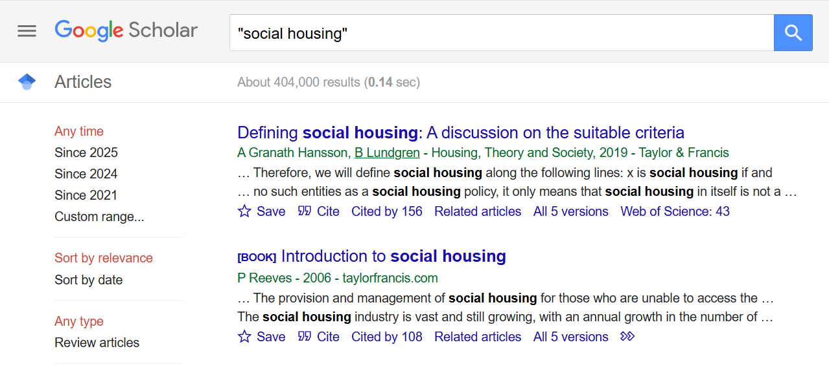
A screenshot of Google Scholar results, showing 404,000 results. Also showing options to filter by time and type and sort by date and by relevance.

Evidence Review database sites
Evidence reviews are publications that have found, analysed and drawn conclusions from other existing publications, rather than by experimentation, observation, surveying, etc. (though the reviewed publications will be of these types). Checking these sites might show that someone has already addressed your question in a review so you can save time and use their findings. There are some databases that only list evidence reviews. Searching them is simpler because reviews are less numerous.
These sites are demonstrated in the seminar recording starting at 32:15.
Cochrane Library
You might notice that this resource offers browsing by Topic and by PICO so you do not necessarily have to search at all.
Campbell Collaboration
Evidence for Policy and Practice Information Centre
National Institute for Health Research Journals Library

Free academic databases
Free academic databases are as close as you can get to academic library collections as a member of the public, online. They hold tens of millions of articles, lots are free to access, and they have good search tools. Good search tools are needed because a well-structured search is what will help you find what you need in the millions of possible results.
NHS Scotland Knowledge Network
PubMed
JSTOR

Why not just use Google?
Google may be fine as one of the search tools you use but not on its own. This is because it produces too many results; the results are custom to your location, history and profile (so un-reproducible in audit); you cannot reliably filter out operational material (e.g. “social housing” search results will be swamped with information for applicants and tenants); there is no quality control in the results and there is no real structure to help you sharpen your search (e.g. including and excluding types of result).

