Sustainable City Outcome Improvement Group
Meeting on Teams 21st September 2023
Present: Alan Simpson, Alison Potts, Alison Stuart, Andy Scott, Daria Shapovalova, Fiona Mann, Jacqui Bell, Jillian Evans, Kelly Wiltshire, Phil Mackie, Richard Findlay, Sarah Irvine, Sinclair Laing, Steven Shaw, Sue Lawrence,
Welcome to new members: Alan (ACC), Alison S. (NESCAN), Andy (Police Scotland) and Sarah (ACVO).
Apologies: Craig Marr, Martin Carle
Actions:
- Agree and submit suggestions for SO and project aim revisions by 5th October

Reflection on Place Standard Workshop (see slides/notes attached from Alison P.)
- Agreement to themes/content from those who’d been at workshop
- Vision in keeping with new ACC transport strategy (walking/cycling benefits – ‘active travel network’ review at present – lived experience very valuable)
- Links with Nature Networks – current SGovt consultation closes 14th December https://consult.gov.scot/environment-forestry/tackling-the-nature-emergency/
- Co-creation needed – bring out linkages / community aspect - cycling infrastructure essential – need evidence around cycle paths
Review of Stretch Outcomes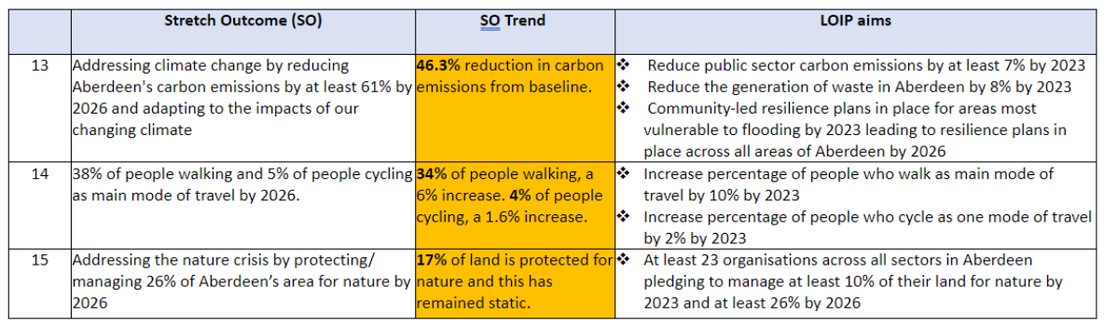
Decisions:
13 | Retain | - suggestion to focus on public sector only, but agreed that ambition is to effect societal change in Aberdeen
14 | Revise | - discussion on how to get the right balance between ambition and realism – we may be able to influence change even if it’s beyond our direct control – don’t let metrics inhibit our goals – the importance of infrastructure for cycling  - possibly keep same SO but change/add to project aims  - suggestions - % not driving, reducing car use (SG target: reducing car miles by 20%; LTS target: reduce car journeys by 50%), % using sustainable travel, to include public transport,  - follow-up meeting to be arranged to agree on feedback to CPA
15 | Retain | - uncontested decision!

Review of Project aims
Decisions:
13.1 | Keep existing aim
13.2 | Revise depending on source of data and new projects for food/community hubs – take circular economy perspective?
13.3 | Revise - Community led resilience plans are in place for areas most vulnerable to flooding (6) in the City by the beginning of 2025. Annually give information, advice, and guidance on overall resilience planning, such as winter preparedness, power outages etc. to be promoted across the City too individuals, communities, and business.  Include develop and promote a suite of generic community resilience plans?
14.1/14.2 | Revise in line with revised SO
15.3 | New aims needed – to include natural health service/social prescribing

Other Relevant Information Shared
- Register for the Grampian Community Resilience Conference https://engage.aberdeenshire.gov.uk/aberdeenshire-community-resilience-strategy/news_feed/community-resilience-conference-registration-open
- Just Transition Participatory Budgeting Fund https://www.jtpbfund.scot
- The Scottish Govt are launching a campaign tomorrow for Scottish Climate Week on travelling sustainably using case studies where people dropped the car for a week and did active or public transport and encouraging people to take the challenge. We could all share that campaign.
- ‘Envirolution’ (Manchester) is an initiative that aims to increase understanding, connection and engagement with the natural world, supporting transition toward a more sustainable future for everyone. https://envirolution.org.uk/

Next meeting: Tuesday 31/10/2023 13:00-14:30 PM
Please contact Jacqui or Jillian with any agenda items.

