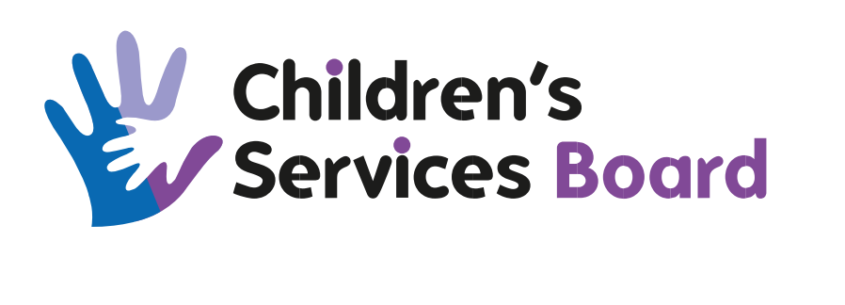

Title of Meeting | Best Start in Life Group
Date of Meeting | 03/09/2024
Time of Meeting | 14.00 Hours
Venue | Via Microsoft Teams

Name | Designation | Organisation
Julie Warrender (Chair) | Chief Nurse | ACH&SCP
Pamela Black | HV Team Leader | ACH&SCP
Cameron McCready | General Manager | Homestart Aberdeen
Natasha Martens | Peep Co-ordinator | Aberdeen City Council
Bethan Murdoch | Deputy Chief Nurse | ACH&SCP
Pippa Robbie | Childsmile co-ordinator | NHS-G
Angela Kazmierczak | Financial Inclusion Team Leader | Aberdeen City Council
Sarah Donaldson | Area Manager | Scottish Childminding
Lorraine Duncan | Community Childminding Co-ordinator | Scottish Childminding
Margaret Hill | Early Years Librarian | Aberdeen City Council
APOLOGIES
Name | Designation | Organisation
Emma Williams | Advanced Public Health Practitioner | NHS Grampian
Grainne Gray | Community Learning Development Manager | Aberdeen City Council
IN ATTENDANCE
Name | Designation | Organisation
Brenda Munro | Team Administrator (minute taker) | ACH&SCP

AGENDA
No. | Item | By | Papers
1. | Welcome and Apologies  Julie Warrender welcomed those present to the meeting and apologies were noted as above. | Chair
2. | Minute of the Last Meeting  The minute of the last meeting was accepted as a correct and accurate record. | Group
3. | Matters Arising from the Minute of the Last Meeting  No action points noted from previous meeting  BSIL Dashboard – access to the dashboard had been discussed at the last meeting and it has subsequently been confirmed that multiple access for BSIL group members is not going to be feasible. Therefore it was agreed to go through the Dashboard and ask group members to note which data groups they were particularly interested in and this data could be shared, perhaps in the form of a newsletter with the group every 8-12 weeks. Group members agreed this was a good resolution and they would welcome the opportunity to see the data.  Bethan Murdoch then shared the dashboard and gave an overview of the data available to view.  Action: Group members to e-mail Bethan to specify which data groups they are interested in receiving updates for  Action: Julie Warrender and Bethan Murdoch to agree a format and frequency for circulating the data to group members.  Healthpoint  Bethan Murdoch addressed the group and welcomed Angela Kazmierczak to join this discussion, it has been suggested that the Healthpoint could be a single point of contact for Financial Inclusion referrals. The Healthpoint would then be able to collate data from all the services as well as providing health and financial awareness advice. There would also be potential to look at other referrals that could be offered to people accessing the Healthpoint.  Angela then spoke in relation to the online benefit calculator that is well used by families, she referred to July’s data where an updated Support for Families booklet had been handed out along with a link to the calculator and there had been an increase from 30 people accessing the online tool to 549 completed actions. Angela then asked if Health had a process to send this information to patients / clients. It was noted that e-mails are not routinely used for contacting expectant and new Mums. However, the question was raised if there was a QR code for accessing this as a QR code could be promoted by the Health Visitors when out on visits etc. and also put on both the NHS-G Facebook page and the Birth in Grampian page and families signposted this way.  It was noted that the Support for Families booklet is currently being printed and will be delivered to Marishcal College, copies of this booklet can be given to frontline staff.  Margaret Hill asked if the link for this information could be shared so she could ensure it was highlighted on the Libraries webpages. She also stated that the Library could be a distribution point for the hard copy booklets.  Angela stated that caution would need to be exercised over sharing the QR code as Aberdeen City Council have advised this following the recent scam. | Group

4. | Project Charters - Updates  Stretch Outcome 4  4.1 Reduce by 5% the no. of children aged 0-4 who are referred to Children’s Social Work as a result of neglect arising from parental mental health, addiction and domestic abuse 2026.  Pamela Black updated the group and the following was noted:  Infant massage sessions continue at Froghall Community Centre and there are plans for a third block following the positive feedback from the attendees.  Parents who attend the massage sessions are then signposted to Peep so they can access something after this.  A Community Nursery Nurse has been identified to work alongside Natasha Marten’s team to deliver “Moving on from Domestic Abuse”.  4.1 Increase by 40% the number of Peep programmes delivered by multi-agency partners by 2025.  Natasha Martens gave an update to the group, the main points of which were noted as follows:  Continuing to try to increase Peep Delivery.  Moving on from Domestic Abuse – a Community Nursery Nurse has been identified to assist with delivering this programme.  Links have been made with Sport Aberdeen and Childsmile.  Antenatal Peep Training – parents can be offered an opportunity to do a little portfolio for qualifications,  There has been a good response from parents who would like to be Peep trained and skill themselves to deliver.  There are more dates for Healthier Families training – an e-mail has gone out with these dates.  Still experiencing the same issues around capacity.  There is currently a block of Antenatal Peep running with another block due to commence on 25/09/2024.  Query over why pregnant women are not signing up for Peep courses and engaging. Noted there are physical posters which can be put up in workplaces as a reminder to frontline staff etc.  The quarterly report has shown an increase in the number of families that were supported in the last quarter with an increase of 35% more families attending.  There is ongoing work to develop a Rainbow Peep for parents who have lost a child.  4.2 100% of urgent requests for first stage infant formula and nutritional support for pre-school children are met by 2024.  No updates as Emma was not in attendance at the meeting  4.2 Increase by 10% the no. of parents with children under 5 who are completing a full benefits check by 2024.  No updates as Emma was not in attendance at the meeting  4.3 Improve dental health at primary 1 to the national average by reducing the levels of dental health in areas of deprivation to 50% by 2025  Multi Agency Torry Health Matters group continues to meet with very positive “buy in” from attendees. Group members have been tasked with asking people in Torry “What is getting in the way of your Health and Wellbeing?”  A proposal has been put forward to have a health led Mum and Baby group to meet every Thursday in the café at Tullos.  There are lots of different partners around the work that is ongoing Sport Aberdeen, Childsmile, Community Midwiefery etc.  Delivering Healthier Families – there is a cohort at Tullos and it is hoped to deliver this at either Greyhope or Deeside.  There is a large Nigerian contingent in Torry and a Childsmile worker who is Nigerian has been linked in to offer advice and support around dental care as they are not often aware of the care they are entitled to when pregnant. |  | Pamela Black  Natasha Martens  Emma Williams  Emma Williams  Pippa Robbie
5. |  | 5 Minute Feedback  Natasha Martens – Geronimo Project  Noted that Peep are partnering up with them, there is a lot of collaborative work and there are still spaces in their 0-5 programme, Families who attend get a meal and there is information around this which could be shared more widely.  Links for upcoming Geronimo sessions.  https://www.eventbrite.co.uk/e/geronimo-time-to-play-tickets-998401875887 Torry Sessions  https://www.eventbrite.co.uk/e/geronimo-time-to-play-tillydrone-tickets-998413310087- Tillydrone Sessions  Margaret Hill – Aberdeen City Libraries  Aberdeen Reads Challenge – there were 800 children took part in this with a total of 3000 books read.  Bookbug Training – there are still 6 spaces left.  La Leche League – there is going to be an updated version of the “Art of Breastfeeding” coming out and it is hoped to have one of the authors come and speak in Aberdeen in late November, further details of this to follow.
7. |  | A.O.C.B.  There was no other business noted.
8 |  | Items for Escalation to CSB  There were no items noted for escalation.
10. |  | Date of Next Meeting  The next meeting will take place on 08/10/2024.

