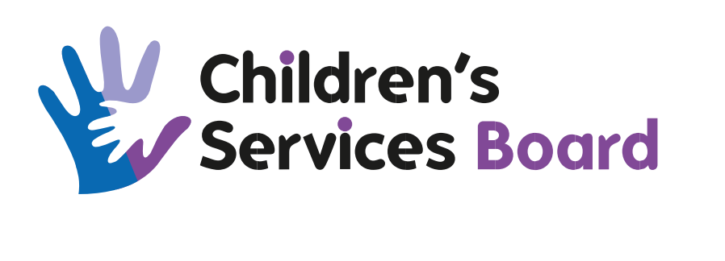

Title of Meeting | Best Start in Life Group
Date of Meeting | 08/10/2024
Time of Meeting | 14.00 Hours
Venue | Via Microsoft Teams

Name | Designation | Organisation
Pippa Robbie | Childsmile co-ordinator | NHS-G
Pamela Black | HV Team Leader | ACH&SCP
Cameron McCready | General Manager | Homestart Aberdeen
Marie Down | Lead Speech & Language Therapist | NHS Grampian
APOLOGIES
Name | Designation | Organisation
Julie Warrender (Chair) | Chief Nurse | ACH&SCP
Lorraine Duncan | Community Childminding Co-ordinator | Scottish Childminding
Louise Beaton | Service Manager, Early Years | Aberdeen City Council
Bethan Murdoch | Deputy Chief Nurse | ACH&SCP
Natasha Martens | Peep Co-ordinator | Aberdeen City Council
Emma Williams | Advanced Public Health Practitioner | NHS Grampian
IN ATTENDANCE
Name | Designation | Organisation
Brenda Munro | Team Administrator (minute taker) | ACH&SCP

AGENDA
No. | Item | By | Papers
1. | Welcome and Apologies  Pippa Robbie welcomed those present to the meeting and apologies were noted as above. | Chair
2. | Minute of the Last Meeting (03/09/2024)  There were amendments to the minute from Natasha Martens, noted as follows  “Links have been made with Sport Aberdeen and Childsmile to deliver a block of Healthier Families Peep.  Antenatal Peep Training – dates have been scheduled in late June 2025  Pathway training is available for Peep practitioners so parents can be offered an opportunity to do a portfolio for qualifications.”  Following the above amendment then the minute of the last meeting was accepted as a correct and accurate record. | Group
3. | Matters Arising from the Minute of the Last Meeting (03/09/2024)  Matters arising from the last meeting were focused around the dashboard information shared by Bethan. Group members were asked by Bethan to email her with the sections of the dashboard they would be interested in reviewing.  Julie and Bethan will agree a format for the dashboard moving forward for future meetings | Group
4. | BSIL Dashboard  Please see above update
5. | Project Charters - Updates  Stretch Outcome 4  4.1 Reduce by 5% the no. of children aged 0-4 who are referred to Children’s Social Work as a result of neglect arising from parental mental health, addiction and domestic abuse 2026.  Pamela noted that work is continuing with and the 3rd block of infant massage is running with continued good attendance. The groups have focused primarily around previous/current mental health issues, experiencing domestic abuse, relationship problems and alcohol/substance misuse. Parents are looking for the next steps after these sessions and staff are currently signposting them onto Peep groups.  A Peep session around moving on from Domestic Abuse is being planned and it is hoped that this will commence in January  Loraine Duncan was unable to attend the meeting however gave the below update to be shared  Scottish Childminding deliver respite service (community childminding) to families in Aberdeen, if we can do anything to support let us know or give you some figures of the families we support. We do have small amount of referrals through social work or there is social involvement, as most come through HV’s.  4.1 Increase by 40% the number of Peep programmes delivered by multi-agency partners by 2025.  Natasha was unable to attend the meeting however sent the below update to be shared  - Charter is progressing well. Compared to this time last year, we have more multiagency partners delivering Peep.  - There are plans in place for NHS (Pamela Black’s team) and Family Learning to deliver a revamped version of the Moving on From Domestic Abuse Peep group in January.  - Childsmile and Sport Aberdeen have been working together to get another block of Healthier Families Peep delivered in Torry next term, before the new year.  - The big push at the moment is using the funding we have received for Peep and Antenatal Peep training. There are still spaces for the Dec 9th and 10th and Jan 8th and 9th Peep training. The Antenatal Peep training will take place in July 2025 but a list of interest has already been created. Spaces for the training are for anyone who is interested in Peep- ACC staff, volunteers, NHS staff, parents, managers supporting practitioners, third sector, etc. Although the hope is to get some more people delivering Peep, part of this is to get the shared language of the programme throughout the city. So please share with partners who might be interested and get in touch with me if you have any questions.  - Peep- Unfortunately due to low numbers, we were unable to run our last block of Antenatal Peep. The next block will be in November. We’re finalising details and I will send out dates and posters later this week.  Loraine Duncan was unable to attend the meeting however gave the below update to be shared  Spoken to Natasha about possible training in the New year for childminders. Arranging the dates is going to be difficult but hope to get round this.  4.2 100% of urgent requests for first stage infant formula and nutritional support for pre-school children are met by 2024.  Emma was unable to attend the meeting however sent the update below  Data for the emergency pathway has been received from Fiona at CFine and will be shared as soon as possible  Loraine Duncan was unable to attend the meeting however gave the below update to be shared  If we can help with this as the childminders look after this age group, even handing out information to families they care for.  4.2 Increase by 10% the no. of parents with children under 5 who are completing a full benefits check by 2024.  The early years financial inclusion pathway is in the process of a revamp. Staff feedback has been taken onboard and the pathway is looking far better now. The new pathway will allow for better data collection and Emma can get access to this  Loraine Duncan was unable to attend the meeting however gave the below update to be shared  If we can help with this as the childminders look after this age group, even handing out information to families they care for.  4.3 Improve dental health at primary 1 to the national average by reducing the levels of dental health in areas of deprivation to 50% by 2025  Pippa was delighted to announce the setting up of a Bumps and Babies group which was successful from HIF funding. This session will be held every Thursday 10.30-11.30 at the Bridge Café, in Torry. The funding will provide a hot drink and snack for attendees.  There will be a number of partner agencies ie Sport Aberdeen, HVs, CNNs, Midwives, Family Learning and Peep attending the sessions on a rota basis to offer the support to families. Information on which agency will be attending on which week will be shared with the community ahead of their attendance.  Donna Cuthill from Community Learning team is producing an infographic to be shared and advertised around Torry to gain as many attendees as possible. The infographic will be shared with the group as soon as available and it is hoped that sessions will commence in November. The group has been funded for an initial 12mths whereupon a review will take place to ascertain if group should continue to run  Loraine Duncan was unable to attend the meeting however gave the below update to be shared  Have had a conversation in the previous about supporting child smile, we have Ann coming out to promote teeth brushing to the childminders through our chatty cafes. | Pamela Black  Natasha Martens  Emma Williams  Emma Williams  Pippa Robbie
6. | 5 Minute Feedback  Marie noted that SLT have held initial discussions with HV service around the possibility of a community assessment day  Cameron noted that Homestart continue to be very busy. A sponsor has now been confirmed for Christmas giving and the team are working on applications at present for winter jackets More volunteer enquiries have also been received which I very positive  Pamela noted that the HV service is starting to widen the pathway visits as staffing in the service is now very positive. Staff are feeling very positive around these changes to the workload  Pamela also noted that the Aberdeen City Libraries had been shortlisted for an award and Pamela would like to pass on congratulations to Margaret and the team
7. | A.O.C.B.  There was no other business noted.
8 | Items for Escalation to CSB  There were no items noted for escalation.
9. | Date of Next Meeting  The next meeting will take place on 26/11/2024

