Introduction to Systematic Reviews & Rapid Evidence Reviews
Dr Leonard Ho, Health Determinants Research Collaboration Aberdeen
This guidance offers a brief introduction to systematic reviews and rapid evidence reviews. We, the Health Determinants Research Collaboration Aberdeen (HDRCA), have been producing several rapid evidence reviews to gather up-to-date evidence to aid the planning and decision-making of Council Officers and our collaborators. Below, Dr Leonard Ho, Research Fellow at HDRCA, first introduces an evidence synthesis design commonly used in academia, namely systematic reviews, followed by an introduction to a ‘simplified’ version of them, rapid evidence reviews. The guidance also provides a comparison of these designs and some common glossary terms that you may encounter when reading or conducting a review yourself.

What is systematic review?
A systematic review aims to collate and synthesise all empirical evidence from primary research studies (hereafter referred to as ‘studies’), that meet pre-specified eligibility criteria, in order to answer a clearly defined research question.[1] It employs systematic, explicit, and replicable methods designed to minimising bias, and produce more reliable findings, from which conclusions can be drawn and decisions made.[1] Systematic reviews are widely used to summarise existing evidence on particular healthcare interventions. In the context of Evidence-Based Medicine, systematic reviews are placed at the top of the Evidence Pyramid [Figure 1],[2] indicating that they are considered to provide the highest quality evidence for clinical and policy decision-making.
Figure 1. Evidence Pyramid
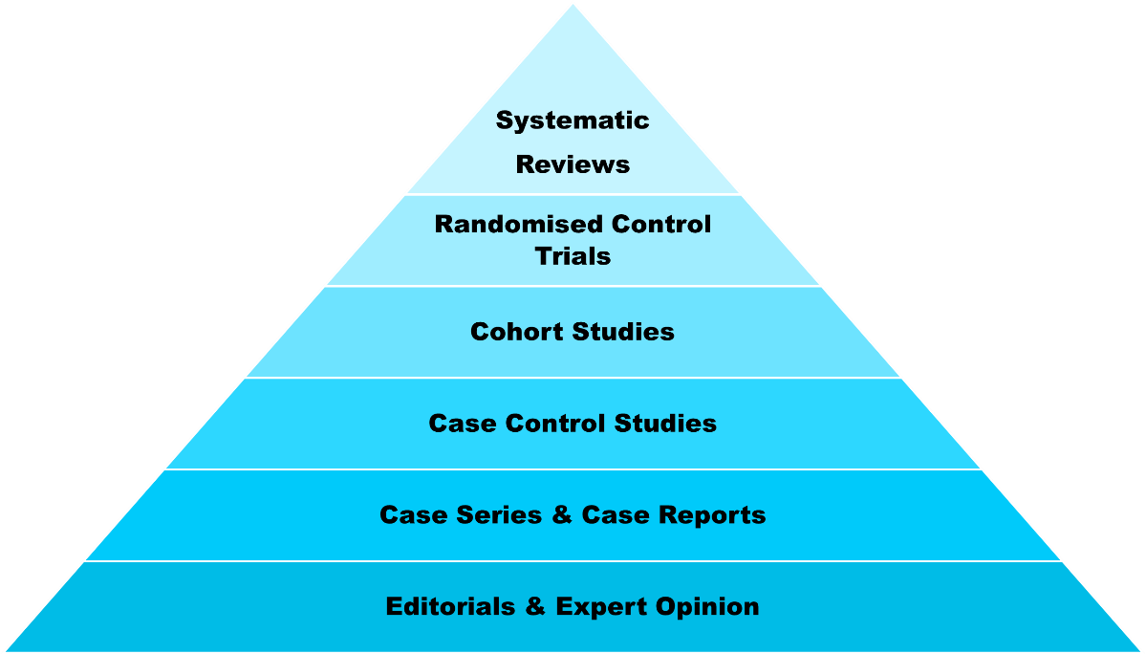
The steps involved in conducting a systematic review are the following:[1]
- Formulate of a specific research question
- Establishment of eligibility criteria for study inclusion
- Development of search strategies tailored to different databases
- Conducting searches across multiple databases and retrieving relevant studies
- Screening of titles and abstracts of the retrieved studies
  - Conducted independently by two reviewers
- Assessment of the full text of studies for eligibility
  - Conducted independently by two reviewers
- Critical appraisal of the risk of bias in the included studies
  - Conducted independently by two reviewers
- Extraction of data from included studies
  - Conducted independently by two reviewers
- Synthesis and analysis of the extracted data
- Drafting of the final report
If conducted with academic rigour for journal submission, completing a systematic review may require up to one year, if not longer.
The specific research question should be formulated based on the PICO approach:[1]
- Population/problem [P] – The population or problem we are interested in
- Intervention [I] – The intervention we want to investigate
- Comparator [C] – The comparator to which we want to compare the intervention
- Outcome [O] – The outcome (or parameter) we want to measure
For example, a systematic review (Naude et al) was conducted in 2021 to investigate if low‐carbohydrate diets [I] are better than balanced‐carbohydrate diets [C] for reducing weight and cardiovascular risk [O] among adults who were overweight or living with obesity [P].[3] The authors synthesised 61 randomised clinical studies, including a total of 6,925 participants, and reported the characteristics of each study in terms of their population, components of their diets, length of the study, and other relevant information.

What is meta-analysis?
To provide overall data on weight and cardiovascular risk reduction, the authors performed a series of meta-analyses. A meta-analysis is a statistical method that combines outcome data from multiple independent studies that address a common research question.[1] By pooling results, a meta-analysis increases the overall sample size and statistical power, allowing for more precise estimates of treatment effects or associations than any individual study alone. For instance, if we identify three studies, reporting on the effectiveness of chemotherapy for treating breast cancer, we can ‘pool’ their data together and produce a single estimate of effect.
After conducting meta-analyses, Naude et al. concluded that there is little or no difference in the weight lost or risk of heart disease between individuals who followed a low-carbohydrate diet and those who adhered to a balanced-carbohydrate diet for up to two years.[3] Specifically, among overweight and obese participants without type 2 diabetes mellitus, a low-carbohydrate diet led to a modest reduction in body weight by (average of 1.07 kg over three to 8.5 months and 0.93 kg over one to two years) when compared to a balanced-carbohydrate diet.[3]

Issues to consider when using a systematic review to inform decisions
Systematic reviews have become a widely used and influential form of research. To ensure our decisions are informed by high-quality evidence, it is essential to assess whether a systematic review has been conducted with methodological rigour. The key characteristics of a well-conducted systematic review include:
- Formulation of a specific research question before the start of the review process
- Definition of a clear scope for the review and criteria for study inclusion
- Exhaustive efforts to identify all relevant studies (e.g., searched in multiple databases and other distribution channels)
- Consideration and mitigation of bias in the included studies
- Objective and impartial analysis of all included studies to draw reliable conclusions
Validated instruments are available to assess the methodological quality of systematic reviews, particularly those focusing on healthcare interventions. For instance, AMSTAR 2 (A MeaSurement Tool to Assess systematic Reviews) is designed to guide the critical appraisal of systematic reviews that include both randomised and/or non-randomised clinical studies.[4] It evaluated the methodological quality across 16 key domains identified by experts in the field, and provides an overall confidence rating. Similarly, the Checklist for Systematic Reviews and Research Syntheses developed by the Joanna Briggs Institute provides an 11-domain framework for appraising the quality of systematic reviews and research syntheses that evaluate different types of evidence.[5]
Even when systematic reviews are conducted according to high methodological standards, their reliability depends on the methodological quality of the included studies. Inclusion of poor-quality studies can compromise the validity of the overall review findings. Therefore, authors of systematic reviews should consider removing studies with a high risk of bias or conducting additional analyses to assess the impact of low-quality studies on the review's conclusions. Due to their specific focus, systematic reviews may also lack generalisability; findings from one review are unlikely to apply broadly to other contexts. For example, the findings from the above systematic review on low-carbohydrate diets versus balanced-carbohydrate diets may not be appropriate for informing decisions about school meal plans for primary school children, because that systematic review focused exclusively on adults aged 18 years or above. Furthermore, despite comprehensive database searches, systematic reviews may miss ‘grey literature’ (e.g., reports, newsletters, government documents) that is not published through conventional academic channels. Omitting grey literature may lead to incomplete evidence and potentially inaccurate assessment of findings.

What is rapid evidence review?
In certain circumstances, there is an urgent need to gather research evidence quickly to support decision-making, such as during the COVID-19 pandemic, when data on vaccine effectiveness was required on a near-daily basis. In such instances, a rapid evidence review (or rapid review) may be appropriate. Like systematic reviews, rapid reviews aim to address a clearly defined research question and systematically synthesise the available evidence.[6] However, they are typically completed within a shorter timeframe (six months or less) and use streamlined methods to reduce resource demands.[6] Although rapid reviews may compromise on certain methodological elements and are generally more susceptible to bias than full systematic reviews,[7] they can still provide credible and timely insights, particularly in fast-moving or evolving situations.
Currently, field experts are developing reporting guidelines for rapid evidence reviews,[8] suggesting that a ‘gold standard’ for conducting these reviews has yet to be established. However, certain characteristics can be identified from published rapid evidence reviews, many of which are also present in systematic reviews. Table 1 below provides a comparison between systematic reviews and rapid evidence reviews, highlighting their key similarities and differences.
Table 1. Compares and contrasts of systematic reviews and rapid evidence reviews
Major steps in reviewing | Rapid evidence reviews | Systematic reviews
Formulating research question | Same across both types of reviews
Establishing eligibility criteria | Same across both types of reviews
Developing search strategies | Same across both types of reviews
Conducting database searches | One (preferably two) major database (e.g., PubMed for health studies)  If feasible, search for unpublished literature (e.g., reports) from other sources like Google | At least three major databases with searches for unpublished literature from other sources
Screening titles & abstracts of studies | Conducted by one reviewer and preferably validated by another | Conducted independently by two reviewers
Assessing full text of studies | Conducted by one reviewer and preferably validated by another | Conducted independently by two reviewers
Appraising risk of bias in studies | Not necessarily conducted but preferable | Conducted independently by two reviewers
Extracting data | Conducted by one reviewer and preferably validated by another | Conducted independently by two reviewers
Synthesising and analysing data | Same across both types of reviews
Drafting final report | Same across both types of reviews

An example of rapid evidence review
Recently, we conducted a rapid evidence review [Appendix] to summarise academic reviews (i.e., reviewing the reviews) on evaluating interventions that support the integration of asylum seekers in host countries. Our research question, framed using the PICO approach, is as follows:
- Population [P] – Asylum seekers
- Intervention [I] – Any interventions supporting integration
- Comparator [C] – Any comparators
- Outcome [O] – Any outcomes measuring the effectiveness of integration
We executed a search for academic literature in Google Scholar, supplemented by a search in Google for reports published by registered charities and research institutes. Due to resource restrictions, titles and abstracts screening, as well as full-text assessment, were performed by a single reviewer and we did not perform a critical appraisal of the two included studies. In addition to the academic literature, we included three reports produced by third-sector organisations, which assessed local-level evidence and documented the lived experiences of asylum seekers during the integration process.

Summary
To support evidence-informed decision-making, conducting systematic reviews are highly recommended due to their ability to maximise transparency and minimise biases. However, when time or resources are constrained, a rapid evidence review may become a practical and efficient alternative. By adhering to the major steps of a systematic review, albeit in a streamlined form, a rapid review strikes a balance between tight timelines and acceptable methodological quality. When conducted appropriately, this approach can still provide actionable evidence to guide decision-making.
A glossary of terms is provided in Table 2 for your reference.
Table 2. Glossary of terms
Term | Definition
Critical appraisal | The process of systematically evaluating the methodological quality of a research study using specific validated tools.
Evidence Pyramid | A visual framework used in healthcare and evidence-based medicine to rank the strength and reliability of different types of research evidence. Levels of the pyramid include (from top to bottom): meta-analysis and systematic reviews, randomised controlled trials, cohort studies, case-control studies, case series and case reports, expert opinion.
Grey literature | Written materials produced outside traditional commercial or academic publishing channels, such as reports, working papers, government documents, and white papers.
Meta-analysis | A statistical method that combines and synthesises data from multiple independent studies on the same outcome, providing a single, overall estimate of effect.
PICO approach | An approach for developing specific research questions by identifying the Population [P], Intervention [I], Comparator [C], and Outcome [O].
Rapid evidence review | A type of evidence synthesis that quickly and efficiently summarises evidence by simplifying or omitting certain steps of a traditional systematic review.
Systematic review | A type of evidence synthesis that collates all empirical evidence from primary research studies, using systematic, explicit, and replicable methods, to answer a specific research question.

References
1. The Cochrane Collaboration: Cochrane Handbook for Systematic Reviews of Interventions. https://training.cochrane.org/handbook (2023). Accessed Apr 2 2025.
2. Minkow D: The Evidence-Based Medicine Pyramid! https://s4be.cochrane.org/blog/2014/04/29/the-evidence-based-medicine-pyramid/ (2014). Accessed Apr 2 2025.
3. Naude CE, Brand A, Schoonees A, Nguyen KA, Chaplin M, Volmink J. Low-carbohydrate versus balanced-carbohydrate diets for reducing weight and cardiovascular risk. Cochrane Database Syst Rev. 2022;1(1):Cd013334. doi: 10.1002/14651858.CD013334.pub2.
4. Shea BJ, Reeves BC, Wells G, Thuku M, Hamel C, Moran J, et al. AMSTAR 2: a critical appraisal tool for systematic reviews that include randomised or non-randomised studies of healthcare interventions, or both. BMJ. 2017;358:j4008. doi: 10.1136/bmj.j4008.
5. Aromataris E, Fernandez R, Godfrey CM, Holly C, Khalil H, Tungpunkom P. Summarizing systematic reviews: methodological development, conduct and reporting of an umbrella review approach. Int J Evid Based Healthc. 2015;13(3):132–40. doi: 10.1097/xeb.0000000000000055.
6. Garritty C, Nussbaumer-Streit B, Hamel C, Devane D. Rapid reviews methods series: assessing the appropriateness of conducting a rapid review. BMJ Evid Based Med. 2025;30(1):55–60. doi: 10.1136/bmjebm-2023-112722.
7. Ganann R, Ciliska D, Thomas H. Expediting systematic reviews: methods and implications of rapid reviews. Implement Sci. 2010;5(1):56. doi: 10.1186/1748-5908-5-56.
8. Stevens A, Hersi M, Garritty C, Hartling L, Shea BJ, Stewart LA, et al. Rapid review method series: interim guidance for the reporting of rapid reviews. BMJ Evid Based Med. 2025;30(2):118–23. doi: 10.1136/bmjebm-2024-112899.

