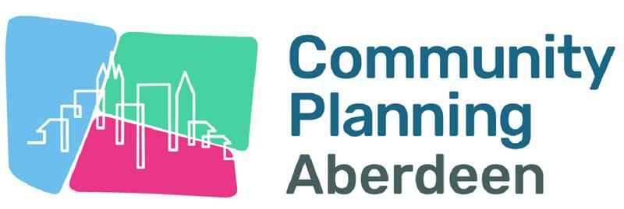

Central

Date: 21.05.25

Meeting: Tillydrone, Woodside & Seaton Priority Neighbourhood Partnership

MEETING NOTE

In Attendance | Apologies
Abeer Helmi, Community Rep and Chairperson | Graham Donald, Aberdeen City Council
Dave Smith, Community Rep | Jane Fullerton, Community Rep
Dave Black, shmu
Chris Smillie, Aberdeen Health and Social Care Partnership
Sara Duncan, Aberdeen City Council
Susan Morrison, ACVO
David Innes, Action for a Fairer World
Corinna Emslie, NESCAN
Jade Leyden, Aberdeen City Council

ACTION POINTS | ACTION LEAD
- Welcome and Introductions

Abeer opened the meeting and everyone gave introductions

- Minutes of previous meeting

Approval

Actions

Minutes were approved

Matters Arising

Jade shared that she had found the platform that can be used to generate AI minutes. Whilst there is a subscription for use of the site, there is also a free function whereby community groups could use it to generate minutes from their meetings a few times per month. The name of the site is Fathom and this is the link: Fathom AI Notetaker - Never Take Notes Again

Aberdeen for a Fairer World/NESCAN

David Shared that following the previous meeting he has met with groups that had previously been promised £3,000 to develop work identified through the previous people assemblies. These groups are:

- Earth and Worms
- Woodside Network (Woodside Decides)
- Seaton Community Council

These groups will take a community commissioning approach to spending this on relevant projects. The groups have a responsibility to report back on the impact of the funding. This funding originated from the Just Transition Community Fund.

The reports will be shared with the Priority Neighbourhood Partnership as it is recognised that these projects will link to priorities identified within the Locality Plans.

It was confirmed that the Enivirolution event will come back this year, 20th September at Seaton Park. It will kick off climate action week. You can find out more here: Envirolution

Your Place, Your Plans, Your Future and the Locality Plan refresh

Jade shared that the consultation closed on the 18th of May, and had a total of 2,087 responses across Aberdeen City. Work is being done currently to analyse the data that was received.

When there is a better picture of the outcome across localities, some communication will be shared across Social Media to share information before reports are available.

Last time the Locality Plans were refreshed, the priorities were played back to this group before the plans were updated. We are looking at ways to extend community involvement in this process to ensure there is community ownership of the plans. Work around how we deliver PNPs will be looked at also.

Dave from shmu explained that shmu ran creative sessions led by creative practitioners to test different ways of generating information for the consultation. Abeer suggested this might be something to look at for future engagements to encourage people to participate.

Abeer also suggested that when we look at ways we can improve PNPs that we come with suggestions/prompts to make for easier conversations.

Funding and Events

Susan helpfully shared the content of the funding and events update. Information on this can be found here: May Funding and Events Update

The Trade’s Widows Fund was also discussed and the webpage can be found here: https://www.twfcharity.org/ - an easy application process for community groups. The most recent round of this funding has just closed and upon checking, I have been advised that it will not open again until roughly November this year and then again in early Spring 2026. Still a while away but thought it useful to share to support any forward planning/dates for the diary.

DoNM

July 2nd, 6.00 – 8.00pm at St Georges Church, Tillydrone

